Stereotaxic Injections into Mouse Cervical Spine

- Scope and Applicability:
This SOP describes the technique of targeting the cervical spinal cord for bi-lateral stereotaxic injection.

- Materials:
  - Anesthesia and related:
    - Isoflurane (Piramal Critical Care Inc. 330250; purchased as Patterson Veterinary 07-890-8115 or equivalent)
    - Reference Care Module CM_S_01_A/B or CM_S_01_C/D for a complete list of required drugs and drug preparations
  - Tool Kit:
    - Black handle scissors, ToughCut (Fine Science Tools 14058-11 or equivalent)
    - Scalpel handle (Fine Science Tools 10003-12 or equivalent)
    - Iris forceps (Fine Science Tools 11064-07 or equivalent)
    - Dumont #5 45° forceps (Fine Science Tools 11251-35 or equivalent)
    - 45° Vanna scissors, 8 cm (World Precision Instruments 500260 or equivalent)
    - Plastic sterilization container (Fine Science Tools 20810-02 or equivalent)
    - Hemostats (Fisher Scientific 12004-16 or equivalent)
    - large iris forceps (Fisher Scientific 13-820-073 or equivalent)
    - Retractor Elastomer (Fine Science Tools 18200-07)
    - Retractors (Fine Science Tools 18200-8 through 18200-12)
  - Consumable Supplies
    - PREempt Disinfectant spray (Contecinc 21101 or equivalent)
    - 70% Ethanol spray bottle (RP0032 or equivalent)
    - Alcohol Wipes (BD326895or equivalent)
    - Sterile Surgical Drape, 18x26” (More Medical 14170 or equivalent)
    - Sterile Multi-well plate, 24 well (VWR 29443-952 or equivalent)
    - Nair Hair Removal Cream (Amazon B00R4HWYNI or equivalent)
    - Betadine solution (McKesson Medical-Surgical 77911 or equivalent)
    - Artificial Cerebrospinal Fluid.V (RP0205 or equivalent)
    - Surgifoam Absorb Gelatin Sponge Size 100 (McKesson Medical-Surgical 403360 or equivalent)
    - Sterile Gauze, 3x3” squares, autoclave sterilized (Patterson Veterinary 07-847-3539 or equivalent)
    - Cotton swabs, double ended, autoclave sterilized (VWR 89133-810 or equivalent)
    - Cotton swabs, double ended, non-sterile (VWR 89133-810 or equivalent)
    - Kimwipes, autoclave sterilized (VWR 21905-026 or equivalent)
    - Kimwipes, non-sterile (VWR 21905-026 or equivalent)
    - Sugi pointed sterile swabs (Fine Science Tools 18105-01 or equivalent)
    - Insulin syringes, U-100, 0.3 ml, 31G (VWR BD328438 or equivalent)
    - Insulin syringes, U-100, 1 ml, 31G (VWR BDBD328418 or equivalent)
    - Luer-Lock Syringe, 20 ml (VWR BD 309661 or equivalent)
    - Luer-Lock Syringe, 10 ml (VWR BD309604 or equivalent)
    - 25G 5/8 inch needle (VWR BD305122 or equivalent)
    - 32 mm Syringe Filter 0.2 µm Supor Membrane (VWR 28143-350 or equivalent)
    - Press ‘n’ Seal (Medline CLO70441 or equivalent)
    - Saran Wrap (Amazon B015FCLAVU or equivalent)
    - Systane Eye Ointment (ALCON293787 or equivalent)
    - Sterilization pouches (Chex-All 082411 or equivalent)
    - Heat-sterilized Glass pipettes (Drummond Scientific 3-000-203-G/X, World Precision Instruments 1B120F-4 or equivalent)
    - Microcapillary Pipette tips (Eppendorf 89009-310 or equivalent)
    - Parafilm (VWR 52858-000 or equivalent)
    - 30 gauge, 2" Backfilling Needle (Amazon B00EOAI5HC or equivalent)
    - Lightweight Mineral Oil (Sigma Aldrich M8410 or equivalent)
    - Suture: vicryl and PDS II, 5-0 (DOTMed 4919655 or equivalent)
    - 5-0 Monofilament suture with 17 mm 1/2C taper needle attached (Stoelting™ 50499 or equivalent)
    - 3M Transpore Surgical tape (Amazon B00KHVWCD0 or equivalent)
    - Lab Tape (Amazon B0889LYH61 or equivalent)

- Equipment:
  - Small Animal Stereotaxic Instrument (Kopf 1900 or equivalent)
  - Stereo Microscope (Leica M80 or equivalent)
  - Fiber optic illuminator (Dolan Jenner MI-152 or equivalent)
  - Bead sterilizer (Germinator 500 or equivalent)
  - Small Animal Temperature Control System (CWE Inc. TC-1000 or equivalent)
  - Heat plate/pad (Lectro Kennel Outdoor Heating Pad or equivalent)
  - Oxygen Concentrator (Puraline or equivalent)
  - Isoflurane with oxygen delivery system (Patterson Scientific 07-8914722 or equivalent)
  - Isoflurane induction chamber (Patterson Scientific 078917853 or equivalent)
  - Electrode Holder (Kopf 1970 or equivalent)
  - Galaxy Mini Centrifuge (VWRC1413V-230 EU or equivalent)
  - P20 Pipettor (Gilson Inc F123600 or equivalent)
  - Nanoject II Variable Volume (2.3 to 69 nl) Automatic Injector (VWR 490007-164 or equivalent)
  - Nanoject III (Drummond Scientific 3-000-207 or equivalent)
  - Magnetic Base Plate (Fine Science Tools 18200-03)
  - Mouse NRB nose cone (Patterson Posi-Vac 78914730)
  - 2x Short Magnetic Fixator (Fine Science Tools 18200-01)
  - 1x Tall Magnetic Fixator (Fine Science Tools 18200-02)

- Safety:
  - Non-Sterile Gloves
  - Disposable lab coat
  - Face mask; 0.6-micron filter (optional)
  - Shoe covers or designated surgery shoes
  - Scrubs
  - Surgical Cap (or hair secured away from face)
  - Biohazard sharps disposal container
  - Biohazard waste disposal container

Warning: Personal Protective Equipment (PPE) should be used at all times while operating this protocol. If you are unsure what PPE you should be using, see your immediate supervisor.

Isoflurane Warning: Acute over-exposure to waste anesthetic gases (WAG) may cause eye irritation, headache, nausea, drowsiness or dizziness. Repeated exposure may cause damage to cardiovascular system and central nervous system. Refer to MSDS for additional information. Consult the surgical workstation guide to ensure all parts of the dispensation rig are functioning properly. Employee exposure monitoring is periodically conducted by EHS and may be requested at any time from EHS.

Only IACUC approved and appropriately trained personnel may perform this procedure. Refer to Section 10.2 for detailed information on IACUC guidelines.

- Output:
  - Adult mouse with bi-lateral viral injections into the spinal cord between C4-C5 vertebrae.

- Reference Documents:
  - CM_S_01_A/B or CM_S_01_C/D: IACUC Care Modules
  - AF0098: Preparation of Sterile Consumables Packets
    - To be Published
  - RP0032: Ethanol Dilutions
    - To be Published
  - RP0205: Artificial Cerebrospinal Fluid V (ACSF.V)
    - https://dx.doi.org/10.17504/protocols.io.besjjecn
  - NSBWI-0012 Suture Training
  - NSBWI-0022 Preparation and take down for NSB surgical procedures
  - NSBWI-0041 Pulling Pipettes for Injections

- Setup:
  - Remove all jewelry that could compromise PPE. Long hair that could fall into the surgical site must be tied back or covered.
  - Wash hands prior to surgery with soap and water and wear clean exam gloves and a disposable lab coat while performing surgery.
    - Surgeons must change gloves between surgical animals.
    - Disinfect or change gloves any time they become dirty or damaged.
    - To disinfect, spray with 70% Ethanol and let air dry.
  - ATTENTION: Before proceeding, please reference the Standards of Care protocol via IRB manager for complete list of drugs and drug preparations required by the procedure being performed.
  - Turn on heating pad, bead sterilizer, stereotaxic digital display.
  - Set the heating pad to 37.0 ± 0.5°C.
  - Turn on compressed air, vacuum, and oxygen concentrator.
  - Disinfect the surgery area.
    - Spray area for the surgical drape with PREempt and let sit for at least 5 min.
    - Spray all other surfaces, surgical rig, induction chamber, station tools, knobs buttons, and switches you touch during the procedure with 70% Ethanol reapplying after 5 min, so you have a minimum contact time of 10 min.
    - Optionally you may use alcohol swabs to wipe down station tools, knobs buttons, and switches you touch during the procedure.
    - If performing multiple surgeries, the induction chamber must be cleaned between animals.
  - Using a non-sterile Kimwipe wipe up any residual PREempt and 70% Ethanol.
  - Cover heating pad on surgical rig with a layer of press ‘n’ seal.
    - If preforming multiple surgeries, the press ‘n’ seal must be changed between animals.
  - Open a fresh sterile drape, touching only the blue side to ensure sterility, place it white side up and blue side down, on the area disinfected with PREempt.
  - Open a sterile 24-well plate and dispense supplies into well.
    - Fill one well with 1 ml Nair.
    - Fill one well with 1 ml Betadine solution and soak three swabs.
  - Open sterile packages surgical supplies, pouring the items onto the surgical drape to preserve sterility.
    - Cotton swabs, Kimwipes, gauze, & sugis.
  - Fill the 10 ml syringe with ACSF (Artificial Cerebrospinal Fluid), then attach 0.2 µm syringe filter and 25G 5/8” needle.
    - Note: Never pull fluid through the filter.
    - ACSF is only sterile after being dispensed though the filter.
  - After checking the Care module acquire 1.0 ml and 0.3 ml insulin syringes to pull drugs.
    - 1.0 ml syringe is for LRS and Carprofen
    - 0.3 ml syringe for all other drugs
  - Remove surgery tools from the sterilization tray and place on the sterile drape, taking care to not touch the instrument tips.
    - Surgical tools must be autoclaved prior to surgery.
  - Additional supplies
    - Remove one aliquot of virus from -80ºC freezer, thaw at room temperature, and spin down in the mini centrifuge.
    - If virus is not present, email the PI and cancel the surgery.
    - Obtain Nanoject-specific beveled pipette (stored in plastic boxes in surgical suite).
    - Parafilm square (expelling oil, placing virus)
  - Prepare pipette
    - Using a 30G, 2” backfilling Hamilton syringe filled with mineral oil, backfill the pipette.
    - Insert the tip of the Hamilton syringe into the pulled pipette, all the way to the shoulder, and slowly depress the plunger on the Hamilton syringe, filling the pipette with oil. Be sure not to introduce bubbles into the system or the injection may not be successful.
    - Once the pipette is backfilled with oil, loosen the collet on the end of the injector. The wire plunger should be 2-3 mm past the collet.
    - Gently slide the pipette over the wire plunger and push it through the chuck and seating it in the green rubber seal.
    - Tighten the collet.
  - Loading the virus into the pipette
    - Once the pipette is secured to the collet, press, and hold the ‘EMPTY’ button on the control box until an audible beep is heard. This will drive the wire plunger out forcing oil to the tip of the pipette. Any excess oil will be expelled. Expel about 4-5 drops and work out any air bubbles.
    - Take virus from ice and spin down for 10-15 seconds.
    - Use the P20 micropipette with a microfil tip to draw up ~2 µl of virus.
    - Using the surgical bed as a platform, aspirate the virus sample onto a clean piece of Parafilm.
    - Using the stereotaxic apparatus, lower the tip of the pipette (secured in the Nanoject) into the sample. Be careful to not “bottom out”.
    - Press and hold the ‘FILL’ button and draw up the desired amount of virus. Release the button when finished.
    - Do not introduce air bubbles into the system as this may result in inaccurate injection volumes.
    - Use standard injection rate of 2 nl/sec
    - Set aside nanoject until ready to inject
  - Use magnetic base and 3 magnetic fixators to hold retractors with elastomer attached.
  - Remove base of heating pad and nosecone/incisor bar.
  - Use standalone nose cone taped to base with lab tape.

- Methodology/Procedures:
  - Position mouse with gauze pillow under torso (tuck the gauze under the neck and forearms). Extend and tape all limbs and tail using Millipore surgical tape. Due to the animal’s body position for this surgery, breathing is more constricted. Pay close attention to the animal’s breathing throughout the surgery.

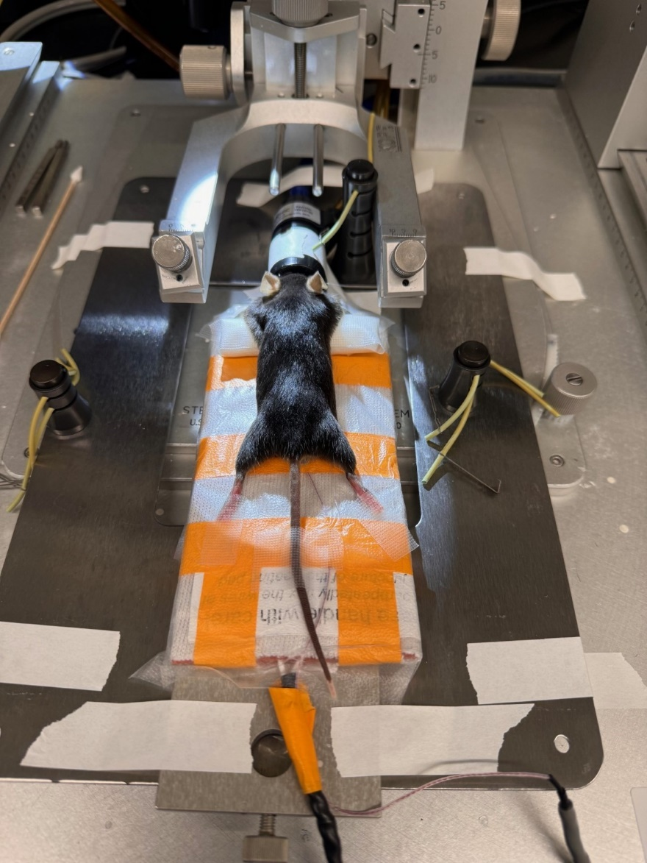
Figure 1. Mouse surgical positioning
  - Cover the mouse’s eyes with a generous amount of eye ointment. Additional eye ointment should be added as needed to prevent eye dryness and protection from the scope light.
  - Administer any drugs that have a timing after induction or prior to incision.
    - Check Standard of Care protocol
  - Expose and prepare the surgical site. Throughout the procedure, spray surgical gloves with ethanol to keep them as clean as possible after touching non-sterile surfaces such as the ceramic trays, freezer/refrigerator doors, or tables/equipment that were not disinfected before the procedure.
  - Use black handled scissors to shorten hair from neck to base of the rib cage. Hair should be removed the lateral edges of the mouse.
    - When finished with the scissors place in your dirty tools area or re-sterilize in the bead sterilizer.
  - Remove remaining hair with Nair. Apply the Nair with the pointed end of a non-sterile cotton swab gently swirling it down to the interface of the skin and hair.
    - The more abrasively you rub it in the more likely you are to get chemical burn.
    - Some animals will not respond to the toe pinch but will react to the Nair. In this instance increase the Isoflurane and closely monitor breathing.
  - Remove all Nair with several alcohol swabs.
  - Disinfect the surgical site with 3 rounds of alternating Betadine-soaked sterile swabs and alcohol wipes. The last application of Betadine should not be wiped off.
  - Place Saran Wrap over the trunk of the animal.
  - Change your gloves.

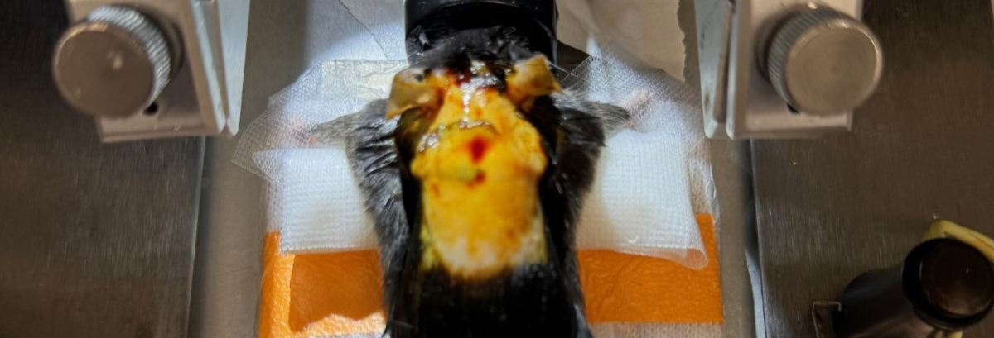
Figure 2. Hair removal

  - Using Blunt Iris forceps and Vanna scissors make a vertical incision from behind the ears to the shoulder blades.
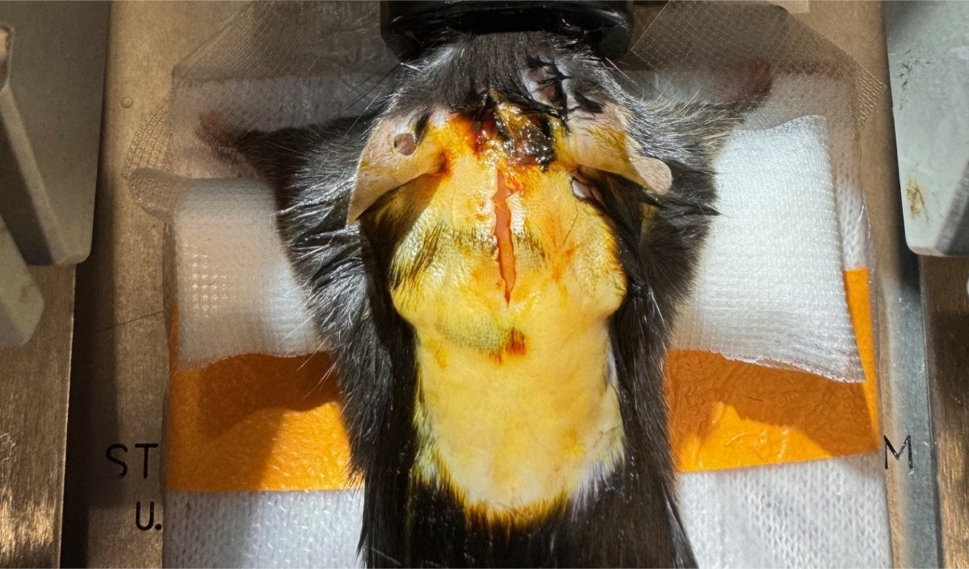
Figure 3. Skin incision

  - Use skin retractors at bottom left, bottom right, and top to hold open skin creating a triangle.

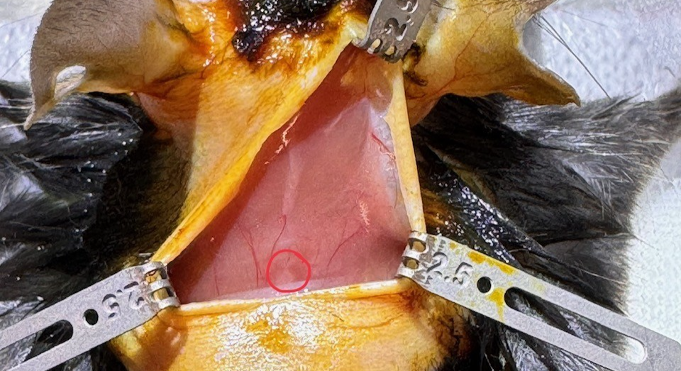
Figure 4. Skin retraction

  - Use blunt dissection to remove the fascia and any adipose tissue and tuck it under the skin retractors.
  - Locate the trapezius muscle and spinous process of T2 at the caudal end of the trapezius muscle (Figure 4, spinous process circled in red).
  - Gently dissect around T2 using Dumonts and free the bone of all muscle attachments.
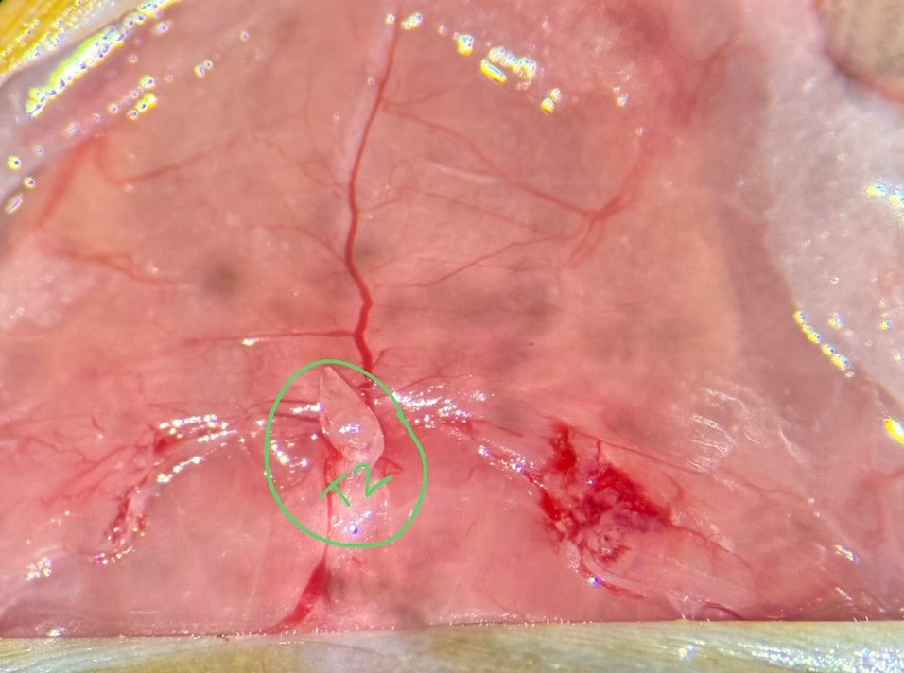
Figure 5. Dissection of T2

  - Using Vanna scissors, cut only the trapezius muscles along the midline – there is a faint white line where the left and right trapezius muscles connect, cut along that line. Try not to cut the splenius capitis or semispinalis capitis muscles underneath the trapezius muscles.

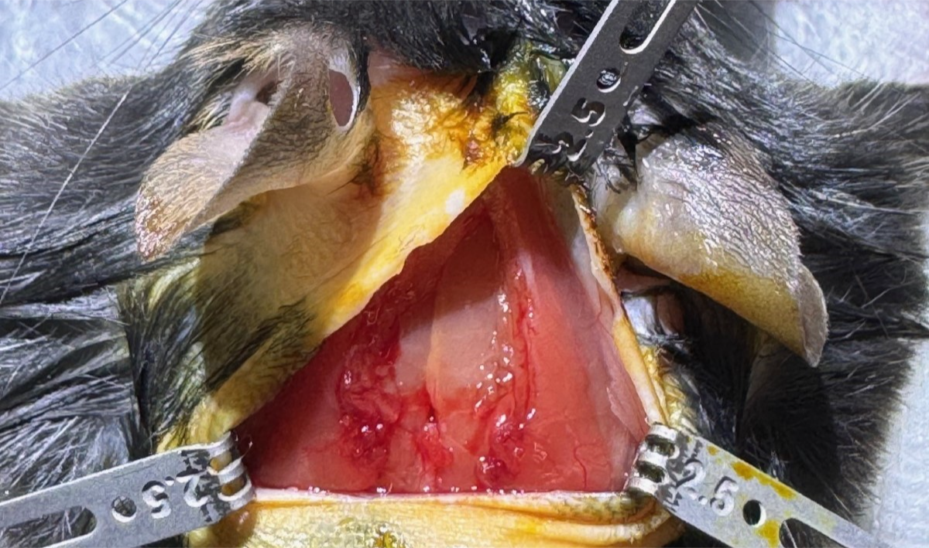
Figure 6. Midline dissection of trapezius muscle.

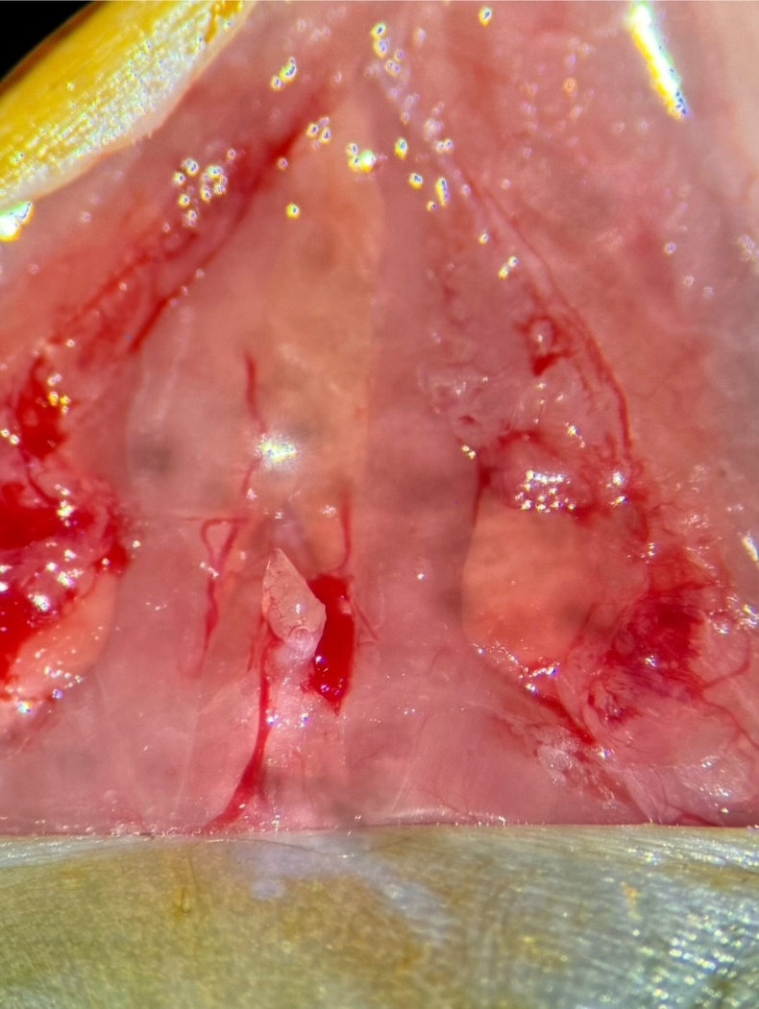 | 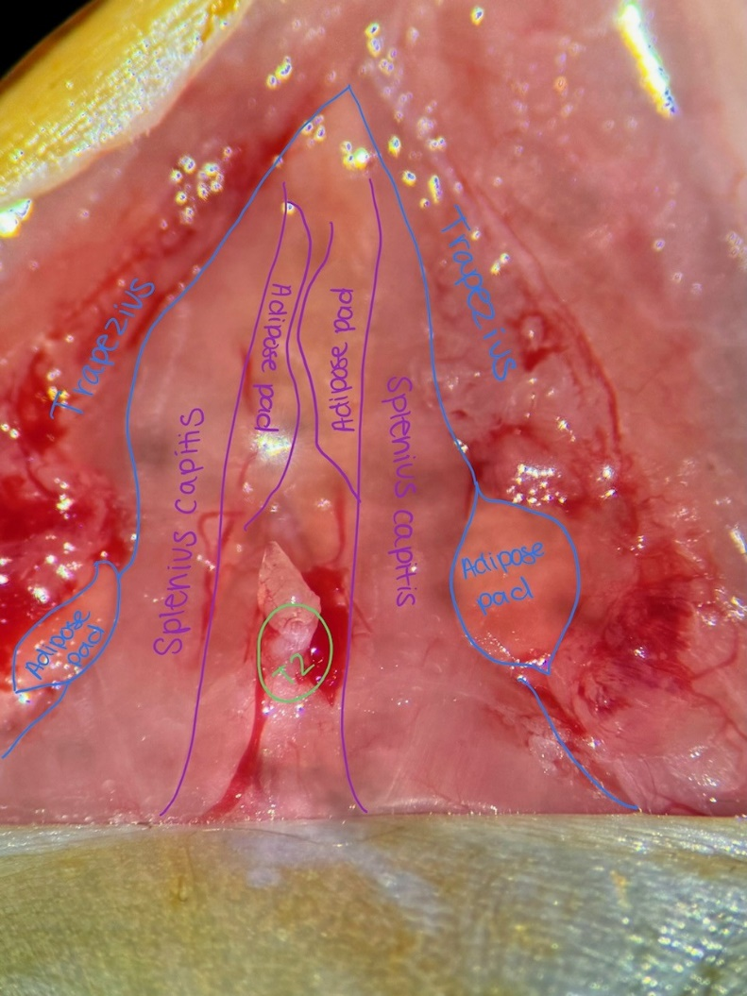
Figure 7. Unannotated and annotated anatomy surrounding the spinal cord.

  - Carefully tuck the trapezius muscles into the left and right muscle retractors. The hook of the muscle retractor should contact the adipose pad underneath the trapezius muscle to minimize muscle damage and bleeding. Tuck the top of the trapezius muscle into the anterior skin retractor to fully draw the muscle away from underlying layers.

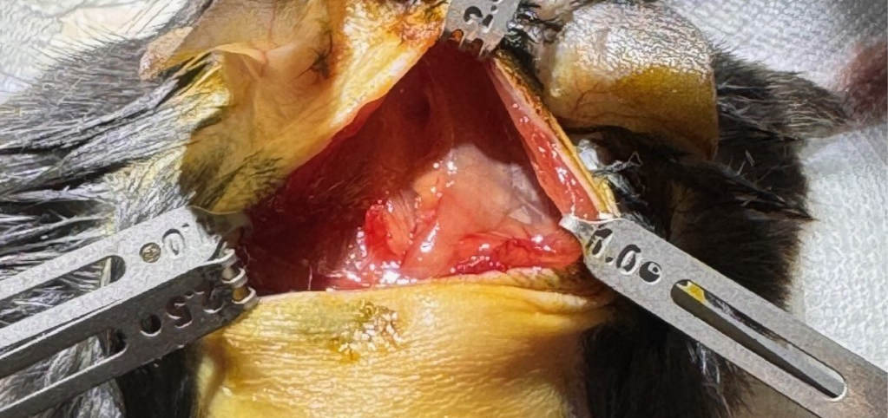
Figure 8. Retraction of trapezius muscles.

  - Using 2 pointed sterile swabs gently separate the splenius capitis muscles and expose the adipose pads of either side of the spinal cord. Tuck the hooks of the muscle retractors into the exposed adipose pads to draw the muscle to the lateral edge of the surgical site.
  - Using Dumonts, carefully remove the remaining muscle fibers attached to the spinal cord – use a combination of blunt dissection or gently tearing the muscle away from the bone. Be very careful to avoid any blood vessels and nerve rootlets. Use Sugi and pressure to stop any bleeds.
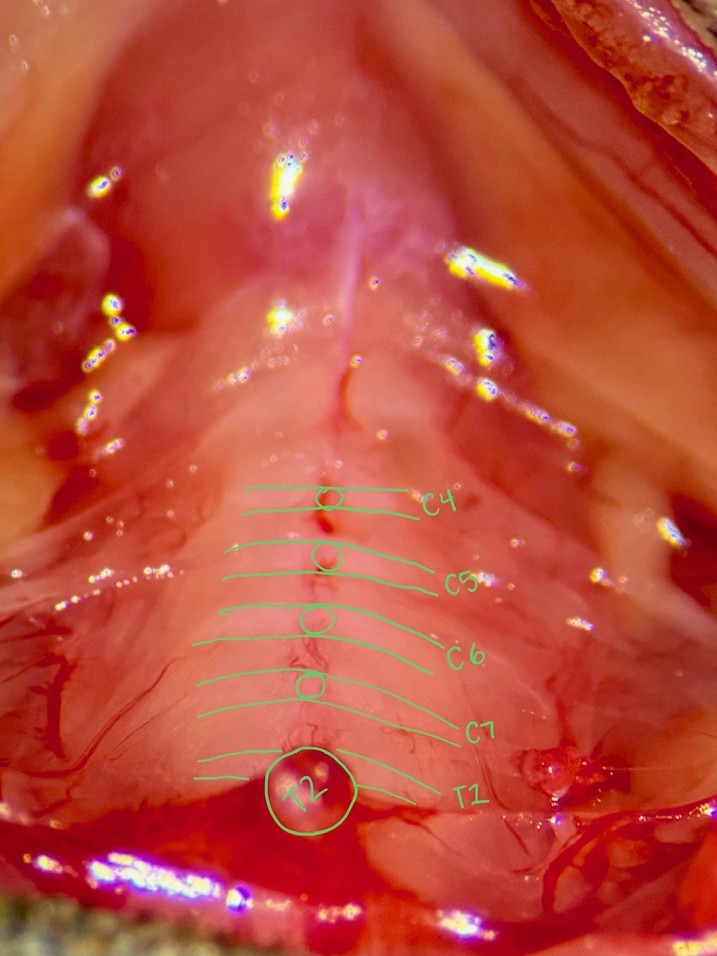
Figure 9. Dissection of the cervical spinal cord vertebrae.

  - Beginning at T2, count the anterior cervical vertebrae until reaching the desired injection location.
  - Using sharp Dumonts or dura probe, tear the meninges (medial to lateral direction) at the desired cervical location. The meninges are a thin protective layer of tissue covering the spinal cord that appears slightly yellow. The spinal cord will appear as a bright, white, vascularized tissue beneath the meninges.
  - Adjust the mouse’s body position (limb and tail tape) as necessary to visualize the spinal cord and create separation between the spinal vertebrae. Zero coordinates at midline of gap between target vertebrae, go to target coordinates, touch the tip of the pipette to the spinal cord and zero the Z coordinate. Puncture the spinal cord and insert the pipette to the desired depth. Observe a 5-minute rest period to allow the spinal cord tissue to settle around the pipette. After 5 minutes, inject the desired volume of virus at a rate of 2 nl/s. Once the injection of virus is complete, observe another 5-minute rest period to allow the virus to settle into the tissue before removing the pipette. Be sure to use a beveled pipette.

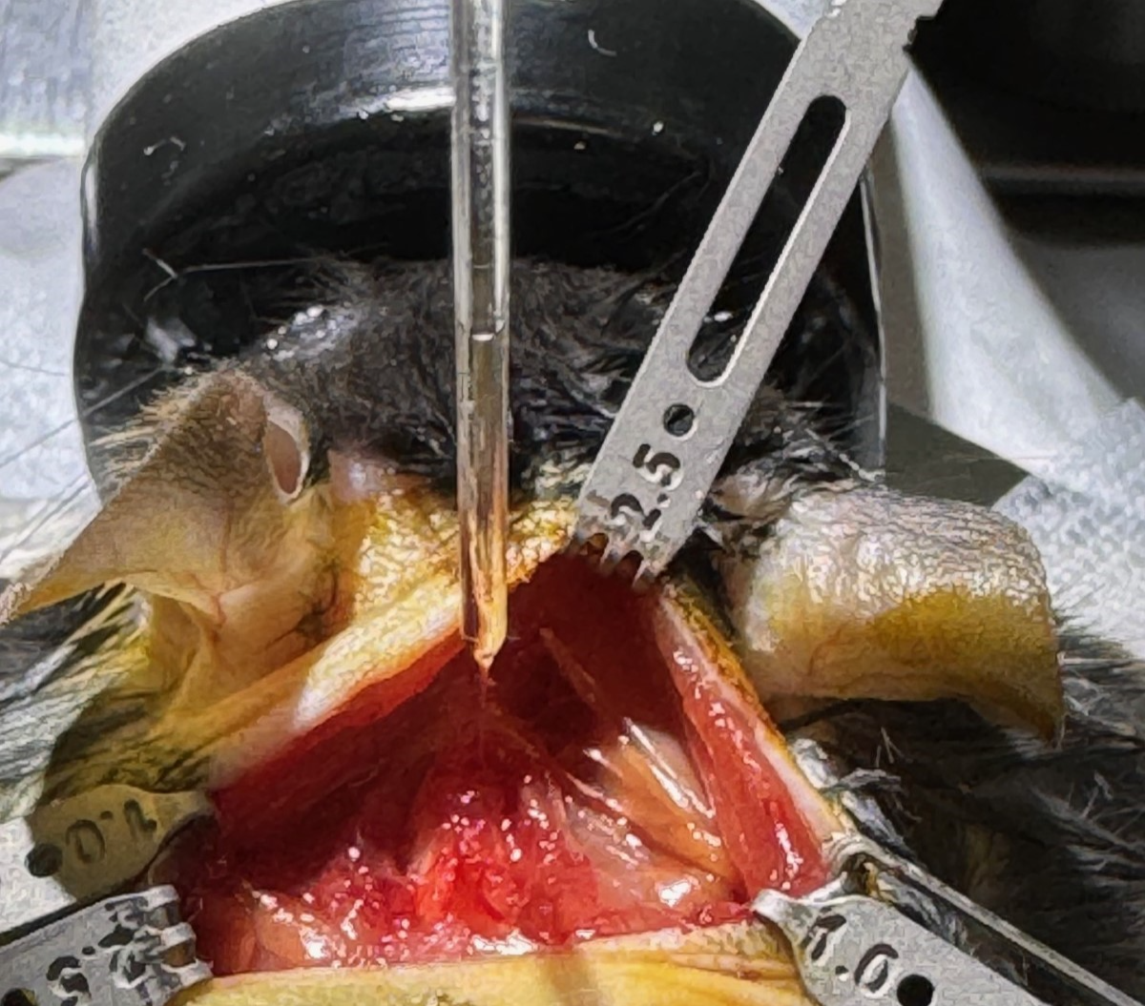
Figure 10. Injection of virus into spinal cord (C4-C5, right).

Release the muscle retractors and suture the trapezius muscle together with 5-0 vicryl braided, absorbable suture.
    - Close the muscle incision with a surgeon’s knot (2 throws) followed by a square knot (2 throws) for a total of 4 throws using an absorbable and braided suture pack. Ensure the suture goes through the trapezius muscle only by lifting the muscle away from the deeper tissue layers when inserting the needle.
  - Suture skin with 5-0 PDS II.
    - Close the skin incision with a surgeon’s knot (2 throws) followed by a square knot (2 throws) for a total of 5 throws using a monofilament suture pack.
  - Turn off Isoflurane and remove the mouse from the surgical rig.
  - ATTENTION: Before proceeding, please reference Care Module CM_S_01_A/B or CM_S_01_C/D for a complete list of drugs and drug preparations required by this procedure.
  - Obtain the mouse’s postoperative weight.
  - Place the mouse back in a recovery cage and put the cage on the 37ºC heat plate.
  - Write the following on the cage card: date of procedure, surgeon’s three letter initials, name and volume of any drugs or fluids administered, route of administration, procedure that was performed, post-operative weight of the animal, and the time the surgery was completed.
    - If a surgical injection was done please include the BSL level and material injected ex (BSL 1 AAV STX INJ)
  - Return mouse to the surgical recovery cart in the vivarium when the mouse is fully conscious.

- Take Down: Refer to NSB Work Instruction NSBWI_0022 for take down instructions.

- Technical Information:
  - Anesthesia and pain control agents:
Drug | Dose | Route | Frequency | Indication
Isoflurane | 1-5% | Inhalation | Continuous | Used to induce anesthesia

