MAPseq and BARseq Dual Sectioning Event
for a Single Mouse Brain

- Scope and Applicability: This protocol enables tissue processing for combined BARseq- MAPseq experiments where axonal projections of individual neurons transduced by unique barcode sequences can be mapped across the brain, with concurrent molecular characterization of transduced cells by gene expression. Mice receive injections of Sindbis virus barcode library targeting region of interest, and fresh brain tissue will be harvested and frozen in OCT 24 hours later. Frozen brain tissue will be stored at -80°C to preserve RNA until ready for sectioning and subsequent processing for in situ sequencing of genes and barcodes and next generation sequencing projection barcodes in dissected tissue.

- Materials:
  - Disposable low-profile cryostat blades (Tissue-Tek® Accu Edge® Sakura 4689, VWR 25608-964 or equivalent)
  - Tissue holder for cryostat sections
  - RNase inhibitor (RNaseZap, RNAse Away or equivalent)
  - 100% Ethanol (200 proof) (for decontamination)
  - 70% Ethanol (for decontamination and cleaning) (RP0032)
  - OCT compound (VWR 25608-930 or equivalent)
  - Kimwipes
  - Napkins
  - Paintbrushes
  - Razor blades
  - Slide Box
2.11 Labels for slide boxes.
  - SuperFrost Gold Slides (Fisherbrand 15-188-48, or Electron Microscopy Sciences 71864-01)
  - Chemical resistant marker or Marker II/SuperFrost solvent-resistant pen or equivalent
  - Reference slide of BARseq reaction chamber.
  - Dry ice
  - Food saver vacuum seal bags

- Equipment:
  - Cryostat Leica 3050S (or similar)
  - -80°C freezer
  - Food saver vacuum sealer

- Safety:
  - Nitrile Gloves
  - Eye protection
  - Lab coat
  - Surgical face mask

Warning: Personal Protective Equipment (PPE) should always be used while operating this protocol. See your immediate supervisor if you are unsure what PPE you should use.

- Output:
  - Tissue sections cut at 300 μm are further microdissected for region-specific barcoded RNA isolation and next-generation sequencing to determine which barcoded cells project to that volume of tissue (MAPseq).
  - Tissue sections cut at 20 μm are used for in situ sequencing (BARseq), where barcodes and signature genes are probed to determine the molecular identity of each cell and which barcodes that cell has been transduced with.
  - The match between BARseq and MAPseq results will tell which individual cells with which molecular signature project to which region.

- Reference Documents:
  - PF0008: Cryostat Operation
    - To be Published
  - RP0032: Ethanol Dilutions
    - To be Published
  - PF0050: Day of Sectioning: Tissue/Block Procurement
    - To be Published
  - PF0311: mFISH Survey Sectioning
    - To be Published
  - Leica 3050S Cryostat Operation Manual.
  - Allen Mouse Brain Atlas

Warning: This protocol is extremely sensitive to RNase contamination; ensure that you have been properly trained using RNAse-free and sterile techniques before starting this protocol.

- Setup:
  - Clean up.
    - One day prior to the sectioning event, clean the paintbrushes you are going to use first with RNAse-away or RNaseZap followed by 70% EtOH, after air drying, place them into the cryostat chamber on a Kimwipe on the tool holder to precool the brushes.
    - Clean everything inside of the cryostat chamber with 100% EtOH (especially anywhere a slice may fall—under the object holder, the tool holder, or the metal pieces on either side) and the outside of the chamber.
    - Clean up the slide box with RNAse-away followed by 70% EtOH and clearly label the outside with a prepared label. Stating the specimen number, tissue thickness, point of contact in the anatomy molecular group, technician name, and date of sectioning.
  - For specific cryostat setup instructions, refer to SOP PF0008, Cryostat Operation.
    - Set the OT (object temperature) to -10°C and the CT (chamber temperature) to -14°C.
    - Place the tissue sample into the cryostat’s chamber 30 min before sectioning to equilibrate its temperature.
    - Add OCT on the tissue holder, glue the tissue block, mount the chuck onto the specimen head, and secure it with the knurled knob. Make sure the tissue block is oriented with the olfactory bulbs facing up and the top portion of the block facing down (where the specimen number is written, this is if LAS embedded the brain in the OCT mold) to keep the dorsal brain region up during the sectioning (Figure 1A).
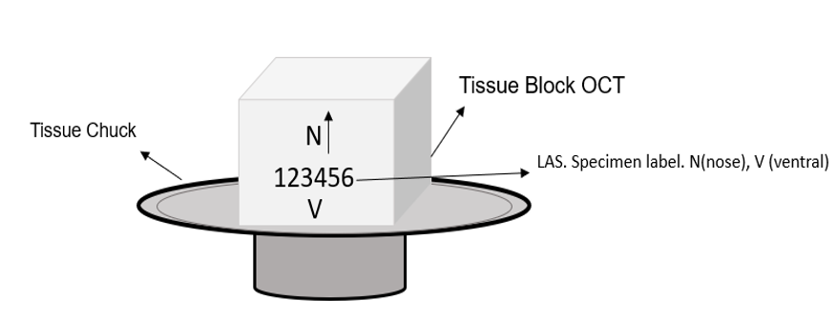
Figure 1A: OCT block, correct attachment orientation to the tissue chunk.

    - Wait until the applied OCT is white and the tissue block is fully attached to the holder.
    - Insert a disposable cryostat blade into the blade holder and adjust the blade holder to the proper slicing position.
    - Equilibrate the specimen block at the set cryostat chamber temperature for at least half an hour before slicing, or the tissue will be too rigid to be sliced and can easily crack.
    - During this waiting time, using the template slide as a reference, mark the MAPseq slides with the sample code, orientation R-> C (Rostral to Caudal), and consecutive numbers starting on 1 to ~12 slides and 300 µm. Also, prepare the BARseq slides using the slide guide with reaction chamber holes on the back of the SuperFrost Plus Gold slides with Sharpie - this is to allow further BARseq processing to attach and align the reaction chamber on the slide, all the cut sections need to be collected/attached in the areas between the marker holes.
    - Label these slides with the sample number, orientation R->C, slide numbers 1 to 20 (or more if needed) and 20 µm (figure 2B-C).
    - CRITICAL: make note of the mounting orientation (i.e. whether the right hemisphere of the brain is mounted on the right-hand side of the slide) and keep that orientation consistent throughout the sectioning event.

- Methodology:
  - MAPseq first round sectioning sample
    - Ensure that the disposable blade that has been inserted into the blade holder is locked in place using the locking lever to the side of the blade holder.
    - Unlock the blade holder lever and move the blade holder so that the blade holder and blade are positioned to one end where the specimen block will make contact. Once this adjustment has been made lock the blade holder. This will allow for multiple uses of one blade, by moving the blade holder along as you progress through sectioning.
    - Begin moving the block forward using the rotating handle on the right side of the cryostat. Be careful in advancing the specimen block, stopping just prior to contacting the blade.
    - Once the specimen block is nearly in contact with the blade, lock the rotating handle on the right side of the cryostat to prevent further movement. Identify how the tissue should be aligned and do so using the knobs on the object holder—to make adjustments to the object holder, ensure that the locking lever on the object holder is in the unlocked position. It is easier to do this with the tissue block close to the blade as the bottom of the OCT specimen block should be parallel to the blade’s edge. Care should be taken to avoid contact with the blade as this can lead to severe injury to digits or extremities as well as damaging the blade leading to poor sectioning results.
    - Once the adjustments have been made to make the specimen block parallel to the blade’s cutting edge, return the object holder’s locking lever to the locked position, ensuring that it’s tightly secured before unlocking the rotating handle to the right of the cryostat and before advancing the specimen block.
    - As you move your rotating handle, advancing the specimen block, ensure that the first few sections being cut are even. This means that you should be hitting the right and left of the specimen block simultaneously. If this is not the case, further adjustment is needed. As you progress further into the first few sections of the block, adjust the x and y axis of the specimen holder until you achieve a fully faced section, this is done when a section is taken and the entire block face is cut by the microtome blade.
    - After your adjustments, ensure that the locking mechanism to the object holder is in the lock position and is secured. Failure to do so will yield inconsistent sectioning quality.
    - If the block is embedded in OCT, trim into the block until tissue becomes visible. Trimming into the block can be done at 50 microns but be sure to return the thickness to the assigned parameter prior to reaching the region of interest. Use the “+” and “-” buttons on the left panel of the cryostat to adjust section thickness. Otherwise, the trim function can be used to alternate between your trimming thickness and your assigned parameter thickness.
    - With the block fully faced, and appropriately aligned, trim into the block until the starting point is reached. Once the tissue is visible, ensure that the cutting thickness is set to correct parameter. MAPseq sections: 300 microns and BARseq sections: 20 microns.
    - Once tissue is reached, further alignment may be necessary. Cutting in from the anterior of the brain, the first anatomical structures visible will be the olfactory bulbs. As seen in the figure below, these anatomical structures should appear equal in size and shape. (Figure 1B). If this is not the case, using the same steps as before, adjust the x and y axis until the structures appear even in size and shape.
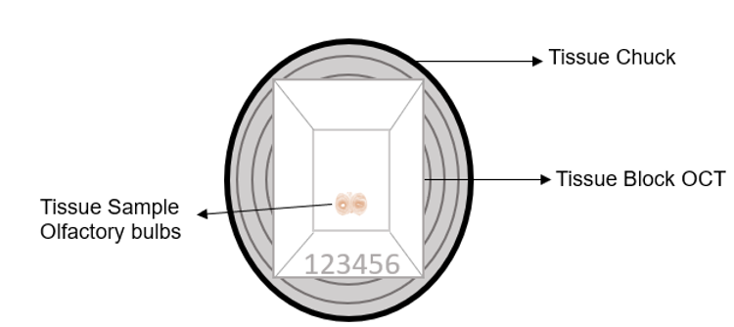
Figure 1B: OCT Block Pyramidal Shape Trimming.

    - Once the olfactory bulbs appear equal in proportion, the OCT surrounding the tissue must be trimmed. Ensure that the locking lever on the object holder is in the lock position and tightly secured, lock the cryostat rotating handle to prevent any accidental movement of the object holder while trimming and ensure that the antiroll plate is placed over the blade to prevent any injury before trimming. Since the olfactory bulbs are small and the most anterior portion of the brain that is currently visible, when trimming the OCT care must be taken to avoid damaging the portion of the brain still not visible further in the OCT. Thus when trimming, face the razorblade away from the tissue and cut away from the tissue at an angle, similar to a pyramidal shape as seen in the figure above (Figure 1B). Using a clean razor blade, the OCT should be trimmed to form a tight margin around the tissue, while ensuring the blade does not damage the visible tissue.
    - This process should be done with careful haste, as prolonged contact with the blade will warm the OCT and surrounding tissue. The image in Figure 1B illustrates how the tissue block should be trimmed. Figure 2A, shows the starting point at 300 μm sections. Note: This image shows section at the level of AON-orbital cortex, but not the olfactory bulb.
    - Keep the tissue orientation consistent when mounting sections on slides throughout the whole sectioning event, making sure the tissue sections are always oriented as is shown in Figure 2B. Consult the PWR, supervisor, or project lead if uncertain of the starting point.
  - MAPseq section cutting
    - For the MAPseq portion of sectioning, to obtain a high-quality section, it is advised not to use the anti-roll plate. As the sections will be cut at 300 microns, this exceeds the limits of space between the antiroll plate and the blade, which would cause damage to each section if the antiroll plate is used. Sections can be taken as you advance the specimen block and using a brush to gently coax the tissue section forward onto the stage as the blade clears the block face to obtain a full section using a slow and consistent speed to turn the rotating handle at the right of the cryostat. The paintbrush bristles should not touch the tissue, rather they should only touch the OCT margin that is left around the tissue. Changes can be made by adjusting the angle of the block face or the angle cutting blade to obtain more consistent sections, if a quality section cannot be obtained. Temperature of the chamber and object holder can also be changed to achieve consistent section quality. Once these adjustments have been made, sectioning can proceed.
    - Place the first labeled SuperFrost Gold slide on the surface of cryostat stage, prior to taking your first section. This will ensure that the slide can equilibrate to the temperature of the cryostat chamber. To take the first section, advance the specimen block using the rotating handle, slowly and consistently moving forward, while using a paint brush at the leading edge of the section to prevent rolling of the section. The brush should only lightly touch and coax the section as the section advances by the force of the advancing specimen block clearing the blade’s edge. Any significant opposing force made by the brush will cause damage to the section, which must be avoided.
    - Once specimen block has cleared the blade’s edge, and an entire full face section has been achieved, collect the section onto the SuperFrost Gold side by using one brush and gently pulling the tissue section on the bottom area, then without causing any tension place the brush inside the OCT rolling up to avoid any tissue damage (Figure 2A). Then, with one or two paint brushes to gently lift the section onto the slide or by using a chilled metal spatula to move the section onto the correct position on the slide. If the section is curling up or is wrinkled, use the small brushes to smooth it out flat before attempting to pick it up. Keep any manipulation of the OCT-embedded tissue to a minimum and orient the tissue sections with the dorsal part of the brain parallel to the longest side of the glass slide, the first section should be placed at the first third of the slide, closest to the label.
    - To adhere the tissue section to the slide, gently lift the glass slide avoiding any sudden movements that may cause you to lose the tissue section, then place your warm, gloved hand underneath the glass slide to melt the OCT onto the slide, continue to hold the slide against your hand until the entire section has fully adhered to the slide.
    - Repeat steps 8.2.1-8.2.4. until you collect the 3 required tissue sections for slide 1 as noted in Figure 2B.
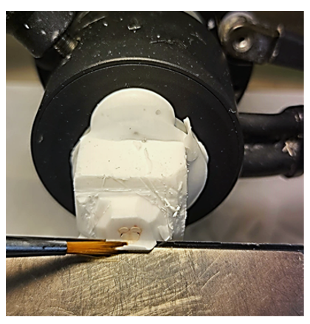
Figure 2A: Brush technique to start collecting the MAPseq sections at 300 µm.

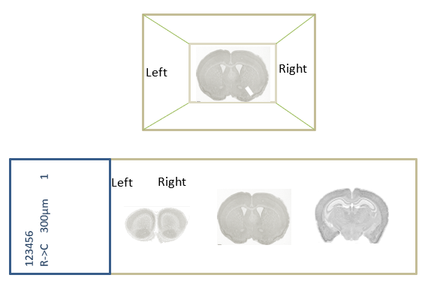
Figure 2B. Tissue sections for MAPseq at 300 μm. Ensure to maintain the tissue orientation with reference to the OCT block consistently throughout all the tissue sections.

    - Place the slide with the 3 collected sections horizontally on a metal platform to freeze down the tissue/OCT, then transfer the slide to the prepared slide box that is sitting on dry ice. The tissue and slides must be kept on dry ice to ensure that RNA quality is preserved. If more dry ice is needed add more.
    - Lock the rotating wheel and move the blade holder over so that an unused area of the blade is available to continue sectioning, replace the blade after you have used it to collect the 3 sections as this would have used up the available, unused space on your disposable blade.
    - Continue sectioning at 300 µm until you reach the specific region referenced in the appendix section.
  - BARseq tissue sectioning
    - Switch the tissue thickness to 20 µm, the cryostat OT temperature to -14°C, and chamber temperature to -16°C, close the cryostat chamber sash, and let the chamber reach the desired temperature.
    - Place the first glass slide with the BARseq guide references on the metal blade holder.
    - Change the blade and start sectioning. To cut a section, the anti-roll plate is gently lowered onto the knife and stage. Do not apply pressure to the anti-roll plate. Simply allow it to rest on the knife back plate. With a slow, consistent speed turn the cryostat wheel to advance the specimen forward. The automatic motor drive can also be used. For more information on the motor, refer to the Leica 3050S Cryostat Operation Manual.
    - After cutting through the block face obtaining a fully faced section, slowly lift the anti-roll plate to expose the tissue and collect the section onto the BARseq chamber marked slide by grasping the slide at the top and bottom edges, gently maneuvering the slide onto the section, allowing the section to adhere to the slide. If done correctly as the slide is lowered slowly the section will fully lift and adhere to the slide. Do not move the slide forward or backwards or left to right as this will cause the tissue to stretch. If the section is curling up or is wrinkled, use the small brushes to smooth it out flat before attempting to pick it up.
    - Start collecting the coronal sections orienting them with dorsal side parallel to the short side of the glass slide and in the first upper corner (Figure 2C).
    - Repeat the steps 8.3.2-8.3.5 and place the second section on the top right corner of the first quadrant (closer to the label). Then collect the sections for the second quadrant (Figure 2C).
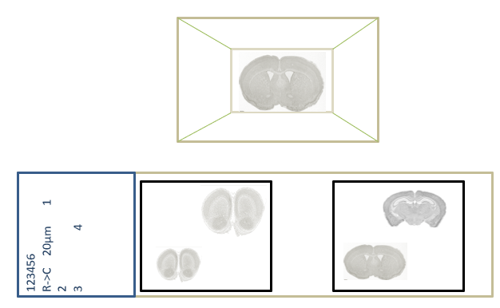
Figure 2C. BARseq slide label and tissue orientation with reference to the OCT block.
Ensure to maintain the tissue sections following the same stipulated order as referenced in the slide label throughout all the slides.
    - Continue sectioning until the desired end region has been reached. Please see the appendix for the specific brain region to be collected.
    - Do not switch the blades during the 20 μm sectioning process as this will affect the angle at which subsequent sections are cut at.
    - Once the Bar-Seq sections have been collected, close the cryostat sash.
    - Collect all the tissue slides in a 25-slide box, label it with the case number, BARseq sections, date of sectioning and initials.
  - MAPseq second round of tissue sections
    - Change the tissue section thickness to 300 µm, OT to -10°C and CT -12°C. Let the cryostat reach the set temperature (approx. 10 mins).
    - Repeat the tissue sectioning explained in steps 8.3.1-8.3.7 until all sections required have been collected.

- Take Down and Cleaning of the Cryostat:
  - Return the specimen head to the home position by pressing the double arrow button on the left options menu.
  - Remove the blade from the knife holder and dispose of in the back of the knife cartridge or in the Sharps disposal container.
  - Remove the specimen disc/chuck from the specimen head. Depending on what the project calls for, save the piece of tissue by vacuum sealing the tissue and placing it in a designated freezer. Mouse tissue can be disposed of directly in the hazardous waste bin. Clean the specimen disc by thawing and removing any OCT then spraying with 70% Ethanol. Clean chucks, forceps, black tray, and other tools as needed by spraying with RNase Away and rinsing with MilliQ water thoroughly. Spray with 70% Ethanol and allow to dry completely before storing.
  - Spray down the inside of the cryo-chamber with 100% Ethanol and wipe out the remaining shavings with Kimwipes. Spray with enough 100% Ethanol to allow the chamber to remain wet with Ethanol for at least 20 minutes. Do not spray the inside of the chilled cryostat chamber with RNase away, as the RNase away will freeze upon contact of the chilled chamber.
  - Close the lid and turn off the light if it is on.

- Appendix 1: Locus Coeruleus targeting region for BARseq after sectioning for MAPseq
  - Area of interest guide to stop collecting the 300 μm (MAPseq) tissue sections (Figure 3A-F).
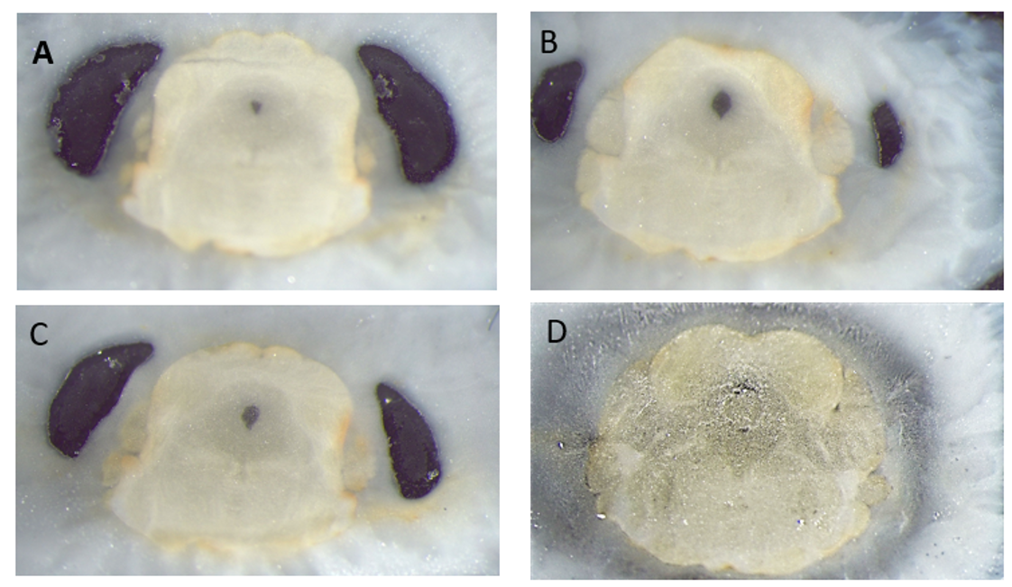
Figure 3A-D: MAPseq 300 µm Tissue Sections. Areas of interest tissue sections. Anterior regions (A-C) are pictured here as a reference. D shows the last section that should be collected at 300 µm.

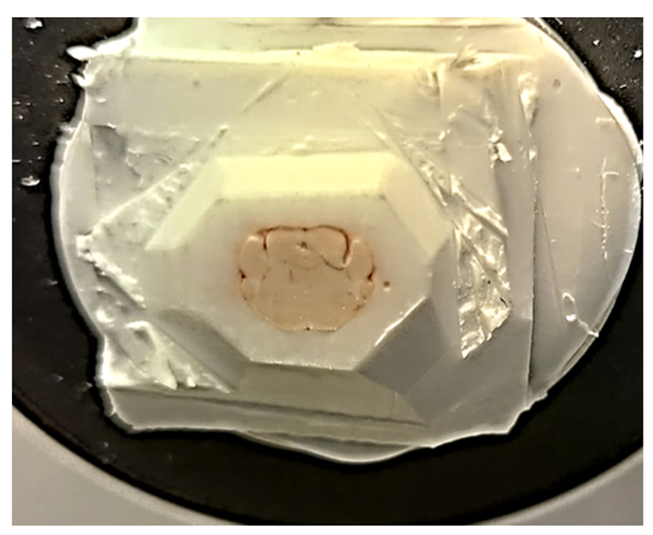
Figure 3E: MAPseq 300 µm tissue section. Actual appearance of the tissue block last section at 300 µm.

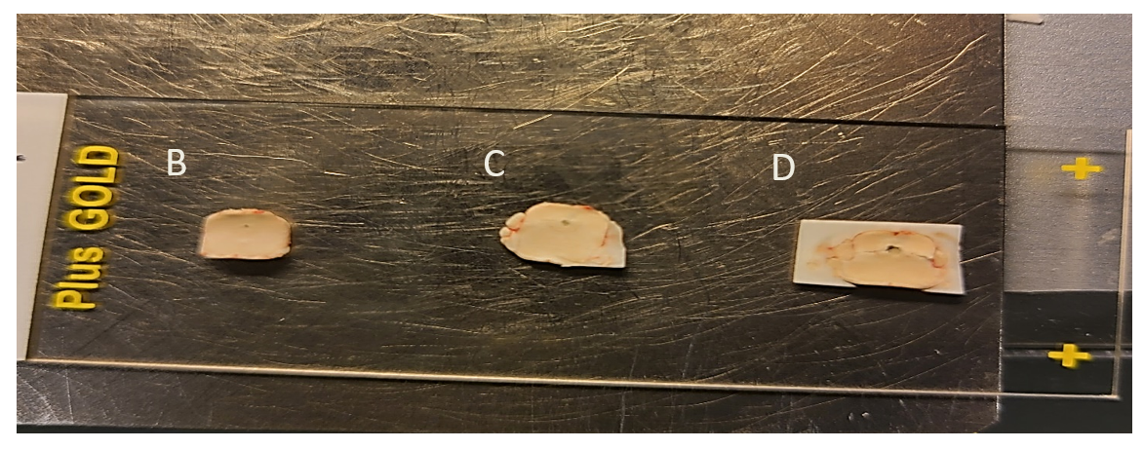
Figure 3F: MAPseq 300 µm tissue section.
Last tissue sections cut at 300 µm showing sections B,C and D on the glass slide at lower magnification.

  - Area of interest guide to start collecting 20 μm BARseq tissue sections (Figure 4A-F).
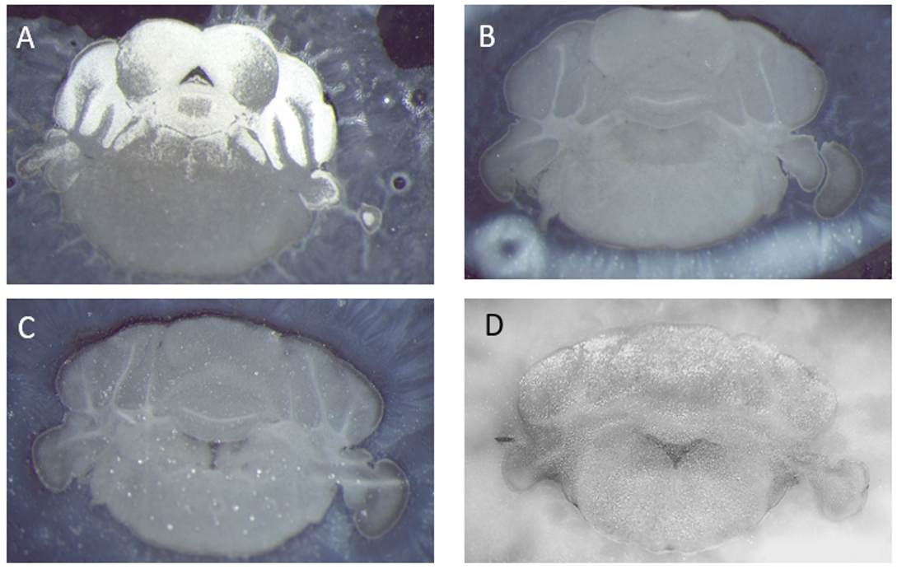
Figure 4A-D: BARseq 20 µm area of interest tissue sections. Anterior regions A-c are pictured here as a reference to start capturing the Locus coeruleus. D: last section that should be collected at 20 µm.

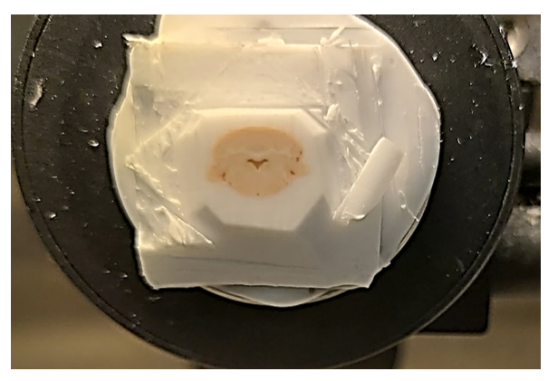
Figure 4E. BARseq 20 μm tissue sections. Actual appearance of the tissue block last section at 20 μm.

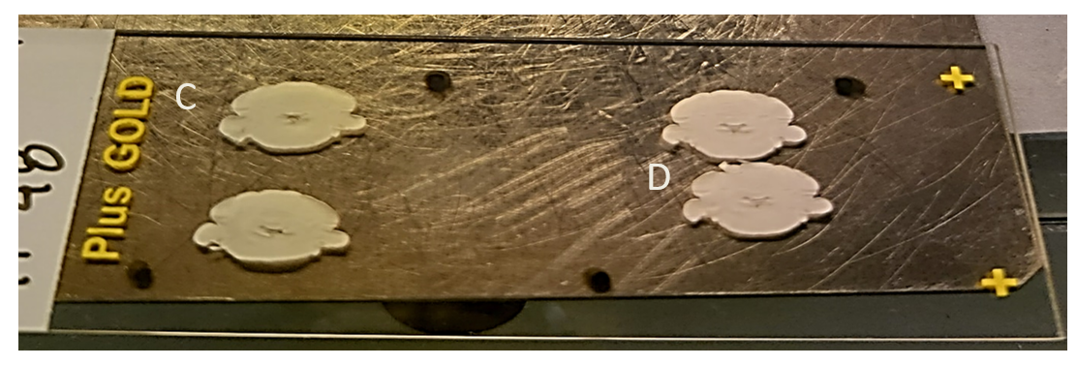
Figure 4F. BARseq 20 μm tissue sections. Tissue sections C and D on lower magnification,
on the last glass slide sectioned at 20 μm.

