10x Multiome Sample Processing

- Scope and Applicability: Allows for the profiling of all the open chromatin regions at a single nuclei level through the rapid generation of NGS-ready libraries, and for rapid generation of 3’ transcriptomic-NGS-ready- single-cell-libraries from the same pool of transposed nuclei.

- Materials:
  - Chromium Next GEM Single Cell Multiome ATAC Kit A (10x Genomics 1000280) (-20°C)
    - ATAC Buffer B (2000193)
    - ATAC Enzyme B (2000265)
    - 20X Nuclei Buffer (2000207)
  - Chromium Next GEM Single Cell Multiome Reagent Kit A (10x Genomics 1000282) (-20°C)
    - Chromium Next GEM Single Cell Multiome GEM Kit A (10x Genomics 1000232) (-20°C)
      - Barcoding Reagent Mix (2000267)
      - Barcoding Enzyme Mix (2000266)
      - Template Switch Oligo (3000228)
      - Reducing Agent B (2000087)
      - Cleanup Buffer (2000088)
      - Quenching Agent (2000269)
    - Chromium Next GEM Single Cell Multiome Amp Kit A (10x Genomics 1000233) (-20°C)
      - Pre-Amp Mix (2000270)
      - Pre-Amp Primers (2000271)
      - Amp Mix (2000047)
      - SI-PCR Primer B (2000128)
      - cDNA Primers (2000089)
  - Library Construction Kit (10x Genomics 1000190) (-20°C)
    - Fragmentation Enzyme (2000090)
    - Fragmentation Buffer (2000091)
    - Ligation Buffer (2000092)
    - DNA Ligase (220110)
    - Adaptor Oligos (2000094)
    - Amp Mix (2000047)
  - DynaBeads MyOne Silane Beads (10x Genomics 2000048) (Stored at 4°C)
  - Chromium Next GEM Single Cell Multiome Gel Bead Kit A (10x Genomics 1000231) (-80°C)
    - Single Cell Multiome Gel Beads A (2000261)
  - Chromium Next GEM Chip J Single Cell Kit (10x Genomics 1000234) (RT)
    - Next GEM Chip J (2000264)
    - Gaskets (370017)
    - Partitioning Oil (2000190)
    - Recovery Agent (220016)
  - Single Index Kit N Set A (10x Genomics 1000212) (-20°C)
    - Single Index Plate N Set A (3000427)
  - Dual Index Kit TT Set A (10x Genomics 1000215) (-20°C)
    - Dual Index Plate TT Set A (10x Genomics 3000431) (-20°C)
  - TempAssure PCR 8-tube strip (USA Scientific 1402-4700)
  - 1.5 ml DNA LoBind Tubes (Eppendorf 022431021)
  - 2.0 ml DNA LoBind Tubes (Eppendorf 022431048)
  - SPRIselect Reagent Kit 60 ml (Beckman Coulter B23318)
  - 50% Glycerol (v/v) aqueous solution (Ricca Chemical Company 3290-32)
  - Nuclease Free Water (Thermo AM9937)
  - Low TE Buffer (Teknova T0221)
  - Tween 20 (Millipore 655204-100ml)
  - 100% Ethanol (AAPER/Pharmco E200G-P)
  - Twin.Tek 96-well PCR Plate Semi-Skirted (Eppendorf 0030129326)
  - Twin.Tek 96-well PCR Plate, Full-Skirted (Eppendorf 0030129300)
  - BioRad Microseal ‘B’ (BioRad MSB1001)
  - High Sensitivity NGS Kit (DNF-474-33)
  - Quant-it PicoGreen Reagent Kit (Thermo P7589)
  - 50 ml conical polypropylene Falcon tubes (Corning 352098)
  - 15 ml conical polypropylene Falcon tube (Corning 430790)
  - 10 ml serological pipette tip (Greiner 607180)
  - 25 ml serological pipette tip (Greiner 357525)
  - 25 ml divided reservoirs (VWR 41428-958)
  - Qiagen Buffer EB (Qiagen 19086)
  - Protector RNase Inhibitor 10000U (Sigma 3335402001)
  - DTT Additive (Sigma 646563)

- Equipment:
  - PCR Hood with UV for chip loading and processing
  - 10x Genomics Chromium Controller
  - BioRad C1000 Thermocycler with a deep-well block
  - Rainin P1000, P20, P200, P10 single channel pipettes
  - Rainin P200, P20, and P10 8-channel pipettes
  - Rainin Pasteur P1000 and P200 low retention filtered tips
  - Rainin 200 and 20 µl low retention filtered tips
  - Rainin 1000, 200 and 20 µl tips filtered tips
  - Eppendorf ThermoMixer C with 1.5 ml SmartBlock and heated lid (Eppendorf 2231000574)
  - Vortex Mixer
  - Ice Bucket
  - Integra aluminum PCR block
  - Aluminum 2 ml microtube rack
  - MicroCentrifuge for both 1.5-2 ml tubes and 8-strips
  - Plate Sealer
  - Plastic spatula for sealing plates.
  - 10x Vortex Adapter (10x Genomics 330002)
  - 10x Chip Holder (10x Genomics 1000195)
  - 10x Magnetic Separator (2X) (10x Genomics 120250)
  - Fragment Analyzer Instrument
  - Post-amplification PCR Hood
  - Post-amplification Vortex Mixer
  - Post-amplification Microcentrifuge for both 1.5-2 ml tubes and 8-strips
  - iPad for photo-documenting GEMs
  - Serological pipette
  - Lab timer with clock

- Safety:
  - Nitrile Gloves
  - Eye protection
  - Lab coat
  - Disposable Lab Sleeves

Warning: Personal Protective Equipment (PPE) should be used at all times while operating this protocol. If you are unsure what PPE you should be using, see your immediate supervisor.

- Output:
  - Massively multiplexed transposed single nuclei NGS libraries for both ATAC and RNA sequencing.

- Reference Documents:
  - Multiome ATAC GEX User Guide
  - MB0073 Fragment Analyzer Operation for PCR Products
      - https://dx.doi.org/10.17504/protocols.io.5jyl8mxwrg2w/v4
  - MB0194 384-Well PicoGreen
      - https://dx.doi.org/10.17504/protocols.io.36wgq5ekxgk5/v4

- Setup (At Least One Hour Before Starting):
  - Aliquot out 1 ml of 50% glycerol into DNA LoBind tubes.
    - Store the aliquots at -20°C until needed.
  - Prepare 50X 1 ml aliquots of 10% Tween 20 by adding 5 ml of Tween 20 to 45 ml of NFdH2O in a 50 ml falcon tube.
    - Invert 20X to mix and let stand at room temperature for 5 minutes.
    - Aliquot out 1 ml of the 10% Tween 20 into 1.5 ml DNA LoBind Tubes.
    - Store the aliquots at room temperature until needed.
    - Dispose of the aliquots after 1 year.
  - Fill the ice bucket with ice and place both the Integra aluminum PCR block and the aluminum 2.0 ml microtube rack onto the ice to cool.
  - Resuspend the lyophilized Template Switch Oligo (3000228) in 80 µl of Low TE Buffer (Teknova T0221).
    - Centrifuge the Template Switch Oligo at 18G for 10min, then use a P200 @ 80 µl add the low TE, making sure the lyophilized pellet is visible before adding the low TE.
    - Vortex the resuspended Template Switch Oligo on max for 30s, centrifuge briefly, and then leave at room temperature for at least 1 hour.
    - Measure the concentration (ng/µl) of the resuspended Template Switch Oligo to ensure adequate resuspension.
    - We found the median concentration of 42 separate Template Switch Oligo tubes quantified in triplicate was 14,757 ng/µl with a coefficient variation of 4.6%.
N of TSO tubes quantified in triplicate | Median Concentration | %CV | Minimum Concentration | Maximum Concentration
42 | 14,757 ng/µl | 4.6% | 13,308 ng/µl | 16,380 ng/µl

- Methodology/Procedures:
  - Transposition (set up at least 15 minutes before the sample hand off)
    - Pull out the following and allow to equilibrate to room temperature:
      - ATAC Buffer B (2000193)
      - 20X Nuclei Buffer (2000207): once thawed will need to be diluted 1:20 in nuclease-free water before use.
        - For 1 ml of 1X Nuclei Buffer add:
          - 50 µl 20X Nuclei Buffer (2000207)
          - 25 µl Protector RNase Inhibitor (Sigma 3335402001)
          - 1 µl DTT additive (Sigma 646563)
          - 924 µl Nuclease-free water
      - Reducing Agent B (200087)
        - This will be used for the GEM Generation and Barcoding step but needs at least 1 hour to thaw.
    - Place ATAC Enzyme B (2000265) on ice.
    - Conduct the following steps in the designated PCR clean UV hood to prevent contamination and potential clogs or wetting failures.
    - Following the table below, prepare enough Transposition mix for each reaction with 10% excess volume, vortex each reagent for 5s at max and adding reagents in the order listed to a 1.5 ml Eppendorf LoBind Tube (Eppendorf 022431021):
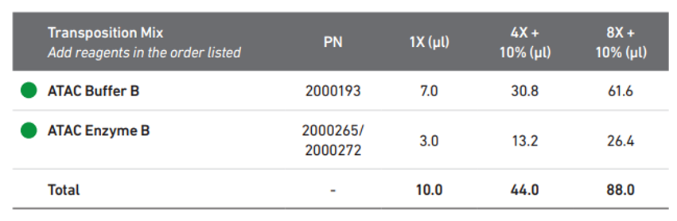

    - Vortex and briefly spin down the Transposition Mix.
    - Using a P20 @10 µl, aliquot 10 µl of Transposition Mix into each well of a TempAssure PCR 8-strip. Centrifuge briefly and keep on ice.
    - Use the Nuclei Concentration Guidelines to calculate the volume of Nuclei stock and 1X nuclei buffer needed for a total volume of 5 µl.
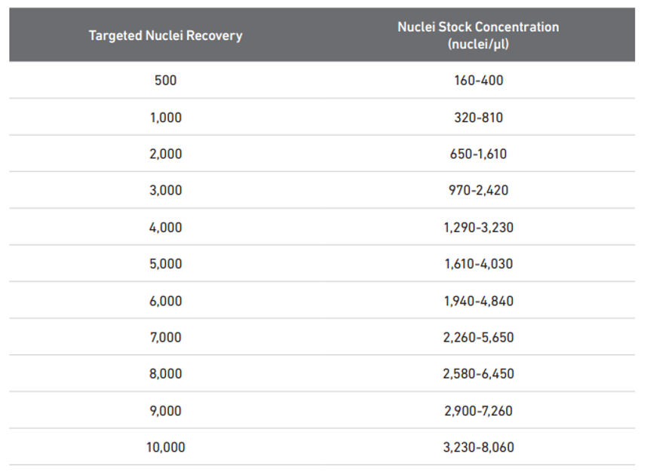

    - Add the calculated volume of 1X Nuclei Buffer to Transposition mix and vortex. Briefly centrifuge to collect at bottom of strip.
    - Using a P200 @ 20 µl, gently pipette mix the nuclei stock solution approximately 10X in the middle of the solution with a low retention tip. Then immediately switch to a P20 low-retention tip set at the calculated nuclei volume, and gently pipette mix the stock 10X in the middle of solution before aspirating the nuclei volume to transfer.
    - Add the solution to the TempAssure 8-strip containing the Transposition mix. Gently pipette mix the solution 6x using a P20 @ 10 µl. Do NOT vortex or centrifuge solution. Do NOT allow bubbles in the samples.
    - Load the strip onto the Thermocycler running the following program.
Lid Temperature | Reaction Volume | Run Time
50°C | 15 µl | 60 min
Step | Temperature | Time
Incubate | 37°C | 60 min
Hold | 4°C | Hold

    - While program runs, prepare for GEM Generation & Barcoding.
  - GEM Generation & Barcoding
    - Prepare the following at least 30 minutes before thermocycler program ends.
      - If processing fewer than 8 reactions, set aside 3 (1 ml) aliquots of 50% Glycerol and equilibrate to room temperature.
    - Remove the Chromium Next GEM Single Cell Multiome Gel Beads A (2000261) from -80°C and allow them to equilibrate at room temperature for at least 30 minutes.
    - Allow the Barcoding Reagent Mix (2000267) to thaw and equilibrate to room temperature.
    - Once thawed, vortex the Barcoding Reagent Mix (2000267), Reducing Agent B (2000087), and resuspended Template Switch Oligo (3000228) for 15s on max.
    - Verify there are no precipitates before returning to the Barcoding Reagent Mix (2000267), the Reducing Agent B (2000087) and Template Switch Oligo (3000228) to room temperature.
      - Repeat every 5 minutes as necessary until no precipitates are present.
    - Remove the Barcoding Enzyme Mix (2000266) from the kit and place it in the aluminum block in the ice bucket.
    - Assemble the Chromium Next GEM Chip.
      - Close the 10x secondary chip holder and carefully attach the gasket (370017) onto the hooks starting from the left to the right. Make sure to do this before inserting the chip so that the gasket will align properly.
      - Open the 10x chip holder with the gasket still attached. Careful not to touch the smooth side of the gasket.
      - Using care to only handle the edges and avoiding contact with the ports or bottom surface, place a Chromium Next GEM Chip J (2000264) into the 10x chip holder (1000195).
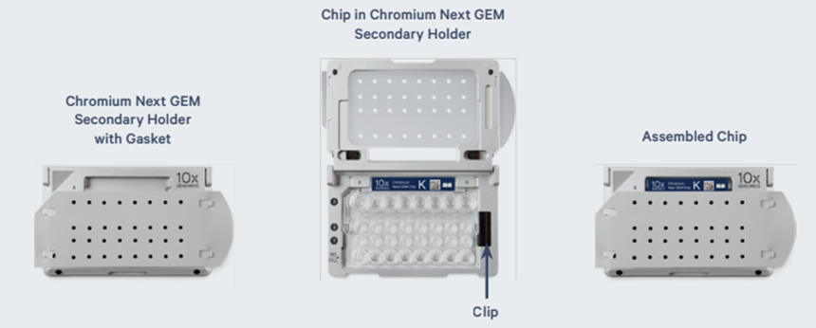

        - Cover both the gasket and the chip with a pipette tip box lid at all times. Only remove the tip box lid when you are actively adding solutions to the chip.
    - Prior to chip loading, if fewer than 8 reactions are planned, add the following volumes of 50% Glycerol to each unused well, in the following order:
      - 70 µl in labeled row 1 unused wells using a P200 @ 70 µl.
      - 50 µl in labeled row 2 unused wells using a P200 @ 50 µl.
      - 45 µl in labeled row 3 unused wells using a P200 @ 45 µl.
    - Following the table below, prepare enough Master mix for each reaction with 10% excess volume, vortex each reagent for 5s at max and add reagents in the order listed to a 1.5 ml Eppendorf LoBind Tube (Eppendorf 022431021):
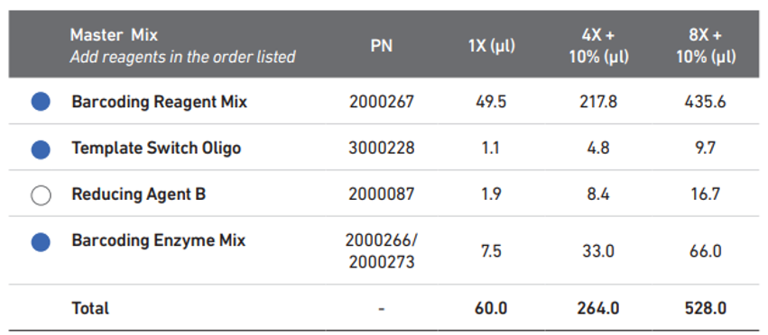

    - Vortex the Master mix tube for 10 seconds at max speed.
    - Briefly spin down the master mix tube to collect.
    - Pull out the TempAssure PCR 8-strip from the thermocycler once the temperature reaches 4°C and place on block on ice.
    - Aliquot 60 µl of Master mix into each well of a TempAssure PCR 8-strip containing the Transposed Nuclei using a P200 @ 60 µl for a total of 75 µl (using a new tip for each sample).
    - Using an 8-channel P200 with low-retention tips @ 70µl, gently pipette mix the master mix + transposed nuclei solution. Then transfer 70ul to row 1 of the chip.
        - Pipette slowly with the tips in the bottom of the central well depression, taking 5s to depress the pipette plunger while raising the tips at the same rate the solution is filling the wells.
        - Take care to not introduce air bubbles.
    - Snap the Single Cell Multiome Gel Beads A (2000261) into the 10x vortex adapter (330002) and vortex on max speed for 30s.
    - Remove the beads from the vortex adapter, snap off the tube strip holder, remove bead strip, and spin down for a full 5s. Place the bead strip back and snap into place with the tube strip holder.
    - Pierce the foil on the bead strips using fresh P200 tips.
      - Discard the tips after piercing.
    - After the 30s gravity prime, add 50 µl of Single Cell Multiome Gel Beads A (2000261) to the labeled row 2 of the chip using an 8-channel P200 @ 50 µl and low-retention tips.
      - Pipette slowly with the tips in the bottom of the central well depression, taking 5s to depress the pipette plunger while raising the tips at the same rate the solution is filling the wells.
      - Take care not to introduce air bubbles.
      - Allow the chip to sit and gravity prime for another 30s before adding additional reagents.
    - Add 45 µl of partitioning oil (2000190) to labeled row 3 using a P200 @ 45 µl and a low-retention tip.
      - Pipette the oil slowly just above the bottom of the well, avoiding bubbles.
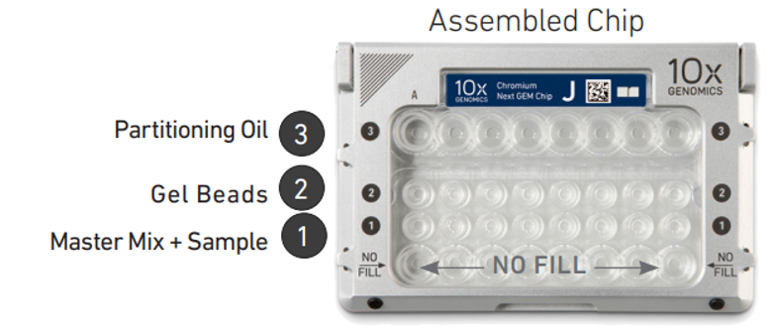

    - Close the 10x chip holder lid with the pre-attached gasket, careful not to touch the smooth side of the gasket.
      - Do not tip the chip holder. Keep the assembly horizontal to avoid any wetting of the 10x Gasket with partitioning oil.
      - Do not press downwards on the gasket. This will lead directly to “wetting errors” that produce failed libraries.
    - Place the assembly into the Chromium Controller.
      - Press the large “Eject” button in the middle of the screen to load the chip.
      - Press the large “Play” button on the screen to begin running the Chromium Controller.
      - Runs will take approximately 18 minutes to finish.
    - Return reagents to their proper storage locations.
      - Note the freeze/thaw cycles of the beads as this may affect performance.
    - Proceed directly to GEM Transfer and Incubation once the chip has finished running.
  - GEM Transfer and Incubation:
    - Label a semi-skirted Twin.Tek PCR plate (Eppendorf 0030129326) with the load name and date according to the paperwork. With lab marker, circle the wells associated with the load. A-H = left-right port position on the 10x chip.
      - Place this plate onto the Integra aluminum block in the ice bucket to chill.
    - Upon completion of GEM formation on the Chromium Controller, press the large “eject” button on the screen.
    - Remove the chip assembly from the Chromium Controller.
    - Carefully remove and discard the 10x Gasket from the assembly.
    - Open the 10x Chip holder (3000332) and fold the lid backwards until it clicks to create a 45 degree well angle.
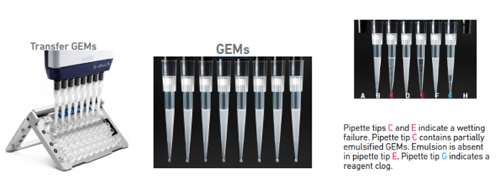

    - Slowly aspirate 100 µl of GEMs from the lowest point of the recovery wells in the top row labeled with a 3, using a multichannel P200 @ 100 µl and low-retention tips.
      - GEMs have high viscosity and need to be pipetted slowly.
      - GEMs should appear even; excess partitioning oil suggests a clog occurred during the run.
    - Photo document the GEMs, saving it in the load document. If there is obviously less than 100 µl of GEMs, take a picture of the chip. Note in a red circle on picture if there is leftover sample in the port and/or beads in the port.
    - Dispense the GEMs into the labeled Twin.Tek PCR plate slowly over the course of ~20 seconds.
      - Pipette against the sidewalls of the wells, keeping the tips above liquid level to minimize GEM loss.
    - Seal the Twin.Tek PCR plate using BioRad microseal ‘B’ (BioRad MSB1001) and a plastic spatula.
    - Load the plate onto the thermocycler running the following program.
Lid Temperature | Reaction Volume | Run Time
50°C | 125 µl | 75 min
Step | Temperature | Time
1 | 37°C | 45 min
2 | 25°C | 30 min
3 | 4°C | Hold

      - Run time is around 75 minutes.
      - Take out the Quenching Agent (2000269) stored at -20°C and allow to thaw at room temperature during the incubation.
    - Upon completion of thermocycler program, immediately remove the plate and transfer it back to the PCR hood.
      - Vortex and spin down the Quenching Agent (2000269), then add 5 µl to each well containing GEMs using a P20 @ 5 µl with a low retention tip. Use a new tip for each well.
      - Using a P200 @ 90 µl and a low retention tip, slowly pipette mix each well containing quenched GEMs 10x. Change tips between wells and make sure all the GEMs are aspirated from the tip.
      - Re-seal the plate with a PlateLoc aluminum seal, and store at -80°C for up to 4 weeks.
    - When ready, proceed to Post GEM Incubation Cleanup.
  - Post GEM Incubation Cleanup:
    - Conduct the following steps in a Post-AMP PCR clean hood.
    - Fill the ice bucket with ice and place both the Integra aluminum PCR block and 1.5-2.0 ml aluminum microtube block on ice to cool.
    - From the 10x Chromium Next GEM Single Cell Multiome GEM Kit A (10x Genomics 1000232) stored at -20°C, remove the following items and allow them to thaw.
      - Reducing Agent B (2000087)
      - Cleanup Buffer (2000088) – Thaw at 65°C for 10 minutes, shaking at 800-1000 rpm in the Eppendorf ThermoMixer until crystals are no longer visible, then allow to acclimate to room temperature.
    - Remove the Dynabeads MyOne Silane beads (2000048) from 4°C and allow them to equilibrate to room temperature.
    - Prepare 15 ml of 80% Ethanol in a 15 ml conical Falcon tube (Corning 430790) by combining 12 ml of 100% Ethanol with 3 ml of water using two 10 ml serological pipettes, switching tips between reagents.
    - Retrieve the Multiome GEM plate from -80°C storage and allow to thaw at room temperature.
    - Add 125 µl of Recovery Agent (220016) to each well using a single-channel P200 @ 125 µl.
      - Use care not to touch the surface of the sample volume to avoid complexity loss.
      - Do not pipette mix or vortex this biphasic mixture.
    - After 60s and under witness, transfer the biphasic mixture to a TempAssure PCR 8-strip (USA Scientific 1402-4700) using an 8-channel P200 2X @ 115 µl and low-retention tips. Use the same tips for both transfers.
    - Immediately after the transfer, carefully pipette out the organic pink phase from the bottom of the tubes using an 8-channel P200 @ 115 µl and low-retention tips. Dispense the organic pink phase in the large side of a 25 ml divided reservoir (VWR 41428-958) labeled for waste.
      - Remove any remaining significant volumes of organic pink phase using a single channel P20 with low-retention tips.
      - Do not remove all the organic phase since much of the cDNA exists at the interphase between layers. Leave between 5-10 µl of pink fluid in the bottom of every well of the sample strip. There will typically be 5 µl to 15 µl remaining to remove.
        - The strip should resemble the below image when finished. Take a photo to document the strips.
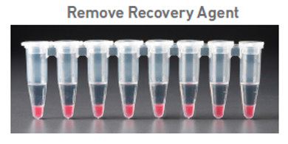

    - Vortex the DynaBeads MyOne Silane Beads (2000048) until fully re-suspended.
    - Prepare DynaBeads cleanup mix by adding the following reagents, in order, to a 2.0 ml DNA LoBind Tubes (Eppendorf 022431048).
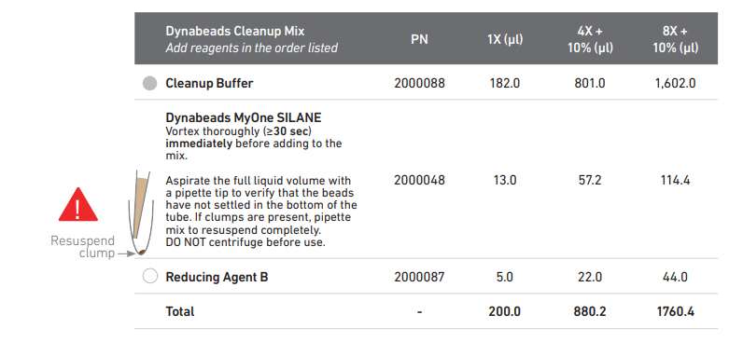

      - Vortex and spin down the room-temperature Cleanup Buffer (2000088).
        - Add 1602 µl of Cleanup Buffer (2000088) to the 2 ml Eppendorf tube using a P1000 @ 1000 µl and a P1000 @ 602 µl.
      - Add 114.4 µl of homogenized and fully re-suspended DynaBeads MyOne Silane beads (2000048) to the DynaBeads Cleanup Mix 2 ml Eppendorf tube using a P200 @ 114.4 µl.
        - Vortex beads thoroughly for >30s immediately before addition to the mix. Tap the tube on the floor of the hood so that the beads settle to the bottom of the tube. Do not use the centrifuge to spin down beads.
      - Vortex and add 44 µl of Reducing Agent B (2000087) to the DynaBeads Cleanup Mix 2 ml tube using a P200 @ 44 µl.
    - Vortex the DynaBeads Cleanup Mix 2 ml tube at max speed for 15 seconds.
      - Do not spin down mix.
    - Add 200 µl of DynaBeads Cleanup Mix to each well in the sample strip using a P200 @ 200 µl using low retention tips.
      - Do not touch the sample with the pipette tip or pipette mix the solution.
    - Close the caps and briefly vortex the strip for 5 seconds at max speed. Take care to make sure the caps remain securely closed.
    - Allow the samples to incubate at room temperature for 10 minutes.
      - Vortex the strip again for 5 seconds at max speed after the first 5 minutes of the incubation.
    - During the 10-minute incubation, prepare Elution Solution 1 by adding the reagents in the order shown below to a 1.5 ml Eppendorf LoBind tube (Eppendorf 022431021):
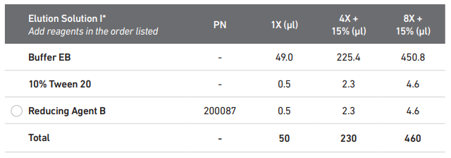

    - Aliquot out 55 µl into each well of a new TempAssure PCR 8-strip using a P200 @ 55 µl.
      - Label that strip “ES1” and set aside for now.
    - Label a new TempAssure PCR 8-strip sample strip with your sample IDs and set aside for now.
    - Once the 10-minute incubation is complete, briefly spin down the tube strip and place it in the 10x Magnetic Separator (120250) in the “High” position.
    - Wait 2 minutes or until the supernatant is clear.
    - Free pour roughly 5 ml of 80% Ethanol into the large side of a 25 ml divided reservoir (VWR 41428-958) and set this aside.
    - Once the sample strip is clear, carefully remove (waste) the supernatant using a P200 @ 150 µl (twice) equipped with low retention tips.
      - Discard tips and waste into an appropriate waste container.
      - Do not disturb the beads. It is better to leave some supernatant instead of picking up beads.
    - Add 150 µl of 80% Ethanol twice (300 µl total) to each well of the sample strip using an 8-channel P200 @ 150 µl and low retention tips. Change tips between additions.
    - Let this solution stand for 30s.
    - Carefully remove and discard the Ethanol wash using an 8-channel P200 @ 150 µl with low retention tips.
      - Repeat with new tips to remove all the residual ethanol.
      - Do not disturb the beads. It is better to leave some supernatant instead of picking up beads.
    - Carefully add 200 µl of 80% Ethanol to the 8-strip using an 8-channel P200 @ 200 µl with low retention tips.
      - Let solution stand for 30s.
    - Remove the Ethanol wash using an 8-channel P200 @ 200 µl with low retention tips.
    - Remove the strip from the 10x Magnetic Separator (120250) and briefly spin it down.
    - Place the strip back into the 10x Magnetic Separator (120250) on the “Low” position.
    - Remove any remaining ethanol from the strips using an 8-channel P20 @ 10 µl with low retention tips.
    - Quickly remove the strip from the 10x Magnetic Separator (120250) and immediately add 51 µl of Elution Solution 1 from the “ES1” strip using an 8-channel P200 @ 51 µl with low retention tips.
    - Close the strip caps and pulse vortex them at max speed for 15s.
    - Briefly spin the strip to collect the sample and incubate it off magnet at room temperature for 2.5 minutes.
    - Return the strip to the 10x Magnetic Separator (120250) in the “Low” position.
      - Leave the strip in the separator until it clears (around 1 minute).
    - Transfer 50 µl of purified GEM products to pre-labeled TempAssure PCR 8-strip using a P200 @ 50 µl with low retention tips.
    - Add 90 µl SPRIselect Reagent to each sample with a P200 @ 90 µl.
      - Vortex and incubate at room temperature for 5 minutes.
    - During incubation, aliquot out 60 µl of Qiagen Buffer EB (Qiagen 19086) into each well of a new TempAssure PCR 8-strip with a P200 @ 60 µl, label the strip “EB” set aside for now.
    - Once the 5-minute incubation is complete, briefly spin down the sample tube strip and place it in the 10x Magnetic Separator (120250) in the “High” position.
    - Wait 2 minutes or until the supernatant is clear.
    - Free pour roughly 5 ml of 80% Ethanol into the large side of a 25 ml divided reservoir (VWR 41428-958) and set this aside.
    - Once the sample strip is clear, carefully remove (waste) the supernatant using a P200 @ 200 µl equipped with low retention tips.
      - Discard tips and waste into an appropriate waste container.
      - Do not disturb the beads. It is better to leave some supernatant instead of picking up beads.
    - Carefully add 200 µl of 80% Ethanol to the 8-strip using an 8-channel P200 @ 200 µl with low retention tips.
      - Let solution stand for 30s.
      - Remove and discard EtOH using an 8-channel P200 @ 200 µl with low retention tips.
      - Repeat step 8.4.42. one time.
    - Remove the Ethanol wash using an 8-channel P200 @ 200 µl with low retention tips.
    - Remove the strip from the 10x Magnetic Separator (120250) and briefly spin it down.
    - Place the strip back into the 10x Magnetic Separator (120250) on the “Low” position.
    - Remove any remaining ethanol from the strips using an 8-channel P20 @ 10 µl with low retention tips.
    - Quickly remove the strip form the 10x Magnetic Separator (120250) and immediately add 47 µl of Buffer EB from the “EB” strip using an 8-channel P200 @ 47 µl with low retention tips.
    - Close the strip caps and pulse vortex them at max speed for 15 seconds.
    - Briefly spin the strip to collect the sample and incubate it off magnet at room temperature for 5 minutes.
    - Return the strip to the 10x Magnetic Separator (120250) in the “Low” position.
      - Leave the strip in the separator until solution clears (around 1 minute).
    - Transfer 46 µl of purified GEM products to pre-labeled TempAssure PCR 8-strip using a P200 @ 46 µl with low retention tips.
    - Proceed directly to Pre-Amplification PCR.
  - Pre-Amplification PCR
    - From the 10x Chromium Next GEM Single Cell Multiome Amp Kit A (10x Genomics 1000233) stored at -20°C, remove the following items and allow them to thaw.
      - Pre-Amp Primers (2000271)
      - Pre-Amp Mix (2000270) – Place on ice
    - Place the 46 µl of purified GEM products in the PCR 8-strip onto an aluminum block in an ice bucket to chill.
    - Prepare Pre-Amplification Mix by adding the following reagents, in order, to a 1.5 ml Eppendorf low-bind tube (Eppendorf 022431021) on ice.
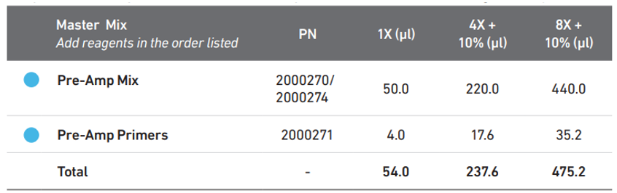

      - Vortex, briefly spin down, and add 440 µl of Pre-Amp Mix (2000270) to Pre-Amplification Mix tube using a P1000 @ 440 µl.
      - Vortex, briefly spin down, and add 35.2 µl of Pre-Amp Primers (2000271) to Pre-Amplification Mix tube using a P200 @ 35.2 µl.
    - Vortex the Pre-Amplification Mix for 5s on max.
    - Spin down the master mix tube briefly to collect.
    - Add 54 µl of the Pre-Amplification Mix to each 46 µl sample on ice using a P200 @ 54 µl.
      - Take care to not touch the pipette tip to the sample when pipetting. Do not pipette mix the sample.
      - Close the caps on the sample tubes and vortex for 5s on max speed.
      - Spin down the PCR tubes to collect the volume and return the tubes to the aluminum block in the ice bucket.
    - Incubate in a thermal cycler with the following protocol- every sample will be run for the same number of cycles regardless of the target nuclei capture.
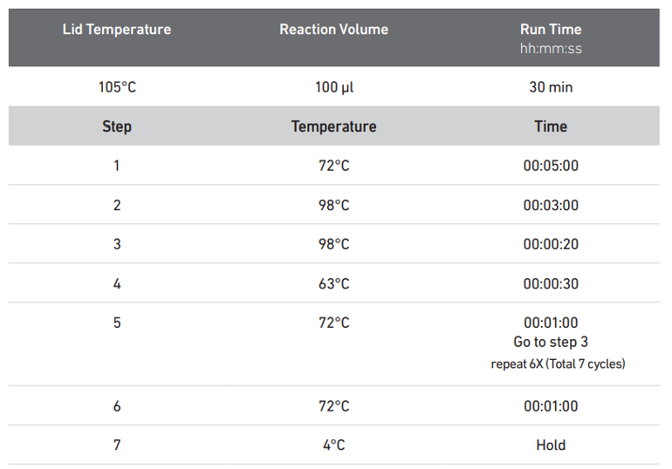

      - Upon completion of PCR, samples may either be stored at 4°C for up to 18 hours or proceed directly with Pre-Amplification SPRIselect cleanup.
    - To begin cleanup, vortex the SPRIselect reagent on max speed until fully resuspended.
    - Free pour 5 ml of 80% Ethanol into the large side of a 25 ml divided reservoir.
    - Label one TempAssure PCR 8-strip (USA Scientific 1402-4700) for EB storage. Label one 96-well Eppendorf Twin.Tek Full-Skirted PCR plate (Eppendorf 0030129300) for the post-cleanup sample storage. Using a lab marker, outline the wells to be used.
    - Fill the 8-strip labeled for EB storage with 170 µl of Qiagen Buffer EB using a P200 @ 170 µl.
    - Using a P200 @ 160 µl, transfer 160 µl of the homogenized SPRI to each sample in the sample strip.
    - Pulse vortex the 8-strip with PCR products and SPRI beads 15 times at max speed.
    - Incubate the strip for 5 minutes at room temperature.
    - Once the 5-minute incubation is over, briefly spin down the 8-strip and place it into the 10x Magnetic Separator (120250) using the “High” position.
      - Leave the strip on the magnet with lids closed until clear.
        - This step generally takes between 2-5 minutes. Check every 2 minutes until clear.
    - Carefully remove and discard the supernatant using an 8-channel P200 @ 150 µl (twice) taking care not to disturb the bead pellet
    - Carefully wash the beads by slowly adding 300 µl of 80% Ethanol from the reservoir using a P200 @ 150 µl (twice). Change tips.
      - Let the wash solution stand on the beads for 30s.
    - Carefully remove and discard the wash solution using an 8-channel P200 @ 150 µl (twice).
    - Repeat the wash step by adding a fresh aliquot of 80% Ethanol from the reagent reservoir using an 8-channel P200 @ 200 µl.
      - Let the wash solution stand for 30s.
    - Remove and discard the Ethanol wash using an 8-channel P200 @ 200 µl.
    - Remove the 8-strip from the magnet, and very briefly (<10s) spin the tube down.
    - Immediately return the 8-strip to the magnet, this time in the “Low” position, and remove any residual Ethanol using 8-channel P20 @ 10 µl.
      - It is very important not to over dry the samples, so small amounts of residual Ethanol are fine.
    - Remove the strip from magnet and immediately add 161 µl Buffer EB using an 8-channel P200 @ 161 µl.
    - Close the caps and pulse vortex the strip 10X at max speed until beads are fully resuspended.
    - Let the strip incubate off magnet for 5 minutes at room temperature.
    - Briefly spin down the strip to collect the volume.
    - Upon completion of the 5-minute room temperature incubation, place the 8-strip back into the 10x Magnetic Separator in the “High” position.
      - Leave the sample on the magnet until it clears (around 2 minutes).
    - Transfer 160 µl of the cleaned Pre-Amplification products to the pre-labeled 96-well Eppendorf Twin.Tek Full-Skirted PCR plate using a P200 @ 160 µl.
    - Store at 4°C for up to 72 hours, -20°C for long term storage, or proceed to ATAC Library Construction and cDNA Amplification.
    - The cleaned Pre-Amplification product contains both barcoded transposed DNA fragments and cDNA. The sample is divided and used as input for two separate steps.
      - 40 µl is used for ATAC Library Construction
      - 35 µl is used for cDNA Amplification
      - The remaining Pre-Amplification product can be stored at -20°C long term.
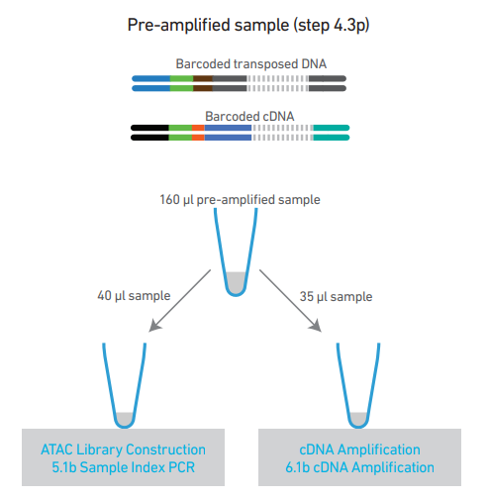

  - ATAC Library Construction
    - From the 10x Chromium Next GEM Single Cell Multiome Amp Kit A (10x Genomics 1000233) stored at -20°C, remove the following items and allow them to thaw.
      - SI-PCR Primer B (2000128)
      - Amp Mix (2000047) – Place on ice
    - Take out the Single Index Plate N Set A (1000212) from -20°C to equilibrate to room temperature.
      - Vortex and spin down once thawed.
    - If done on the same day as the Pre-Amplification PCR then use the remaining 80% Ethanol. If not, create a fresh batch.
    - Equilibrate Pre-Amplification product to room temperature if stored at -20°C. Vortex briefly and spin down.
      - Transfer 40 µl of Pre-Amplification product to a pre-labeled TempAssure PCR 8-tube strip (USA Scientific 1402-4700).
      - Label wells with the pre-selected index well for each sample.
      - Transfer must be done under witness.
      - Place PCR tubes in an aluminum block on ice.
    - Prepare Sample Index PCR mix by adding the following reagents, in order, to a 1.5 ml Eppendorf low-bind tube (Eppendorf 022431021) on ice.
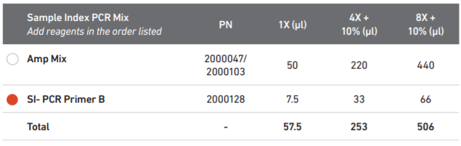

      - Vortex and add 440 µl of AMP Mix (2000047) to the Sample Index PCR Mix tube using a P1000 @ 440 µl.
      - Vortex and add 66 µl of SI-PCR Primer B (2000128) to the Sample Index PCR Mix tube using a P200 @ 66 µl.
    - Vortex the Sample Index PCR Mix for 5s on max speed.
    - Spin down the master mix tube briefly to collect.
    - Add 57.5 µl of Sample Index PCR mix to each 40 µl sample using a P200 @ 57.5 µl.
      - Take care to not touch the pipette tip to the sample when pipetting. Do not pipette mix the sample.
    - Add 2.5 µl of a pre-determined individual Single Index N Set A to the corresponding sample well using a P10 @ 2.5 µl under witness.
    - Close the caps on the sample tubes and briefly vortex for 5s on max speed.
    - Spin down the PCR tubes to collect the volume and return the tubes to the aluminum block on ice.
    - To determine PCR cycling conditions, consult the following table for some basic guidelines surrounding nuclei captured during the load.
Multiome ATAC LIBRARY Index PCR Cycles
Targeted Nuclei Recovered | Mouse | Human
<2000 | 12 | 10
2001-4000 | 11 | 9
4001-6000 | 10 | 8
>6001 | 9 | 7

    - Refer to the sample and study set cycling parameters document.
      - There are many layers of factors that go into the cycling decisions, the most important thing is that these decisions be made using empirical data. A few examples that influence cycling conditions are sample type, species, isolation method, NeuN negative percentage, and region of interest dissected.
    - Load the tubes containing sample and PCR mix onto a thermocycler and run the program below with the pre-determined PCR cycles.
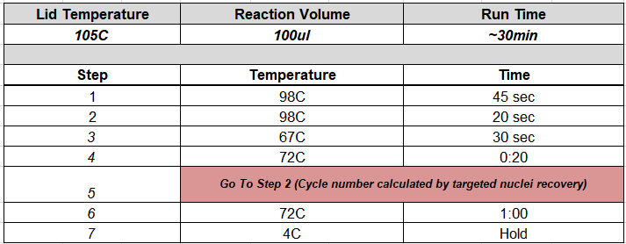

    - Upon completion of PCR, samples may either be stored at 4°C for up to 72 hours or proceed directly with Double Sided Size Selection- SPRIselect cleanup.
    - To begin cleanup, vortex the SPRIselect reagent on max speed until fully re-suspended.
    - Free pour 5 ml of 80% Ethanol into the large side of a 25 ml divided reservoir.
    - Label two TempAssure PCR 8-strips (USA Scientific 1402-4700), one for sample QC, and one for EB storage. Label one 96-well Eppendorf Twin.Tek Full-Skirted PCR plate (Eppendorf 0030129300) for the post-cleanup samples. Using a lab marker, outline the wells to be used for samples.
    - Fill the 8-strip labeled for EB storage with 30 µl of Qiagen Buffer EB using a P200 @ 30 µl.
    - Using a P200 @ 60 µl, transfer 60 µl of the homogenized SPRI to each sample in the sample strip.
    - Pulse vortex the 8-strip with PCR products and SPRI beads 15 times at max speed.
    - Incubate the strip for 5-minutes at room temperature.
    - Once the 5-minute incubation is over, place the 8-strip into the 10x Magnetic Separator (120250) using the “High” position.
      - Leave the strips on the magnet with their lids closed until clear.
        - This step generally takes between 2-5 minutes. Check every 2 minutes until clear.
    - Vortex to resuspend SPRI mix.
    - Add 95 µl of SPRI mix to a new 8-strip.
    - Carefully transfer the supernatant from the 8-strip on the 10X Magnetic Separator (120250) using an 8-channel P200 @ 150 µl, taking care not to disturb the bead pellet, to the new 8-strip with 95 µl of SPRI mix.
      - Do not discard the supernatant as it contains the desired fraction of the sample.
      - Discard the strip (with beads) sitting on the magnetic separator.
      - Vortex and incubate new 8-strip with 95 µl of SPRI mix and 150 µl of supernatant at room temperature for 5 minutes.
    - At the end of the 5-minute incubation, quickly spin down sample then place on the 10x Magnetic Separator (120250) using the “High” position.
    - Leave on strip until solution clears, which usually takes 1-2 minutes.
    - Carefully pipette and remove supernatant with a P200 @ 125 µl twice (solution at 245 µl).
    - Carefully wash the beads by adding 300 µl of 80% Ethanol from the reservoir using a P200 @ 150 µl (twice). Change tips.
      - Let the wash solution stand on the beads for 30 seconds.
    - Carefully remove and discard the wash solution using an 8-channel P200 @ 150 µl (twice).
    - Repeat the wash step by adding a fresh aliquot of 80% Ethanol from the reagent reservoir using an 8-channel P200 @ 200 µl.
      - Let the wash solution stand for 30 seconds.
    - Remove and discard the ethanol wash using an 8-channel P200 @ 200 µl.
    - Remove the 8-strip from the magnet, and very briefly (<3s) spin the tube down.
    - Immediately return the 8-strip to the magnet, this time in the “Low” position.
    - Uncap the tubes and remove any residual ethanol using an 8-channel P20 @ 10 µl.
      - It is very important not to over dry the samples, so small amounts of residual Ethanol are fine.
    - Quickly remove the strip from the magnet and add 21 µl of Qiagen Buffer EB (Qiagen 19086) from the EB 8-strip using an 8-channel P200 @ 21 µl.
    - Close the caps and pulse vortex the strip 10X at max speed until beads are fully resuspended.
    - Let the strip incubate off magnet for 5 minutes at room temperature.
    - Briefly spin down the strip to collect the volume.
    - Upon completion of the 5-minute room temperature incubation, place the 8-strip back into the 10x Magnetic Separator in the “Low” position.
    - Leave the sample on the magnet until it clears (around 2 minutes).
    - Transfer 20 µl of the cleaned products to the pre-labeled 96-well Eppendorf Twin.Tek Full-Skirted PCR plate using a P20 @ 20 µl, match the sample index to the plate wells which should be outlined.
    - Add 19 µl of Qiagen Buffer EB (Qiagen 19086) from the EB 8-strip to the QC labeled 8-strip using an 8-channel P20 @ 19 µl.
    - Transfer 1 µl of cleaned product to the QC strip using an 8-channel P10 @ 1 µl.
      - Close and vortex the QC strip for 5 seconds at max speed then spin down to collect.
      - Store the QC strip and 4°C until ready for Library Quant and QC.
    - Store cleaned library samples at 4°C for up to 72 hours, or -20°C for long term storage.
    - Proceed to Library Quant and QC using the 20-fold diluted 10x libraries in the QC strip.
  - Library Quant and QC
    - Follow MB0194: 384-well PicoGreen to quantify the sample, using 3 µl from the 10X diluted QC strip.
    - Multiply the resulting concentration and yield by 20 to achieve the actual sample concentration and yields.
    - Run 1 µl of the 20-fold diluted 10x QC sample on the FA using the Fragment Analyzer Operation SOP (MB0073)
    - Check the trace of the ATAC Library. High quality ATAC Libraries should closely resemble the following:
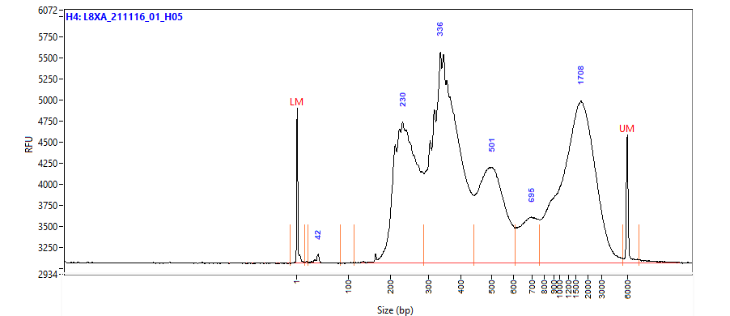

      - There should be four distinct peaks as seen above. From left to right, nucleosome free peak, mono-nucleosome peak, di-nucleosome peak, and multinucleated fragments.
      - Check for significant differences between the FA yield and PicoGreen yield.
    - Calculate the molarity of each library using the average size from the FA and the concentration from PicoGreen.
      - In general, we target molarity above 60nM, and samples below 20nM would be considered a failure and should be rescued with additional index PCR cycles. However, there are instances of samples of known lower quality, or that cannot be re-done that will still pass.
      - Below are the molarity ranges we have seen for 1633 Multiome ATAC libraries that have passed on to sequencing.
Passing Multiome ATAC Libraries
 | Stock nM
Sample Number | 1633
Min | 10.76
Max | 441.23
Average | 145.80
Median | 131.13

nM Range of Library | Passing Sample Number | % of Samples
<20nM | 3 | 0.2%
20-30nM | 7 | 0.4%
30-60nM | 140 | 9%
60-100nM | 385 | 24%
100-200nM | 714 | 44%
200-300nM | 328 | 20%
>300nM | 56 | 3%
Total: | 1633

  - cDNA Amplification
    - From the 10x Chromium Next GEM Single Cell Multiome Amp Kit A (10x Genomics 1000233) stored at -20°C, remove the following items and allow them to thaw.
      - cDNA Primers (2000089)
      - Amp Mix (2000047) – Place on ice
    - If done the same day as the Pre-Amplification PCR then use the remaining 80% Ethanol. If not, create a fresh batch.
    - Equilibrate Pre-Amplification product to room temperature if stored at -20°C. Vortex briefly and spin down.
      - Under witness, transfer 35 µl of Pre-Amplification product to a pre-labeled TempAssure PCR 8-tube strip (USA Scientific 1402-4700).
      - Place PCR tubes in an aluminum block on ice.
    - Prepare cDNA Amplification Mix by adding the following reagents, in order, to a 1.5 ml Eppendorf low-bind tube (Eppendorf 022431021) on ice.
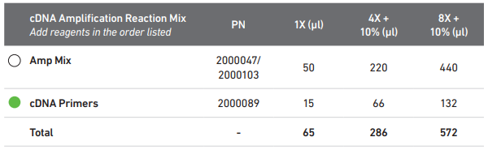

      - Vortex and add 440 µl of AMP Mix (2000047) to the cDNA Amplification Reaction Mix tube using a P1000 @ 440 µl.
      - Vortex and add 132 µl of cDNA Primers (2000089) to the cDNA Amplification Mix tube using a P200 @ 132 µl.
    - Vortex the cDNA Amplification Reaction Mix for 5s on max speed.
      - Spin down the master mix tube briefly to collect.
      - Add 65 µl of cDNA Amplification Reaction Mix to each 35 µl sample using a P200 @ 65 µl. Change tips.
        - Take care to not touch the pipette tip to the sample when pipetting. Do not pipette mix the sample.
      - Close the caps on the sample tubes and briefly vortex for 5 seconds on max speed.
      - Spin down the PCR tubes to collect the volume and return the tubes to the aluminum block on ice.
    - To determine PCR cycling conditions, consult the following table for some basic guidelines surrounding nuclei number captured during the load.
Multiome cDNA Amp
Targeted Nuclei Recovered | Mouse | Human
<2000 | 11 | 11
2001-4000 | 10 | 10
4001-6000 | 9 | 9
>6001 | 8 | 8

      - There are many layers of factors that go into the cycling decisions, the most important thing is that these decisions be made using empirical data. A few examples that influence cycling conditions are sample type, species, isolation method, NeuN negative percentage, and region of interest dissected.
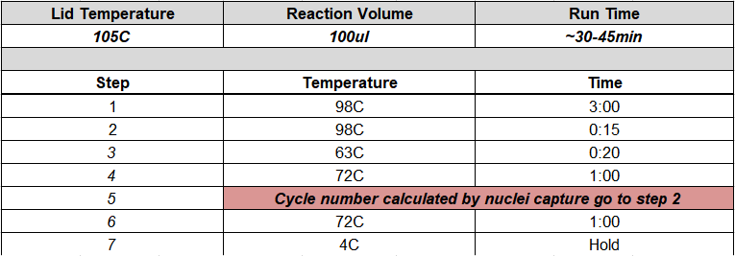

      - Upon completion of PCR, samples may either be stored at 4°C for up to 72 hours, or at -20°C for up to 1 week, or proceed directly with SPRIselect cleanup.
    - To begin cleanup, vortex the SPRIselect reagent on max speed until fully re-suspended.
    - Free pour 5 ml of 80% Ethanol into the large side of a 25 ml divided reservoir.
    - Label two TempAssure PCR 8-strips (USA Scientific 1402-4700), one for sample QC, and one for EB storage. Label one 96-well Eppendorf Twin.Tek Full-Skirted PCR plate (Eppendorf 0030129300) for the post-cleanup samples. Using a lab marker, outline the wells to be used.
    - Fill the 8-strip labeled for EB storage with 50 µl of Qiagen Buffer EB using a P200 @ 50 µl.
    - Using a P200 @ 60 µl, transfer 60 µl of the homogenized SPRI to each sample in the sample strip. Change tips.
    - Pulse vortex the 8-strip with PCR products and SPRI beads 15 times at max speed.
    - Incubate the strip for 5-minutes at room temperature.
    - Once the 5-minute incubation is over, place the 8-strip into the 10x Magnetic Separator (120250) using the “High” position.
      - Leave the strips on the magnet with their lids closed until clear.
      - This step generally takes between 2-5 minutes. Check every 2 minutes until clear.
    - Carefully remove and discard the supernatant using an 8-channel P200 @ 160 µl taking care not to disturb the bead pellet.
    - Carefully wash the beads by slowly adding 200 µl of 80% Ethanol from the reservoir using a P200 @ 200 µl.
      - Let the wash solution stand on the beads for 30 seconds.
    - Carefully remove and discard the wash solution using an 8-channel P200 @ 200 µl.
    - Repeat the wash step by adding a fresh aliquot of 80% Ethanol from the reagent reservoir using an 8-channel P200 @ 200 µl.
      - Let the wash solution stand for 30 seconds.
    - Start a lab timer for 2 minutes, then promptly remove and discard the Ethanol wash using an 8-channel P200 @ 200 µl.
    - Remove the 8-strip from the magnet, cap it, and very briefly (<10s) spin the tube down.
    - Immediately return the 8-strip to the magnet, this time in the “Low” position.
    - Uncap the tubes and remove any residual Ethanol using an 8-channel P20 @ 10 µl.
      - It is very important not to over dry the samples, so small amounts of residual Ethanol are fine.
    - Upon completing the end of the 2-minute drying, remove the strip from the magnet and add 41 µl of Qiagen Buffer EB (Qiagen 19086) from the EB 8-strip using an 8-channel P200 @ 41 µl.
    - Close the caps and pulse vortex the strip 10X at max speed until beads are fully resuspended.
    - Let the strip incubate off magnet for 5 minutes at room temperature.
    - Briefly spin down the strip to collect the volume.
    - Upon completion of the 5-minute room temperature incubation, place the 8-strip back into the 10x Magnetic Separator in the “High” position.
      - Leave the sample on the magnet until it clears (around 2 minutes).
    - Transfer 40 µl of the cleaned post cDNA amplified products to the pre-labeled 96-well Eppendorf Twin.Tek Full-Skirted PCR plate using a P200 @ 40 µl. Destination wells should be outlined.
    - Add 9 µl of Qiagen Buffer EB (Qiagen 19086) from the EB 8-strip to the QC labeled 8-strip using an 8-channel P10 @ 9 µl.
    - Transfer 1 µl of cleaned post cDNA amplified product to the QC strip using an 8-channel P10 @ 1 µl.
      - Close and vortex the QC strip for 5 seconds at max speed then spin down to collect.
      - Store the QC strip at 4°C until ready for Post AMP 10x Quant and QC.
    - Store cleaned cDNA samples at 4°C for up to 72 hours, or -20°C for up to four weeks before library preparation.
  - Post AMP 10x Quant and QC
    - Follow MB0194: 384-well PicoGreen to quantify the sample, using 3 µl from the 10X diluted QC strip.
    - Multiply the resulting concentration and yield by 10 to achieve the actual sample concentration and yields.
    - Run 1 µl of the 10X diluted 10x QC sample on the Fragment Analyzer following SOP MB0073.
      - Check the trace of the amplified cDNA. High quality cDNA should closely resemble the following:
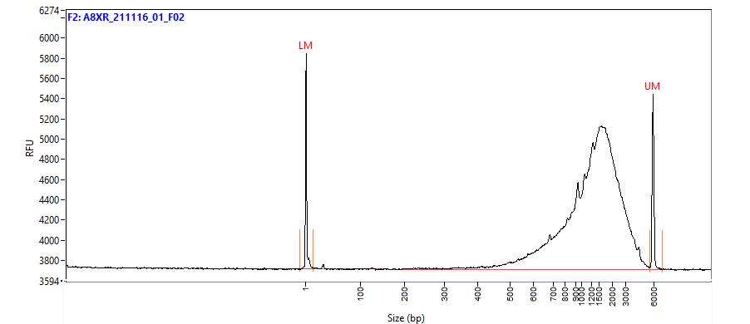

    - In addition, check the trace for:
      - Any extraneous peaks.
      - Significant products smaller than 400bp.
      - Significant differences in yield when compared to PicoGreen results.
  - Quantify the nanogram input for library based on PicoGreen results. In general, target a cDNA input of 111-500 ng.
    - Nanogram input will vary based on a variety of factors such as sample type, species, isolation method, NeuN negative percentage, region of interest dissected, and sample quality.
    - In general, samples with an input of less than 20ng for library are considered failed. However, there are instances of samples of known lower quality, or that cannot be re-done that will still pass to library. This is not recommended if the sample can be rescued.
    - Below are the yield ranges we have seen for 1643 Multiome cDNA amplifications that have passed on to library construction.
Passing Multiome cDNA Amplifications
 | ng input for lib | PG (ng/ul)
Sample Number | 1643 | 1643
Min | 3.03 | 0.30
Max | 1188.79 | 118.88
Average | 260.09 | 26.01
Median | 220.96 | 22.10

ng Input for Libray Range | Passing Sample Number | % of Samples
<10ng | 9 | 1%
10-30ng | 40 | 2%
30-60ng | 98 | 6%
60-100ng | 133 | 8%
100-200ng | 446 | 27%
200-300ng | 371 | 23%
300-500ng | 396 | 24%
>500ng | 150 | 9%
Total: | 1643

    - Samples which do not pass QC should not proceed to gene expression library preparation. All other samples should proceed with Gene Expression Library Construction.
  - Gene Expression Library Construction
    - Conduct the following steps in a Post-AMP PCR hood.
    - Fill an ice bucket with ice and place both the Integra aluminum block and 1.5-2 ml microtube block on the ice to chill.
    - Remove the following items from the Library Construction Kit (10x Genomics 1000190) (-20°C) and allow them to equilibrate to room temperature:
      - Ligation Buffer (2000092)
      - Fragmentation Buffer (2000091)
      - Adaptor Oligos (2000094)
    - Remove the following items from the Library Construction Kit (10x Genomics 1000190) (-20°C) and place them directly in the microtube block on ice:
      - Fragmentation Enzyme (2000090)
      - DNA Ligase (220110)
      - AMP Mix (2000047)
    - Remove the Dual Index Kit TT Set A (10x Genomics 1000215) from the -20°C and place it at room temperature to thaw.
    - Fill a 50 ml Falcon tube (Corning 352098) with 16 ml of 100% Ethanol using a 25 ml serological pipette (Greiner 357525).
    - Add 4 ml of NFdH2O (Thermo AM9937) to the 16 ml of Ethanol using a 10 ml serological pipette (Greiner 607180) to make 20 ml of 80% Ethanol.
    - Prepare a thermocycler by initiating the Frag, A-Tail protocol.
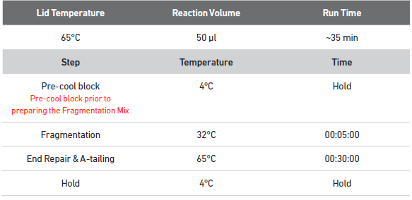

    - Remove the cleaned post cDNA amplified product from either the 4°C or -20°C and place it on the Integra block in the ice bucket.
    - Vortex the Fragmentation Buffer (2000091) and verify there is no precipitate.
    - Vortex again if needed.
    - Prepare the fragmentation master mix on ice by adding the reagents in the order and volumes shown below to a 1.5 ml Eppendorf LoBind tube (Eppendorf 022431021).

      - Vortex and add 44 µl of Fragmentation Buffer (2000091) to the fragmentation mix tube using a P200 @ 44 µl.
      - Vortex and add 88 µl of fragmentation Enzyme (2000090) to the fragmentation mix tube using a P200 @ 88 µl.
    - Vortex the fragmentation master mix for 10s at max speed. Spin down to collect.
    - Together with a witness, label a new TempAssure PCR 8-tube strip with the sample names determined by the index well that will be used and place it on ice. This can be done the day before. Samples kept overnight at 4°C to use the next day.
    - Add 15 µl of fragmentation master mix to each well in the new, labeled TempAssure PCR strip using a P20 @ 15 µl.
    - Add 25 µl of Qiagen Buffer EB to each well using a P200 @ 25 µl, to bring the volume up to 40 µl.
    - Transfer 10 µl of purified cDNA to each well containing the fragmentation master mix using an 8-channel P10 @ 10 µl. Do this under witness to ensure sample integrity.
      - The remaining 30 µl of cDNA can be stored long term at -20°C for generation of additional 3’ gene expression libraries.
    - Close the caps and pulse vortex 5 times at max speed.
    - Spin down the strip to collect the volume.
    - Transfer the tube strip to the pre-cooled thermocycler running the Frag, A-Tail protocol and press “Skip” to initiate the protocol.
    - Upon completion of the thermocycler protocol, proceed directly with double sided size selection using SPRIselect.
    - Vortex the SPRIselect reagent until fully re-suspended.
    - Fill a TempAssure 8-strip with 60 µl of Qiagen buffer EB (Qiagen 19086) using a P200 @ 60 µl and label this strip “EB”.
    - Add 30 µl (0.6X) of homogenized SPRIselect reagent to each sample using a P200 @ 30 µl. Change tips.
    - Cap and pulse vortex the strip 5 times at max speed.
    - Allow the strip to incubate at room temperature for 5 minutes.
    - Spin down the strip to collect the volume and place it in the 10x magnetic separator in the “High” position. Let strips sit in magnet for minimum of 2 minutes.
    - Label a new TempAssure 8-strip with your sample IDs.
    - Add 10 µl (0.8X) of homogenized SPRIselect reagent to each well of the newly labeled TempAssure strip using a P10 @ 10 µl.
    - Once the sample strip in the magnetic separator clears, transfer 75 µl of the supernatant, using an 8-channel P200 @ 75 µl, to the new strip containing 10 µl of beads.
      - Do not discard the supernatant as it contains the desired fraction of the sample.
      - Discard the strip (with beads) sitting on the magnetic separator (now with supernatant removed).
    - Pulse vortex the new TempAssure strip containing the sample and beads 5 times at max speed.
    - Allow the strip to incubate at room temperature for 5 minutes.
    - Spin down the strip to collect and place it in the 10x magnetic separator in the “High” position. Let strips sit in magnet for minimum of 2 minutes.
    - Fill the long half of a divided reservoir (VWR 41428-958) with 5 ml of 80% Ethanol by free pouring.
    - Once the solution is clear, remove and discard 80 µl of supernatant using an 8-channel P200 @ 80 µl.
    - As the bead volume is small, it is critical to not disturb or remove any of the beads. Some residual volume is preferable to prevent this from occurring.
    - Add 125 µl of 80% Ethanol from the divided reservoir using an 8-channel P200 @ 125 µl.
    - Allow the Ethanol wash to stand for at least 30 seconds.
    - Carefully remove and discard the Ethanol wash with an 8-channel P200 @ 125 µl.
    - Repeat the wash by adding 125 µl of 80% Ethanol from the divided reservoir using an 8-channel P200 @ 125 µl.
    - Incubate the Ethanol wash for at least 30 seconds.
    - Carefully remove and discard the Ethanol wash with an 8-channel P200 @ 125 µl.
    - Cap the strip and briefly spin the tubes and return to the 10x magnetic separator in the “Low” position.
    - Remove the residual Ethanol with an 8-channel P20 @ 10 µl, being careful to not remove any of the beads.
    - Immediately remove the strip from the magnetic separator and add 51 µl of Qiagen buffer EB to the 8-strip using an 8-channel P200 @ 51 µl.
      - Vortex strip until beads are re-suspended.
      - Due to the low volume of beads, it is critical to not over dry the beads, so re-suspend the beads immediately after the Ethanol is removed.
    - Incubate the strip and beads for 5 minutes at room temperature.
    - Spin down the strip briefly to collect the volume and place the strip back into the 10x magnetic separator in the “High” position. Let strips sit in magnet for minimum of 2 minutes.
    - Label a new TempAssure 8-strip with your sample IDs.
    - Transfer 50 µl of the double-sided SPRIselect cleaned products (eluant) into the newly labeled TempAssure 8-strip tube using a P200 @ 50 µl.
    - Dispose of the divided reservoir containing 80% Ethanol.
    - Start the 20C LIGATE protocol on the thermocycler.
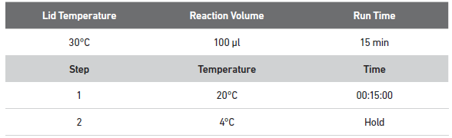

    - Prepare adaptor ligation mix in a 1.5 ml Eppendorf LoBind tube (Eppendorf 022431021) by vortexing and adding the following regents in order:
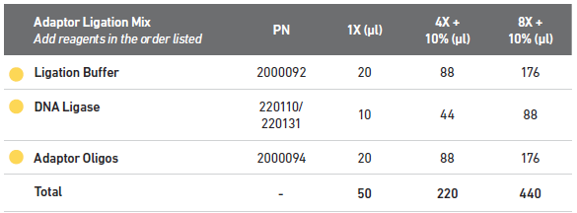

      - Vortex and add 176 µl of ligation buffer (2000092) using a P200 @ 176 µl.
      - Vortex and add 88 µl of DNA Ligase (220110) using a P200 @ 88 µl.
      - Vortex and add Adaptor Oligos (2000094) using a P200 @ 176 µl.
    - Vortex the adaptor ligation master mix at max speed for 5s and spin down briefly to collect.
    - Using P200 @ 50µl, add 50 µl of adaptor ligation master mix to each well of the 8-strip containing double-sided SPRIselect cleaned products. Change tips.
    - Close the caps and vortex the strip for 5s.
    - Spin down the strip briefly to collect the volume.
    - Transfer the strip to the thermocycler running the 20C LIGATE and advance the protocol to begin the 15-minute 20°C ligation incubation.
    - Upon completion, return the samples to the Post-AMP hood to begin post-ligation cleanup.
    - Free-pour 5 ml of 80% Ethanol into the large side of a 25 ml divided reservoir (VWR 41428-958).
    - Label TempAssure 8-tube strip(s) (USA Scientific 1402-4700) to accommodate the final cycling conditions (1 strip per cycling condition) and library IDs of each sample.
    - Label a TempAssure 8-tube strip (USA Scientific 1402-4700) “EB” and add 40 µl of Qiagen Buffer EB (Qiagen 19086).
    - Vortex the SPRIselect reagent until fully re-suspended.
    - Add 80 µl of SPRIselect reagent to each sample in the 8-strip using a P200 @ 80 µl. Change tips.
    - Cap the strip and pulse vortex at max speed for 5s.
    - Incubate the strip for 5 minutes at room temperature.
    - Place the strip in the 10x magnetic separator in the “High” position until the solution clears. Let strips sit in magnet for minimum of 2 minutes.
    - Carefully remove and discard the supernatant using an 8-channel P200 @ 180 µl.
    - Add 200 µl of 80% Ethanol from the reagent reservoir to the strip using an 8-channel P200 @ 200 µl.
    - Let the Ethanol wash sit for 30s.
    - Carefully remove and discard the Ethanol wash using an 8-channel P200 @ 200 µl.
    - Repeat the Ethanol wash a second time by adding 200 µl of 80% Ethanol using an 8-channel P200 @ 200 µl.
    - After 30 seconds carefully remove and discard the Ethanol wash using an 8-channel P200 @ 200 µl.
    - Cap and briefly centrifuge the 8-strip to collect the residual Ethanol.
    - Start a timer for 2 minutes, place the 8-strip into the 10x magnetic separator on the “Low” position, and uncap the tubes.
    - Remove any residual Ethanol using an 8-channel P20 @10 µl.
    - Just before the 2-minute drying time is up, remove the strip from the magnet and add 31 µl of Qiagen Buffer EB (Qiagen 19086) from the “EB” strip using an 8-channel P200 @ 31 µl.
      - Vortex the beads and elution buffer at speed 9 until the beads are homogenous in solution.
    - Incubate the eluted beads in the strip for 5 minutes at room temperature.
    - Briefly centrifuge the strip to collect the volume and place it in the 10x magnetic separator in the “Low” position until the solution clears (around 2 minutes).
    - Transfer 30 µl of the post-ligation cleanup products (eluant) to the labeled TempAssure 8-strip tubes using a P200 @ 30 µl.
    - Spin down the thawed Dual Index Plate TT Set A (10x Genomics 3000431).
    - Briefly vortex the thawed Amp Mix (2000047) reagents for 5 seconds at max speed, spin to collect.
    - Add 50 µl of Amp Mix (2000047) to each tube containing 30 µl of post ligation sample using a P200 @ 50 µl. Change tips.
    - Under witness, add 20 µl of individual index from the Dual Index Plate TT Set A (10x Genomics 3000431) to each well.
      - Record the index IDs associated with each sample for demultiplexing.
    - Cap and vortex the tubes for 10 seconds at max speed. Spin down tubes.
    - Consult the following table for the number of PCR cycles based off the amount of cDNA input determined by PicoGreen from the amplification step earlier:
 | LIBRARY
 | ng Library Input | Sample Index Cycles
 | 1-12ng | 16
 | 13-25ng | 15
 | 26-65ng | 14
 | 66-110ng | 13
cDNA target | 111-150ng | 12
cDNA target | 151-300ng | 11
cDNA target | 301-500ng | 10
 | 501-750ng | 9
 | 751-100ng | 8
 | 1001-1250ng | 7
 | 1251-1500ng | 6
 | >1500ng | 5

    - After determining the PCR cycling conditions, run the following PCR protocol on the thermocycler: INDEX PCR NN where NN is equal to the number of PCR cycles.
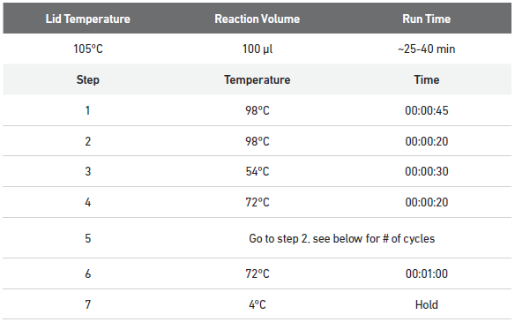

    - Store samples at 4°C for up to 72 hours or proceed with the final double-sided size selection.
    - Label four TempAssure 8-tube PCR strips, one for QC, one for buffer EB, and two for samples during cleanup.
    - Label a 96-well Eppendorf Twin.Tek Full-Skirted PCR plate (Eppendorf 0030129300) with the library name for post-cleanup sample storage. Using a lab marker, outline the destination wells.
    - Add 50 µl of Qiagen Buffer EB (Qiagen 19086) to the EB labeled strip.
    - Free pour 5 ml of 80% Ethanol into the large side of a new divided reservoir (VWR 41428-958).
    - Vortex the SPRIselect reagent (Beckman Coulter B23318) until completely re-suspended.
    - Label a TempAssure 8-tube PCR strip with the sample IDs.
    - If necessary, to condense the samples into single 8-strips, transfer the entire volume (100 µl) of sample from the 8-strip tubes to the corresponding wells of the sample ID labeled 8-strip.
    - Add 60 µl of homogenized SPRIselect reagent (Beckman Coulter B23318) reagent to the sample labeled 8-strip using a P200 @ 60 µl. Change tips.
    - Cap and vortex the tube strip and then let it stand at room temperature for 5 minutes.
    - Briefly spin down the strip to collect the volume and place it in the 10x magnetic separator in the “High” position. Let strips sit in magnet for minimum of 2 minutes.
    - In the other TempAssure 8-tube PCR strip labeled for cleanup, add 20 µl of homogenized SPRIselect reagent to each well of the new 8-strip using a P20 @ 20 µl.
    - Once clear, transfer 150 µl of the supernatant from the strip on the magnetic separator to the strip containing 20 µl of SPRIselect using an 8-channel P200 @ 150 µl.
      - Take care to not transfer any of the beads at this point.
      - Discard the strip from the 10x magnetic separator with large products bound to the beads.
    - Cap and vortex the new cleanup strip for 10 seconds at max speed.
    - Allow the strip to incubate off-magnet for 5 minutes at room temperature.
    - Once the incubation is over, place the strip into the 10x magnetic separator in the “High” position until the solution is clear. Let strips sit in magnet for minimum of 2 minutes.
    - Carefully remove and discard the supernatant using an 8-channel P200 @ 165 µl.
      - NOTE: Due to the low volume of beads it is important to not discard any beads with the supernatant, so the listed volumes will leave some small volume behind with the beads.
    - With the strip still in the magnetic separator, add 200 µl of 80% Ethanol to the beads to wash them using an 8-channel P200 @ 200 µl.
    - Allow the wash to stand for 30 seconds.
    - Remove and discard the Ethanol wash using an 8-channel P200 @ 200 µl.
    - Repeat the wash a second time by adding 200 µl of 80% Ethanol using an 8-channel P200 @ 200 µl.
    - Allow this wash to stand for 30 seconds.
    - Remove and discard the Ethanol wash using an 8-channel P200 @ 200 µl.
    - Cap the tubes and briefly centrifuge them to collect any residual volume.
    - Place the strip in the 10x magnetic separator in the “Low” position.
    - Remove and discard any residual Ethanol wash using an 8-channel P20 @ 10 µl.
    - Remove the strip from the magnet and immediately add 36 µl of Qiagen Buffer EB (Qiagen 19086) from the “EB” labeled strip to the strip containing the beads using an 8-channel P200 @ 36 µl.
    - Vortex the beads with EB on speed 9 until the solution is homogenous.
    - Allow the strip to stand off-magnet at room temperature for 5 minutes.
    - Return the strip to the 10x magnetic separator in the “Low” position until clear. Let strips sit in magnet for minimum of 2 minutes.
    - Transfer 35 µl from the tube strip into the labeled Twin.Tek 96-well PCR plate (Eppendorf 0030129300) using an 8-channel P200 @ 35 µl.
      - The samples should be transferred to the well in the plate that corresponds with their selected index. Destination wells should be outlined.
    - Add 9 µl of Qiagen Buffer EB (Qiagen 19086) to the “QC” labeled strip using an 8-channel P10 @ 9 µl.
    - Add 1 µl of the cleaned 10x library product in the Twin.Tek 96-well PCR plate to the “QC” strip using an 8-channel P2 @ 1 µl. Cap, vortex and then spin down QC strip.
    - Store samples at 4°C for up to 72 hours, or -20°C long term.
    - Proceed to Library Quant and QC using the 10-fold diluted 10x libraries in the QC strip.
  - Library Quant and QC
    - Follow MB0194: 384-well PicoGreen to quantify the sample, using 3 µl from the 10x diluted QC strip.
    - Multiply the resulting concentration and yield by 10 to achieve the actual sample concentration and yields.
    - Run 1 µl of the 10x diluted 10X QC sample on the FA using the Fragment Analyzer Operation SOP (MB0073).
      - Check the trace of the amplified cDNA. High quality cDNA should closely resemble the following:
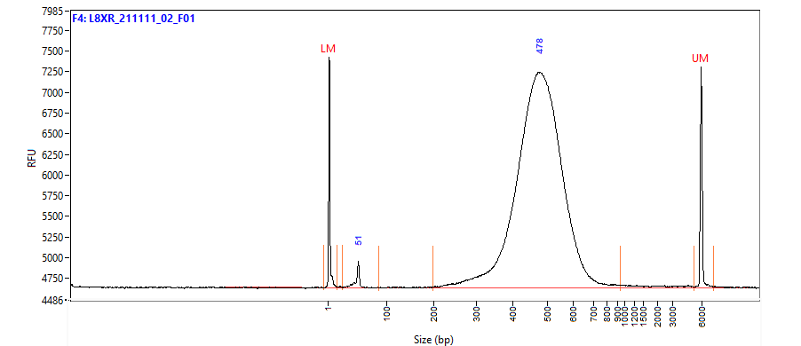

      - All products should be between 200-600bp since those are ideal sizes for sequencing.
      - Check for significant differences between the Fragment Analyzer yield and PicoGreen yield.
    - Calculate the molarity of each library using the average size from the FA and the concentration from PicoGreen.
      - In general, we target molarity above 60nM, and samples below 20nM would be considered a failure and should be rescued with additional index PCR cycles. However, like the cDNA amplification, there are instances of samples of known lower quality, or that cannot be re-done that will still pass.
      - Below are the molarity ranges we have seen for 1643 Multiome RNAseq libraries that have passed on to sequencing.
Passing Multiome Rseq Libraries
 | Stock nM
Sample Number | 1643
Min | 14.16
Max | 378.04
Average | 106.17
Median | 96.56

nM Range of Library | Passing Sample Number | % of Samples
<20nM | 2 | 0%
20-30nM | 14 | 1%
30-60nM | 206 | 13%
60-100nM | 644 | 39%
100-200nM | 696 | 42%
200-300nM | 75 | 5%
>300nM | 6 | 0%
Total: | 1643

- Take Down:
  - Return any unused reagents.
  - Clean the hood and ice bucket per the MolBio HowTo documents.

