Making Data Publicly Available
File Name: SOP Making Data Publicly Available v1.3 (2/3/2023)
Developed by: Drs. Eric Billman, Clement Sohoulande, and Matias Vanotti
USDA-ARS, Florence, SC

Objective:
This SOP was created to comply with the new P&P 630.0 Data Management (usda.gov) ‘Data Management & Public Access Requirements for ARS’ which affects all journal papers produced at ARS locations. It was developed by an Ad-Hoc Data Committee to help implement Data Management Plans (DMPs) in three new ARS Projects at the location (NP 211, 212, and 301).
Reference & Policy:
The policy in this P&P 630.0 lists the following requirements concerning public access for USDA-funded Research Data (for detail see section 4.2 of P&P 630.0):
  - Digital Scientific Research Data must be “published” in a data repository that can be searchable and usable for analysis by public (i.e re3data.org)
  - Digital Scientific Research Data with a digital object identifier (DOI), preserved long-term, machine-readable format
  - Timing: Digital Scientific Research Data in the data repository within 12 months after completion of data collection
- “completion of data collection” is defined in the approved DMP of the ARS project plan. Example: 12 months after date of publication of the peer-review article, or 12 months after a decision not to publish a peer-reviewed article based on the data.
d) Digital Scientific Research Data must also be catalogued in NAL (Ag Data Common) with 3 additional pieces of information:
1. USDA funding source
2. Dataset description
3. Associated published research documents
- If there is an exception to making data publicly available: Must obtain an extension or waiver from USDA Chief Scientist

SOP Conceptual Diagram:

Users of this SOP: Scientists and Support Staff (Cat 3 and Technicians). The SOP was developed so that Category 3 scientists and Technicians involved in data collection and summarization can assist the SY in the additional work required to make the research data publicly available (tasks shown at the right of the vertical line in the conceptual diagram above). However, the SY is responsible for 1.) content of the research data made publicly available, 2.) final submission of the ARS 115 form for Digital Data, 3.) final submission of digital data to the repository, and 4.) submission of the metadata to the NAL Ag Data Commons.
Repository to use: In this SOP, we use the Dryad Data Repository as a functional example that will work for any journal publication. The Dryad Data Repository is partnered with the Tri-Societies (ASA/CSSA/SSSA) and is free for any articles published in their respective journals. It costs $120 for any submission of datasets tied to other publishers (e.g., Elsevier).
However, the SY should decide which data repository to use based on convenience, if the journal has its own public repository (e.g., Figshare, part of ASABE), and the cost of publishing in that repository. The requirements in P&P 630.0 for acceptable data repositories are that they:
- can be searchable and usable for analysis by public (a list of acceptable repositories can be found at re3data.org).
- digital scientific research data in the data repository must be given a digital object identifier (DOI), preserved long-term, and readable.

SOP Table of Contents:
Part 1: Publishing Digital Scientific Research Data in Data Repository…………………...…Pg. 1
- Prepare dataset for upload in the Dryad Data Repository…………………………….Pg. 1
- Enter dataset into Dryad Data Repository…………………………………….…..…..Pg. 2
- Prepare and get approval of ARS 115 Form for Dataset submission…………………Pg. 4
- Submit Digital Scientific Research Data to Dryad……………………………………Pg. 4
- How to cite Digital Scientific Research Data………………………………………... Pg. 5

Part 2: Creating a Metadata: Digital Scientific Research Data is catalogued in Ag Data Commons (NAL)……………………………………………………………………...Pg. 6
- Preliminary steps for metadata submission to Ag Data Commons (National Agricultural Library, NAL) .…………………………………………………...……………...……Pg. 6
- Submitting the metadata to Ag Data Commons………………………………………Pg. 8

Part 3: End Products………………………………………………………………………....Pg. 10

Appendices:
Appendix A: Entering a Dataset into the Dryad Data Repository………………………...…Pg. 12
Appendix B: Preparing ARS 115 for Dataset Submission.……………...…………………..Pg. 16
Appendix C: Example of Dryad Outputs…………………………………………………….Pg. 22
Appendix D: Preparing and Entering Data into the NAL Repository……………………….Pg. 24

Part 1: Publishing Digital Scientific Research Data in Data Repository
Note: we use the Dryad Data Repository as a functional example that will work for any journal publication.
- Prepare dataset for upload in the Dryad Data Repository
  - In Microsoft Excel, organize and present the original data used to generate final products (tables, figures, etc.) shown in the published manuscript.
    - Use a separate tab for each sub-dataset (table, figure, etc.) and clearly label what table, figure, or other product it is related to in the manuscript
    - In certain situations, a sub-dataset (tab) can include data that is presented in more than one table and figure in the paper. (DATASET A linked below has one situation like this).
    - For example, if 3 reps were used to create one datapoint ± error in a figure or table in the paper, present here the 3 replicates with a separate column indicating replicate #.
    - The sub-datasets should have clearly labelled column headings that include units, using same names and units used in the publication.
  - Explain what is included in each sub-dataset; this can be done two ways (THIS IS THE ONLY PORTION OF THE SOP WHICH WILL REQUIRE ORIGINAL SY INPUT):
    - Provide a brief description of each sub-dataset using a textbox directly on each tab of the Excel file If there are abbreviations for column headings, define them here.
AND
    - create a “ReadMe.docx” text file that describes how to interpret all the datasets included in the data files. Guidance can be found on Dryad’s website: https://datadryad.org/stash/best_practices?msclkid=0cdf953ac0c511ec82af294557c1b9e7#describe
  - Optional: Save the spreadsheet as a CSV (Comma Separated Value).
    - Note: This forces each tab (sub-dataset) of the spreadsheet to be saved as an individual file, so you may have several files to save and upload to Dryad.
A complete DATASET A (https://datadryad.org/stash/dataset/doi:10.5061/dryad.79cnp5ht4, download the dataset in the upper righthand corner of the webpage, you will find 1 ReadMe file and 1 Excel file) is included for a paper by Eric Billman et al. published in a Tri-Societies (ASA_SSSA_CSSA) journal
A complete DATASET B (https://datadryad.org/stash/landing/show?id=doi%3A10.5061%2Fdryad.qnk98sfdz, download the dataset in the upper righthand corner of the webpage, you will find 1 ReadMe file, and 5 CSV files) is included for a paper by Clement Sohoulande et al. published in an Elsevier journal.

- Enter dataset into Dryad Data Repository (See Appendix A for Screenshots)
  - Login to the Dryad Data Repository using the SYs personal ORCID iD (Figure A1). (SYs personal ORCID iD are used to link data assets and products).
    - Link: https://datadryad.org/stash/sessions/choose_login
    - Note: If the scientist does not have an ORCID iD, they can follow the prompts on the page to create his/her personal ORCID iD . (this is mandatory for ARS SYs)
  - Once logged in, click on “Start New Dataset” in the upper right corner to navigate to the submission page (Figure A2)
    - Under “Preliminary Information” (Figure A3), select “a published article” since you will be submitting the dataset following publication, and provide the journal name and manuscript number (provided by the journal).
    - Under “Dataset: Basic Information” (Figure A4), provide the dataset title in the following format “Digital research data from: (Insert Manuscript Title)”, the name of the lead author, their institutional affiliation, and their email address. Using the dropdown menu, select the appropriate “Research Domain” that most applies to the dataset. Provide the name of any funding entity and the grant award number. Finally, provide the new abstract, which should be formatted as follows:
      - Begin with, “This is digital research data corresponding to a published manuscript in (Insert Manuscript Title, Journal Name, and Volume and Page Numbers)”.
      - Copy and Paste the first part of the abstract from the published journal article, only including the introduction and materials and methods portions.
Example abstract in DATASET A: This is digital research data corresponding to a published manuscript, Mob and rotational grazing influence pasture biomass, nutritive value, and species composition, in Agronomy Journal, Vol. 112 p. 2866-2878.
Mob grazing, which uses very high stocking densities for short durations followed by a relatively long rest period, was designed to mimic bison (Bison bison) grazing in western U.S. grassland. This project assessed the suitability of mob grazing for livestock production in the Northeast. Objectives were to compare the effects of mob and rotational grazing on dry matter (DM) mass, nutritive value, and botanical composition across four grazing seasons. Eight, 0.10‐ha paddocks were established in 2014 as a randomized complete block with four replications, and seeded with alfalfa (Medicago sativa L.), white clover (Trifolium repens L.), orchardgrass (Dactylis glomerata L.), narrowleaf plantain (Plantago lanceolata L.), and tall fescue [Schedonorus arundinaceus (Schreb.) Dumort]. Mob‐grazed (MOB) paddocks were grazed by yearling beef cattle twice each year, (70–90–day interval), and rotationally grazed (ROT) paddocks were grazed four to six times each year (when sward height reached 25 cm).
Example abstract in DATASET B: These research data are associated with the manuscript entitled “Climate-driven prediction of land water storage anomalies: An outlook for water resources monitoring across the conterminous United States” (https://doi.org/10.1016/j.jhydrol.2020.125053).
The study focused on the conterminous United States (CONUS) which extends over a region of contrasting climates with an uneven distribution of freshwater resources. Under climate change, an exacerbation of the contrast between dry and wet regions is expected across the CONUS and could drastically affect local ecosystems, agriculture practices, and communities. Hence, efforts to better understand long-term spatial and temporal patterns of freshwater resources are needed to plan and anticipate responses. Since 2002, the Gravity Recovery and Climate Experiment (GRACE) and GRACE Follow-On (GRACE-FO) satellite observations provide estimates of large-scale land water storage changes with an unprecedented accuracy. However, the limited lifetime and observation gaps of the GRACE mission have sparked research interest for GRACE-like data reconstruction. This study developed a predictive modeling approach to quantify monthly land liquid water equivalence thickness anomaly (LWE) using climate variables including total precipitation (PRE), number of wet day (WET), air temperature (TMP), and potential evapotranspiration (PET). The approach builds on the achievements of the GRACE mission by determining LWE footprints using a multivariate regression on principal components model with lag signals. The performance evaluation of the model with a lag signals consideration shows 0.5 ≤ R² ≤ 0.8 for 41.2% of the CONUS. However, the model’s predictive power is unevenly distributed. The model could be useful for predicting and monitoring freshwater resources anomalies for the locations with high model performances. The processed data used as inputs in the study are here provided including the GIS files of the different maps reported.
    - Under “Data Description” (Figure A5), add up to five relevant keywords (these can be from the published paper), “Methods”: describe how the data was collected and processed, “Usage Notes”: and provide any notes necessary to use the dataset.
      - Fill in appropriate Methods and Usage Notes statements describing how the data was collected and processed, using the template below:
        - Template 1 used in DATASET A:
Methods: Methods are described in the manuscript https://doi.org/10.1002/agj2.20215
Usage Notes: Descriptions corresponding to each figure and table in the manuscript are placed on separate tabs in the Excel file and accompanying README file to clarify abbreviations and summarize the data headings and units.
        - Template 2 used in DATASET B:
Methods: Methods are described in the manuscript https://doi.org/10.1016/j.jhydrol.2020.125053
Usage Notes: Descriptions corresponding to each figure and table in the manuscript are placed in the Read Me.docx file that is included as part of the Dryad dataset.
    - Under “Related Works” (Figure A5), list any related articles and their associated DOI link (This should include the original manuscript).
    - Click “Proceed to Upload” (Figure A5) in the lower right corner.
  - Upload your files (Figure A6)
    - Upload all relevant data files (it is okay to have multiple files). Be sure to include the “ReadMe.docx” file if you have opted to use that to describe the dataset (section 1.b above).
    - You can either “drag and drop files” or “choose files” from the file explorer to upload.
    - Click “Proceed to Review” in the lower right corner.

- Prepare and get approval of ARS 115 Form for Dataset submission (see Appendix B for example)
  - For the abstract, use the same abstract that was submitted to Dryad (same as the green and yellow text in section 2.b.ii, above)
  - For publication type, select D=Database/Dataset
  - SY submit the 115 and obtain approval from the Research Leader prior to final submission of the Digital Scientific Research Data to Dryad

- Submit Digital Scientific Research Data to Dryad (Figure A7)
- Review that your author names/affiliations and uploaded files are correct
- DO NOT check the box “Keep my dataset private…”, as we are only submitting datasets once the papers are published.
- Check the boxes that agree to Dryad’s license and terms of service agreements.
- Check the box agreeing to Dryad’s payment terms $120
    - The submitter will receive an email requesting payment and can contact your location PSA for assistance in making the payment. It will be charged to the Center’s publication account. Certain journals (e.g., Agronomy Journal and Crop Science) have agreements with Dryad that allow datasets from associated publications to be uploaded to Dryad free of charge).
- Note: Exit the page (work will automatically be saved) and notify the lead author/SY that the upload is ready to be submitted. The SY will then login and conduct a final review and submit the dataset for publication at Dryad

Appendix C contains two examples of complete Dryad processed output:
- One example is the Dryad processed output containing the information entered for the paper of Eric Billman (DATASET A).
- The other example is the Dryad processed output containing the information entered for the paper of Clement Sohoulande (DATASET B).

- How to cite Digital Scientific Research Data
Once published in Dryad, you are provided with a new DOI and you can cite the dataset, like you cite any publication. You need to update also the 115 created in part 3 above with this new citation information. Here are two examples of the full citations for DATABASES A and B:
- Dataset A: Billman, E. et al. (2020), Data from: Mob and rotational grazing influence pasture biomass, nutritive value, and species composition, Dryad, Dataset, https://doi.org/10.5061/dryad.79cnp5ht4
- Dataset B: Sohoulande, C. et al. (2020), Data from: Climate-driven prediction of land water storage anomalies: An outlook for water resources monitoring across the conterminous United States, Dryad, Dataset, https://doi.org/10.5061/dryad.qnk98sfdz

Part 2: Creating a Metadata: Digital Scientific Research Data is Catalogued in Ag Data Commons (NAL)
- Preliminary steps for metadata submission to Ag Data Commons (National Agricultural Library, NAL)

NOTE: We created a fillable MS Word template available on the P-Drive (MetadataTemplate.docx) to collect all the required information for inclusion in the Ag Data Commons. This information can be compiled and drafted by support scientists or technicians, the details of which can be found below. The actual login and submission into the Ag Data Commons will be conducted by the SY (because the Ag Data Commons account is a government account and Usernames and Passwords cannot be shared, per our internet security training).

  - Preparing your submission on Ag Data Commons
- Authorship: The submission of the Metadata to Ag Data Commons (NAL) repository requires a contact person’s name and email address. Hence, we recommend the first author (must be an SY) to be listed. In a situation where the first author is not an SY (e.g. postdoc), the supervisor (co-author and SY) should be listed as the contact name for the metadata.
- Title: The title should follow the format [Metadata for: “Title of the related published paper”].
- Summary: The summary shall include three major parts including:
- a short introduction on the metadata mentioning the related published paper;
- a short description of the research objective and method, (This is a cut and paste from the manuscript abstract)
- a short description of the metadata, the variables, the data collection. (This is a cut and paste from the Methods and Usage Notes sections of the Dryad dataset submission, see Part 1.2.iii.2)
Example 1 for DATASET A:
This is digital research metadata corresponding to a published manuscript in Agronomy Journal, "Mob and rotational grazing influence pasture biomass, nutritive value, and species composition", Vol. 112 p. 2866-2878. Dataset may be accessed via the included link at the Dryad data repository.
Mob grazing, which uses very high stocking densities for short durations followed by a relatively long rest period, was designed to mimic bison (Bison bison) grazing in western U.S. grassland. This project assessed the suitability of mob grazing for livestock production in the Northeast. Objectives were to compare the effects of mob and rotational grazing on dry matter (DM) mass, nutritive value, and botanical composition across four grazing seasons. Eight, 0.10‐ha paddocks were established in 2014 as a randomized complete block with four replications, and seeded with alfalfa (Medicago sativa L.), white clover (Trifolium repens L.), orchardgrass (Dactylis glomerata L.), narrowleaf plantain (Plantago lanceolata L.), and tall fescue [Schedonorus arundinaceus (Schreb.) Dumort]. Mob‐grazed (MOB) paddocks were grazed by yearling beef cattle twice each year, (70–90–day interval), and rotationally grazed (ROT) paddocks were grazed four to six times each year (when sward height reached 25 cm).
Methods are described in the manuscript https://doi.org/10.1002/agj2.20215. Descriptions corresponding to each figure and table in the manuscript are placed on separate tabs to clarify abbreviations and summarize the data headings and units.

Example 2 for DATASET B:
Data reported in the csv files are gridded monthly time-series used in the article “Sohoulande, C.D., Martin, J., Szogi, A. and Stone, K., 2020. Climate-Driven Prediction of Land Water Storage Anomalies: An Outlook for Water Resources Monitoring Across the Conterminous United States. Journal of Hydrology, p.125053”.
The study focused on the conterminous United States (CONUS) which extends over a region of contrasting climates with an uneven distribution of freshwater resources. Under climate change, an exacerbation of the contrast between dry and wet regions is expected across the CONUS and could drastically affect local ecosystems, agriculture practices, and communities. Hence, efforts to better understand long-term spatial and temporal patterns of freshwater resources are needed to plan and anticipate responses. Since 2002, the Gravity Recovery and Climate Experiment (GRACE) and GRACE Follow-On (GRACE-FO) satellite observations provide estimates of large-scale land water storage changes with an unprecedented accuracy. However, the limited lifetime and observation gaps of the GRACE mission have sparked research interest for GRACE-like data reconstruction. The study developed a predictive modeling approach to quantify monthly land liquid water equivalence thickness anomaly (LWE) using climate variables including total precipitation (PRE), number of wet day (WET), air temperature (TMP), and potential evapotranspiration (PET). The approach builds on the achievements of the GRACE mission by determining LWE footprints using a multivariate regression on principal components model with lag signals. Methods are described in the manuscript https://doi.org/10.1016/j.jhydrol.2020.125053. Descriptions corresponding to each figure and table in the manuscript are placed in the Read Me.docx file that is included as part of the Dryad dataset.

- Publication DOI: Have the DOI of the published paper linked to the data
- Data DOI: have the DOI of the published digital scientific research data (Dryad repository or repository used in part 1)
- Funding Sources: have the name and code of the funded project related to the data.
- ARIS Log number of the metadata: the ARIS log number is taken from the ARS-115 form of the dataset.
- Author ORCID: have the SY’s ORCID number.
- The data files to upload: You do not need to upload the data file since the digital dataset was already published on Dryad (Part 1 of this SOP). Providing the DOI of the published data during the submission on Ag Data Commons (step 5 above) takes care of this.

- Submitting the Metadata to Ag Data Commons
  - SY should register for an account on https://data.nal.usda.gov/. Once you click on register then enter information needed as shown by Figure D1 (See Appendix D)
- Username: Enter a username
- E-mail address: Enter your email address (i.e. your USDA.GOV email)
- Organization: Enter your organization’s URL. E.g. https://www.ars.usda.gov/southeast-area/florence-sc/coastal-plain-soil-water-and-plant-conservation-research/
- About: this is optional
- Title: Your job title. E.g. Ag. Engineer, Soil Scientist etc.
- Phone: optional but you can enter your office phone
- Click on “Create new account”
Once your Ag Data Commons account is approved, the SY will receive an e-mail containing information about how to log in, set your password, and other details.
  - As shown in Figure D2, appendix D:
    - Log into your Ag Data Commons account at https://data.nal.usda.gov/ then click submit data.
- As shown in Figure D3, appendix D:
- Enter data title using the format [Metadata for: “Title of the related published paper”] as indicated in Part 2.1.b.ii.;
- URL, Tags, Groups, License: leave as default
- Description (Summary): Enter the Summary as indicated in Part 2.1.b.iii.

- As shown in Figure D4, appendix D:
- Geographic coverage: You have three options (Map, GeoJson, or Points). First click on one of these options and process as below:
  - Map: Use the “+” to zoom in or “-” to zoom out. Used points, polygons, or bounding boxes to indicate the study region/ the location of study field/ Lab related to the metadata on US map or globe map. Then click “finish”. In Case you need to edit then just click “cancel”.
  - GeoJSON: this option is recommended if user has the geoJSON encoded geographic structure information
  - Points: Just add the latitude and longitude of the study region/ the location of study field/ Lab related to the metadata, then click on the “ADD
- Spatial description: just enter a caption that best describe the location of the study. E.g. Florence, SC
- Date time: Check the “Show end date” box, then enter the beginning and end dates of the data collection. E.g.: 2018/07/09 and 2019/01/05. Time can be left as default

- As shown in Figure D5, appendix D:
- Contact name: Enter SY’s name
- Contact email: Enter SY’s email
- Public access level: public
- Resources: keep blank
- Extended Metadata: Do not input anything here if sole SY name is sufficient to cite the metadata. In case additional authors names need to be added, then click the “Add new author” tab to add information for each co-author. However, there is no need to add reviewer (ignore “Add reviewer” tab).
- As shown in Figure D6, appendix D:
- Click the “Add citation” then enter the citation for the article that directly describes the metadata.
- Click “Add funding source” then provide the information about the project related to the metadata.
- In the “Dataset DOI” box, enter the DOI of the published dataset on Dryad or any other platform you may have published your data.
- As shown in Figure D7, appendix D:
- ARIS log number: enter the ARIS log number of the ARS 115 form that was approved for the dataset submission.
- ISO Topics: select one or more that best describe the metadata
- State or territory: select the State or territory based on the study region of the metadata
- Highlight image: you may upload an image or chart that best describes your data. This is optional
- Bureau code and program code: optional
- As shown in Figure D8, appendix D:
- Publisher: keep default “Ag data Commons”
- Authoring information: verify SY name, enter the date the data is published.
- SY should save the inputs by clicking the highlighted green “save”.
- Review the metadata entered and submit it (Submission is made by clicking the ‘Submit for Review” tab as shown by Figure D8, Appendix D). Once submitted, an Ag Data Commons reviewer will be assigned to review the metadata and will contact SY for edits if needed. The approved metadata will thereafter be released on the NAL repository and accessible. (Figure D9, Appendix D).

Part 3: End products
At the end of the new publication process, you will have:
- two citable publications (journal and dataset), each with their own 115 and their own DOI.
- a metadata at NAL with a web link
Example 1 for DATASET A:
Published journal paper: Billman, E. D., Williamson, J. A., Soder, K. J., Andreen, D. M., & Skinner, R. H. (2020). Mob and rotational grazing influence pasture biomass, nutritive value, and species composition. Agronomy Journal, 112(4), 2866-2878. https://doi.org/10.1002/agj2.20215
Published Dataset: Billman, Eric D.; Williamson, Jessica, A.; Soder, Kathy J.; Andreen, Danielle M.; Skinner, R. Howard. (2020). Data from: Mob and rotational grazing influence pasture biomass, nutritive value, and species composition, Dryad, Dataset, https://doi.org/10.5061/dryad.79cnp5ht4 .
Metadata: Billman, Eric D.; Williamson, Jessica, A.; Soder, Kathy J.; Andreen, Danielle M.; Skinner, R. Howard. (2020). Metadata from: Mob and rotational grazing influence pasture biomass, nutritive value, and species composition. Accessed 2021-01-11.Link to Ag Data Commons: https://data.nal.usda.gov/dataset/metadata-mob-and-rotational-grazing-influence-pasture-biomass-nutritive-value-and-species-composition

Example 2 for DATASET B:
Published journal paper: Sohoulande, C. D., Martin, J., Szogi, A., & Stone, K. (2020). Climate-driven prediction of land water storage anomalies: An outlook for water resources monitoring across the conterminous United States. Journal of Hydrology, 588, 125053. https://doi.org/10.1016/j.jhydrol.2020.125053
Published Dataset: Sohoulande, Clement D.D.; Martin, Jerry; Szogi, Ariel; Stone, Kenneth (2020). Data from: Climate-driven prediction of land water storage anomalies: An outlook for water resources monitoring across the conterminous United States, Dryad, Dataset, https://doi.org/10.5061/dryad.qnk98sfdz
Metadata: Sohoulande, Clement. (2020). Metadata for: Climate-driven prediction of land water storage anomalies: An outlook for water resources monitoring across the conterminous United States. Link to Ag Data Commons: https://data.nal.usda.gov/dataset/metadata-climate-driven-prediction-land-water-storage-anomalies-outlook-water-resources-monitoring-across-conterminous-united-states

Appendix A: Entering a Dataset into the Dryad Data Repository
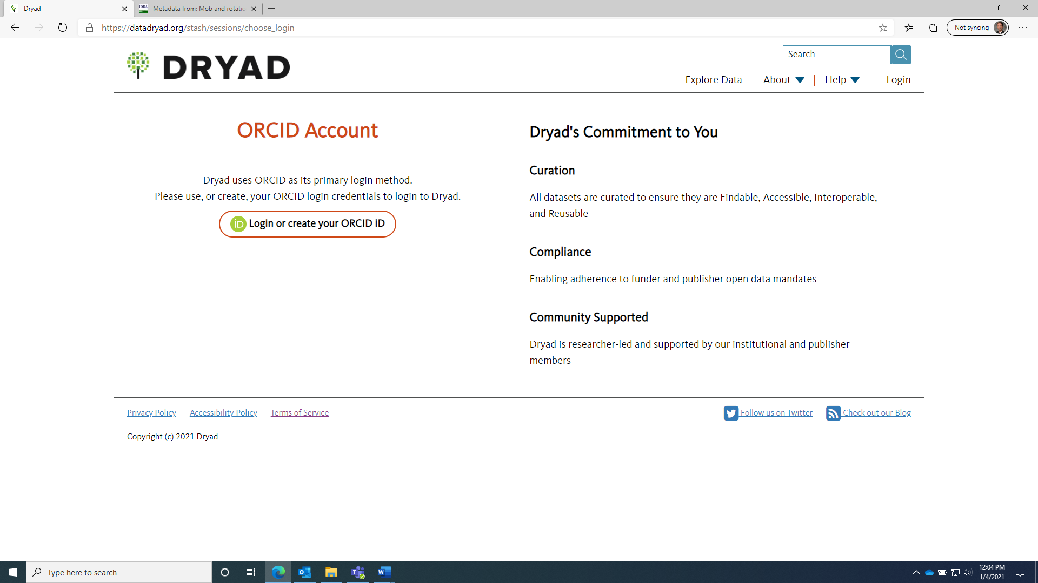
Figure A1. Dryad Login Screen. Click “Login with your ORCID iD” circled in red to continue.
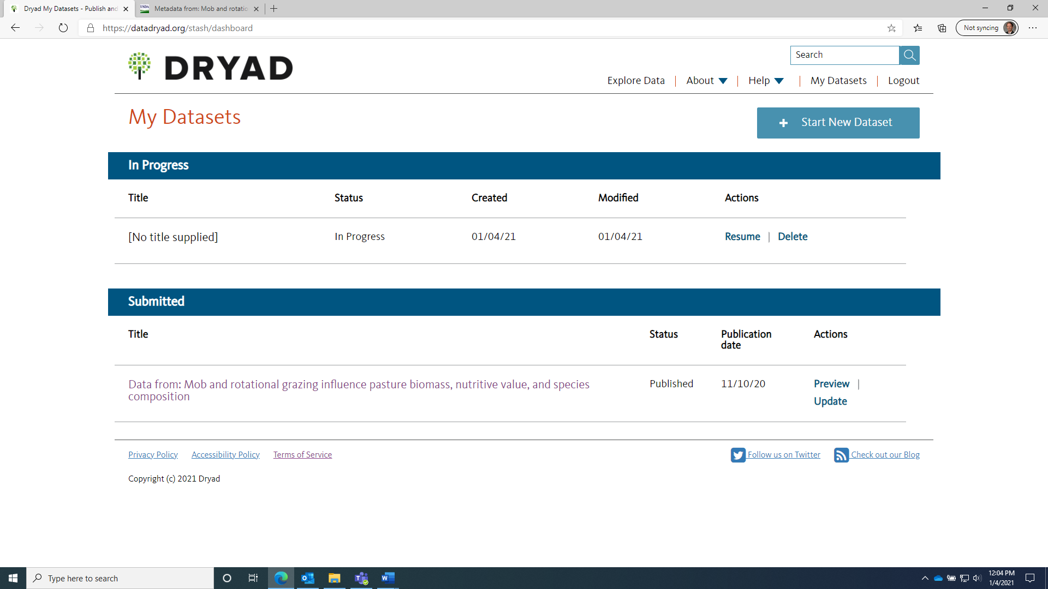
Figure A2. Dryad Dataset Menu view after signing in. Click “Start New Dataset” circled in red to continue
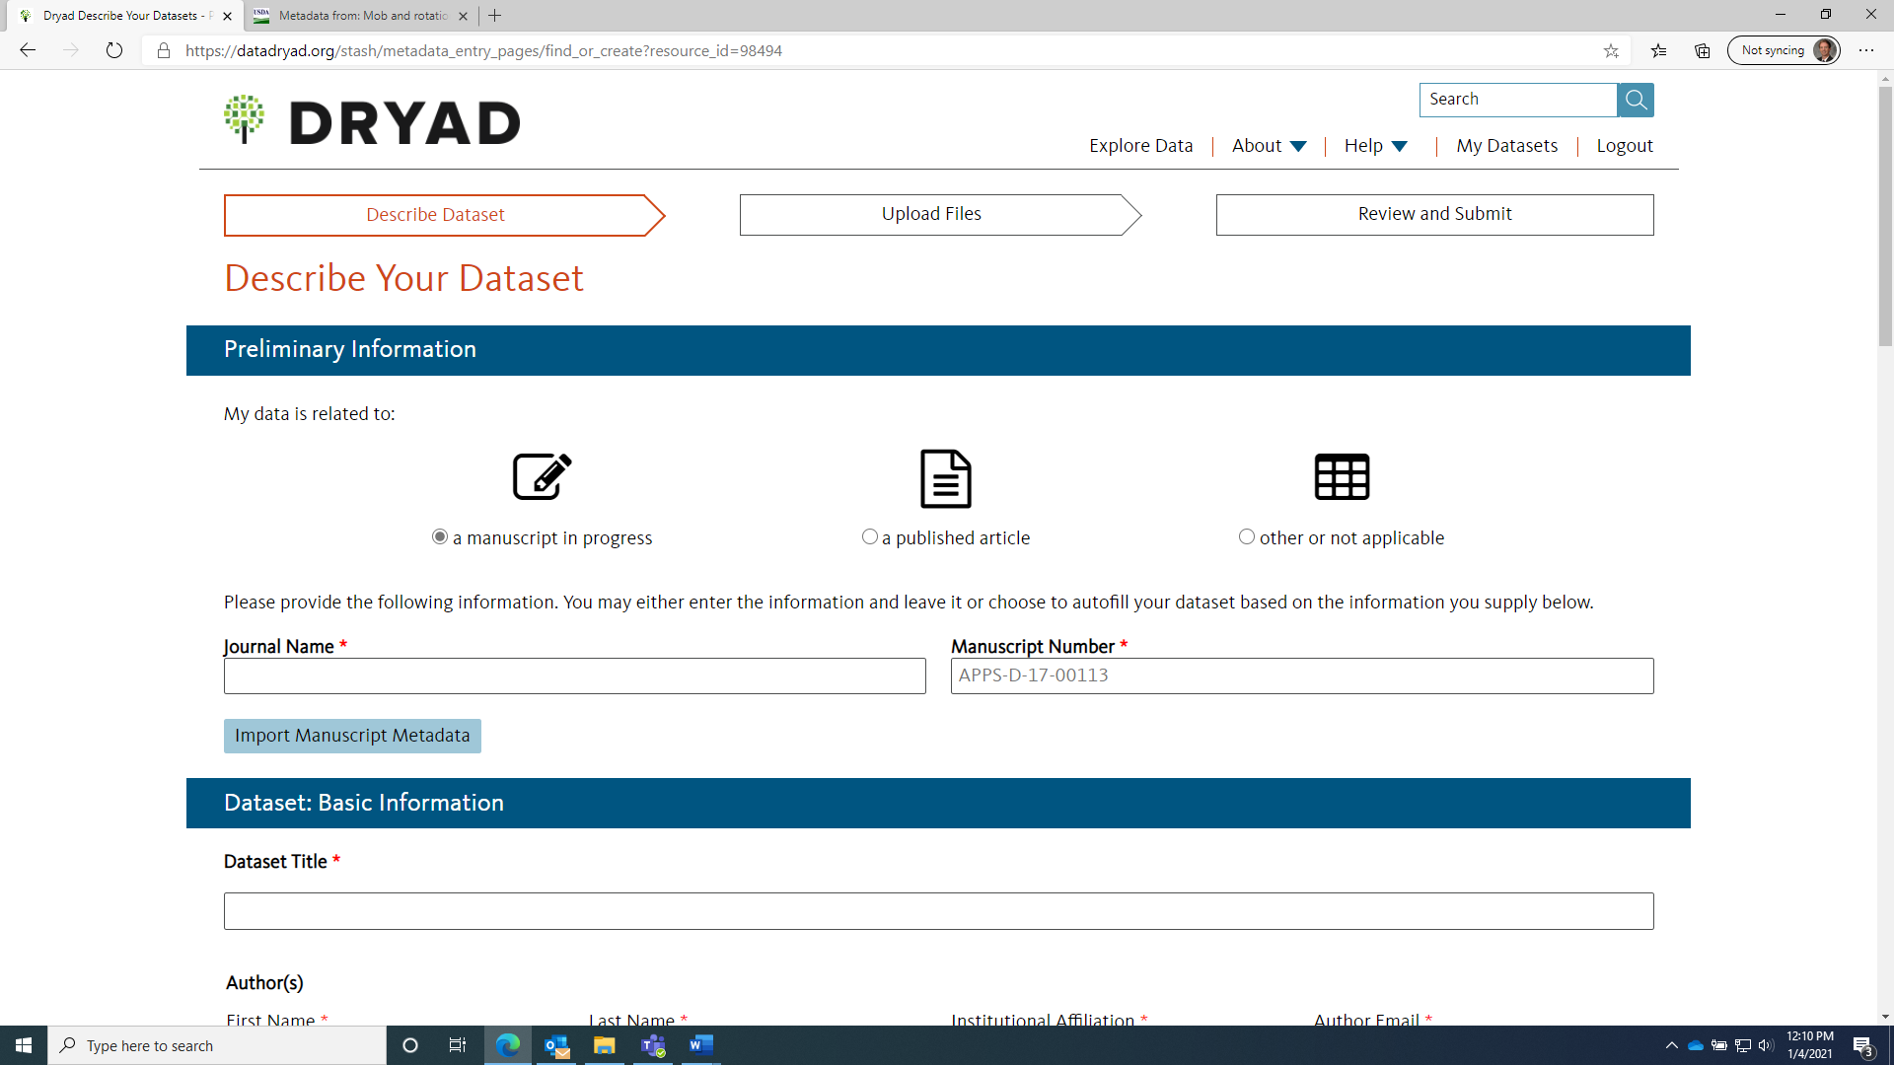
Figure A3. Describe your dataset; Preliminary Information.

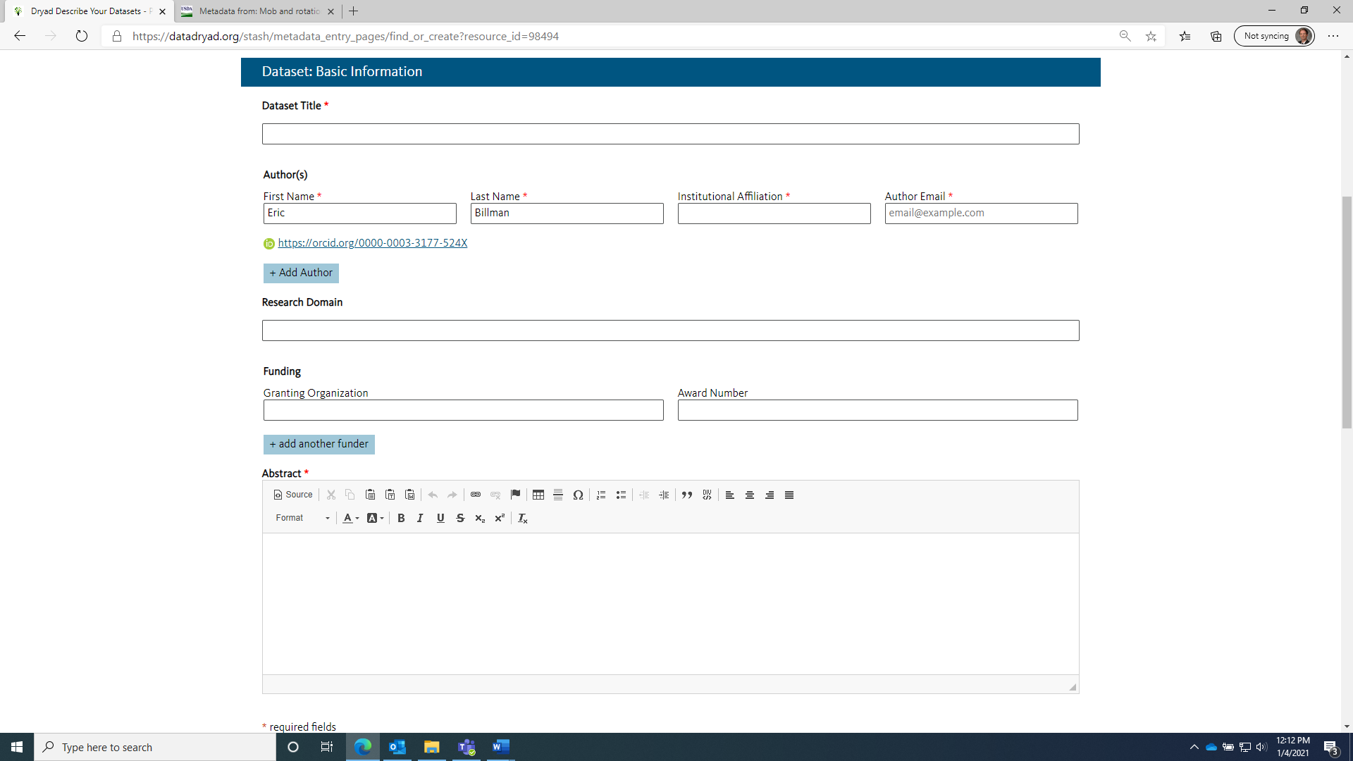
Figure A4. Describe your dataset; Dataset: Basic Information.
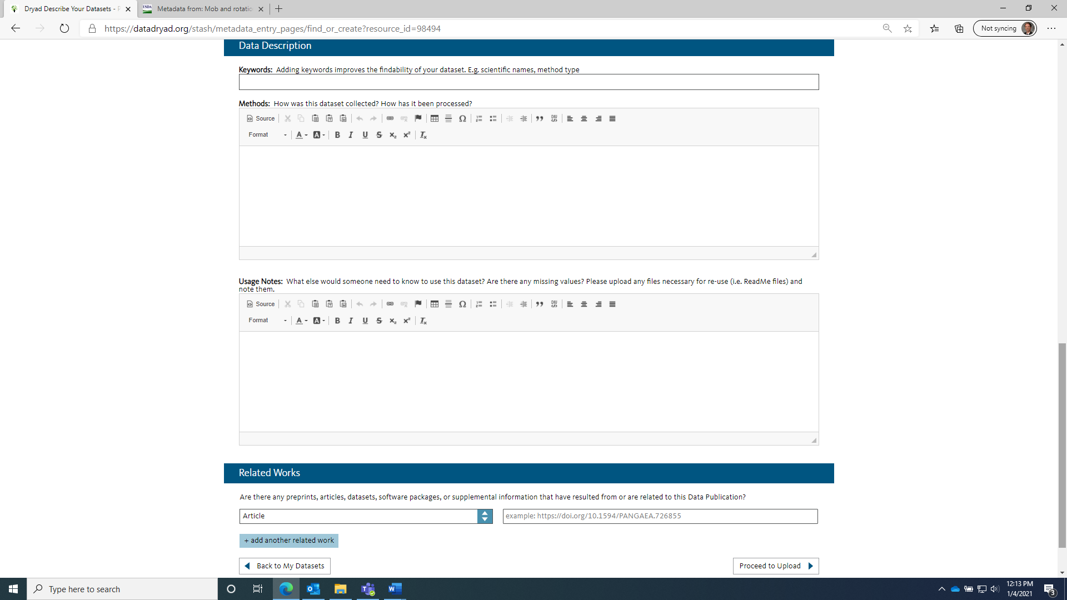
Figure A5. Describe your dataset; Data Description and Related Works. Click “Proceed to Upload” circled in red to continue.

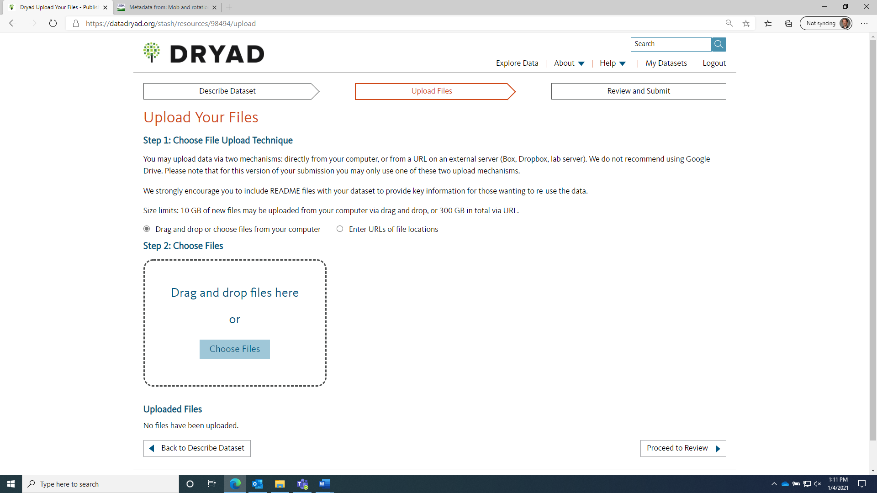
Figure A6. Upload your files; Click “Choose Files” circled in blue to upload all files, and then click “Proceed to Review” circled in red to move to the final step.
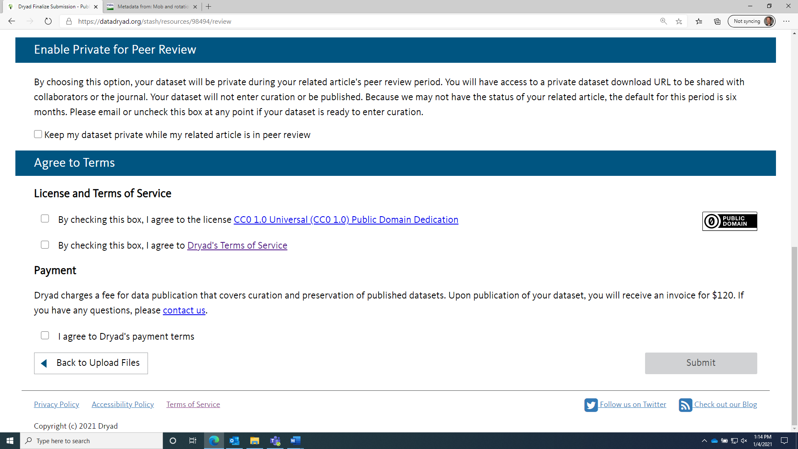
Figure A7: Review Submission Page. As we are submitting only after publication, DO NOT check the box “Keep my dataset private while my related article is in peer review”. Check the boxes that agree to the license agreement and the terms of service. Also check the box saying you agree to Dryad’s payment terms. Click “Submit” circled in red when finished.

Related ARS Project (# or name): 6082 - 21000 - 008 - 00D
Manuscript Title (use sentence case!):
Data from: Mob and rotational grazing influence pasture biomass, nutritive value, and species composition
Manuscript Peer Reviewed: Y N
(If Yes: Please give the Unit ARIS user the ARS-533 Peer Review forms and a copy of the manuscript)
1st Formal Report other than Abstract? Y N
(Is this the first time that this original scientific information has been made public, other than abstract-only? If 115 is not for original research (e.g.,literature review) mark No (Also select No if this is an Abstract entry))
Does this manuscript report CRADA research? Y N
Has the Cooperator Reviewed and Approved this Publication? Y N
If Yes, CRADA No.: 58 -0201- - (Example: 58-0201-9-1234 or 58-0201-5-6789M)
If marked Yes will go to OTT for review

SCINet Computing Resources Used: Y N
Submitter: Billman Eric D  (Last name) (First name) (MI) Phone: (843) 669-5203 Email: eric.billman@usda.gov  Contact: _Billman _ _Eric _D (Last name) (First name) (MI)  Phone: (843) 669-5203 _ E-mail: eric.billman@usda.gov | Submitter:  - Must be the RL or an Active Cat. 1, 4, 6 scientist  - Submitter does not need to be an author on the publication being entered.  - Submitter & Contact can be the same person (Unit choice).  Contact:  - Must be an ARS employee, Category 1, 4, or 6  - If a post doc is submitting the 115: Use the RL or a Cat. 1, 4, or 6 scientist as the Contact.  - Post docs can be listed as authors but not as the Submitter or Contact (ARIS system control, no alternative).
Comments/Additional Info: REQUIRED (if being presented at a meeting) meeting name, location, dates; Non-ARS Author clearance issues; explain a rejection & resubmission, etc.
Prominent Issues:
Potential to Attract Media Interest/Attention Represents a Significant Scientific Advancement Significantly Affect Existing or Future USDA Policy Potential Trade Implications
Associated with Emerging and/or Invasive Organisms or First Report of a Pest(s)
Other (specify)

Authors: List all authors and their affiliation (ARS employee, University, Company or Organization, ARS-Retired/Collaborator, etc.) Only one senior author designation per manuscript; not required.

Clearance (Non-ARS Authors only): Allows ARS to post the Non-ARS author's name/affiliation to ARS websites. It is not a request for approval/permission for ARS to publish.

Name (Last, First, MI) | Employer/Affiliation | Clearance? (Y/N) |  | Senior Author (Y/N)
1 Billman, Eric, D. |  |  |  | Y
2 Williamson, Jessica, A. | Pennsylvania State University | Y
3 Soder, Kathy, J.
4 Andreen, Danielle, M.
5
6
7
8
9
10

Additional Authors:

Name of Meeting or Journal:
Dryad Data Repository

Include dates and location for a meeting/presentation: (Example: Agronomy Meetings, San Diego, CA. Nov. 1-5, 2011)

Publication Type:

A = Abstract | J = Peer Reviewed  Manuscript upload required if DURC or Prominent Issue |  | T = Trade Journal
B = Book/Chapter | L = Literature Review |  | U = Research Technical Update  (Use for Natural Resources Res. Update Only)
C = Pct (Patent Cooperation Treaty)  (Check with TTC or Patent Advisor before entering) | M = Monograph |  | V = Government Publication
✔ D=Database/Dataset | N = Research Notes |  | X = Other
E = Experiment | O = Popular Publicaton |  | Z = Patent Application  Serial #:  (Check with TTC or Patent Advisor for assistance)
F = Rapid Release |  | P = Proceedings/Symposium
H = Germplasm Registration  Plant Material Docket Number: | R = Review Article

Previously Submitted (applies to resubmission) *: Y
journal/equivalent).
N (Yes if submitted to another

NOTE: original 115 entry should be updated if the resubmission is due to rejection or other issues. New journal submission date, original journal name, and reason for resubmission should be entered in comments.

Hold from Tektran until:
Published

Permanently

Due to patent potential, is retention of intellectual property rights desired? Y N (Contact Tech. Transfer Coordinator for help/info)

Patent Information: If Yes, please submit a Patent/Invention Disclosure form through the ARIS Licenses/Invention system.; If Yes, will go to OTT for review.

Provide the dates shown below as soon as they become available. The dates are required entries in order to allow the 115 to propagate to the ARS website. The 115 cannot be used in the final Annual Report (ARS-421 Progress Report) unless dates are entered & the 115 citation is complete.

REQUIRED Date Submitted to Journal: _11/6/2020 journal or other outlet).

(Date the manuscript or abstract is sent to the

REQUIRED Acceptance Date: _11/9/2020 (Date journal/other outlet accepts it for publication or the committee accepts it for a meeting, etc.) (Required to be listed on the web).
REQUIRED Volume, Page numbers, etc.: _

REQUIRED Publication Date: 11/10/2020

Both publication date and volume/page number required to generate citation

DOI: https://doi.org/10.5061/dryad.79cnp5ht_4

- Must be entered with the prefix: https://doi.org/10.xxx

Interpretive Summary Needs to be written for the general public (non-scientists) and include a problem, accomplishment and contribution of accomplishment to solving the problem:

Technical Abstract:
This is digital research data corresponding to a published manuscript, Mob and rotational grazing influence pasture biomass, nutritive value, and species composition, in Agronomy Journal, Vol. 112 p. 2866-2878. Mob grazing, which uses very high stocking densities for short durations followed by a relatively long rest period, was designed to mimic bison (Bison bison) grazing in western U.S. grassland. This project assessed the suitability of mob grazing for livestock production in the Northeast. Objectives were to compare the effects of mob and rotational grazing on dry matter (DM) mass, nutritive value, and botanical composition across four grazing seasons. Eight, 0.10‐ha paddocks were established in 2014 as a randomized complete block with four replications, and seeded with alfalfa (Medicago sativa L.), white clover (Trifolium repens L.), orchardgrass (Dactylis glomerata L.), narrowleaf plantain (Plantago lanceolata L.), and tall fescue [Schedonorus arundinaceus (Schreb.) Dumort]. Mob‐grazed (MOB) paddocks were grazed by yearling beef cattle twice each year, (70–90–day interval), and rotationally grazed (ROT) paddocks were grazed four to six times each year (when sward height reached 25 cm). Cumulative pre‐grazing forage biomass (PGFM) of ROT was greater than MOB in three of four years. At the final grazing, the PGFM of ROT exceeded MOB by 2,500 kg ha−1. Within year, PGFM of ROT was more consistent, varying by only 1,000–1,400 kg DM ha−1 compared with 1,800– 2,800 kg DM ha−1 for MOB. Grazing strategy altered botanical composition; ROT favored grasses while MOB favored alfalfa. Forage fiber content was consistently lower in ROT than MOB paddocks, indicating superior nutritive value. Results suggest rotational grazing is likely suitable for more consistent forage production of greater nutritive value in temperate, cool‐season grass‐legume pastures of the northeastern United States.

Appendix C: Example of Dryad Output
Dataset A:
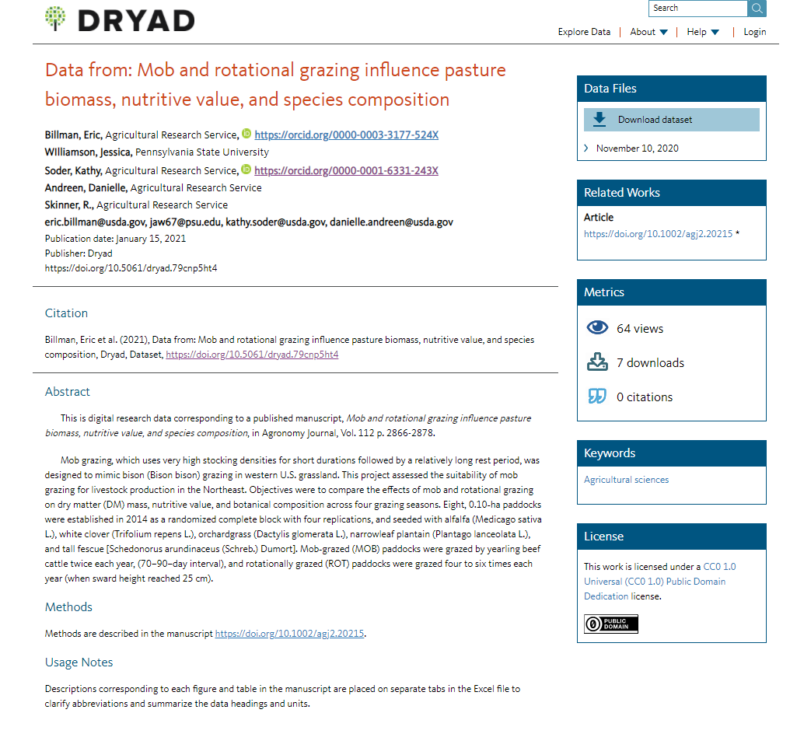

Dataset B:
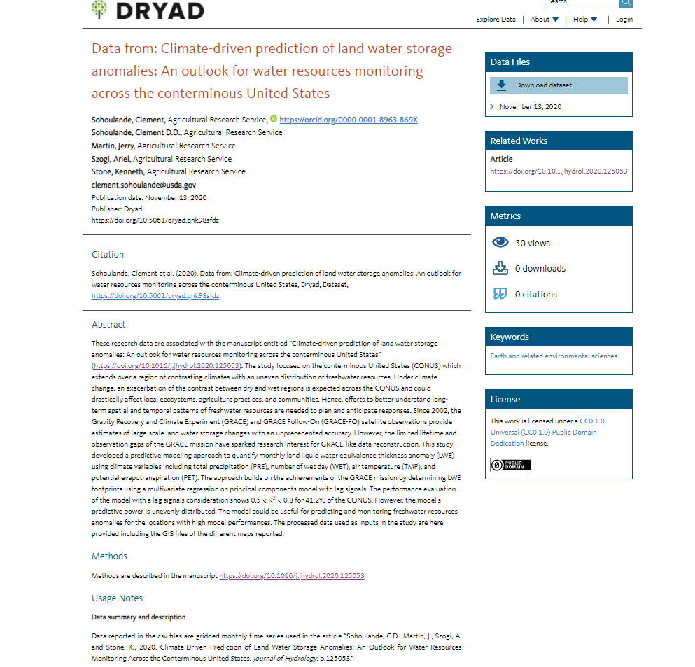

Appendix D: Preparing and Entering Metadata into the NAL Repository

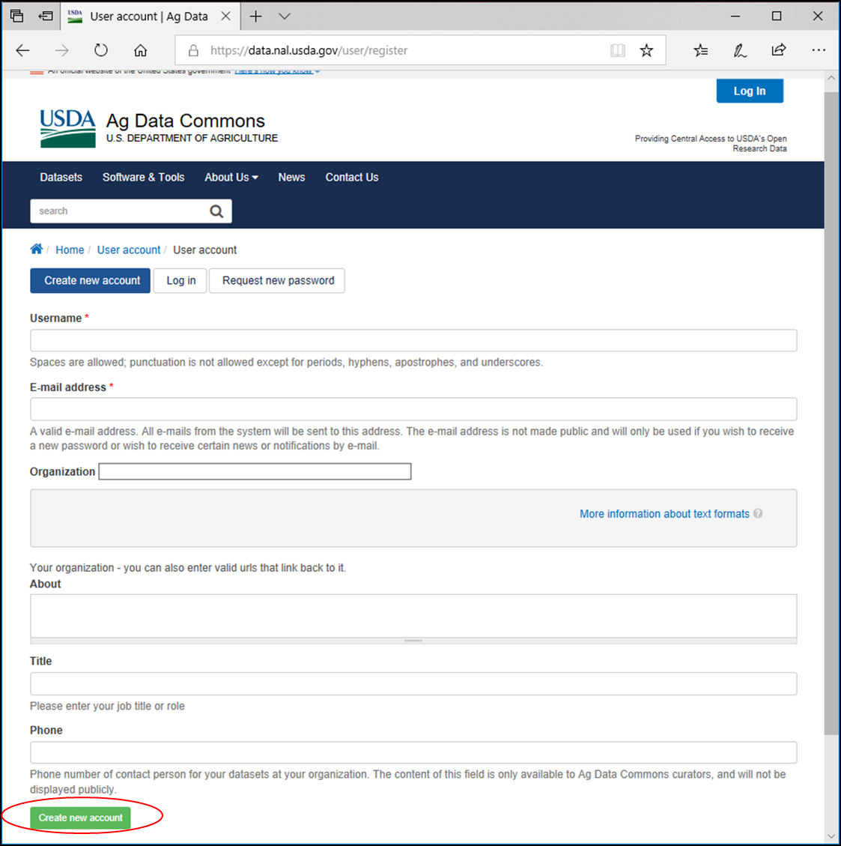
Figure D1: Creating an account on National agricultural library repository https://data.nal.usda.gov/ . Follow instructions as provided in the SOP.

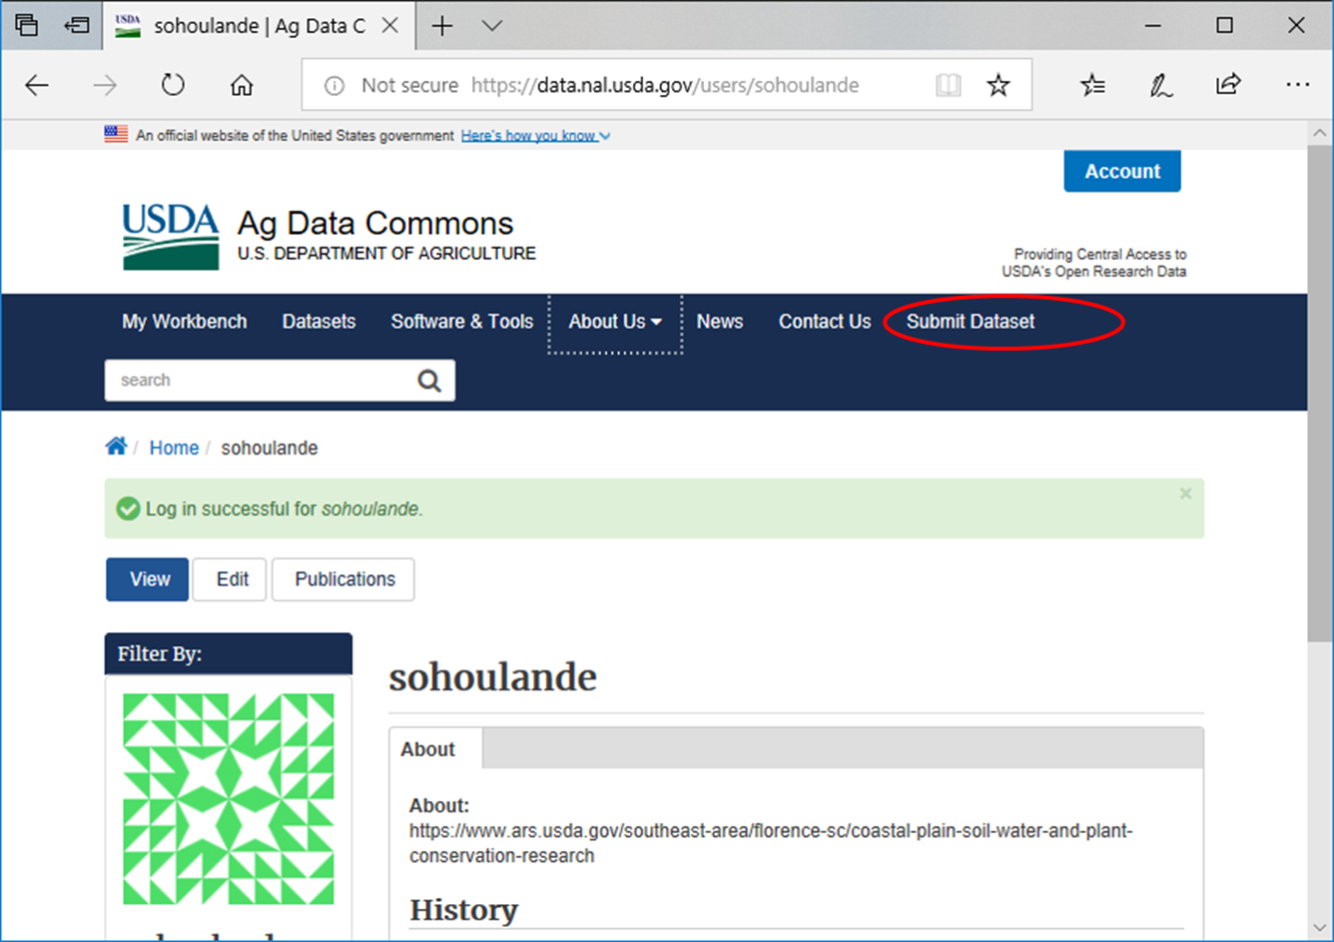
Figure D2: Logging into https://data.nal.usda.gov/ to submit metadata
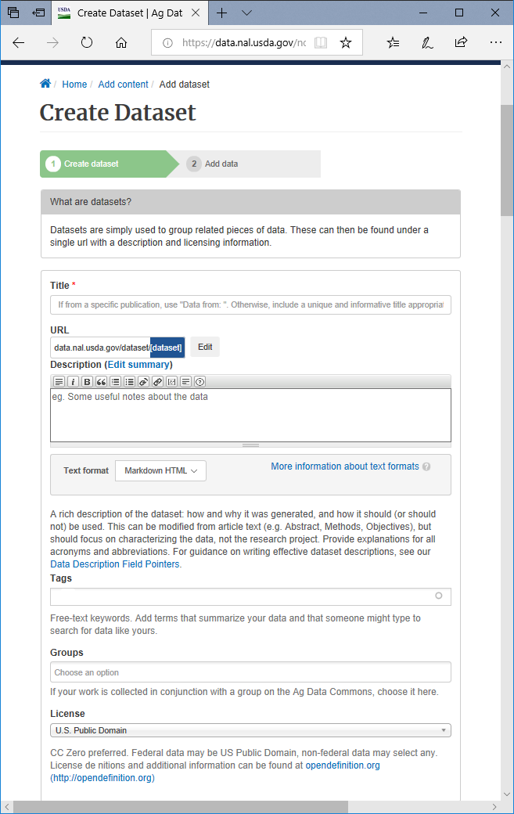
Figure D3: Submitting metadata on Ag data Commons (Part 1). Enter the title based on the guidance in the SOP (in Part 2.b.ii).

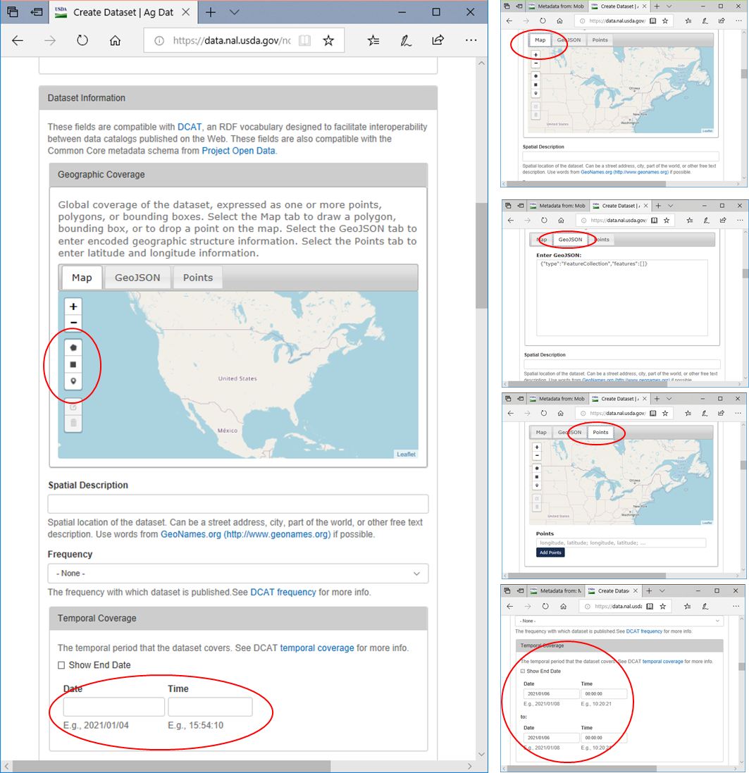
Figure D4: Submitting metadata on Ag data Commons (Part 2). Provide the coordinate of the research station or upload the shapefile on the map.
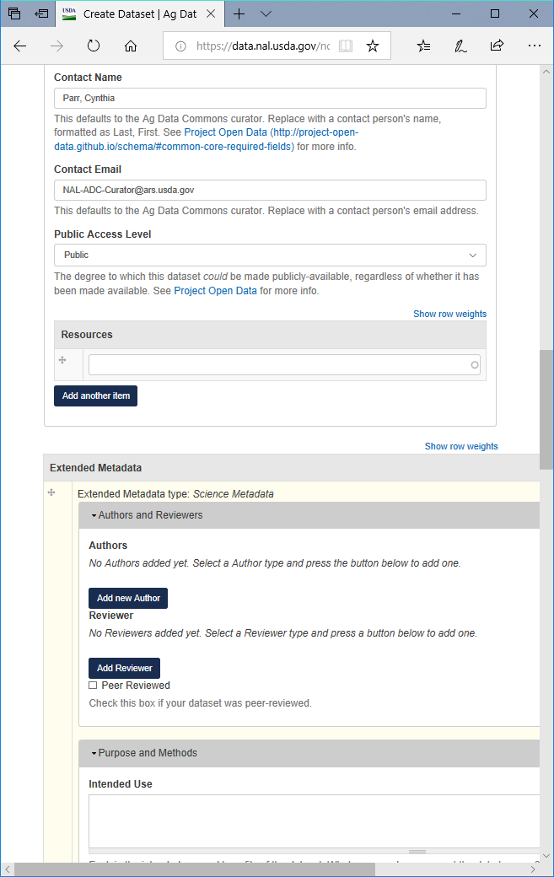
Figure D5: Submitting metadata on Ag data Commons (Part 2). The contact name is as indicated in the SOP.
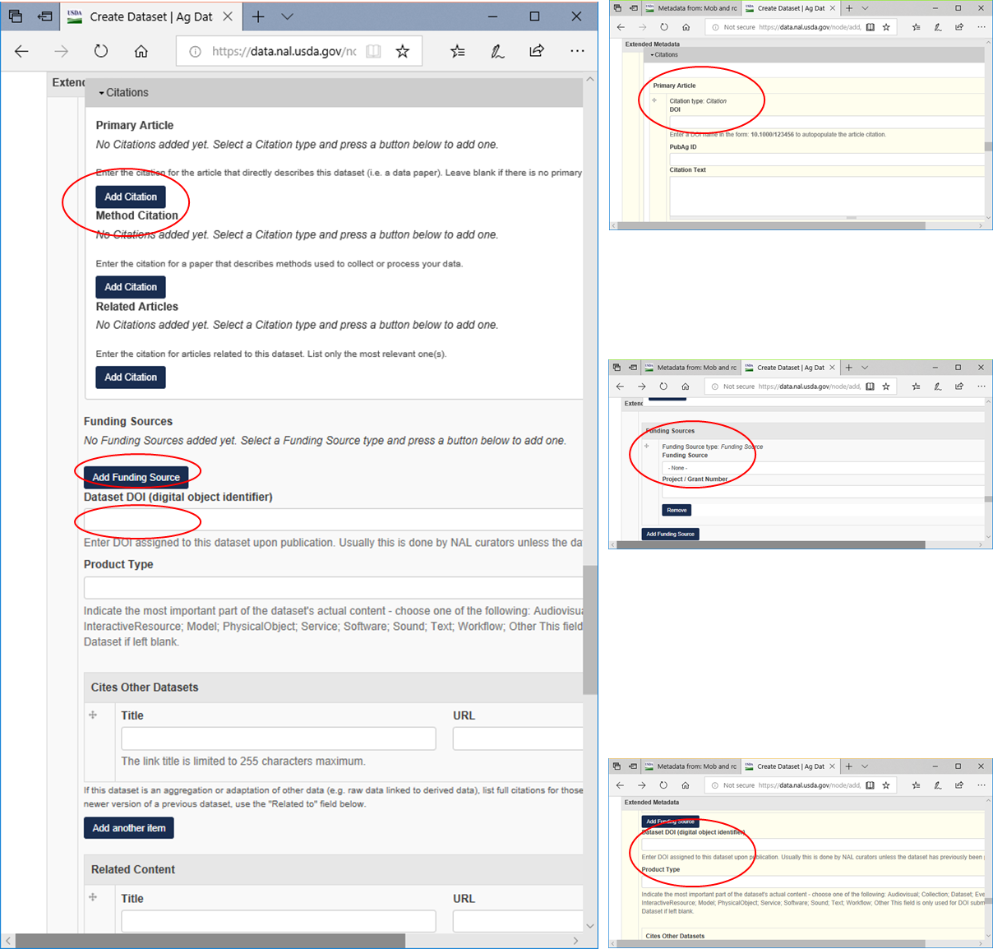
Figure D6: Submitting metadata on Ag data Commons (Part 3). Enter the DOI of the dataset if published elsewhere (e.g. Dryad)

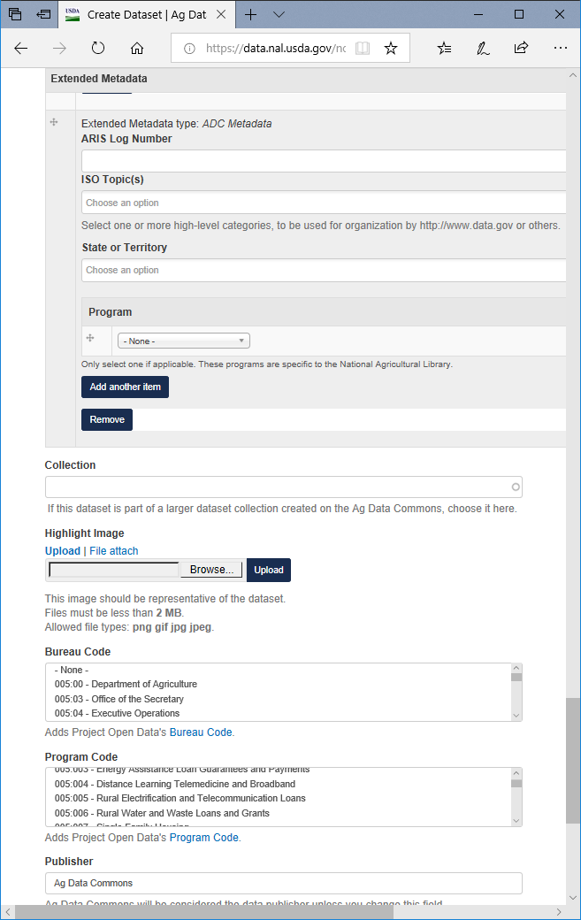
Figure D7: Submitting metadata on Ag data Commons (Part 4). Enter the ARIs log number for the metadata.

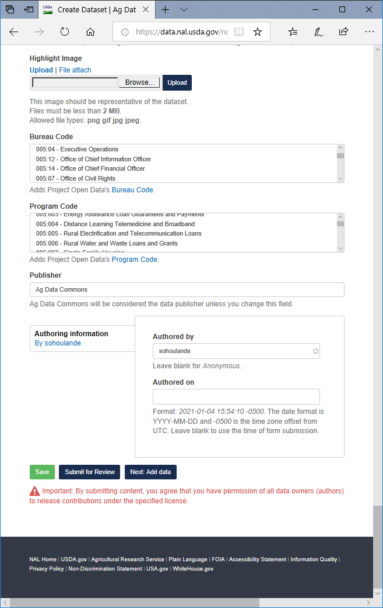
Figure D8: Submitting metadata on Ag data Commons (Part 5). Click submit once the required information is entered.

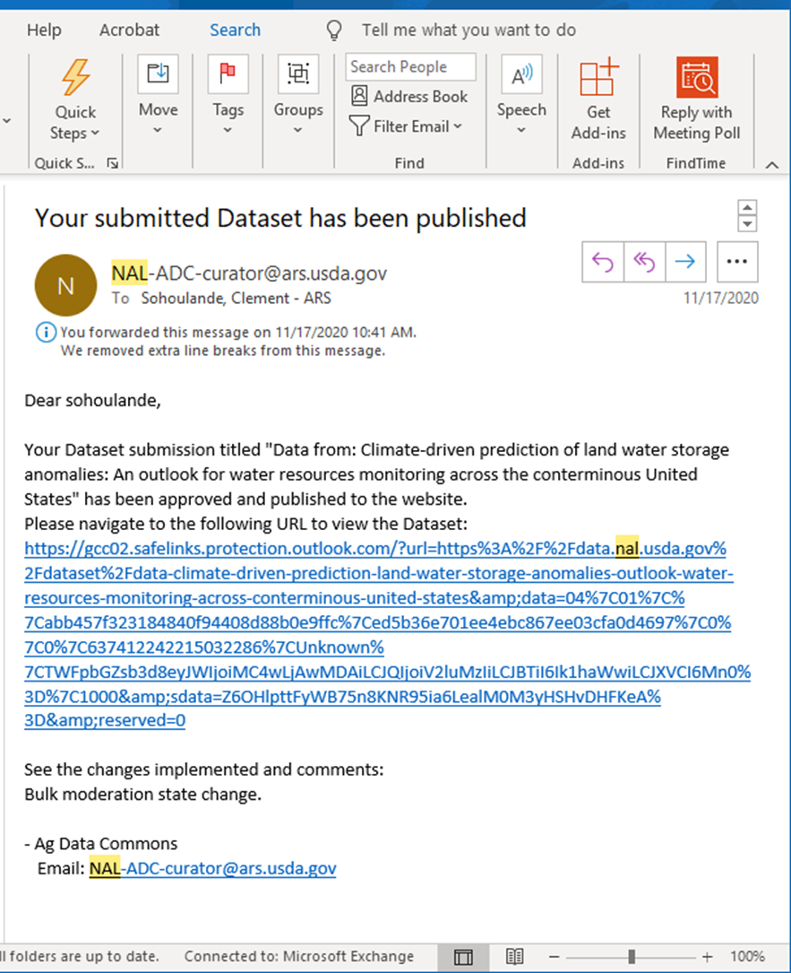
Figure D9: Example of email of approval on Ag data Common

