Stock Solution Preparation Documentation Sheet

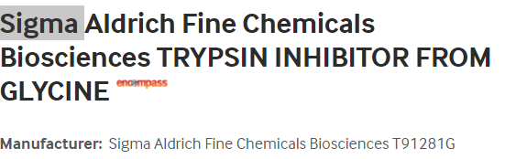
- Fisher Product Catalog #501784544 Trypsin Inhibitor from Glycine max (soybean) – lyophilized powder

2.0 Preparation of Trypsin inhibitor Stock (10 mg/mL) for Addition to Media:

Preparation of 10 mg/mL Trypsin Inhibitor Stock: (Follow instructions below)
Note: The expiration date is indicated on the Certificate of Analysis and/or bottle. Store frozen at -20 ⁰C. Attach a copy of the CoA to this sheet.

Material | Source | Lot# | Expiration Date | Quantity Required | Quantity Used
Trypsin Inhibitor |  |  |  | 1000 mg
PIM (T) (no additives) |  |  |  | QS to 100 mL

Prepared by Date

Preparation of Stock Trypsin Inhibitor for Addition to Media:

- Weigh 1 gm (1000 mg) of trypsin inhibitor from the bottle and QS to 100mL with serum free PIM(T) ® (no additives). This will give a stock concentration of 10 mg/mL
- Mix with a stir bar and stirring plate until totally dissolved
- Allow to stand on ice at least 30 min before filter sterilizing
- Filter sterilize the solution using a 0.2 µm filter
- The expiration date of the solution is indicated on the Certificate of Analysis (CoA) and/or the bottle. Document expiration date as listed on the CoA.
- Aliquot into sterile tubes, 5 mL samples, label as stock solution, add expiration date.
- Store and freeze at -20ºC for later use. Stock solution is stable at -20ºC.
- Inhibitor must be added fresh to the medium before culture or shipment. Add 5 mL of Trypsin Inhibitor stock to each 500 mL bottle of PIM(T)®. This will give a final working concentration of 100 μg/mL of Trypsin Inhibitor in the media.

- Addition to Media:

  - Add 5 mL of Trypsin Inhibitor stock to each 500 mL bottle of PIM(T)® for NIPT shipping. This will give a final working concentration of 100μg/mL of Trypsin inhibitor in the media.

