Description of gDNA protocol
We developed a single cell multiomics protocol for analysis of replication timing (RT) and gene expression from single cells (sc). As part of the multiomics approach, we developed a technique to amplify gDNA in house. This gDNA protocol can be used in combination with the mRNA isolation or as a stand-alone protocol for amplification of sc-gDNA. The protocol is compatible with both cells and nuclei as the starting material.
Briefly, we fragmented gDNA and then used a degenerate oligonucleotide-polymerase chain reaction (DOP-PCR) method of amplification. After amplification, we performed restriction enzyme (RE) digestion of the gDNA fragments to get rid of majority of primer sequences with high G% and repeat regions. We then performed library prep using the Nextera DNA prep kit and sequenced the gDNA. The cDNA part of the protocol was adopted from G&T protocol¹ with minor edits and can be found in the cDNA protocol file.

Reagents and Materials
- Agencourt AMPure XP beads (Beckman Coulter- A63881)
- Nuclease free water (Ambion- AM9937)
- 100% Ethanol
- Lysis and Fragmentation buffer recipe
For 96-well plate-
Component | Volume (uL)
10× Single-cell Lysis and Fragmentation Buffer (Sigma, cat. no.L1043-500Rxn) | 96
20 mg/ml proteinase K (Sigma, P4850-1ML) | 6
Nuclease free water (Ambion AM9937) | 800

- Library mix recipe
Universal WGA primer 5’-TGTGTTGGGTGTGTTTGGKKKKKKKKKKNN-3’ (30 bp)
For 96-well plate-
Reagent | Stock conc | Final conc | Volume (ul)
dNTPs (Life Technologies - 18427-013) | 2 mM | 0.2 mM | 21
MgCl2 (Ambion- AM9530G) | 1000 mM | 30 mM | 6.3
Universal WGA primer | 100 uM | 50 uM | 105
Nuclease free water (Ambion- AM9937) |  |  | 77.7
Total Volume (uL) |  |  | 210

- Klenow Fragment of DNA polymerase (NEB- M0210L)
- PCR master mix
For 96 well plate-
Reagent | Per reaction (uL) | Per plate (105 reactions)
5× Taq Master mix | 20 uL | 2100 uL
ddH2O | 58 uL | 6090 uL

- WGA_RE primer- 5'-TTA ATA CTG AAG TTA ATA CTG AAG TGT GTT GGG TGT GTT TGG-3'
- NEB AcuI (R0641) enzyme for RE digestion
- 10x NEB buffer (NEB #B6002)
- Nextera XT DNA preparation kit (Illumina- FC-131-1096)
- Nextera 96-index kit (Illumina- FC-131-2001)
- 96-well plates
- Invitrogen Qubit 4 Fluorometer
- Agilent 2100 Bioanalyzer Instrument
Amplification of single cell genome for Replication timing
We developed an in-house protocol for isolation of genomic DNA from single cells. This protocol can be used in combination with the mRNA isolation or as a stand-alone protocol for amplification of sc-gDNA. This protocol is compatible with cells or nuclei as the starting material.

Summary of the steps-
- Isolation of gDNA per cell
  - If the protocol is performed only for sc-gDNA extraction form cells, single cells/ nuclei can be sorted into wells of 96 well-plates containing 9uL of ‘lysis and fragmentation buffer’. After that proceed with steps –… onwards for amplification of the gDNA.
  - If the protocol is performed in combination with sc-mRNA extraction, perform steps …-… until separation of mRNA from gDNA and transfer of gDNA into new plates with cell identity maintained. The gDNA is then pulled down onto Ampure beads.
- Fragmentation of sc-gDNA using ‘lysis and fragmentation buffer’
- Whole genome amplification of sc-gDNA with custom primers containing RE digestion sites.
- Purification of amplified sc-gDNA.
- Quantification and Quality Control of purified and amplified gDNA.
- Restriction enzyme digestion of sc-gDNA to reduce length of primers on DNA fragments. Quality control to ensure successful RE digestion.
- Tagmentation based library preparation of sc-gDNA using Nextera XT sample preparation kit.
- Sequencing of pooled sc-gDNA samples.
- Analysis of sc-gDNA for replication timing, copy number variation etc.

- Isolation of gDNA per cell
NOTE: If processing only gDNA per cell, sort single cells/ nuclei into individual wells of a 96-well plate containing 9uL of the ‘Lysis and Fragmentation buffer’. Continue with steps --- for fragmentation and processing of the sc-gDNA. In this case, no Ampure XP beads are present in the processing of the gDNA until after amplification.

NOTE: If continuing from step --- after separation of mRNA from gDNA, proceed with the following steps. The gDNA in the new plate labelled ‘gDNA collection' plate would currently be in 38.5uL of buffer per well after the wash steps --…--.

(Pull down gDNA from supernatant buffer onto AMPure XP beads)

  - Ampure XP beads need to be warmed to room temperature for approximately 15 minutes and then mixed well before use.
  - If the gDNA collection plate was frozen at step ---, first thaw the plate on ice and then centrifuge at 1000g, 4 °C, 1 minute to collect the buffer at the bottom of the well.
  - To 38.5 uL of gDNA solution, add 25 uL of AMPure XP beads (1:0.65 ratio) and mix well by pipetting multiple times until the beads are suspended in the buffer. Allow the mixture to stand for 20 minutes at room temperature. This allows the gDNA to bind to the beads.
  - Transfer the gDNA collection plate with the beads onto a low-elution magnet. Allow the plate to stand for ~20 minutes until the solution is clear and the beads have attached to the bottom of the plates.
  - Carefully remove and discard the supernatant from each well without disturbing the beads.
  - With the plate on the magnet and without disturbing the beads, add 100uL of freshly prepared 80% ethanol (vol/vol) onto the beads. After 30 seconds, remove and discard the ethanol.
  - Repeat step 1.6 again. Allow the beads to dry for ~2-3 minutes. Meanwhile, using a 10uL multichannel pipette remove any remaining ethanol in the wells.

CRITICAL: Do not allow the beads to dry too long as this will disrupt the gDNA attached to the beads. Proceed immediately to the next step.

- Fragmentation of sc-gDNA

  - To each well in step 1.7, add 9 uL of the ‘Lysis and Fragmentation buffer’. Remove the gDNA collection plate from the magnet. Mix well by pipetting multiple times until the beads are completely resuspended in the buffer in each well. Centrifuge at 100g, 4 °C, 20 seconds to bring the solution the mixture to the bottom of the well.

NOTE: Avoid high centrifugation speeds. The goal is to bring any stray liquid drops to the bottom, not to separate the beads from the buffer. You can also skip centrifugation if no stray liquid drops are observed.

  - Seal the plate and then transfer to the thermocycler at the following conditions-

Step | Temperature (C ) | Time
1 | 50 °C | 60 mins
2 | 99 °C | 4 mins
3 | 4 °C | Hold

PAUSE POINT- Fragmented gDNA can be stored at 4 °C overnight before proceeding with next steps.

- Whole genome amplification of sc-gDNA

(Attaching WGA primers to DNA fragments)
  - Centrifuge the gDNA collection plate at 1000g, 4 °C, 1 minute to bring all the liquid and beads to the bottom of the well. Store the plate on ice.
  - Prepare the ‘Library Mix’ according to number of wells being processed. To each well of the 96-well plate, add 2uL of freshly prepared ‘Library Mix’. Mix well by pipetting multiple times. Centrifuge at 100g, 4 °C, 20 seconds to bring the solution the mixture to the bottom of the well.
  - Proceed with thermocycler at 95°C, 1 minute for. This step denatures the gDNA into single strands. Immediately transfer plate to ice for 2 minutes to prevent re-hybridization of the single strands. Centrifuge at 100g, 4 °C, 20 seconds and then place on ice again.
  - To each well, add 1uL of Klenow fragment of DNA Polymerase and mix well. Centrifuge at 100g, 4 °C, 20 seconds.
  - Proceed with thermocycler conditions-

Temperature | Time | Cycles
16°C | 20 min | 1
24°C | 20 min | 1
37°C | 20 min | 1
75°C | 5 min | 1
4°C | Hold | 1

Centrifuge at 100g, 4 °C, 20 seconds and place the plate on ice.

(PCR amplification of DNA fragments using custom primers)

  - Prepare the ‘PCR master mix’ according to number of wells being processed. To each well, add 10uL of the WGA_RE primer (7 uM conc). Then add 78 uL of the PCR master mix to bring the total volume of the well to 100uL.
  - Mix well by pipetting multiple times until the beads are resuspended in the solution. Centrifuge at 100g, 4 °C, 20 seconds.
  - Proceed with thermocycler conditions-

Temperature | Time | Cycles
95°C | 3 mins | 1
94°C | 30 seconds | 22-24  (Cycle number needs to be optimized for different samples.)
65°C | 5 mins
65°C | 30 mins | 1
4°C | Hold | 1

PAUSE POINT- Amplified gDNA can be stored at 4 °C overnight before proceeding with next steps.

- Purification of Amplified gDNA
  - Ampure XP beads need to be warmed to room temperature for approximately 15 minutes and then mixed well before use. Centrifuge the plate with amplified gDNA at 1000g, 4 °C, 1 minute.
  - To 100 uL of amplified gDNA solution per well (also contains beads from the previous gDNA isolation step), add 100 uL of AMPure XP beads (1:1 ratio) and mix well by pipetting multiple times until all the beads are suspended in the buffer. The total volume of the solution is now 200uL.
  - Transfer 100 uL (half the total volume) from each original ‘old’ well into ‘new’ wells of a 96-well plate while maintaining well identity. Allow the mixture to stand for 7 minutes at room temperature in old and new plates. This allows the gDNA to bind to the beads.

NOTE: As the original volume is 200 uL with the beads, splitting into ‘new’ wells will help speed up bead settling with the elution magnet in the next step. From this point on, treat ‘old’ and ‘new’ plates as separate samples until after elution in Step --. Both need to be processed through the following steps.

  - Transfer the gDNA plate with the beads onto a low-elution magnet. Allow the plate to stand for ~5-7 minutes until the solution is clear and the beads have attached to the bottom of the plates.
  - Carefully remove and discard the supernatant from each well without disturbing the beads.
  - With the plate on the magnet and without disturbing the beads, add 100uL of freshly prepared 80% ethanol (vol/vol) onto the beads. After 30 seconds, remove and discard the ethanol.
  - Repeat step 4.6 again. Allow the beads to dry for ~2-3 minutes. Meanwhile, using a 10uL multichannel pipette remove any remaining ethanol in the wells.

CRITICAL: Do not allow the beads to dry too long as this will disrupt the gDNA attached to the beads. Proceed immediately to the next step.

  - Add 25 uL of nuclease free water to each well with the beads. Take the plates off the magnet and mix with repeated pipetting until the beads are completely resuspended.

NOTE: Total elution volume per sample is 50uL which is divided between the ‘old’ and ‘new’ plates (25uL+25uL). Elution volume depends on final concentration of gDNA/uL required per cell. Start with recommended volumes, you can dilute with more water to reduce concentration of gDNA/uL after quantification.

  - Incubate the plates for 2 minutes off the magnet at room temperature.
  - Return the plates to the low elution magnet. Incubate for ~5 minutes or until the beads have completely settled down and the supernatant is clear.
  - Carefully remove the supernatant and transfer it to new wells of a 96-well plate labelled ‘purified amplified gDNA’ plate. At this step, you can combine the supernatant from the ‘old’ and ‘new’ wells while maintaining well identity. Centrifuge the plate with amplified gDNA at 1000g, 4 °C, 1 minute.

PAUSE POINT: The purified amplified gDNA can be stored at -20°C before proceeding with the next steps of QC, RE digestion, and library prep for sequencing.

- Quality Control of purified and amplified gDNA
  - Quantification of each well containing the amplified gDNA was performed using a Qubit 4 Fluorometer.
The subsequent steps of RE digestion require 0.1 ug of gDNA/cell and library preparation requires 0.32 ng of gDNA/cell for processing. The number of cycles needs to be optimized based on the cell type to have enough amplified gDNA per cell, without the problem of PCR duplicates due to overamplification. We found a range of 24-27 cycles to be optimum for HepG2 cells and 24 cycles for zygotes, 2cell and 4cell embryo cells. With 24 cycles, we got between 350-450 ng of amplified gDNA from HepG2 single cells.

  - gDNA fragments detected using Agilent 2100 Bioanalyzer.
In addition to quantification, it is necessary to make sure that the amplified gDNA fragments are in the bp range that we expect them to be in. This ensures that we have enough gDNA reads and not just amplification of the primers. The single cell amplified gDNA were detected using the high sensitivity screen tapes. The range of fragments should be between ~100-500 bp with a peak between 250-290 bp.

Example peak of gDNA from a single HepG2 nucleus.
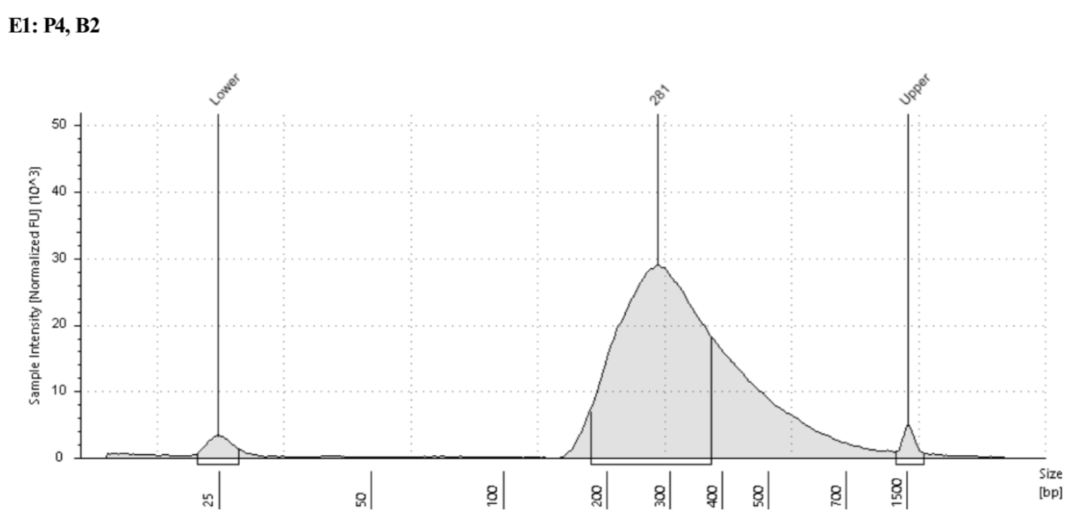

- Restriction Enzyme Digestion of amplified gDNA
  - Centrifuge the purified amplified gDNA plate at 1000g, 4 °C, 1 minute.
  - In a new 96-well plate labelled ‘RE digestion gDNA’, prepare 10uL RE reaction mix/well with 1 unit of restriction enzyme AcuI + 0.1 ug gDNA + NEB buffer (to make up solution to 10uL). 10uL mixes provide enough gDNA for downstream library preparation.
  - Mix the RE mix/well by pipetting up and down multiple times. Centrifuge the plate at 1000g, 4 °C, 1 minute.
  - Incubate the ‘RE digestion gDNA’ plate in the thermocycler with the RE digestion settings- 37°C for 15 mins and 65°C for 20 mins (heat inactivation of the enzyme).
  - Centrifuge the plate at 1000g, 4 °C, 1 minute.
  - At this point, you can confirm RE digestion of the gDNA by randomly picking a few wells and looking at the peaks on the Agilent Bioanalyzer.

Example of DNA peaks before (E1) and after (D1) RE digestion. After RE digestion, the primer peak can be observed at ~45 bp and a reduction in the overall peak of the gDNA fragments from ~240 bp to ~200 bp can be observed.

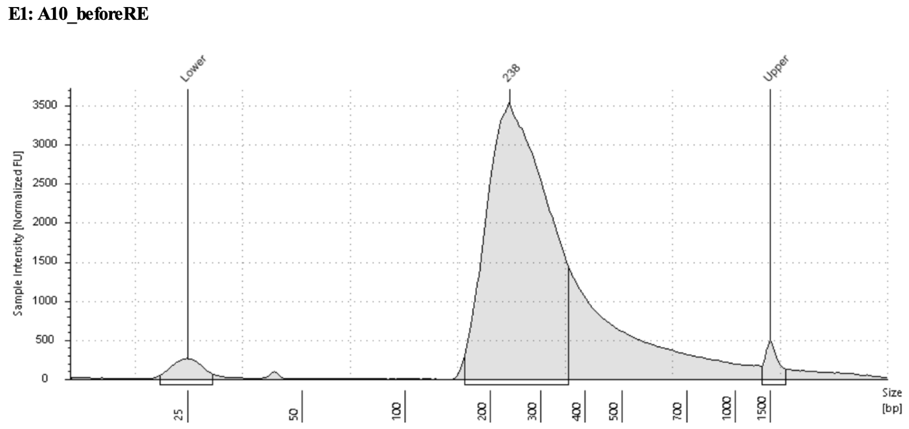 | 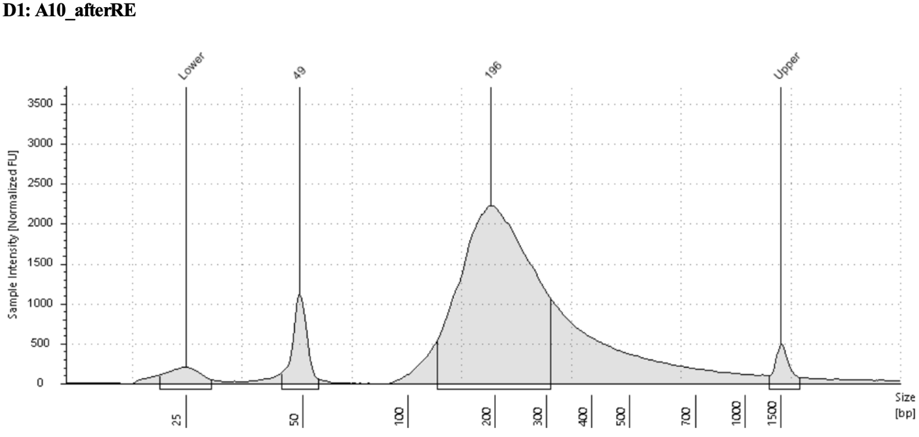

- Tagmentation based library preparation using Nextera XT DNA preparation kit
The protocol as described in the Nextera XT DNA preparation sample guide was used for library preparation of the single cell gDNA. Detailed steps are also in the cDNA processing protocol section 7. After introduction of unique primer combinations (N7xx and N5xx) per well using the Nextera 96-Index Kit and amplification of the tagmented gDNA, all the samples can be pooled together before purification.
Note- If performing library prep as part of the sc-multiomics protocol, gDNA and cDNA samples can be processed simultaneously and pooled after amplification with unique indexes.

- Pooling of library prepped gDNA and purification
  - Combine 5uL of gDNA from each well into a microcentrifuge tube. Quantification of gDNA in each well before pooling of all samples can prevent skewing of samples during sequencing. However, if working with 48-96 samples at a time, quantification was not done.
  - AmPure XP beads were warmed to room temperature and purification was performed as detailed in steps – to --- by adjusting the ratio of solution to beads to 1:0.6. (For eg. if pooling 48 wells together, the pooled sample is 240 uL and 144 uL of Ampure XP beads are used for clean-up).
  - The quality of the pooled sample is checked using high sensitivity chip on Bioanalyzer. After library preparation with the Nextera XT kit, a peak ~380 bp was observed as shown below.

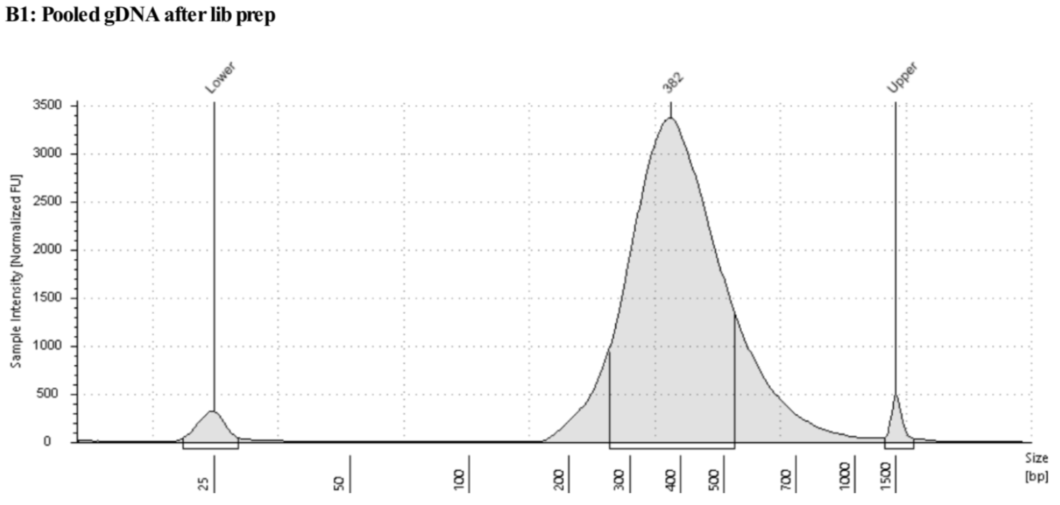

  - The pooled sample was also quantified using a Qubit. For sequencing, the sample can be diluted if required.

Note- If following the sc-multiomics protocol, gDNA samples and cDNA samples labelled with unique combinations of oligos during library preparation can be pooled together before sequencing and can be sequenced on the same chip.

  - Sequencing depth- A sequencing depth of ~2 million reads per cell was sufficient for deducing single cell replication timing, at the level of individual genes, across the HepG2 genome. We have sequenced using both the P1 and P2 lanes on NextSeq2000 for 300 cycles, 150 PE.

