Description of cDNA protocol
We developed a single cell multiomics protocol for analysis of replication timing (RT) and gene expression from single cells. The cDNA part of the protocol was adopted from G&T protocol¹. The SMART-seq2 technique was used for separation of gDNA from mRNA per cell and the cDNA was processed as described in G&T protocol with minor modifications which have been detailed here. The gDNA was processed using an in-house protocol and can be found in the gDNA protocol file.

Reagents and materials-
Refer to the G&T protocol¹ for list of reagents and materials required for gDNA and cDNA separation and cDNA processing.

- Sorting of cells or nuclei into 96-well plates
  - RNAse inhibitor should be used for every wash buffer and the lysis buffer during FACs prep (conc of RNAse inhibitor used 0.5U/uL). Extract nuclei from cells or use live cells for sorting. For extraction of nuclei, follow the 10x genomics nuclei extraction protocol. Time of lysis varies for each cell line. For HepG2 cells, 7 mins lysis time for 2 million cells gives ~>90% nuclei.
  - In hood, prepare 96 well plates with 2.5uL of Buffer RLT Plus (Qiagen, cat. no. 1053393) and seal plates with adhesive film. Centrifuge at 1000g for 1 minute to bring the buffer to bottom of the wells.
  - Sort single cells, positive control (10 cells) and negative control (no cells) into 96 well plates.
  - After sorting, immediately centrifuge the plates with the cells at 1000g for 1 minute and then immediately transfer to -80C or proceed with separation of gDNA and mRNA per well.

PAUSE POINT- cells can be processed at any time after this. Has been tested for up to 6 months after sorting.

- Isolation and separation of mRNA from gDNA in single cells
The protocol for isolation and separation of gDNA and mRNA from each cell was adapted from the G&T protocol¹. This protocol was used to separate gDNA and mRNA from single nuclei with minor modifications. For nuclei, double the concentration of suggested RNAse inhibitor was added for all steps and reagents of the protocol to prevent degradation of mRNA. Volume of water was adjusted accordingly, with the increased RNAse inhibitor. Every step was performed in a DNAse and RNAse free environment.

Preparation of solutions- some of the steps in the protocol are time sensitive so preparation of the solutions listed below in advance is necessary.
- Preparation of oligodT30VN-labeled beads- for pulling down mRNA from cell lysis solution.
- Preparation of RT master mix- for reverse transcription of the pulled down mRNA (RT of mRNA is a time sensitive step).
- Preparation of the G&T-seq wash buffer- for separation of gDNA from pulled down mRNA using multiple wash steps.
Summary of Steps-
- Addition of ERCCs to the sample plate (optional step).
- Addition of oligodT30VN-labeled beads to sample plate and pull down of mRNA using low elution magnet.
- Separation of supernatant with gDNA into new ‘gDNA’ well.
- 3 wash steps using G&T wash buffer in original sample plate with pulled down mRNA.
- Separation of all wash buffer into new ‘gDNA collection’ well.
- Addition of RT master mix to pulled down mRNA, mix well, and immediately proceed with cDNA generation and amplification.

First prepare the RT master mix and store on ice until use. The Oligo-dT30VN-labeled beads need to be used within 30 mins after preparation so it’s better to start with preparing the RT master mix first.

2.1 Preparation of the RT master mix for the reverse transcription of mRNA. Prepare 500uL of RT master mix per 96 well plate (100 reactions). Add each reagent in the following order. Store the final RT master mix on ice until use.

Component | Amount (uL) | Final concentration
Nuclease free water | 167
dNTP mix (10 mM) | 50 | 1 mM
TSO (100 uM) | 5 | 1 uM
MgCl2 (1 M) | 3 | 6 mM
Betaine (5 M) | 100 | 1 M
Superscript II first strand buffer (5x) | 100 | 1x
DTT (100 mM) | 25 | 5 mM
Superscript II reverse transcriptase (200 U/uL) | 25 | 10 U/uL
RNAse inhibitor (20 U/uL) | 25 | 1 U/uL
Total Volume | 500

2.2 Preparation of the oligo-dT30VN-labeled beads

The beads should be prepared in a laminar flow hood. If processing less than 96 wells/ run, adjust volume of each component accordingly. Thaw Biotinylated Oligo-dT30VN beads beforehand and store on ice.

2.2.1 Add 50 µl of Dynabeads to a 1.5-ml Eppendorf tube and place it on a magnet designed for handling Eppendorf tubes (e.g., DynaMag Spin Magnet from Thermo Fisher Scientific) for 30 s (or until a clear solution is obtained), and then completely remove and discard the supernatant while keeping the tube on the magnet.

2.2.2 Remove the tube from the magnet and resuspend the beads in 200 µl of Dynabead solution A. Return the tube to the magnet for 30 s (or until a clear solution is obtained), and remove and discard the supernatant while keeping the tube on the magnet. Repeat this step once.

2.2.3 Remove the tube from the magnet and resuspend the beads in 200 µl of Dynabead solution B. Return the tube to the magnet for 30 s (or until a clear solution is obtained), and remove and discard the supernatant completely while keeping the tube on the magnet.

2.2.4 Remove the tube from the magnet and resuspend the beads in 50 µl of 2× B&W buffer.

2.2.5 Add 50 µl of 100 µM Biotinylated Oligo-dT30VN to the beads.

2.2.6 Incubate the mixture for 20 min with gentle rotation on the rotator for 1.5-ml microcentrifuge tubes.

During the incubation step, thaw sample plate and add ERCCs (optional) according to steps 2.3.1-2.3.3.

2.2.7 Place the Eppendorf tube containing the Oligo-dT30VN-conjugated beads on the magnet for 30 s (or until a clear solution is obtained) and discard the supernatant while keeping the tube on the magnet.

2.2.8 Wash the beads four times in 200 µl of 1× B&W buffer. For each wash, remove the tube containing the beads from the magnet, resuspend the beads in 200 µl of 1× B&W buffer, then return the tube to the magnet and remove—while keeping the tube on the magnet—and discard the supernatant once the bead suspension has cleared.

2.2.9 Prepare 1 ml of bead resuspension buffer by combining and mixing the reagents indicated in the table below, and then add 1 ml of bead resuspension buffer to the beads and mix the beads by vortexing until completely resuspended.

Component | Amount (uL) | Final Concentration
Superscript II first strand buffer (5x) | 200 | 1x
RNAse inhibitor (20U/uL) | 100 | 2 U/uL
Nuclease free water | 700

CRITICAL- Once RNAse inhibitor is added, beads should be used within 30 minutes.

2.3 Addition of ERCC spike-ins (optional step)
These steps can be performed during the 20 minutes incubation in step 2.2.6 to ensure the final beads are used within 30 minutes of preparation.

2.3.1 Remove the plate that contains the single cells in RLT Plus solution (from Step 1.4) from the −80 °C freezer and allow it to thaw on ice. When thawed, centrifuge at 1,000g for 1 min at 4 °C.

2.3.2 In the preamplification laminar flow cabinet, add 1 µl of a suitable dilution of ERCC spike-in to each well using a digital multi dispensing pipette (e.g., Multipette Xstream from Thermo Fisher Scientific), dispensing the droplet onto the side of the well. Seal the plate.

2.3.3 Centrifuge the plate at 1,000g for 1 min at 4 °C to collect the ERCC droplets at the bottom of the well with the single-cell lysate.

Recommended conc for ERCC spike ins is 1/10th the suggested concentration in the G&T protocol¹.

2.4 Physical separation of polyadenylated mRNA from gDNA

2.4.1 Prepare the wash buffer in 96 well plate - Mix 2,450 µl of G&T-seq wash buffer with 50 µl of RNAse inhibitor at room temperature. Dispense 25 µl of this wash buffer mix into each well of a new 96-well plate labeled ‘G&T-seq wash buffer plate’. Seal plate, centrifuge at 1000g for 1 minute and store at RT until use (Can also perform this step during the 20 minutes incubation in step 2.4.3).

2.4.2 Add 10 µl of Oligo-dT30VN beads from Step 2.2.9 to each well of the 96-well plate containing the lysed single-cell samples from Step 2.3.3.

2.4.3 Incubate with mixing (2,000 r.p.m. using an on-deck mixer or thermomixer) for 20 min at room temperature.

2.4.4 Place the plate on a low-elution magnet for 96-well plates for 1 min and remove the supernatant. Carefully transfer the supernatant—which contains the gDNA of the cell—to a new 96-well plate in the same orientation and keep track of the address of each cell. This is the ‘gDNA collection’ 96-well plate.

CRITICAL STEP Use the same tips per well for all subsequent washes and transfers of supernatant (Steps 2.4.5 onwards). This will help to minimize the loss of gDNA during these steps.

2.4.5 Wash the beads with 10 µl of G&T-seq wash buffer. Resuspend the beads off the magnet in G&T-seq wash buffer and mix for 5 min using the on-deck orbital shaker or a thermomixer at room temperature.

2.4.6 Return the bead-resuspended 96-well plate to the low-elution magnet and allow the beads to settle for 1 min. Carefully transfer all the supernatant to the corresponding well in the ‘gDNA collection’ 96-well plate.

2.4.7 Repeat steps 2.4.5-2.4.6 to wash the beads a second time.

Start preheating the thermomixer to 42°C for the RT step so samples can be processed as soon as possible (the preheating takes some time).

2.4.8 Wash the pipette tips with G&T-seq wash buffer. Aspirate the remaining 5 µl of G&T-seq wash buffer into the tips, and transfer this to the corresponding well in the ‘gDNA collection’ 96-well plate. The entire 25 µl of the G&T-seq wash buffer should now have been transferred to the corresponding well on the ‘gDNA collection’ 96-well plate.

2.4.9 Dispense 5 µl of RT master mix (from Step 2.1) into each well of the bead-containing 96-well plate. This plate is now referred to as the ‘polyA(+) mRNA 96-well plate’.

Do not let the beads dry and stick to the sides of the well, centrifuge the beads and RT master mix to the bottom of the well as soon as possible.

2.4.10 Collect the ‘gDNA collection’ 96-well plate from the liquid-handling robot, and seal and centrifuge (1,000g for 1 min at 4 °C) it to collect all of the liquid at the bottom of the well. The gDNA can now be stored at −80 °C until further processing (refer gDNA processing protocol for gDNA amplification and processing steps).

2.4.11 Collect the polyA(+) mRNA 96-well plate from the liquid-handling robot, and seal and centrifuge (1,000g for 1 min at 4 °C) it to collect both the RT master mix and bead-captured mRNA at the bottom of the well.

CRITICAL STEP Immediately continue with Reverse Transcription to process the polyA(+) mRNA.

- Reverse Transcription of mRNA

  - Place the polyA(+) mRNA 96-well plate (from Step 2.4.11) on an Eppendorf Thermomixer C equipped with a ThermoTop to prevent evaporation, and perform the thermal and mixing steps outlined below. This RT reaction will convert the polyA(+) mRNA to PCR-amplifiable cDNA molecules.

Cycle | Temperature | Time | Mixing RPM | Purpose
1 | 42°C | 2 min | 2000 | Resuspension of the beads, RT and template switching
2 | 42°C | 60 min | 1500 | RT and template switching
3 | 50°C | 30 min | 1500 | RT and template switching
4 | 60°C | 10 min | 1500 | Enzyme inactivation

  - Once RT is complete, centrifuge the plate (1,000g for 30 s at room temperature) to collect liquid at the bottom of the wells.

- PCR amplification of cDNA

  - Prepare the PCR reaction master mix fresh, as described in the table below.
Component | Amount (uL) | Final Concentration
Kapa HiFi HotStart ReadyMix (2×) | 625 | 1x
IS PCR primers (10 µM) | 12.5 | 0.1 uM
Nuclease-free water | 112.5
Total volume | 750

  - Add 7.5 µl of the PCR reaction master mix directly to the side of each well of the 96-well plate containing PCR-amplifiable cDNA molecules from Step 3.2, resulting in a total volume of 12.5 µl. Seal the plate and centrifuge (1,000g for 30 s at room temperature) to collect the liquid at the bottom of the wells.

  - Mix the beads and reaction mixture briefly on the Eppendorf Thermomixer C (60 s at 2,000 r.p.m., room temperature) to ensure suspension of the beads.

  - Perform cDNA amplification as tabulated below on a thermal cycler equipped with a heated lid set to 105 °C. When complete, remove the plate containing the amplified cDNA from each single cell from the thermal cycler, and centrifuge it at 1,000g for 1 min at 4 °C.

Cycle | Denature | Anneal | Extend | Final
1 | 98°C, 3 mins
2-23 | 98°C, 20 s | 67C, 15 s | 72C, 6 min
24 |  |  | 72C, 5 min
25 |  |  |  | 4C, hold

Cycle number needs to be optimized for cell types. 22 cand 24 cycles were tested for HepG2 nuclei and worked well for analyzing sc-RNA data.

PAUSE POINT- The cDNA product can be stored at −20 °C for several months before purification.

- Purification of the amplified cDNA

  - Allow Agencourt AMPure beads to warm up to room temperature for 15 min before use, gently mixing to ensure that the beads are evenly resuspended. Meanwhile, also spin the plate containing the amplified cDNA of each single cell (from Step 4.4) at 1,000g for 1 min at 4 °C.

  - Add 12.5 µl of the Agencourt AMPure beads to each well of the 96-well plate containing the PCR-amplified cDNA molecules (1:1 ratio) at room temperature and mix thoroughly by pipetting up and down. Allow the mixture to stand for 5 min at room temperature.

  - Transfer the plate to a low-elution magnet, and allow the beads to settle for 2 min or until the solution is clear.

  - Once the Agencourt AMPure beads have settled, carefully remove, and discard the supernatant without disturbing the beads.

  - Keeping the 96-well plate on the magnet, wash the Agencourt AMPure beads with 100 µl of freshly prepared 80% (vol/vol) ethanol for 30 s, and then remove and discard the ethanol wash. This should be done without disturbing the beads.

  - Repeat Step 5.5 once.

If manually washing multiple rows, use a multichannel pipette for each row and do not account for any waiting time. Wash 3 rows at a time one after the other to make sure ethanol is not in the wells for more than 30s.

  - Remove and discard any remaining ethanol solution from the well without disturbing the beads, and then allow the Agencourt AMPure beads to dry for ~2-3 min. (Use a 10uL pipette if required to get out any remaining ethanol from the wells).

  - Add 25 µl (or 50uL, depends how dilute you want the sample) of nuclease-free water to the Agencourt AMPure beads, remove the plate from the magnet and resuspend by pipetting up and down at room temperature.

  - Incubate this 96-well plate for 2 min off the magnet at room temperature.

  - Return the 96-well plate to the magnet and allow the Agencourt AMPure beads to settle for 5 min or until the solution is clear.

  - Carefully remove the supernatant, which contains the purified cDNA, without disturbing the beads, and transfer it to a new 96-well plate at room temperature.

PAUSE POINT- The purified cDNA product can be stored at −20 °C for several months before QC.

- Quality control of Amplified cDNA
Use a high sensitivity D5000 bioanalyzer chip to check quality of amplified cDNA. A fragment distribution between 500 and 4000 bp, with an average size of 1.5–2 kb (a). No band will be observed in negative control wells (b). A peak specific to the primers/ERCCs might be observed at ~150 bp but these are removed during the bead purification steps after library preparation.

B)
A)
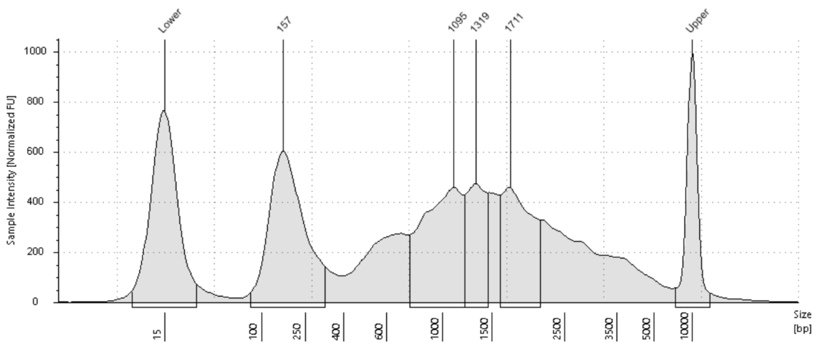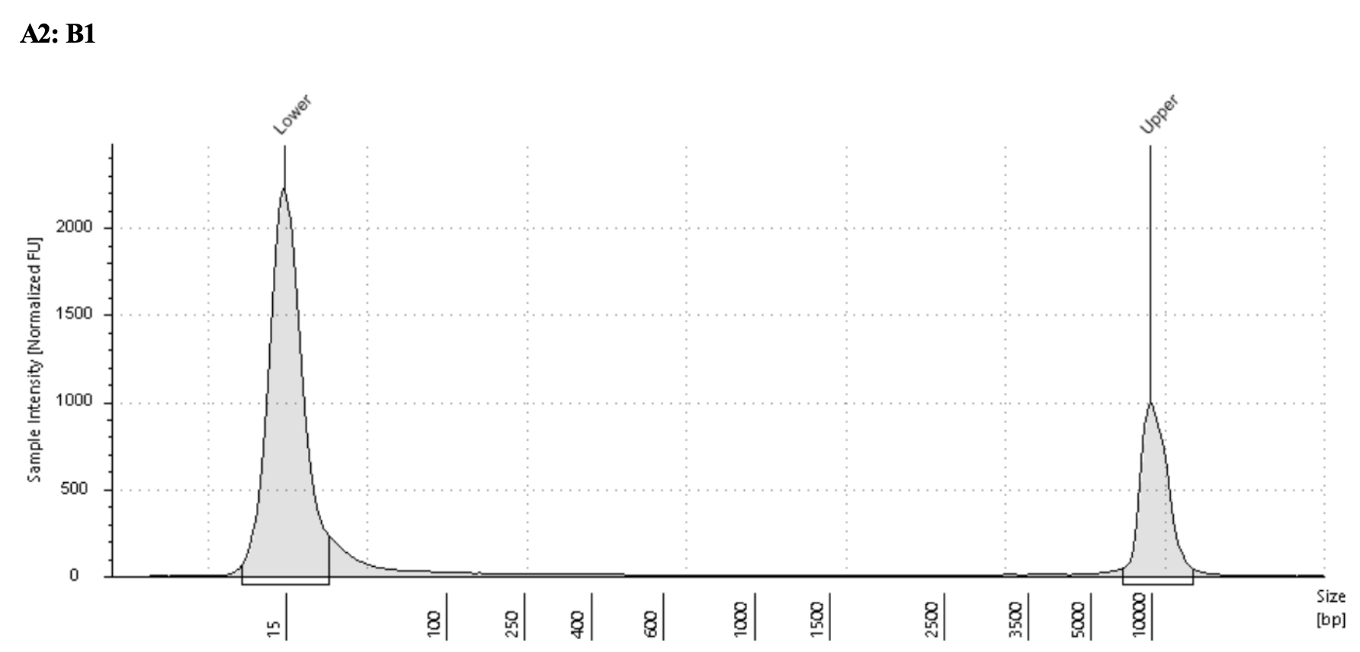

- Tagmentation-based library preparation using the Nextera XT Sample Preparation Kit

Tagmentation based library preparation was used for both amplified cDNA and amplified gDNA (from the gDNA processing protocol). We used the Nextera XT DNA Library Prep Kit (Illumina). We used the Nextera 96-indexes for labelling the cDNA and gDNA from each well with unique oligos. This allows us to pool all the samples together for sequencing on the same chip.
The steps detailed below are also available on the Nextera XT DNA preparation sample guide on the kit website.

Total starting material of cDNA or gDNA per well needed- 0.2ng/ul * 1.25 uL= 0.25 ng

  - Dilute purified WTA product (i.e., amplified and purified single-cell cDNA from Step 5.11) or purified WGA product (i.e., amplified and purified single-cell gDNA from gDNA processing protocol) to 0.2 ng/µl.

  - Prepare the tagmentation master mix for one 96-well plate of purified WTA or WGA product as described in the table below using the reagents provided with the Nextera XT DNA Library Prep Kit, then mix the solution carefully with a pipette and keep it on ice.

Component | Volume (uL)
Tagment DNA buffer | 300
Amplicon tagment mix | 150
Total volume | 450

  - Dispense 3.75 µl of tagmentation master mix to each well of a new 96-well plate on ice.

  - Transfer 1.25 µl of the diluted WTA or WGA product to each well of the ‘tagmentation master mix’ plate, keeping the plates in the same orientation and mixing gently with each addition. Perform this step on ice.

  - Seal the ‘tagmentation reaction’ plate, mix gently using an Eppendorf thermomixer C or similar (1,000 r.p.m. for 1 min at room temperature), and centrifuge (1,000g for 1 min at 4 °C) to collect the mixture at the bottom of the wells.

  - Perform the tagmentation reaction on the thermal cycler using the following settings.

Cycle | Temperature (°C) | Time
1 | 55 °C | 10 mins
2 | 10 °C | Hold

  - Centrifuge (1,000g for 1 min at 4 °C) to collect the mixture at the bottom of the wells.

  - Add 1.25 µl of Buffer NT (component of the Nextera XT kit) to each well of the 96-well ‘tagmentation reaction’ plate on ice, mixing gently with each addition.

  - Centrifuge (1,000g for 1 min at 4 °C) to collect the mixture at the bottom of the wells.

  - Add 3.75 µl of Nextera PCR Mastermix to each well of the 96-well ‘tagmentation reaction’ plate on ice, mixing gently with the pipette with each addition. Discard the tips after each addition.

  - Add 1.25 µl of the appropriate Index 1 (N7xx from the Nextera 96-Index Kit) primer to each well of the 96-well ‘tagmentation reaction’ plate on ice, mixing gently with the pipette with each addition. Discard the tips after each addition.

  - Add 1.25 µl of the appropriate Index 2 (N5xx from the Nextera 96-Index Kit) primer to each well of the 96-well ‘tagmentation reaction’ plate on ice, mixing gently with the pipette with each addition. Discard the tips after each addition.

  - Once the Nextera PCR Mastermix and both index primers have been added to each well, seal the plate and centrifuge (1,000g for 1 min at 4 °C) to collect the reaction mix at the bottom of the wells.

  - Perform the amplification of the tagmented DNA fragments on a thermal cycler using the following program.

Cycle number | Denature | Anneal and extend | Conditions
1 | 72 °C, 3 min
2 | 95 °C, 30 s
3-14 | 95 °C, 15 s | 55 °C, 10 s | 72°C, 30 s
15 |  |  | 72 °C, 5 min
16 |  |  | 4 °C, hold

- Pooling and quantification of libraries

8.1 Pool the amplified libraries by transferring 5 µl from each well to a clean microcentrifuge tube. The remaining library can be kept for deeper sequencing (i.e., less multiplexing), should this be required.

CRITICAL- If sequencing depth needs to be matched exactly between samples, we recommend quantification and normalization of the individual libraries before pooling according to standard methods for Illumina sequencing libraries.

8.2 Perform an Agencourt AMPure bead cleanup of the pooled library products, as described in Steps 5.1–5.11, adjusting the volume of the beads in Step 5.2 to have a 1:0.6 ratio between the library pool and the Agencourt AMPure beads (e.g., for a whole plate, 480 µl of library pool will be collected, to which 288 µl of Agencourt AMPure beads should be added and mixed).

8.3 Check the quality of the purified library pool using a high-sensitivity chip on an Agilent Bioanalyzer. A successful Nextera library preparation reaction, and hence also the library pool, should consist primarily of cDNA and gDNA fragments between 2500 and 800 bp (C).
C)

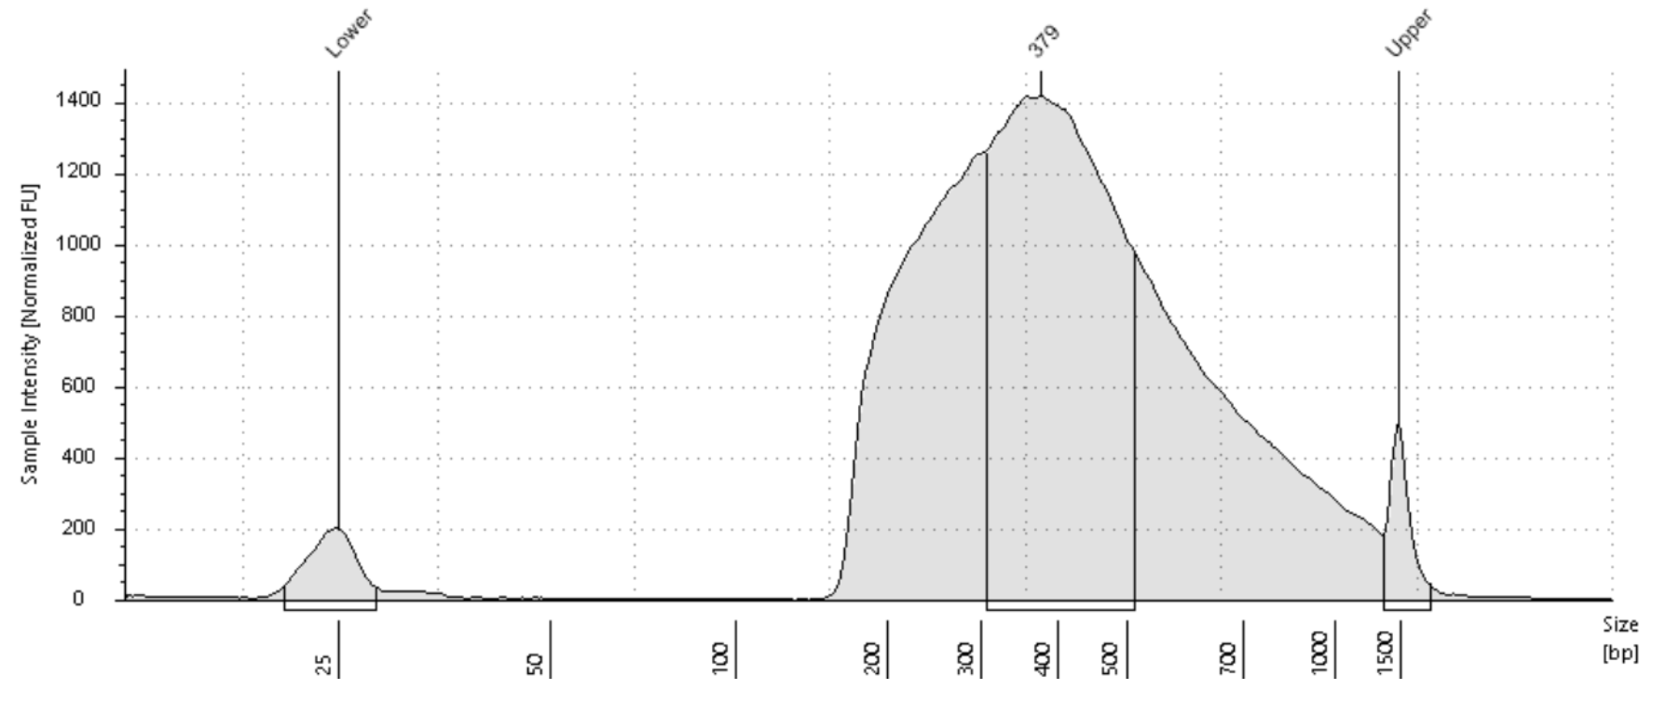

8.4 Quantify the Nextera library pool derived from the single cells’ WTA or WGA product. We routinely quantify our libraries using the Kapa Library Quantification Kit for Illumina platforms per the manufacturer’s instructions. After quantification, dilute the library, if required (we typically dilute to 4 nM).

- Sequencing depth- ~1 million cDNA reads per cell was sufficient for the gene expression analyses we performed. The cDNA from this protocol was successfully sequenced on multiple platforms such as MiSeq, NextSeq, Novaseq.

