Survival and Mortality of Cancer (SAMOC): Prospective observational study protocol for patients diagnosed with cancer

Basic Information
Title : Survival And Mortality of Cancer Patients (SAMOC study)
Abstract :
Indicators of cancer mortality are essential for public health planning. In Tunisia, significant progress has been made in cancer management, including enhanced screening, treatment availability, and reimbursement through the National Health Insurance Fund.
The Survival And Mortality Of Cancer (SAMOC) study is a prospective observational protocol designed to assess the impact of these advances on patient outcomes by estimating cancer-specific survival and mortality. SAMOC includes all patients diagnosed with cancer in a Tunisian governorate between 2002 and 2014. Data were obtained from the Cancer Registry of Central Tunisia and cross-verified with the Regional Register of Hospital Morbidity and oncology departments. Mortality status was ascertained through a multi-step process using hospital records and national death registries in collaboration with the Ministry of Social Affairs and municipalities with access to the national mortality database.
This updated protocol refines data linkage, verification steps, and integration of multiple data sources to maximize completeness and accuracy. The study will provide robust estimates of cancer survival, mortality, and trends, informing targeted primary and secondary cancer prevention strategies in Tunisia and comparable settings.

Keywords : Cancer, Incidence, Mortality, Survival Rate, Epidemiology, Screening, Cohort Studies, Disability-Adjusted Life Years, Cancer registry, Tunisia.

Introduction / Background
Statistics on mortality rates are of great interest in the field of public health. The determination and evaluation of the specific causes of death represent key components of health system strategies and health policy to develop specific preventive actions (1). Mortality indicators can be used for different purposes. They can be used to assess the health status of a population, to contribute to decision making, and to determine public health priorities. These indicators include number of deaths, crude mortality rate, specific mortality rate, age-standardized mortality rate and years of potential life lost (YPLL) (2).
Determining mortality rates among patients diagnosed with cancer is particularly important. In fact, cancer represents the major cause of death in the world. Roughly 10 million deaths, or about one in every six deaths, are caused by cancer in 2020 (3). In Tunisia, according to the National Statistics on the Causes of Death in 2020, tumoral causes represented 15.6% of deaths in the general population. Malignant tumors of the digestive organs and malignant tumors of the trachea, bronchus and lung represented the 6th and 7th cause of all deaths representing 3.7% and 3.4% of deaths respectively (4). Analysis of data on cancer mortality and therefore cancer survival allows to emphasize the importance of cancer prevention at an early stage. Early detection including screening and early diagnosis can reduce cancer mortality.
In Tunisia, the Medical Certificate of Death is the main tool for collecting data on death. The registration of deaths is systematic in municipalities through the civil registration method which is based on the compulsory and continuous recording of the occurrence of vital events such of death status. In our country, the system of information on medical causes of death was created at the end of the 1990s. By introducing the use of the international model of the medical certificate specifying the cause of death, Tunisia is now part of the restricted group of countries where the information on medical causes of death is one of the fundamental and unavoidable bases of medical research, epidemiological surveillance, rationalization and management of health services (5).
The Medical Certificate of Death is made up of an upper section completed in a nominative copy and an anonymous copy, and a lower section signed by a doctor. The National Institute of Public Health receives the anonymous upper copy and the lower part in order to monitor the causes of death. The Information System on Causes of Death has shown a notable improvement in its coverage rate and in the quality of data. The nominative upper copy is archived at the municipality. The Ministry of Social Affairs receives this part which contains all the names and surnames of all the deaths whatever the cause (4).
In Tunisia, the number of oncology departments and oncologists has increased. Moreover, the National Health Insurance Fund is taking care of cancer patients directly, which has facilitated access to treatment, particularly chemotherapy sessions. Accordingly, we want to evaluate the impact of these advances on the outcomes of cancer patients

Objectives
The SAMOC study, conducted in collaboration with the Ministry of Social Affairs, targets a population diagnosed with cancer in a Tunisian governorate between 2002 and 2018. Its objectives are to determine cancer-specific mortality, estimate 5-year prevalence, project mortality trends to 2030, and analyze survival outcomes in light of national cancer prevention policies.

Methods
4.1 Study design & setting
- SAMOC is a historical cohort study including all patients diagnosed with cancer in Monastir governorate (Tunisia) between 2002 and 2014, with follow-up extending to 2022.
- Tunisia has had three regional cancer registries (North, Center, South) since 1987. The Cancer Registry of tunian center , established in 1987 by Professor Chadli Bouzakoura, documents all cancer cases in central Tunisia, including Monastir. In 1990, Professor Mohamed Soltani, head of Preventive Medicine and Epidemiology, founded the Hospital Morbidity and Mortality Registry, covering all hospital-based morbidity and mortality, including cancer cases at Monastir University Hospital. A collaboration between the Central Cancer Registry and the Hospital Morbidity Registry ensured comprehensive identification and documentation of all cancer cases in the governorate. Between 2002 and 2014, all cancer cases in Monastir were managed exclusively within public health facilities. Cancer treatment is covered by the national health insurance system in Tunisia. Mortality data were obtained in 2023 following authorization from the National Authority for the Protection of Personal Data and the Ministry of Social Affairs. These data were merged with cancer case records, and the vital status (deceased/survivor) was verified. The final dataset was anonymized prior to statistical analysis, while the original database was preserved under coded access to prevent unauthorized use.
4.2 Participants
Inclusion Criteria: This study encompassed all confirmed cases of cancers, diagnosed in patients residing in the governorate of Monastir between 2002 and 2014, including those diagnosed and treated outside the region. Participant follow-up was ensured through linkage with the Monastir all-cause mortality database, spanning the years 2001 to 2022.
Exclusion Criteria: Benign and in situ tumors, tumor recurrences, and the metastatic progression were not included in the study.
4.3 Variables collected
Malignant neoplasms were classified using the ICD-10. The dataset included key variables such as sexe, date of birth, year of diagnosis, cancer topography and morphology, the status (deaths, survival) and the year of death. Version 2008, cancer sites were classified as follows (6): C00-C14: Malignant neoplasms of lip, oral cavity and pharynx, C15-C26: Malignant neoplasms of digestive organs, C30-C39: Malignant neoplasms of respiratory and intrathoracic organs, C40-C41: Malignant neoplasms of bone and articular cartilage, C43-C44: Melanoma and other malignant neoplasms of skin, C45-C49:Malignant neoplasms of mesothelial and soft tissue, C50-C50: Malignant neoplasm of breast, C51-C58: Malignant neoplasms of female genital organs, C60-C63: Malignant neoplasms of male genital organs, C64-C68: Malignant neoplasms of urinary tract, C69-C72: Malignant neoplasms of eye, brain and other parts of central nervous system, C73-C75: Malignant neoplasms of thyroid and other endocrine glands.
4.4 Data sources
Data on confirmed cancer cases, histological diagnosed between 2002 and 2014 were prospectively collected by merging the hospital morbidity registry data and the regional cancer registry of the Center. In December 2019, the team from the Department of Epidemiology and Preventive Medicine of Monastir completed the verification of data conformity.
Next, deaths among these cases and their dates were ascertained using multiple sources: the hospital death database and the Ministry of Social Affairs mortality database, covering all deaths in Monastir from 2001 to 2022. The study protocol was approved by the Ethics Committee of the Faculty of Medicine of Monastir in January 2022, with access to the mortality database authorized in May 2022 by the National Authority for the Protection of Personal Data. The dataset included 60,280 deaths registered in Monastir between January 1, 2002, and January 26, 2023 (accessed February 2023). For unresolved cases, a name-by-name check was conducted in the municipal death registry, which systematically records all deaths in Tunisia (Figure 1).
4.5 Data management steps (workflow)
Data collection and validation were finalized in 2023 through a structured, multi-step process (Figures 2-3).
Patient identification (Databases 1–2):
Patients diagnosed with cancer between 2002 and 2014 in the governorate of Monastir were first identified from the Regional Register of Hospital Morbidity and from hospital departments. Additional cases were retrieved from the Cancer Registry of the Center of Tunisia to capture patients who had consulted outside the region. All records were verified with pathology departments before integration.
Data completion:
A major effort was undertaken to recover missing information. Identifiers such as names, dates of birth, and parental surnames were meticulously extracted from the hospital admission and index registries. Duplicates were systematically detected and removed, keeping only the earliest validated diagnosis of cancer.
Database integration (Database 3):
The datasets from the different sources were then merged into a master database. Records with incomplete cancer site or missing diagnosis dates were excluded (<1%).
Vital status ascertainment (Databases 4–8):
Vital status was determined in two stages. First, in-hospital deaths were identified through hospital discharge registers. Second, deaths occurring outside hospitals were collected from municipal records in collaboration with the Ministry of Social Affairs and the National Informatics Center. Records from these multiple sources were matched and reconciled. Cases with uncertain matches were rechecked using the national mortality file, and each patient was ultimately classified as either deceased (code 1) or alive (code 0).
Anonymization and security:
The final working dataset (Database 8) was anonymized prior to statistical analysis. The original file containing personal identifiers was securely stored with restricted coded access to prevent unauthorized use.

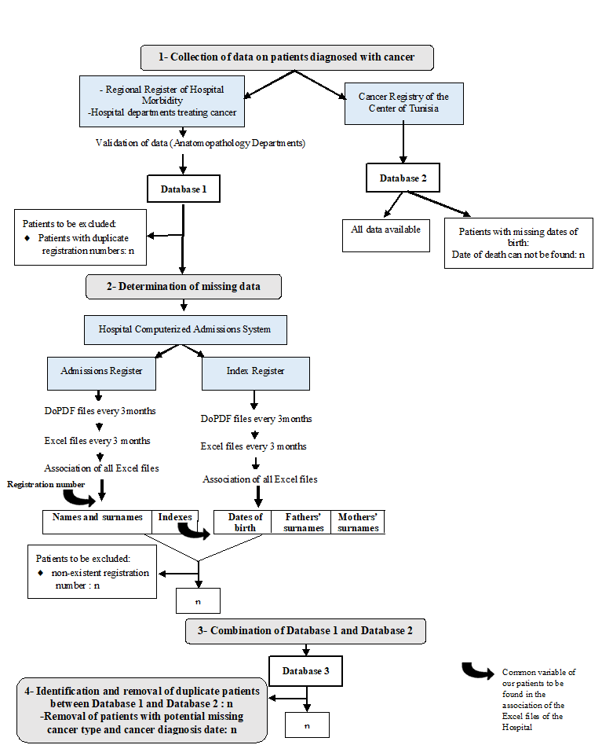
Figure 1: Step-by-step flow chart describing the methods of the exaustive research of cancer cases in a Tunisian governorate, 2002-2014

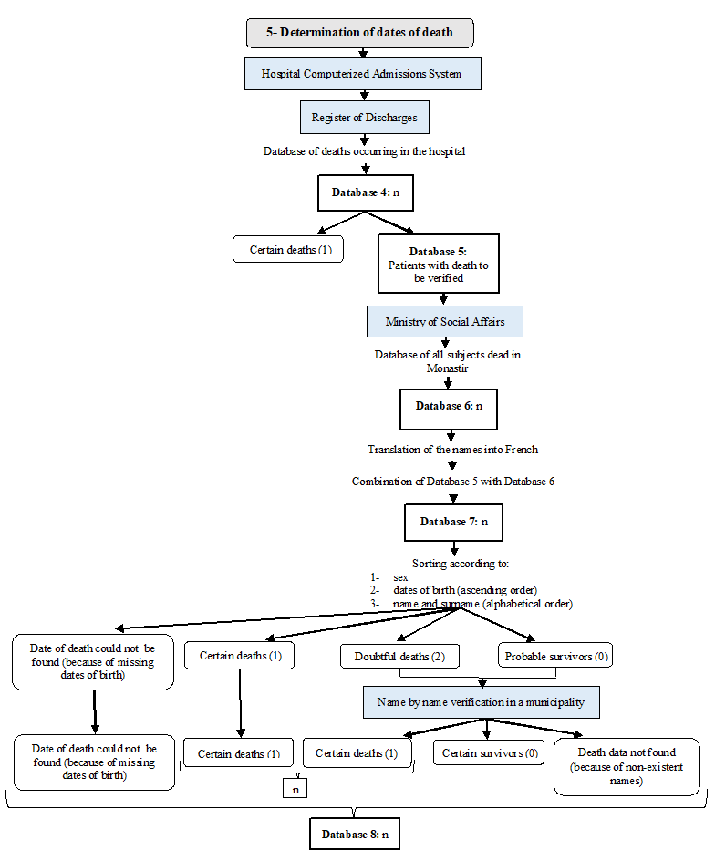
Figure 2: Step-by-step flow chart describing the methods of determination of dates of death among cancer cases in a Tunisian governorate, 2002-2022

4.6 Statistical analysis
Excel software was used for data entry. Statistical Package for the Social Sciences (SPSS) version 21.0 was used for data analysis..
The Crude Incidence Rate (CIR) and the Crude Mortality Rates (CMR) will be calculated based on Tunisian National Institute of Statistics data and will be expressed per 100,000 women (7). We calculated CIR for 100,000 Women.
$$crude incidence rate in a given year =\frac{number of new cases }{number of females-time at risk } in a given year$$
The ASIR and Age-Standardized Mortality Rate (ASMR) per 100,000 Women-years (WY) will be calculated using the world standard population according to the World Health Organization statement of 2013 (15).
$${Standardized rate}^{}=\sum_{i-1}^{n}{ti*proportion of the age class in the reference population}$$
Where n represents the number of total age classes and ti the incidence rate specific by age group.
The chi-squared test for independent samples will be applied to compare incidence and mortality rates between sexes and across age groups. Trends in the crude incidence rate (CIR) will be assessed using Annual Percentage Change (APC) calculated with the Joinpoint Regression Program. Predictions of cancer incidence for 2025 and 2030 will be estimated using Age-Period-Cohort analysis based on Poisson log-linear regression. A p-value < 0.05 will be considered as statistically significant.
For the calculation of Disability-Adjusted Life Years (DALYs), Years of Life Lost (YLL) will be computed by multiplying the number of cancer-related deaths by the standard life expectancy at the age of death. Years Lived with Disability (YLD) were estimated by multiplying the
For survival analysis, only patients with a clearly defined vital status (alive or deceased) will be included in the analysis. Overall and cancer-specific survival will be analyzed using Kaplan–Meier estimators and compared across groups using the log-rank test. Cox proportional hazards models will be applied to evaluate the effect of demographic and cancer type on survival outcomes.
4.7 Timeline
- Data collection: 2020–2023
- Data analysis: 2024

Ethics
- The study used hospital morbidity and mortality registry data that received formal approvals for research use since 1990 (Appendix of approbation of 2006 and 2019).
- We examined anonymized aggregate data. Our study was conducted in accordance to the relevant guidelines and regulations. The Ethics committee of the faculty of medicine of Monastir approved the protocol of this study (IORG 0009738 N°101/OMB0990-0279)Protection des données personnelles (Appendix).
- Access to mortality data for the Monastir governorate from the Ministry of Social Affairs was granted by the National Authority for the Protection of Personal Data (INPDP). All data were handled in accordance with national regulations to ensure confidentiality and ethical compliance (Appendix).

Expected outcomes / Dissemination
The study will report the following outcomes:
- Age-standardized and crude incidence and mortality rates
- Annual percent change in incidence and mortality
- Incidence projections to 2030
- Disability-adjusted life years (DALYs)
- One-year and five-year survival rates
- Survival curves estimated using Kaplan–Meier analysis
- Hazard ratios and risk estimates derived from Cox proportional hazards models

Limitations

- Missing data, including patient identifiers
- Lack of a unique health identifier for patients, which could have facilitated data linkage and verification

Authors’ contributions / Competing interests / Data availability

Authors & Affiliations :
Amani Maatouk^{1,2}, Meriem Kacem^{1,2,3}, Cyrine Bennasrallah^{1,2,3}, Wafa Dhouib^{1,2,3}, Manel Bouatay⁵, Amel Gara^{1,2}, Manel Njima⁷, Moncef Mokni^{6,8}, Sonia Zaied⁹, Ines Bouanene^{1,2,3}, Asma Belguith Sriha^{1,2,3,}, Imen Zemni^{1,2,3}
¹ Department of Epidemiology and Preventive Medicine, University Hospital Fattouma Bourguiba of Monastir, Tunisia
² Department of Community Medicine, Faculty of Medicine, University of Monastir, Tunisia
³ Research Laboratory Technology and Medical Imaging - LTIM - LR12ES06, University of Monastir, Tunisia
⁴ Department of Intensive Care Medicine and Clinical Toxicology, Montfleury, Tunis, Tunisia
⁵ Department of Family Medicine, University of Monastir, Tunisia
⁶ Cancer Registry of the Centre of Tunisia, Farhet Hached University Hospital, Sousse, Tunisia
⁷ Department of Pathology, University Hospital Fattouma Bourguiba of Monastir, Tunisia
⁸ Department of Pathology, Farhet Hached University Hospital, Sousse, Tunisia
⁹: Department of oncology, University Hospital Fattouma Bourguiba of Monastir, Faculty of medicine of Monastir, Monastir, Tunisia.
Conceptualization: Amani Maatouk, Imen Zemni, Asma Belguith Sriha
Methodology: Amani Maatouk, Imen Zemni, Manel Bouatay, Amel Gara, Meriem Kacem
Project administration: ,, Imen Zemni, Asma Belguith Sriha
Supervision: Manel Njima, Sonia Zaied, Moncef Mokni, Ines Bouanene, Asma Belguith Sriha
Visualization: Ines Bouanene, Asma Belguith Sriha
Writing – original draft: Amani Maatouk, Wafa Dhouib, Cyrine Bennasrallah.
Writing – review & editing: Leila Njim, Moncef Mokni, Ines Bouanene, Asma Belguith Sriha
Funding : “No funding.”
Competing interests
The authors declare that they have no competing interests.
Data availability
The datasets generated and/or analyzed during the current study are not publicly available due to reasons of patient confidentiality but are available from the corresponding author on reasonable request..
Acknowledgements
The authors thank Mr. Sofiene Hemissi and Mr. Helmi Soltani (Tunisian Ministry of Social Affairs) as well as Mr. Amor Ayed (Computer Department, University Hospital of Monastir, Tunisia) for their valuable contributions to data collection. The authors also acknowledge the assistance of ChatGPT in drafting sections of the manuscript.

References
1. Ben Khelil M, Kamel M, Lahmar S, Mrabet A, Borsali Falfoul N, Hamdoun M. Death certificate accuracy in a Tunisian Emergency Department. Tunis Med. 2017;95(6):422-428.
2. Michel E, Jougla E. Principaux indicateurs utilisés pour l'analyse descriptive des causes médicales de décès (Main indicators used for the descriptive analysis of medical causes of death). Bull Cancer. 2000;87(10):755-759.
3. World Health Organization. Cancer. https://www.who.int/news-room/fact-sheets/detail/cancer. Cited 7 February 2023.
4. Ministère de la Santé, Institut national de la santé. Statistiques nationales sur les causes de décès en Tunisie 2020 . 2021. http://www.santetunisie.rns.tn/images/statistiques-deces2021.pdf. Cited 7 February 2023.

5. Institut National de Santé Publique. Causes médicales de décès. http://www.insp.rns.tn/index.php?option=com_content&view=section&id=26&Itemid=224. Cited 7 February 2023.
6. World Health Organization. International Statistical Classification of Diseases and Related Health Problems, 10 th Revision (ICD-10) Version for 2008. Available from URL: https://icd.who.int/browse10/2008/en#/II. Cited 7 May 2023.
7. Institut National de la Statistique. Statistiques | INS [Internet]. [cited 2025 Apr 2]. Available from: https://www.ins.tn/statistiques/111

