Dual Culture Antagonism Assay
The antagonistic potential of ‘Candidatus P. auctus’ JDE115 against A. rolfsii was evaluated using a dual culture assay on potato dextrose agar (PDA). PDA was prepared by dissolving 24 g of potato dextrose broth and 15 g of agar in 1 L of deionized water, sterilization at 121°C for 15 minutes. The media was then poured into sterile petri dishes and allowed to solidify.
Seven parameters were tested: (a) JDE115 placed directly on A. rolfsii sclerotia, (b) JDE115 alone, (c) JDE115 and sclerotia placed distantly, (d) sclerotia alone, (e) JDE115 and fungal hyphal plug placed distantly, (f) hyphal plug alone, and (g) JDE115 placed directly on hyphae. Fresh cultures of JDE115 (OD600 ≈ 0.6) and A. rolfsii (sclerotia or 6–8 mm hyphal plugs) were used in all treatments (Fig. 1). Plates were incubated at 28°C for 7 days. Each treatment included five biological replicates and was repeated independently five times. Fungal growth inhibition was assessed visually and documented photographically to evaluate antagonistic effects under both contact and non-contact conditions (Khan et al. 2018). In a complimentary dual plate assay, the radial growth of A. rolfsii was measured in centimeters after 7 days of incubation at 28°C. The experiment consisted of two treatments: (1) A. rolfsii control, where sterile water was applied instead of JDE115, (2) JDE115 treatment, in which the bacterium was streaked 4 cm away from the fungal plug (Ali et al. 2020). Each treatment included 10 biological replicates, and the experiment was independently repeated three times under identical conditions. Fungal inhibition was quantified by calculating the percentage suppression of radial growth of using the following formula (Montealegre et al. 2003):
Suppression (%) = (1 − Mean growth in treatment / Mean growth in control​) × 100
In Vitro Antagonism of JDE115 against Agroathelia rolfsii
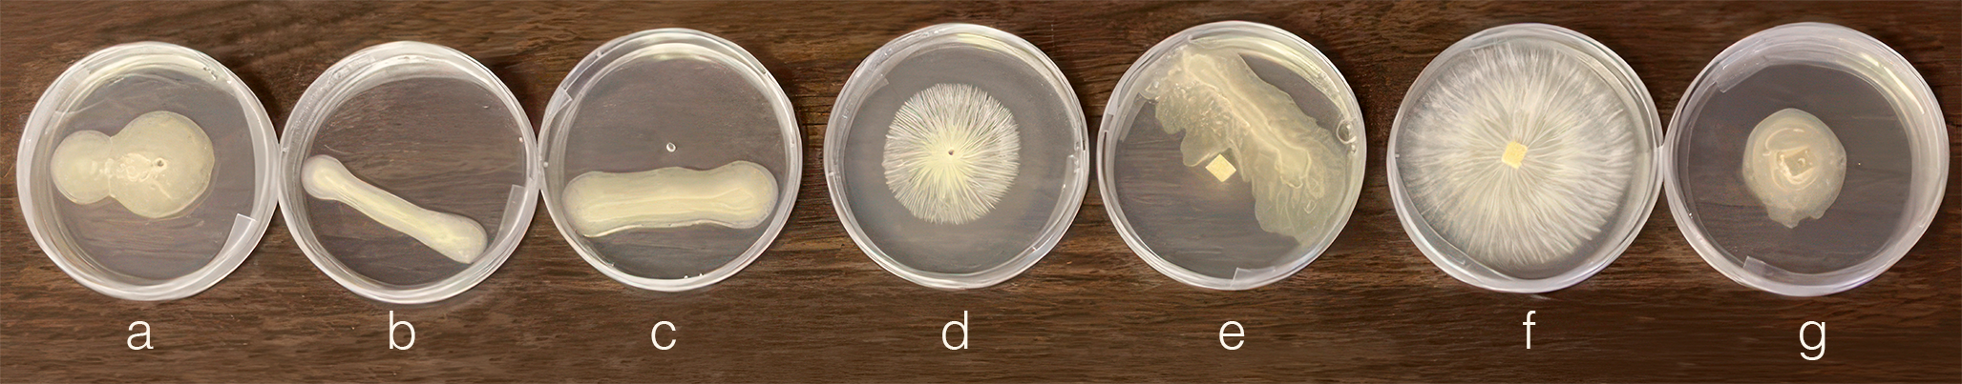
Fig. 1. Dual culture assay showing the antagonistic activity of ‘Candidatus Pseudomonas auctus’ JDE115 Ali et al. 2025 against Agroathelia rolfsii (Curzi) Redhead & S.T. Mull. (2021) on PDA medium. From left to right: (a) JDE115 placed directly on fungal sclerotia, (b) JDE115 alone (bacterial control, (c) JDE115 and sclerotia placed at a distance, (d) A. rolfsii sclerotia alone (fungal control), (e) JDE115 and fungal hyphae placed at a distance, (f) A. rolfsii hyphae alone (fungal control), and (g) JDE115 placed directly on fungal hyphae. The assay demonstrates the ability of JDE115 to inhibit both sclerotial germination and hyphal growth through direct and distance-based antagonism.

