SEM Analysis of Sclerotial Morphology
Three sclerotial sample types were prepared for scanning electron microscopy (SEM): (a) sclerotia incubated on PDA plates with JDE115 for 7 days (treatment), (b) untreated sclerotia from the original stock (negative control), and (c) sclerotia incubated on PDA for 7 days without JDE115 (positive control). After incubation, sclerotia were gently harvested using sterile forceps and rinsed with phosphate-buffered saline (PBS) to remove residual media. Samples were fixed overnight at 4°C in 4% glutaraldehyde prepared in PBS (pH 7.2). Following fixation, they were rinsed three times with PBS and dehydrated through a graded ethanol series (30%, 50%, 70%, 90%, and 100%; 10 minutes at each step). Dehydrated samples were freeze-dried to preserve surface morphology. Dried sclerotia were mounted onto aluminum stubs using double-sided carbon tape and sputter-coated with a thin layer of gold using a EMITech® SC7620 Mini Sputter Coater. SEM imaging was performed under high vacuum using a a Jeol® NeoScope® JCM-5000 scanning electron microscope at 10 kV accelerating voltage and a working distance suitable for capturing surface features at 54× magnification (Fig. 5 and 6).
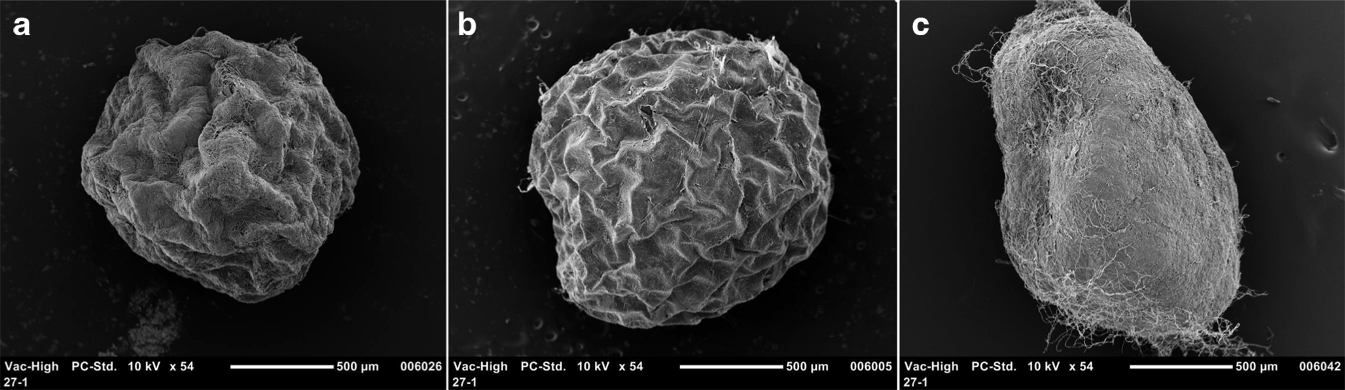
Fig. 5. Scanning electron microscopy (SEM) images showing structural integrity of Agroathelia rolfsii (Curzi) Redhead & S.T. Mull. (2021) sclerotia under different treatment conditions. From left to right: (a) Sclerotia exposed to ‘Candidatus P, auctus’ JDE115 Ali et al. 2025 for 7 days, (b) Untreated stock sclerotia (negative control) representing natural morphology, and (c) Sclerotia incubated for 7 days on PDA without JDE115 (positive control for fungal development). All samples were processed under identical preparation conditions and imaged at 10 kV using SEM at 54× magnification.
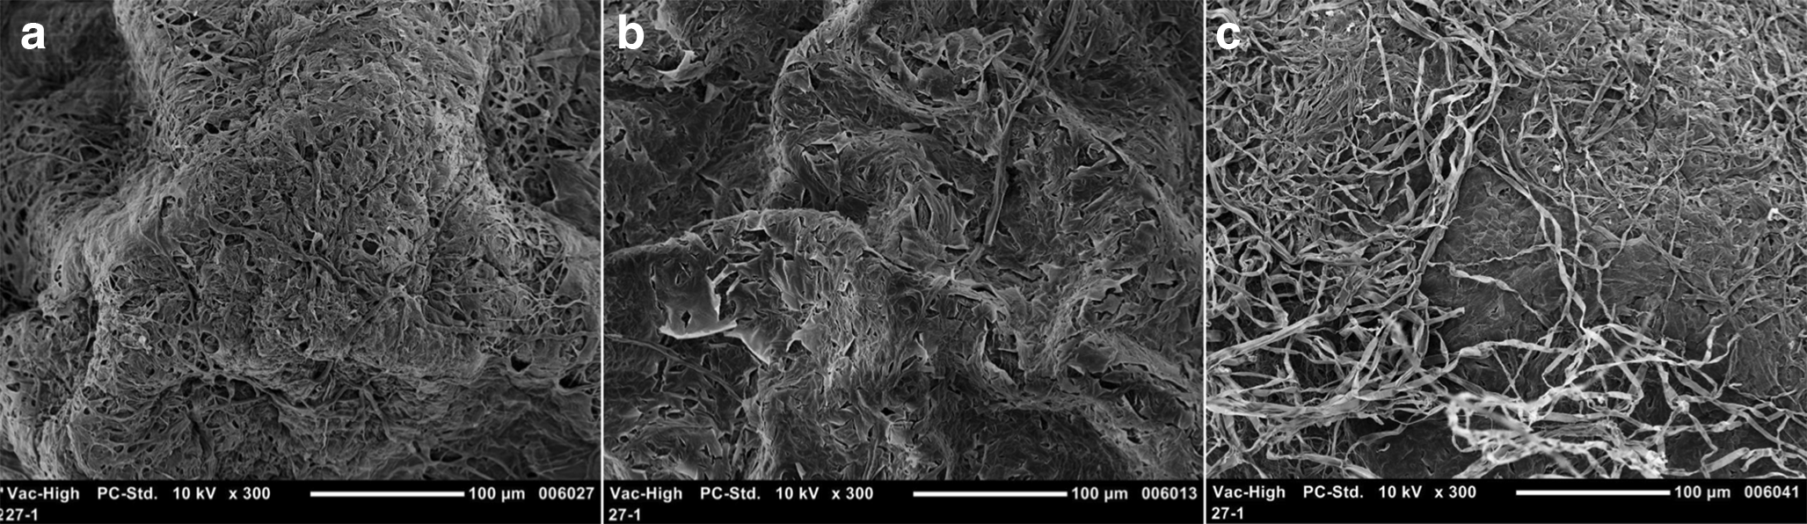
Fig. 6. High-resolution scanning electron microscope (SEM) images of Agroathelia rolfsii (Curzi) Redhead & S.T. Mull. (2021) sclerotia under different treatment conditions at 300× magnification. From left to right: (a) Sclerotia treated with ‘Candidatus P. auctus’ JDE115 Ali et al. 2025, (b) Stock sclerotia (negative control), and (c) Sclerotia incubated for 7 days without JDE115 (positive control). The mages highlight ultrastructural differences in surface integrity and hyphal network organization, with notable disruption observed in sclerotia treated with JDE115.

