Protease Activity Assay
Proteolytic activity of the bacterial isolate was assessed using a skim milk agar plate assay based on a modified casein hydrolysis method. To prepare the medium, 25 g of skim milk powder and 5 g of agar were each dissolved separately 200 mL of deionized water with constant stirring. The two solutions were combined in a 1 L bottle, and the beakers were rinsed with a small amount of deionized water to ensure complete transfer of contents. The final volume was adjusted to 500 mL, thoroughly mixed, and sterilized by autoclaving at 121°C for 15 minutes. After cooling to a pourable temperature, the medium was poured into sterile Petri dishes and allowed to solidify (Khalil et al. 2014). The plates were used to evaluate protease production by observing zones of casein hydrolysis around the bacterial colonies.
The cell culture of JDE115 was prepared as described previously. Ten microliters of each dilution (b-e) were spotted onto sectors of the skim milk agar plantes. Sector ‘a’ received LB broth only as a negative control, while sector ‘P’ was inoculated with undiluted Pseudomonas sp. as a positive control (Fig.). Plates were incubated at 28°C for 24 hours. Proteolytic activity was assessed by the measuring the diameter of clear zones formed around the inoculation points, indicating casein degradation. Each treatment included five biological replicates and was independently repeated three times to ensure reproducibility.
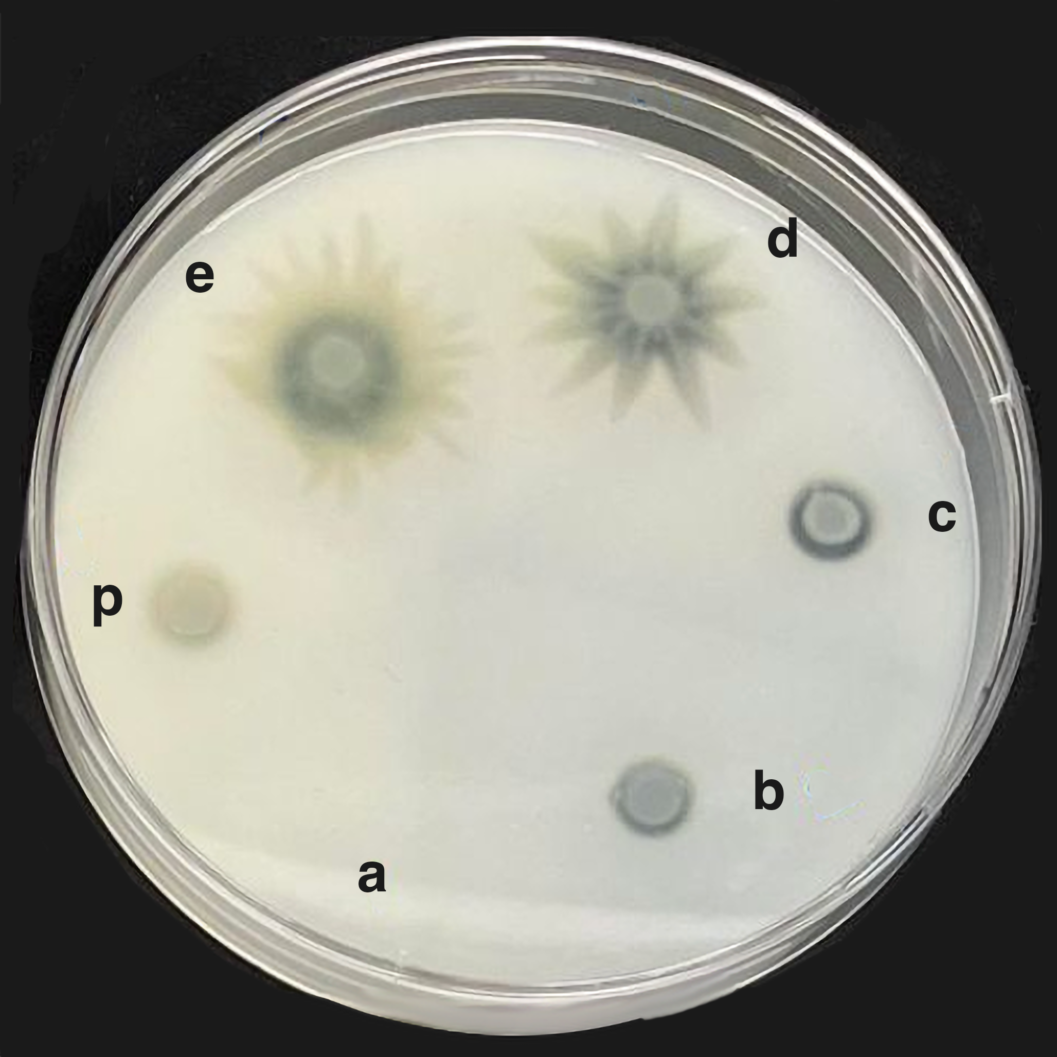
Fig. 8. Detection of protease activity by JDE115 Alli et al. 2025 using the skim milk agar assay. Clear halos around bacterial colonies indicate casein hydrolysis resulting from extracellular protease secretion. Sectors b-e represent increasing concentrations of JDE115 (from 1:1,000 dilution to undiluted). Sector a contains the negative control (LB broth only), and sector P contains the positive control. Halo formation was assessed 24 hours after inoculation.

