Siderophore Detection assay
Siderophore production by JDE115 was assessed using Chrome Azurol S (CAS) agar, following a modified Schwyn and Neilands (1987) protocol. First, 900 mL of LB agar was prepared by dissolving 5 g of yeast extract, 10 g of NaCl, and 15 g of agar in deionized water, then sterilized by autoclaving. Separately, the CAS reagent was prepared by dissolving 72.9 mg of HDTMA in 40 mL of deionized water and 60.5 mg of CAS dye in 50 mL of deionized water, each in separate 100 ml beakers. A 1 mM FeCl₃ stock solution was freshly prepared, and 10 mL of it was added to the HDTMA-CAS mixture to complete the CAS reagent. The final volume was adjusted to 100 mL. After both the LB agar and the CAS reagent were cooled to a pourable temperature, the CAS reagent was aseptically mixed with the LB agar at a 1:10 ratio (100 mL CAS reagent to 900 mL LB agar). The mixture was poured into sterile petri dishes for solidification and used to screen for siderophore production.
To prepare the bacterial inoculum, a single colony of ‘Candidatus P. auctus’ JDE115 was cultured in 10 mL of LB liquid broth at 28°C with shaking at 150 rpm until it reached the logarithmic phase (OD₆₀₀ ≈ 0.6). Ten microliters of this suspension were then spotted onto the CAS agar plates in a sector-wise layout. They are LB broth only (negative control); D1, D2, and D3 - serial dilutions of JDE115 at 1:1,000; 1:100; and 1:10, respectively; JDE115 - undiluted JDE115; and Positive control – undiluted (Fig.). Plates were incubated at 28°C for 5–7 days. Siderophore production was indicated by the appearance of yellow-orange halos surrounding the colonies. The Siderophore Production Index (SPI) was calculated by dividing the total diameter of the halo plus the colony by the diameter of the colony alone (Fig.). The treatment included five biological replicates, and the experiment was independently repeated three times to ensure reproducibility and statistical validity.
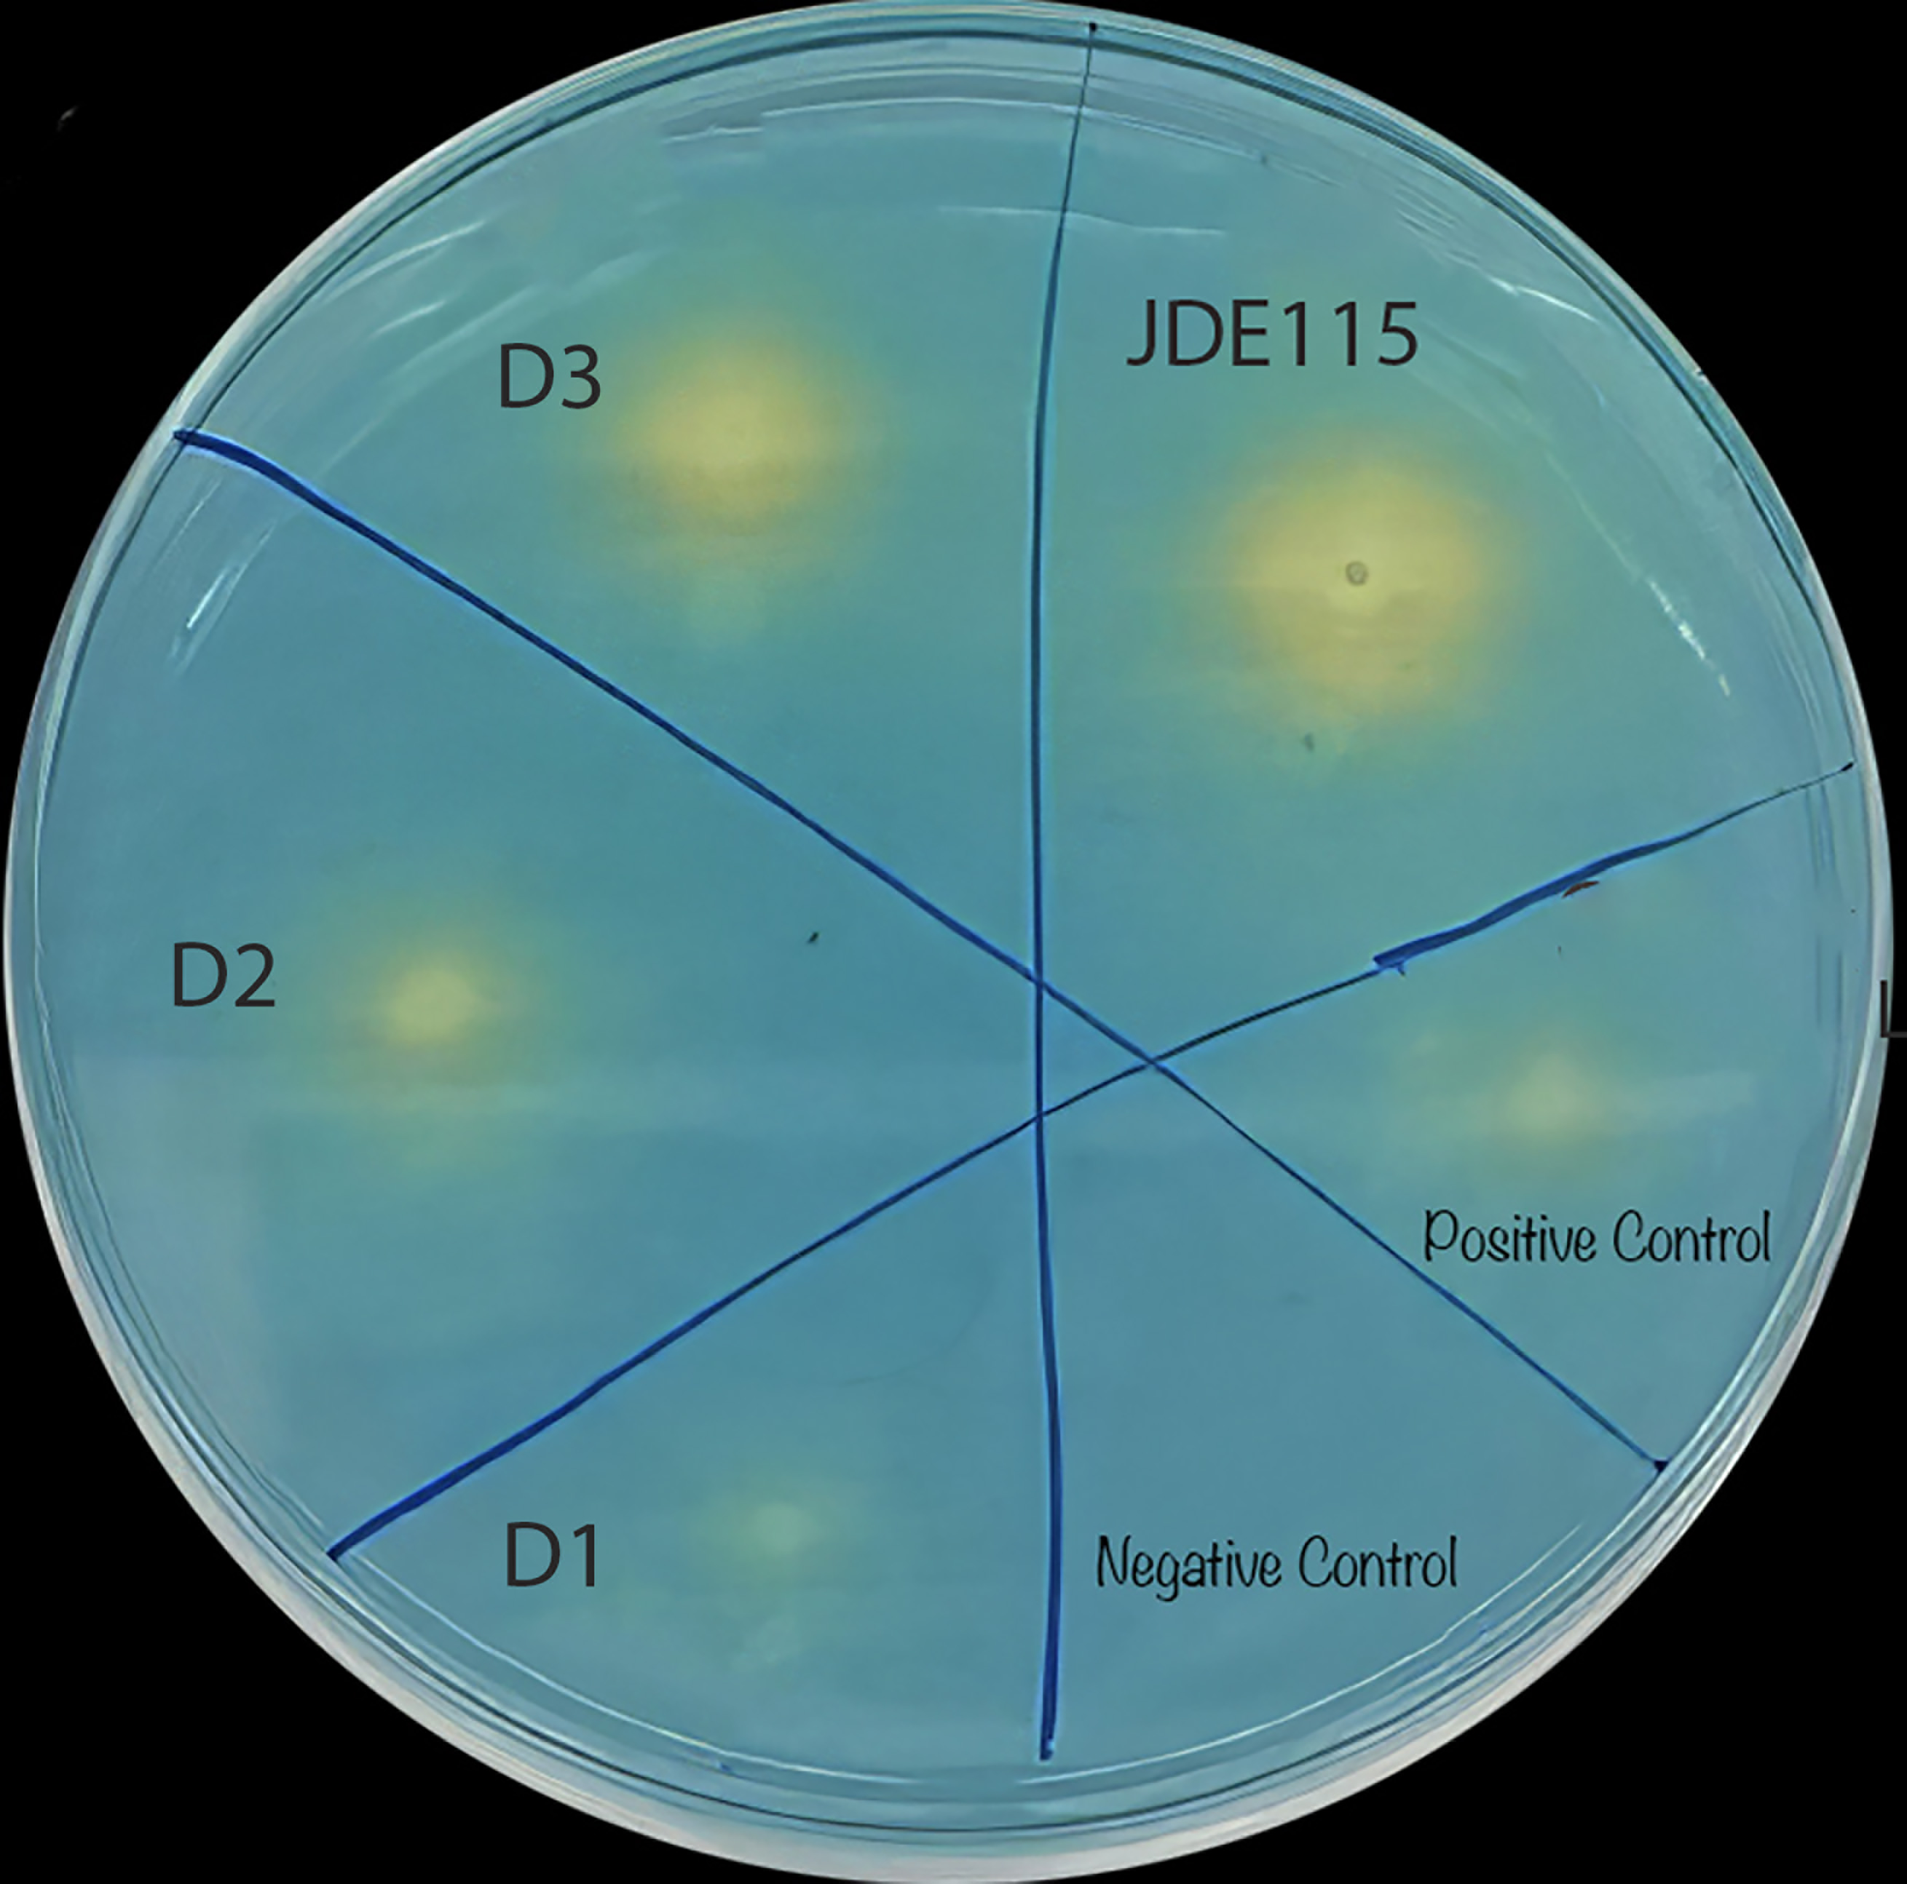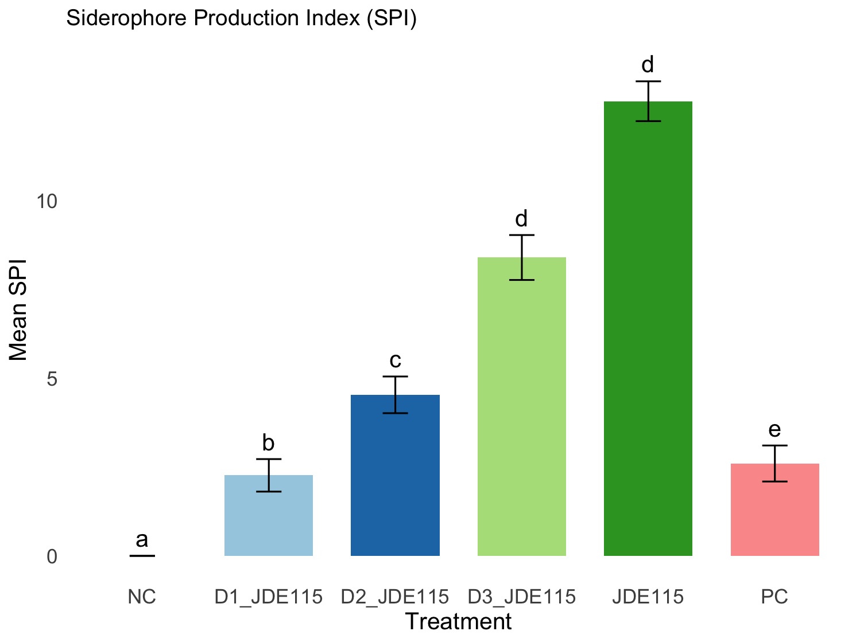
Fig. Siderophore production by JDE115 Ali et al 2025 on Chrome Azurol S (CAS) agar. The plate shows zones of color change from blue to yellow surrounding bacterial colonies, indicating siderophore secretion. Sector 1: LB broth only (negative control), Diluted JDE115 (D1 -D3): Serial dilutions of JDE115 (1:1,000; 1:100; and 1:10), JDE115: undiluted, and positive control (PC): undiluted. Bar graph shoes a graphical representation of the Siderophore Production Index (SPI) based on the ratio of halo diameter to colony diameter. Different lowercase letters denote statistically significant differences among treatments (p < 0.05).

Schwyn, B., & Neilands, J. B. (1987). Universal chemical assay for the detection and determination of siderophores. Analytical Biochemistry, 160(1), 47–56. https://doi.org/10.1016/0003-2697(87)90612-9
Arora, N. K., & Verma, M. (2017). Modified microplate method for rapid and efficient estimation of siderophore production. 3 Biotech, 7(6), 381. https://doi.org/10.1007/s13205-017-1008-y

