Hydrogen Cyanide (HCN) Assay
HCN production by ‘Candidatus P. auctus’ JDE115 was evaluated following a modified picrate-impregnated filter paper method. The test medium consisted of nutrient sucrose agar containing 5 g L⁻¹ sucrose, 4 g L⁻¹ yeast extract, 4 g L⁻¹ peptone, 2 g L⁻¹ beef extract, and 15 g L⁻¹ agar, supplemented with 4.4 g L⁻¹ glycine to enhance HCN biosynthesis. After sterilization by autoclaving, the medium was poured into sterile Petri dishes and allowed to solidify.
A single colony of JDE115, previously grown on LB agar for 48 h at 28°C, was streaked onto the prepared medium. Sterile Whatman No. 1 filter paper disks were soaked in a freshly prepared solution of 0.5% picric acid in 1% sodium carbonate (Na₂CO₃) and affixed to the upper surface of each Petri dish lid, ensuring no contact with the agar surface. Plates were sealed tightly and incubated at 25°C for 7 days. Control plates containing only LB medium were included to confirm background color stability. HCN production was qualitatively confirmed by a color change of the filter paper from yellow to orange or reddish-brown (Fig.). The assay was performed with five biological replicates and independently repeated three times to ensure reproducibility.
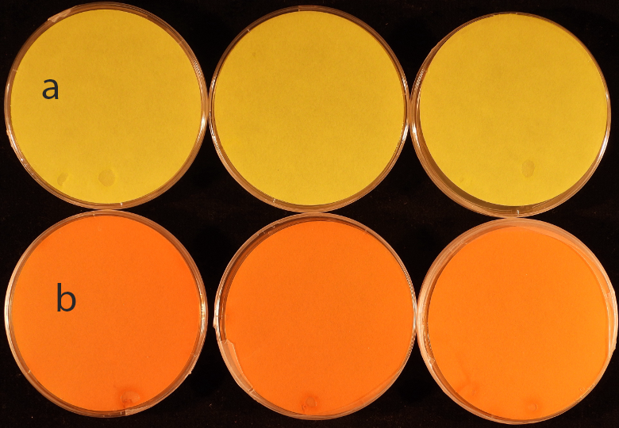
Fig. Detection of Hydrogen cyanide (HCN) production by ‘Candidatus Pseudomonas auctus’ JDE115 Ali et al 2025 as assessed by the picrate paper assay. a) shows negative control plates containing only LB medium, while b) displays plates treated with JDE115. A visible color change of the picrate-soaked filter paper from yellow to reddish-brown after 7 days indicates positive HCN production by JDE115.

