SPME-GC/MS Analysis of Volatile Compound
Volatile organic compounds (VOCs) produced by ‘Candidatus P. auctus’ JDE115 were identified using headspace solid-phase microextraction (SPME) coupled with gas chromatography-mass spectrometry (GC-MS). Four experimental conditions were prepared in airtight 20 ml vials containing 10 ml of PDA medium incubated at 28°C: (i) JDE115 (bacterial control), (ii) A. rolfsii (fungal control), (iii) JDE115 and A. rolfsii co-culture and (iv) Medium-only control.
Headspace VOCs were collected using a 50/30 µm DVB/CAR/PDMS StableFlex® fiber (Supelco®, USA), pre-conditioned according to manufacturer’s instructions. Samples were allowed to equilibrate at room temperature for 30 minutes before the SPME fiber was exposed to the headspace for 10 minutes. The VOCs adsorbed on the fiber were then thermally desorbed by inserting the fiber directly into the GC injector port for analysis.
GC-MS analysis was conducted using an Agilent® 7890 gas chromatograph coupled with a 5975C mass selective detector (MSD). VOCs were separated on a DB-5 capillary column (30 m × 250 µm × 0.25 µm film thickness). Samples were injected in split mode (1:10) with an injector temperature set to 200°C. Helium was used as the carrier gas at a constant flow rate of 1.0 mL/min. The oven temperature program was as follows: an initial hold at 35°C for 3 minutes, followed by a ramp of 15°C/min to 200°C, and then held at 200°C for 5 minutes. The transfer line temperature was maintained at 220°C. Mass spectra were acquired in electron ionization (EI) mode. VOCs were identified by comparing their mass spectra to those in the Wiley and NIST libraries (Fig.). All samples were analyzed under identical instrument settings to ensure reproducibility.
Volatile Organic Compounds (VOC) Profiling and Quantification via SPME-GC/MS
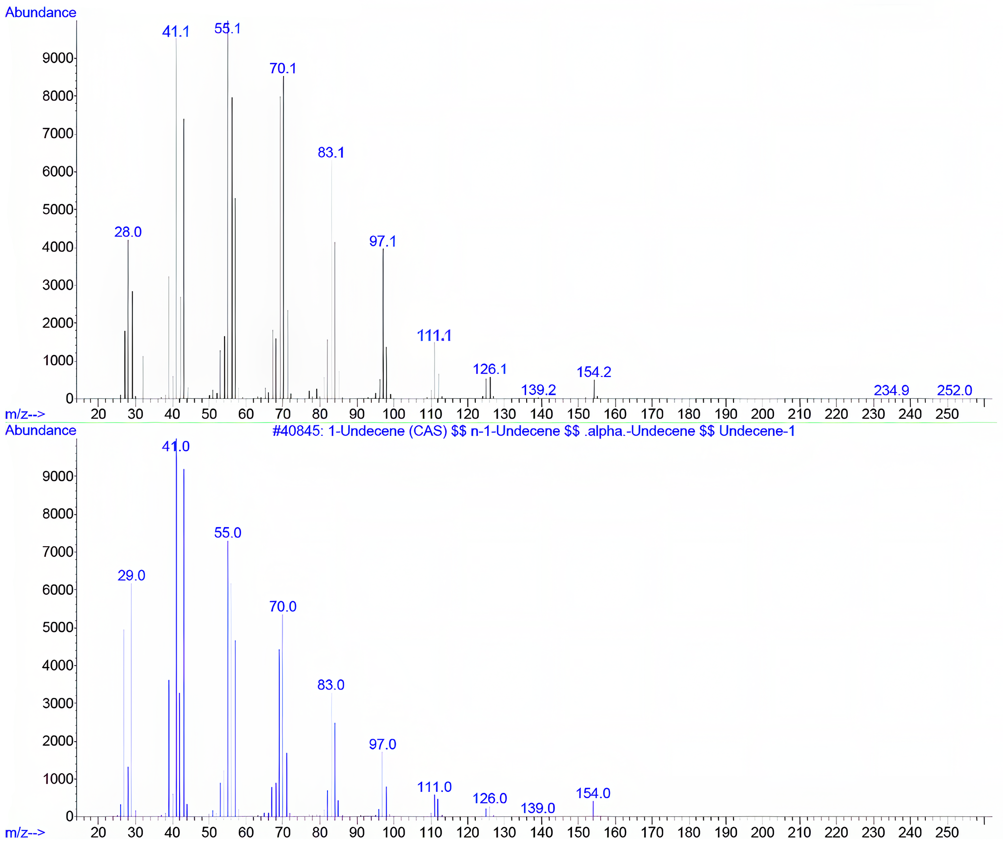
Fig. Identification of volatile organic compounds (VOCs) produced by ‘Candidatus Pseudomonas auctus’ JDE115 Ali et al. 2025 using solid-phase microextraction (SPME) and gas chromatography-mass spectrometry (GC-MS). Mass spectral analysis confirmed the presence of 1-undecene identified by matching the sample spectra to reference data in the Wiley mass spectral database.

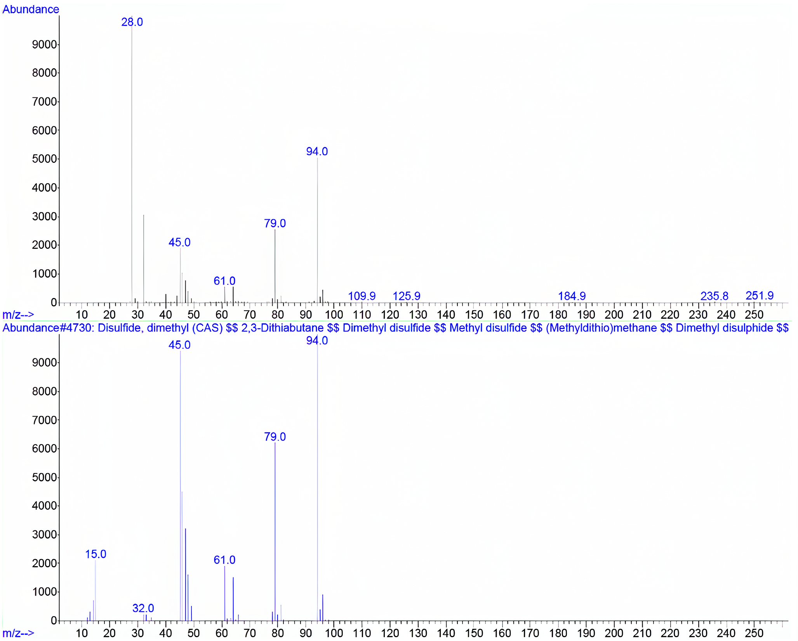
Fig. Identification of volatile organic compounds (VOCs) produced by ‘Candidatus Pseudomonas auctus’ JDE115 Ali et al. 2025 using solid-phase microextraction (SPME) coupled with gas chromatography-mass spectrometry (GC-MS). Mass spectral analysis confirmed the presence of and dimethyl disulfide (DMDS) by comparison with reference spectra from the Wiley mass spectral database.

