Fluorescent Image Acquisition on VS200

- Scope and Applicability:
This protocol details the use of the Olympus (Evident Scientific) VS200 automated slide-scanning microscope for fluorescent imaging of fixed mouse, human, and nonhuman-primate tissues sections mounted on barcoded glass 1x3” or 2x3” slides. The instrument is capable of loading up to 210 1x3” glass slides, or 105 2x3” slides. The images are viewable in Evident’s proprietary OlyVIA image viewing software. This document is intended to describe routine use of the instrument and software, including the initial steps required to configure the software for image capture (section 8.3), which includes specific exposure times for the Viral Genetic Tools (VGT) primary screen.

- Materials:
  - Olympus slide loading tray(s) for VS200
  - Barcode-labeled 1x3” glass microscope slides with fluorescing samples.

- Equipment:
  - Olympus VS200 microscope with autoloader module
  - Excelitas X-Cite XYLIS Model: XT720L. Array of LEDS: 385, 430, 475, 545, 635, 735
  - Hamamatsu Orca Fusion-BT 16-bit camera
  - PC with VS-ASW microscope control software
  - Objectives:
Magnification | Objective type | Lateral resolution: Brightfield (μm) | Lateral resolution: Fluorescent (μm) | Numerical Aperture | Working distance (mm) | Refractive index
2x | Plan N | 2.738 | 3.25 | 0.06 | WD 5.8 | 1.00 (air)
4x | UPlanXApo | 1.369 | 1.625 | 0.16 | 13 | 1.00 (air)
10x | UPlanXApo | 0.4756 | 0.65 | 0.4 | 3.1 | 1.00 (air)
20x | UPlanXApo | 0.2378 | 0.325 | 0.8 | 0.6 | 1.00 (air)
40x | UPlanXApo | 0.1369 | 0.1625 | 0.95 | 0.18 | - air)
  - Filters (organized by channel configuration):
Channel | Excitation filter (FFW) | Dichroic | Emission filter (added to cube) | Emission filter (FFW)
DAPI | Semrock FF01-378/52 | Semrock FF409/493/573/650/759-Di01 | FF01-432/515/595/681/809-25 | Semrock FF01-432/36
CFP | Chroma ET430/24x | Chroma 89007bs | Chroma 69008m | Chroma ET470/24m
FITC | Semrock FF01-474/27 | Semrock FF409/493/573/650/759-Di01 | FF01-432/515/595/681/809-25 | Semrock FF01-515/30
YFP | Chroma ET500/20x | Chroma 89007bs | Chroma 69008m | Chroma ET535/30m
TRITC (AKA Cy3) | Semrock FF01-554/23 | Semrock FF409/493/573/650/759-Di01 | FF01-432/515/595/681/809-25 | Semrock FF01-595/31
mCherry | Chroma ET572/35x | Chroma 89007bs | Chroma 69008m | Chroma ET632/60m
Cy5 | Semrock FF01-635/18 | Semrock FF409/493/573/650/759-Di01 | FF01-432/515/595/681/809-25 | Semrock FF01-680/42
Cy7 | Semrock FF01-735/28 | Semrock FF409/493/573/650/759-Di01 | FF01-432/515/595/681/809-25 | Semrock FF02-809/81
  - Safety:
    - Nitrile Gloves
    - Slides may break, please use caution while cleaning and loading/unloading cassettes.
Warning: Personal Protective Equipment (PPE) should be used at all times while operating this protocol. If you are unsure what PPE you should be using, see your immediate supervisor.

- Output:
  - Images with a Virtual Slide Image (.vsi) file format, with OME-spec TIFF images embedded in subfolders OR
  - Images with a Virtual Slide Image (.vsi) file format, with Olympus .ets images embedded in subfolders.

- Reference Documents:
  - MC0026: Microscopy Slide Check-in
    - To be Published
  - MC0031: Core Protocol for Cleaning Glass Slides
    - To be Published
  - VS200 Instruction for Use: https://www.olympus-lifescience.com/en/downloads/detail-iframe/?0%5bdownloads%5d%5bid%5d=847253432

- Setup:
  - Turn on the VS200
    - The UPS should already be turned on. If it is not on, turn it on first.
    - Turn on the components in the following order.
      - Computer.
      - Excelitas Xylis illuminator (flip switch to upper position on the front of the unit, Figure 1A).
      - VS200 (push switch on the lower front panel of the instrument, will illuminate green when on, Figure 1B).
      - Hamamatsu Orca Fusion-BT (flip switch on top of camera, Figure 1C).
      - On the Computer, login to the ICS account, and open VS200-ASW (microscope control software).
  - To shut down the instrument, reverse steps 6.1.2.2-6.1.2.4. Do not turn off the UPS.

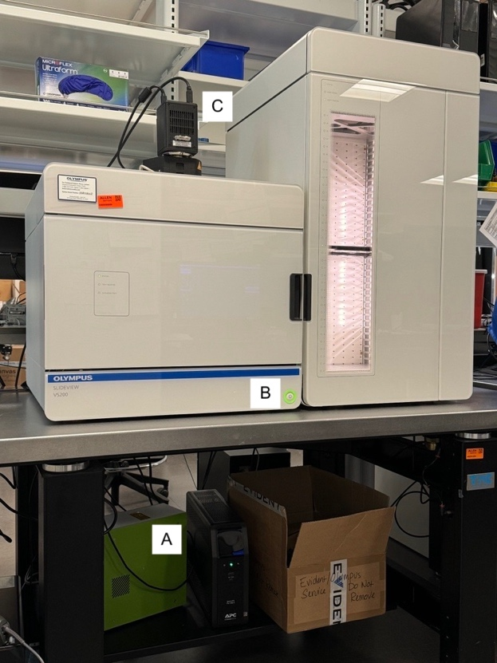
Figure 1. VS200 Components.

- Methodology/Procedures:
  - Loading slides into VS200 trays:
    - Obtain the slides to be scanned. Ensure that slides have been accounted for by the Microscopy group. For production slide check-in, refer to SOP MC0026: Microscopy Slide Check-In.
    - Obtain a VS200 slide tray.
    - Clean slides per SOP MC0031: Core Protocol for Cleaning Glass Slides.
    - Load slides starting from slot 1 (left).
      - Retract the slide clip by actuating the satin metal circle above the slot 1 and place the slide in the tray with the barcode facing UP.
      - Release the slide clip and push on the label region or edge of the slide to push it into the lower right corner. Consistent alignment facilitates easier rescans. See an example of a properly loaded slide in Figure 2.

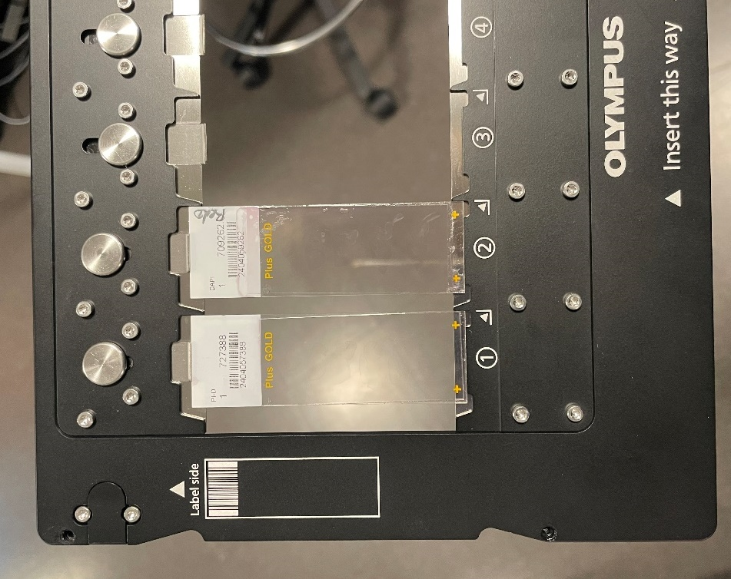
Figure 2. Two 1x3” slides loaded in a VS200 slide tray.

  - Loading slide trays into VS200 autoloader tower:
    - In VS-ASW, click the “Exchange Trays” Button (Figure 3).
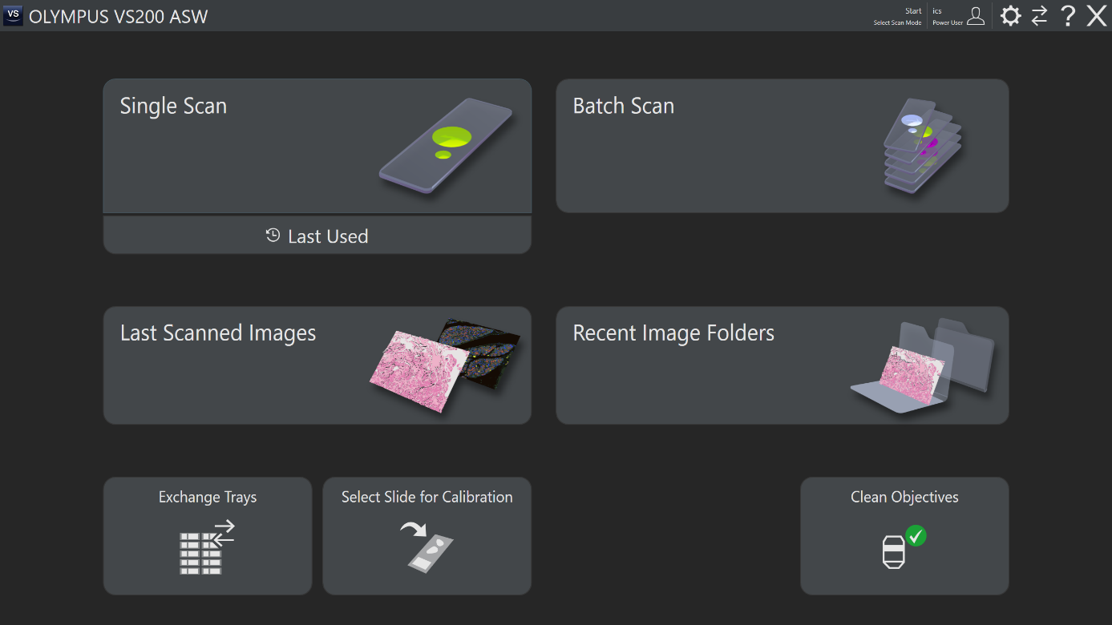
Figure 3. VS-ASW Homescreen.

    - When the instrument is ready, a new menu will open on-screen and the “Door Locked” LED on the VS200 will go from green to off. Wait for this indicator to turn off before attempting to open the door. Note – the detent for the door is quite strong, expect the air table to rock before or upon opening.
    - Insert trays into slots with slide labels oriented to the far wall of the loader tower. Place the trays to the back and to the left within their slots for proper engagement with the tray forklift. If you placed the tray correctly, the green indicator light to the left of the tray will turn on.
    - Close the door by pushing the door until the spring pulls it shut, on its own (quite a bit of force is needed, otherwise). Return to the software to lock the door (Figure 4, lower right).
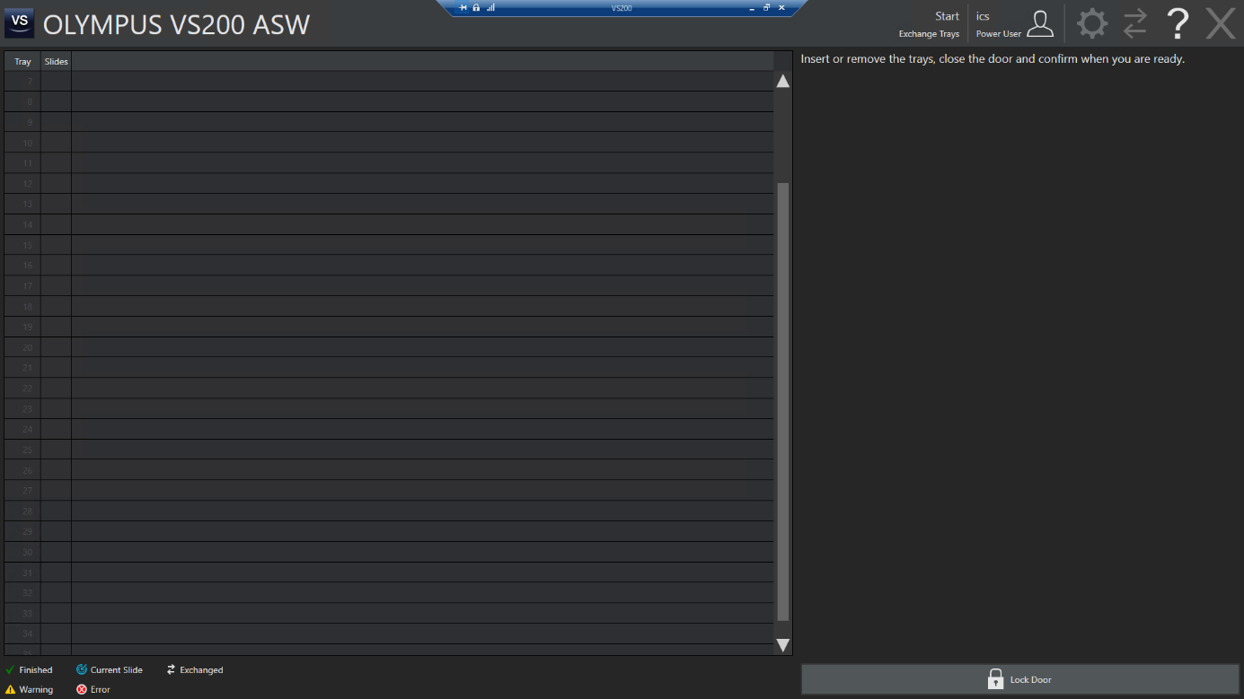
Figure 4. Lock Door button. Click the lock door button (lower right) to have VS-ASW check the occupied tray and slot positions, this will allow other software functions to resume.

  - Defining Fluorescent Experimental Parameters, “Scan Project” Creation:
    - From the VS-ASW homepage, select “Single Scan” (Figure 3, upper left corner).
    - Select Fluorescence as the scan type and select a scan project (Figure 5, upper right), then click the “Edit Scan Settings” button (Figure 5, lower right). This will bring you to a setting editor page (Figure 6).
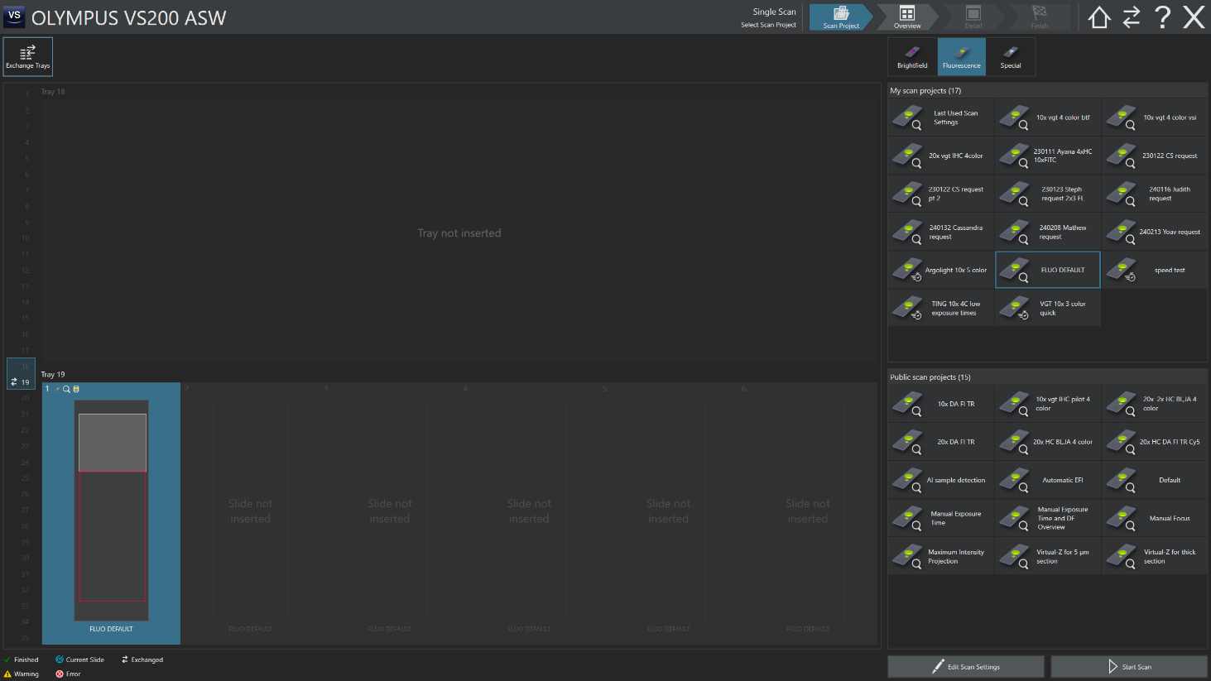
Figure 5. Single Scan, Project selection.

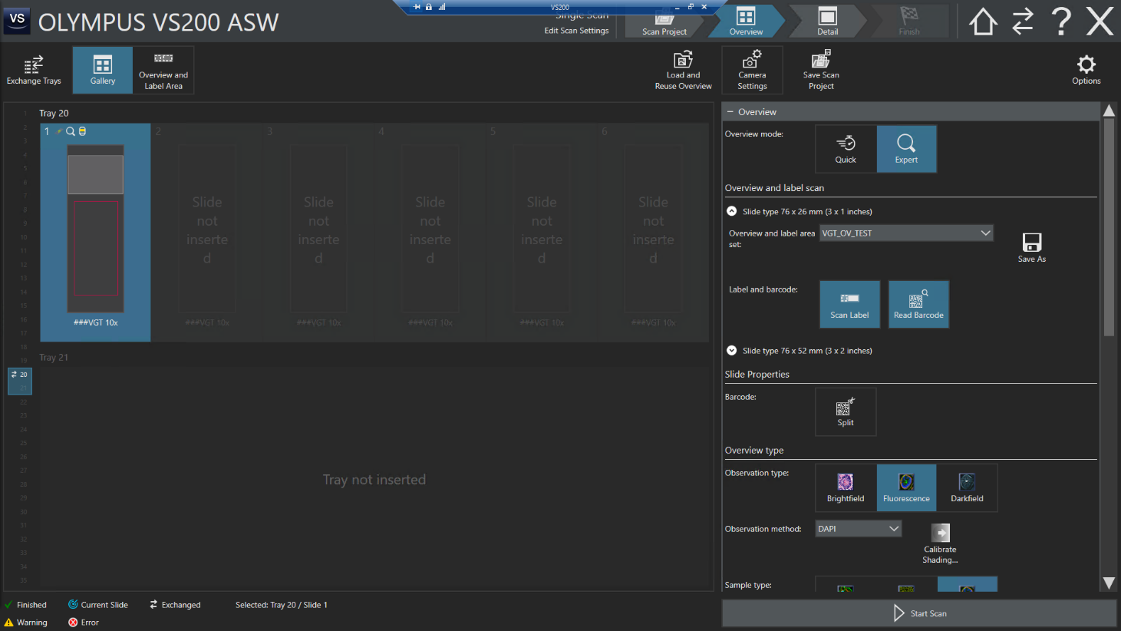
Figure 6. Scan Setting editor page.

    - Options Menu
      - The correct image file format options must be selected before any overview images are generated. Hold down the shift key while clicking the “Options” cog icon in the upper right corner of the screen (Figure 6). An “Options” window will open (Figure 7).

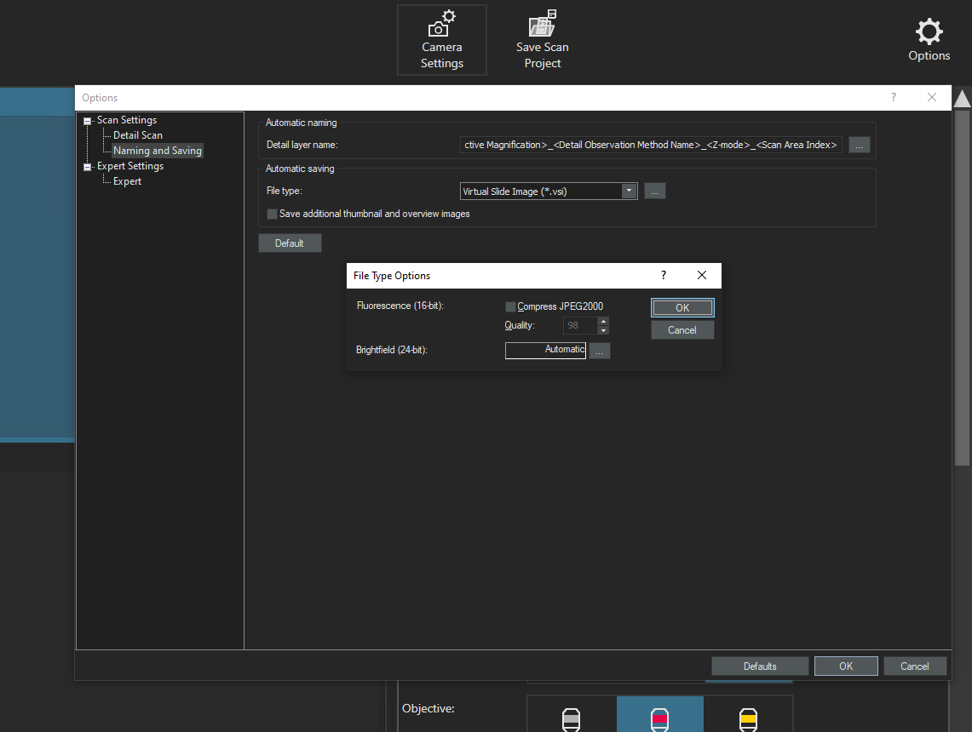
Figure 7. Options window, part 1. Note the “File Type Options” window will open upon clicking the “…” button right of the file type currently selected.

      - In the Options window, select the Scan Settings > Naming and Saving from the directory on the left. Under Automatic saving, ensure that VS-ASW is saving images to the Virtual Slide Image (.vsi) file format. Then, hold the shift key while left clicking the ellipsis button. Ensure that the box for “Compress JPEG2000” is deselected and hit OK.
      - Then, use the Directory at the left-hand column of the window to select Expert Settings > Expert. This menu will open in the window (Figure 8). The settings shown in Table 1 should be selected.
      - Then hit the “OK” button in the lower right to apply the settings.

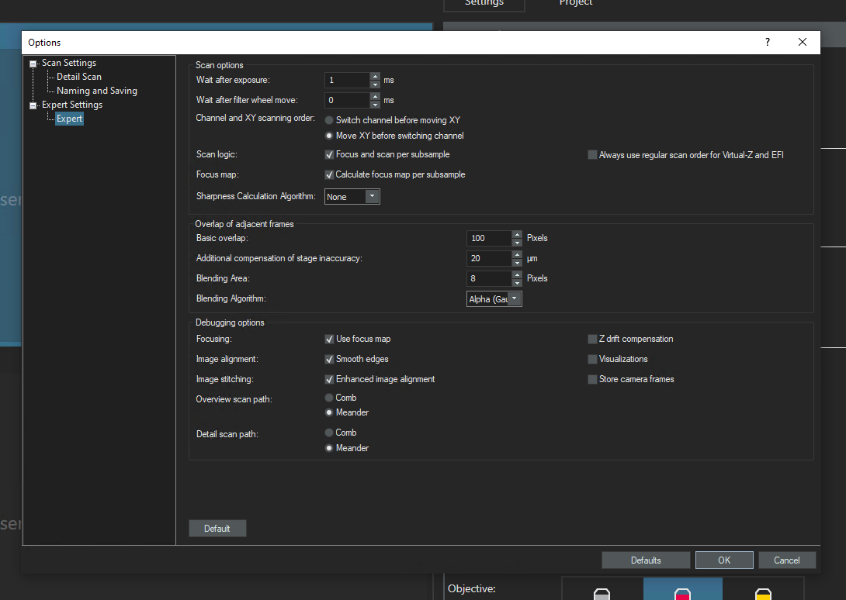
Figure 8. Options window, part 2. Ensure all the settings match this figure, but pay particular attention to
“Channel and XY scanning order” as the VS-ASW default is not preferred.
Setting | Setting | Value
Scan Options | Wait after exposure: | 1 ms
Scan Options | Wait after filter wheel move | 0 ms
Scan Options | Channel and XY scanning order | Select Move XY before switching channel
Scan Options | Scan logic | Check ‘Focus and scan per subsample’  Uncheck ‘Always use regular scan order for Virtual-Z and EFI’
Scan Options | Focus map | Check ‘Calculate focus map per subsample’
Scan Options | Sharpness Calculation Algorithm | None
Overlap of adjacent frames | Basic Overlap | 100 Pixels
Overlap of adjacent frames | Additional compensation of stage inaccuracy: | 20 μm
Overlap of adjacent frames | Blending Area | 8 Pixels
Overlap of adjacent frames | Blending Algorithm | Alpha (Gauss)
Debugging Options | Focusing | Check Use focus map, disable Uncheck Z drift compensation
Debugging Options | Image alignment: | Check Smooth edges, disable Uncheck visualizations
Debugging Options | Image stitching | Check Enhanced image alignment, Uncheck Store camera frames
Debugging Options | Overview scan path | Meander
Debugging Options | Detail scan path | Meander
Table 1. Scan Settings

    - Overview Settings
      - Set the Overview mode to “Expert” edit or troubleshoot the Sample detection or Focus maps. Later, we will change the VGT scan project to “Quick” mode, so that scan areas and focus points to not require review during batch scanning (Figure 5).
      - Under Overview and label area (Figure 6, right column), use the drop-down menu to select the “VGT_OV” overview and label area.
      - Under Label and barcode ((Figure 6, right column), select “Scan Label” as well as “Read Barcode.”
      - Leave the Barcode “Split” option deselected.
      - Scroll down in the right column to bring the Overview type and Overview focusing sections into view (Figure 9).
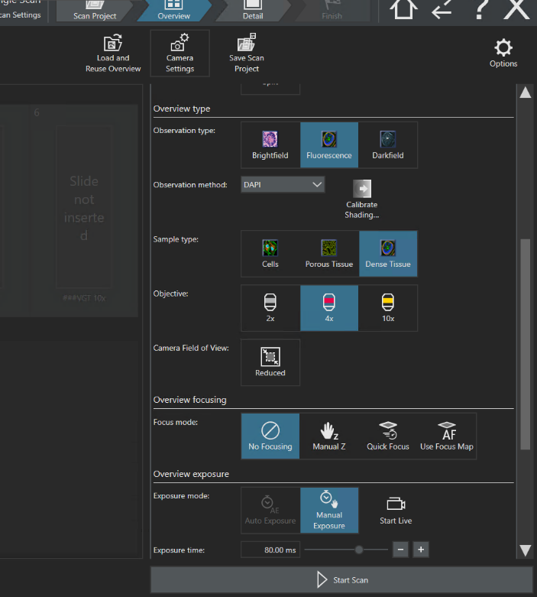
Figure 9. Overview Scan Setting editor page.

      - Set the parameters for a Fluorescent overview in the DAPI channel, using the 4x objective. Leave the ‘Reduced camera field of view’ unselected (Figure 9).
      - Under ‘Overview focusing’, select: No Focusing.
      - Scroll down to the Overview Exposure setting (Figure 10).
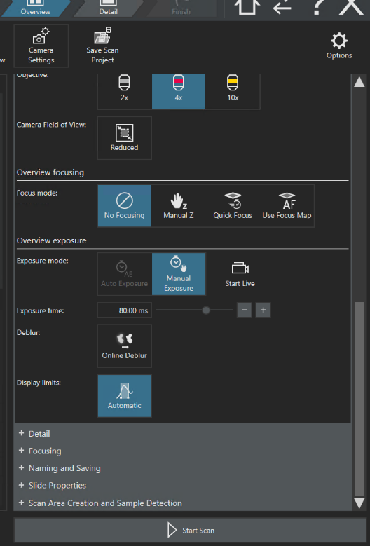
Figure 10. Overview Scan Setting editor page.

      - Under ‘Focus mode’ select Manual Exposure. Overview exposure time of 80 ms and 4x has been working well, but it may be adjusted to improve tissue detection. Note that overview exposure does not impact the image capture parameters of the Detail Scan (higher magnification 10x or 20x) image.
      - Select a slide and then hit “Start Scan” (Figure 6, lower right). An overview image will be acquired.
    - Detail Scan Settings
      - Select the “+ Detail” Bar in the settings column (Figure 10, low) to open the settings for the detail portion of the scan (Figure 11).
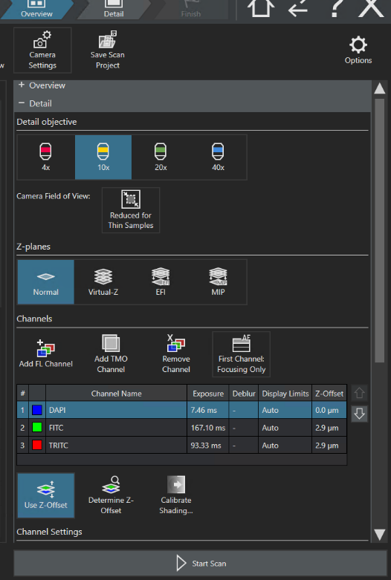
Figure 11. Detail Scan Setting editor page.

      - For Viral Genetic Tools (VGT) primary screen scanning, select the following parameters:
        - Detail objective: 10x
        - Z-planes: Normal
        - Scroll down. Ensure that manual exposure is selected. Online Deblur and automatic Display limits should be deselected. Hit Start Live to enter a live view, where display limits may be adjusted using the histogram in the upper left-hand corner of the window. The text fields sync to the histogram, and the Channel list will update when you alternate between channels within Live mode, or when you exit Live mode. Ensure the correct channels have been added, in the correct order. Unless otherwise noted, production slides consisting of mouse tissue are “Routine Primary Screen” slides, and should be acquired in DAPI, YFP, and mCherry with the specified exposure times. Table 2 shows that CFP is to be used as the focusing channel in the absence of DAPI stain. Alternative filters and exposure times may be used upon request by VGT members for non-routine slides (ex. non-human primate tissue or alternative fluorescent proteins). These instructions must be communicated prior to slide delivery to the Microscopy Core. Finally, verify that the correct settings have been selected for Exposure times, Display Limits, and Z-Offset (Table 3).
        - Enable Z-offset (and then set z-offset per the parameters listed above)

Slide Type | DAPI | CFP | FITC | YFP | TRITC | mCherry
Routine Primary Screen | X (F) |  |  | X |  | X
No DAPI stain |  | X (F)
Table 2. VGT Production Slide Scanning Parameters: Channels to image based on slide type. (F) indicates the channel in which to acquire focus.

Channel | Exposure (ms) | Display Limits (grey values) | Z-Offset (μm)
DAPI | 6 | 2000-20000 | 0.0
CFP | 250 | 3000-16000 | 2.9
FITC (green) | 250 | 2000-11000 | 2.9
YFP | 250 | 2000-20000 | 2.9
TRITC (red) | 100 | 2000-35000 | 2.9
mCherry | 100 | 2000-35000 | 2.9
Table 3. Fluorescent Channel Parameters

    - Focusing
      - Open the “+ Focusing” bar. A new menu will open (Figure 12).
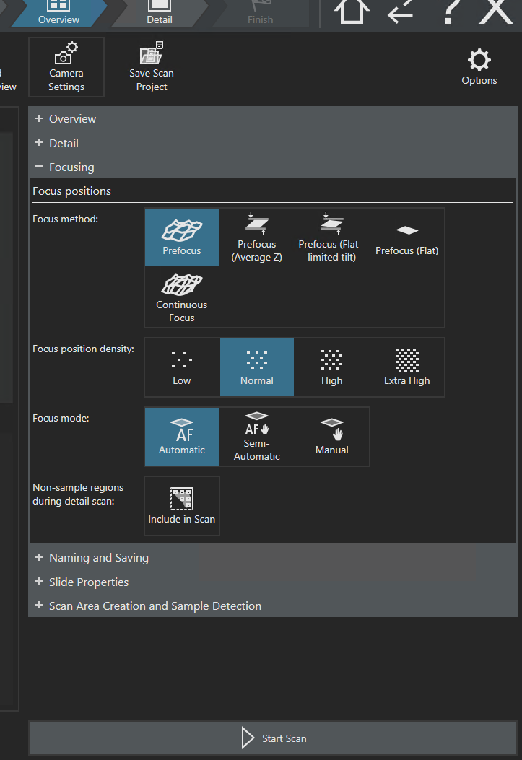
Figure 12. Detail Scan settings - Focusing.

      - Set ‘Focus method’ to Prefocus, ‘Focus position density’ to Normal, and ‘Focus mode’ to Automatic (Figure 12). Ensure that ‘non-sample regions during detail scan’ is deselected. Open the Naming and Saving menu (below the Focusing menu). A new menu will open (Figure 13).
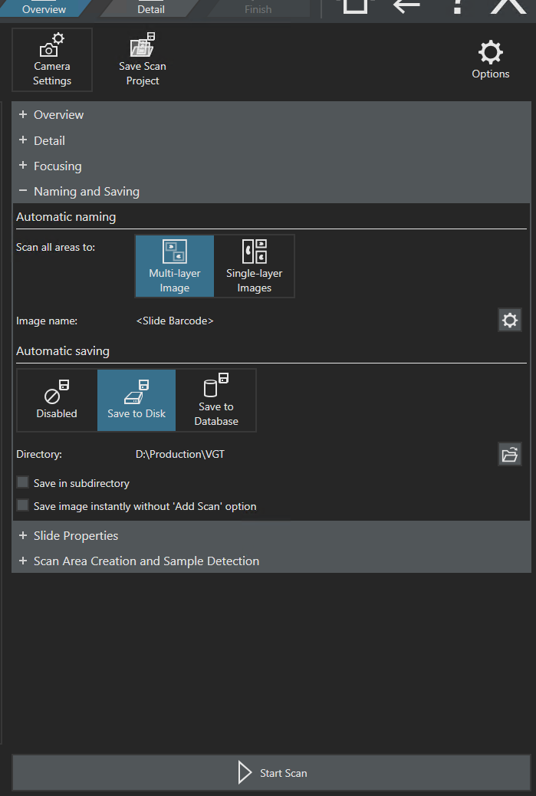
Figure 13. Detail Scan settings – Naming and Saving.
    - Naming and Saving
      - Under the ‘Automatic naming’ header (Figure 13), set ‘Scan all areas’ to Multi-layer Image.
      - Under ‘Image name’, click on the Cog icon on the right side of the column. A new window will open (Figure 14). This menu allows for naming barcodes according to many metadata parameters.

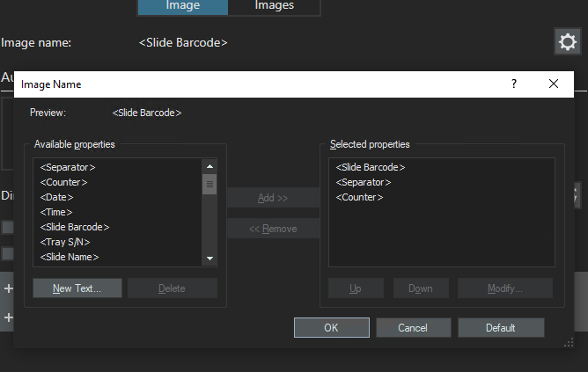
Figure 14. Detail Scan settings – Naming and Saving – Naming menu.
        - For VGT slides, images are named according to barcode. However, adding the ‘Separator’ and ‘Counter’ components ensures that a first image will not be overwritten if the second with the same barcode is saved to the same directory.
        - For VGT slides: Add, Remove, and move Up or Down the components such that the Selected Properties are <Slide Barcode>, <Separator>, and <Counter>, in that order.
        - Click “OK” to confirm the selection, the window will close.
      - Set the saving directory to the desired folder using the folder icon (Figure 13, center right). VGT production slides are saved in D:\Production\VGT.
      - Skip the ‘Slide Properties’ menu and select the ‘Scan Area Creation and Sample Detection’. A new menu will open (Figure 15).
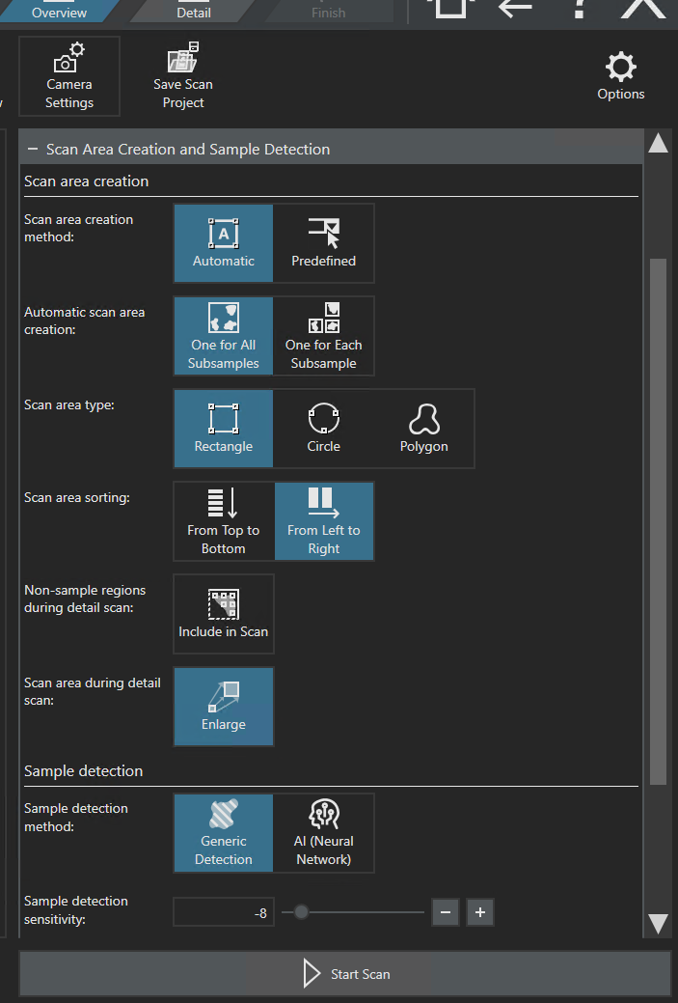
Figure 15. Detail Scan settings – Scan Area Creation and Sample Detection.
    - Scan Area Creation and Sample Detection
      - Ensure that ‘Scan Area Creation’ is configured according to Table 4.
      - Ensure that ‘Sample Detection Configuration’ is configured according to Table 5 for VGT slides. Sample detection serves to determine the proper scan areas and focus maps for samples. These may be adjusted to better optimize scan time and preventing the tissue sample detection from excluding tissue from scans.
Setting | Selection
‘Scan area creation method’ | Automatic
‘Automatic Scan area Creation’ | One for All Subsamples
‘Scan area type’ | Rectangle
‘Scan area sorting’ | From Left to Right
‘Non-sample regions during detail scan’ | do not include in scan (leave unselected).
Scan area during detail scan | Enlarge (Scroll Down for More Options)
Table 4. Options for Scan Area Creation.

Setting | Selection
Sample detection Method | Generic
Sample detection sensitivity: | 2
Non-colored sample detection weight: | 35 %
Only Keep objects of size between: | 5.806 – 130000 mm²
Fill holes smaller than: | 20.000 mm²
Table 5. Sample Detection Configuration for VGT slides.

      - The settings in Table 5 may be adjusted on a runplan-by-runplan or slide-by-slide basis in order to preclude missed tissue and to reduce the capture of non-tissue. These settings are specified here for the creation or recreation of the Scan Projects for VGT primary screen.
    - The Scan Settings should now conform to this SOP, so you will save them for future use. Go to the top right of the screen and select Save Scan Project (Figure 6, upper right). Save the scan project. Adding a special symbol such as “#” will place the production scanning parameters at the top of the list of available fluorescent scan projects.
  - Batch scanning
    - Single Scan mode is most convenient for changing scan settings; however, Batch Scan will be used for most production slides. Navigate to the home screen by clicking the house/home icon (Figure 6, upper right). From the home screen (Figure 3), Select Batch Scan. A new page will display (Figure 16).
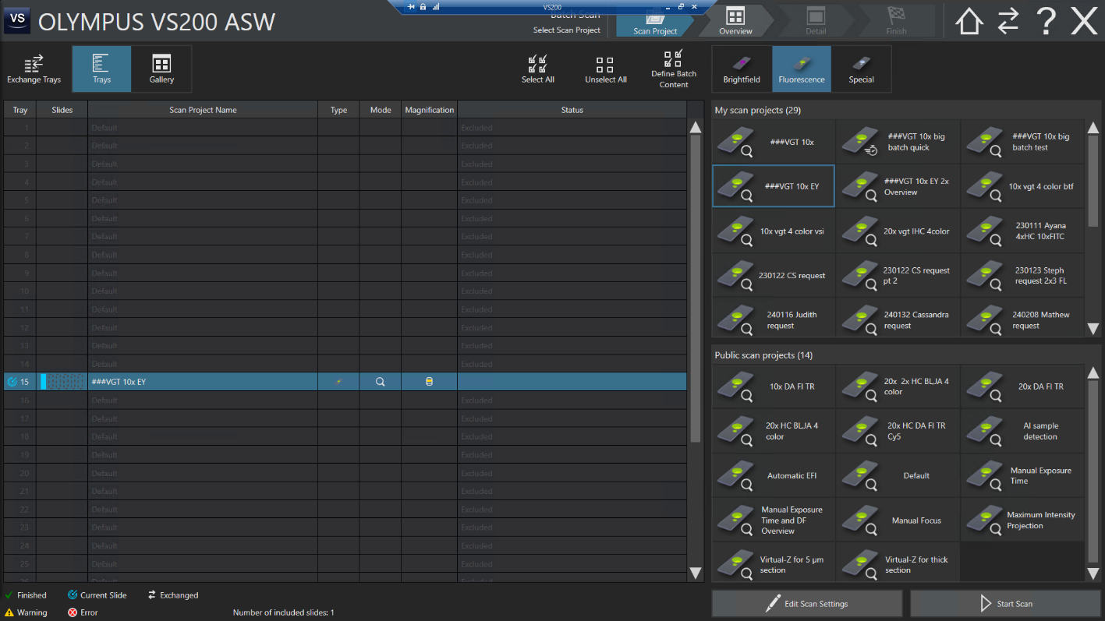
Figure 16. Batch scanning – Scan project page.
    - Select one or more trays to be imaged (click then shift+click).
    - Select the appropriate scan project and note that the scan project names change for the selected trays.
    - Hit “Start Scan.”
    - After the scan is complete, the images may be reviewed by Clicking ‘Image.’ Make note of any slides that need to be rescanned by their respective tray and slot positions. Use the exchange trays feature to pull any slides that need to be cleaned before rescanning and load them for another smaller batch scan.
    - Repeat 7.4.5 as necessary.

- Take Down:
    - After scanning is complete, unload the instrument by removing all the trays, and all the slides from those trays. Close the instrument’s door.
    - To take down, begin by closing out of VS-ASW.
    - Perform To shut down the instrument, reverse steps 6.1.2.1- 6.1.2.4.
    - Do not turn off the UPS.

