For -protocols.io
A standardised protocol for extracting environmental DNA (eDNA) from honey samples of diverse origin
Gopika Bhasi ^{1,2}, Gemma Zerna ^{1,2} and Travis Beddoe ^{1,2}*
¹ Department of Ecological, Plant and Animal Science, School of Agriculture, Biomedicine and Environment, La Trobe University, Bundoora 3083,Australia; 20522812@students.latrobe.edu.au (G.B.); g.zerna@latrobe.edu.au (G.Z.)
² La Trobe Institute for Sustainable Agriculture and Food, La Trobe University, Bundoora 3083, Australia
* Correspondence: t.beddoe@latrobe.edu.au

Abstract : We have optimised and validated an in-house protocol for extracting environmental (eDNA) that is applicable to both processed (Commercial honey samples) and unprocessed (backyard hive honey samples) honey samples. The protocol comprises a pre-treatment phase and post-treatment phase for eDNA isolation. A flow diagram of the pre-treatment and post-treatment phase is provided for easy understanding.
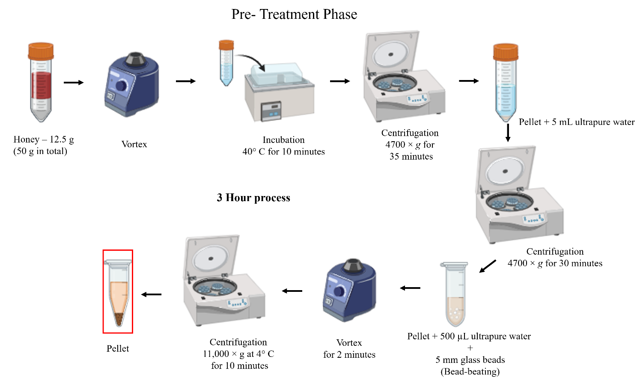
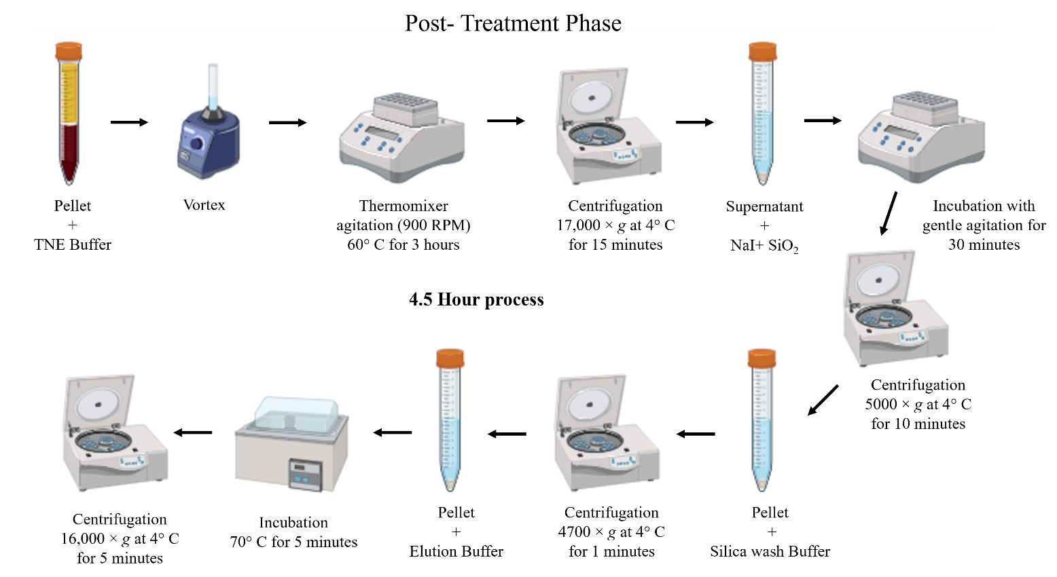
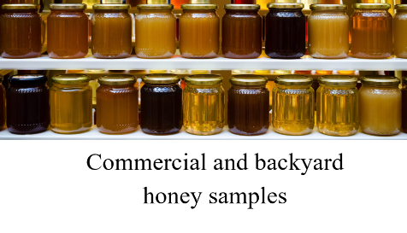
Pre-treatment pellets serve as starting material for post-treatment

Materials Required
- Honey samples
- Ultra-pure water
- 50 mL tubes
- 5 mL tubes
- 1.5 mL and 2 mL tubes
- 5 mm Glass beads
- TNE Buffer (pH 7.5)
- 5 M guanidine hydrochloride (w/v)
- Proteinase K solution (20 mg/ml⁻¹)
- 6M sodium iodide (NaI)
- 100 mg/mL silica dioxide (SiO₂)
- Silica wash buffer
- 10 mM Tris-HCl Elution Buffer (pH 8)
Protocol
Pre-Treatment Phase
Step 1 : A total of 50 g of honey was carefully divided into four sterile 50 mL centrifugation tubes, with 12.5 g transferred into each tube.
Step 2 : 40 mL of ultrapure water (Milli-Q®) is added to each tube and vortexed thoroughly to ensure complete homogenisation.
Step 3 : Samples are incubated in a water bath at 40°C for 10 minutes.
Step 4 : Samples are then centrifuged at 4700 ×g for 35 minutes.
Step 5 : Following centrifugation, the supernatant is carefully discarded, and each resulting pellet is resuspended in 5 mL of ultrapure water.
Step 6 : The suspensions were pooled into sterile 50 mL centrifugation tubes corresponding to the original honey samples.
Step 7 : The pooled samples are then subjected to an additional centrifugation at 4700 ×g for 30 minutes.
Step 8 : After centrifugation, the supernatant is carefully discarded, and the pellet is resuspended in 500 µL of ultrapure water.
Step 9 : This suspension is then transferred to a 2 mL microcentrifuge tube containing seven 5 mm sterile glass bead.
Step 10 : The microcentrifuge tubes are vortexed for 2 minutes.
Step 11 : The glass beads are removed using sterile fine-tipped tweezers.
Step 12 : The suspension then centrifuged at 11,000 ×g at 4° C for 10 minutes.
Step 13 : The supernatant is carefully discarded, and the resulting pellet serves as the starting material for the post-treatment phase.

Post-Treatment Phase
Step 14 : The pellet obtained from the pre-treatment phase is resuspended in 860 µL of pre- heated (60° C) TNE extraction buffer (10 mM Tris-HCL, 150 mM NaCl, 2mM ethylenediaminetetraacetic acid, 1% (w/v) sodium dodecyl sulfate, pH 7.5).
Step 15 : To the lysate, 100 µL of 5 M guanidine hydrochloride (w/v) and 40 µL of proteinase K solution (20 mg/ml-1) were added to facilitate protein denaturation and prevent enzymatic degradation of DNA.
Step 16 : This lysis mixture is incubated at 60° C for 3 hours in a Thermomixer Comfort (Eppendorf AG, Hamburg, Germany) with agitation at 900 RPM.
Step 17 : Followed by centrifugation for 15 minutes at 17,000×g at 4° C.
Step 18 : The supernatant is collected in a 5 mL tube for DNA purification.
Step 19 : The supernatant is mixed with 2 Volumes of 6M sodium iodide (NaI) and 100 µL of 100 mg/mL silica dioxide (SiO2).
Step 20 : The samples are allowed to mix well by gentle agitation on a rocker for 30 minutes.
Step 21 : This is followed by centrifugation for 10 minutes at 5000 ×g at 4° C.
Step 22 : The supernatant is carefully discarded.
Step 23 : The pellet is resuspended in 500 µL of silica wash buffer (50% (v/v) ethanol, 10 mM Tris-HCl, 100 mM NaCl, 1 mM EDTA, pH 8) by vortexing.
Step 24 : This suspension is then centrifuged for 1 minute at 4700 ×g at 4° C.
Step 25 : The wash step (step 23 and 24) is repeated two more time.
Step 26 : The supernatant is carefully discarded.
Step 27 : To elute eDNA from the silica matrix, 50 µL of elution buffer (10 mM Tris-HCl, pH 8) is added and incubated at 70°C for 5 minutes.
Step 28 : Following incubation, the samples are centrifuged for 5 minutes at 16,000 ×g.
Step 29 : The supernatant is carefully pipetted into a 1.5 mL microcentrifuge tube and stored in -20 ° C.
Step 30 : The concentration of isolated eDNA is measured using a Nanodrop Eight spectrophotometer.
Step 31 : The isolated eDNA is validated by performing end-point Polymerase Chain Reaction (PCR) targeting Apis mellifera mtDNA. Genomic DNA from a healthy adult bee is used as a positive control, and nuclease-free water as a no-template control (ntc).
Step 32 : Amplified PCR products are visualized by agarose gel electrophoresis using a 2% (w/v) agarose gel prepared in 1X TBE buffer (0.13 M Tris, 45 Mm Boric acid, 2.5 mM EDTA pH 7.6) containing 0.2 µg/mL ethidium bromide.
Step 33 : The DNA bands are visualized under a UV illuminator to confirm successful amplification

Reference
1. Soares, S., Amaral, J. S., Oliveira, M. B. P. P., & Mafra, I. (2015, 2015/2//). Improving DNA isolation from honey for the botanical origin identification. Food control, 48, 130-136. https://doi.org/10.1016/j.foodcont.2014.02.035
2. Mafra, I., Silva, S. A., Moreira, E. J., da Silva, C. S. F., Beatriz, M., & Oliveira, P. (2008). Comparative study of DNA extraction methods for soybean derived food products. Food control, 19(12), 1183-1190.

