SOP 3: Standard Operating Procedure for Focus Group Discussions

Project title | VERDI – SARS-coV2 variants Evaluation in pRegnancy and paeDIatrics cohorts
Appendix title | Standard Operating Procedure for Focus Group Discussions
SOP number | 3
Version | 1.0
Date | 23 October 2025
Authors | Tom Witney, Shema Tariq

Summary
This standard operating procedure (SOP) provides an overview of organising qualitative focus group discussions. It provides a step-by-step guide to organising a focus group discussion and handling the qualitative data generated. This SOP is to be used in conjunction with Qualitative Umbrella Protocol (LINK).

Table of Contents
1. Summary 1
2. Definitions 3
3. Abbreviations 3
4. Focus group discussions 4
4.1 Background 4
4.2 Rationale 4
4.3 Advantages and Disadvantages of Focus Group Discussions 5
4.4 Sampling 5
4.5 Recruitment 6
4.6 Procedures 6
4.7 Analysis 7
4.8 Ethics 8
4.9 Patient and public involvement (PPI) 9
4.10 Related methods 9
5. Supporting documentation 11
6. References 16

Definitions
Key definitions

Abbreviations
FGD: Focus group discussion
SSI: Semi structured interview
WP: Work Package

Focus group discussions

Background
Focus group discussions (FGDs) are a qualitative research method involving a small group of individuals (typically 6-8) facilitated by two researchers (or a member of a community organisation) to discuss a specific topic in a relaxed environment. The primary aim is to elicit diverse perspectives, opinions, beliefs, and experiences on a topic through guided interaction and discussion among participants. FGDs emphasise group dynamics and the generation of data through social interaction, often revealing shared understandings, norms, and disagreements within a community.
FGDs can provide qualitative insights into diverse research questions during a disease outbreak. These might include some or all of the following:
- Understanding community knowledge, attitudes, and practices regarding the disease, its transmission, prevention, and control measures.
- Identifying barriers and facilitators to current or planned public health interventions, including vaccination campaigns, hygiene practices, or isolation protocols.
- Assessing community information needs and effectiveness of health messages.
- Exploring the social, psychological, and economic impacts of the outbreak on individuals and families.
- Informing development of culturally appropriate and effective public health policies, interventions, and communication strategies during an outbreak.
- Rapid assessment of emerging issues: FGDs can be deployed quickly to gather preliminary insights into rapidly evolving situations, such as community reactions to new policies or the emergence of new symptoms.

Rationale
Focus Group Discussions can be selected to answer a variety of research questions and achieve diverse objectives. They are particularly well suited to the following aims:
- To gain in-depth understanding: Generate rich, nuanced data that quantitative methods cannot capture, for example exploring the reasons that people hold certain beliefs or behave in particular ways.
- To explore sensitive topics: The group dynamic can encourage participants to share experiences and opinions on sensitive or stigmatized topics that might be difficult to express in individual interviews.
- To observe group dynamics and consensus/dissent: Interaction between FGD participants can reveal how opinions are formed and negotiated within a community, identifying areas of agreement and disagreement.
- To provide community voice and address power imbalances: Engaging with a group of participants drawn from a community can enhance the inclusion of community perspectives and needs in research, integrating them into research and public health responses, fostering ownership and trust.

Advantages and Disadvantages of Focus Group Discussions
Advantages
- Provide rich, in-depth data that can yield insights into complex issues.
- Capture the social context of opinions and beliefs and allow exploration of group norms that cannot be achieved in individual interviews.
- A flexible method that is adaptable to emerging themes and participant interests within the discussion guide, this allows for organic interaction and the emergence of new ideas.
- Can empower participants by giving them a platform to share their experiences.
Disadvantages
- Moderating a discussion can be challenging and requires skill to ensure that all participants are heard and that individuals feel supported to express opinions that do not conform to perceived group opinions.
- Logistical challenges: Recruiting, scheduling, and safely conducting FGDs can be difficult, particularly during outbreaks.
- Data analysis complexity: Requires specialised skills for qualitative data analysis, with particular attention to dynamics of conversation and non-verbal communication.

Sampling
The size and composition of a FGD is important, as this influences group dynamics and richness of the data generated.
Size
While there are no strict rules, group size should support both depth of discussion and effective facilitation. Aim for 6–8 participants to balance rich interaction with manageable group dynamics. Small groups may lack sufficient diversity and interaction, limiting data richness. Large groups can be difficult to moderate and may restrict individual contributions.

Group composition
Composition of FGDs needs to be considered carefully to ensure that diverse voices are included and populations that are key to the research question are represented. For instance, in an infectious disease outbreak patients, caregivers, and frontline healthcare professionals may be included.
It is important to be aware of potential power differentials and likelihood that participants will feel more comfortable with others who share characteristics or experiences. What these characteristics are will depend on the research topic. For example, when discussing sexual behaviour people may prefer to be in groups of similar gender. If speaking to professionals, it may be necessary to include junior and senior members of teams in separate FGDs.
Researchers should actively probe for differing views.

Recruitment
Recruitment will depend on the research topic and population(s) of interest. This might include people attending healthcare, healthcare professionals (via professional networks, or within healthcare settings), and community participants. Participants in community settings can be recruited in diverse ways including in collaboration with community-based organisations, advertising (posters and social media), snowball sampling, and via personal and professional networks. It is important to be aware of the risk of imposters when recruiting people online whereby people who do not meet the inclusion criteria seek involvement to obtain reimbursement. For this reason, we advise not advertising reimbursement.
You will need to define exclusion and inclusion criteria.
You will also outline informed consent procedures and consider participant reimbursement.

Procedures
All FGDs will be conducted using a topic guide. This will be developed by the research term (ideally in collaboration with people with lived experience), with specific attention to questions and activities that will generate interactions between participants and engage them. FGDs are usually facilitated by two people (two researchers, or a researcher and a community representative). The co-facilitator can assist with setting up, any technical issues, and making notes and observations. Before starting you should introduce yourselves and the project and establish some ground rules (see additional material).
FGDs can be conducted in person, online or by telephone. It is advised to offer a range of options to maximise inclusion.
In person
You should identify a private space that is accessible and meets the access needs of participants (you may wish to consider sending an access needs survey in advance). Your schedule should include a comfort break, and it is good practice to provide refreshments. You will record the FGD using digital voice recorders (ideally two).
Online
Your choice of video-conferencing platform will depend on your own preference and local data protection requirements. At University College London we use Microsoft Teams as any recorded data are stored in the Cloud in the UK/EU. You should ensure participants are familiar with this platform prior to FGDs, which may require arranging pre-meetings.
Mode of recording will depend on the sensitivity of the data and local data protection requirements and is likely to be either Microsoft Teams or a digital voice recorder.
Data will be transcribed verbatim (usually intelligent verbatim, missing out pauses and ‘uhs’, ‘er’).

Analysis
You will need to check transcripts for accuracy and will have notes to also assist in analysis. You are likely to use qualitative data analysis software (e.g., NVivo, Atlas.ti) to support the process of analysis. We currently do not recommend AI-supported qualitative analysis due to concerns about data protection.
We recommend using Rapid Assessment Procedure (RAP) sheets (see additional material and RAP SOP) to capture reflections after the FGD.
The most appropriate form of analysis will depend on the precise research question and aim, but the following approaches are most likely to be of greatest use during an outbreak.
Reflexive thematic analysis: The most common approach, involving the systematic identification, analysis, and reporting of patterns (themes) within the qualitative data. Braun and Clarke provide an overview of different approaches to qualitative thematic analysis and a step-wise approach to completing an analysis (1, 2). Also see https://www.thematicanalysis.net/doing-reflexive-ta/
Discourse analysis: Examines how language is used in social contexts to construct meaning, power relations, and social realities (3).
Narrative analysis: Focuses on the stories and experiences shared by participants, exploring how they construct meaning from their experiences during the outbreak (4).
Framework analysis: A systematic method using a matrix to organise data into themes and categories guided by both pre-set and emerging concepts (5) .
We advise that a proportion of FGD transcripts are double coded to ensure consistency and reliability. FGD findings can be triangulated with other data sources (e.g., surveys, key informant interviews, epidemiological data) to enhance validity.

Ethics
As a research activity involving human participants, all studies using FGDs will need to be approved by a recognised ethics review board or institutional review committee. Exact requirements must be checked with the appropriate ethics committee, but key considerations include:
Informed consent
Ensure all participants provide informed consent. Clearly explain the purpose of the FGD, how the data will be used, and participants’ right to withdraw at any time without penalty. You should inform them that due to the nature of FGDs as a conversation, you will be unable to remove any data provided prior to the point of withdrawal as it can impact meaning. People should have sufficient time to consider participation and opportunity to ask questions (ideally at least 24 hours).
Participants can complete the consent form online using an electronic signature/printed name (and the consent form emailed back to the research team) or software such as DocuSign. Participants can also request verbal consent, in which case the research team will arrange to speak to them prior to the FGD and audio record the consent process.
For in-person FGDs, participants can choose to sign the consent form in any of the ways stated above, as well as in person immediately before the FGD.
Confidentiality
Participants are likely to be sharing highly sensitive information including about their health and, depending on how the infection is acquired, potentially their sexuality. Therefore, data must be handled with the highest of standards regarding confidentiality and data protection.
Maintain strict confidentiality of participant identities and responses. Use pseudonyms in transcripts and reports, and remove any other identifying information. Prior to the FGD ask participants not to share the discussion beyond the FGD.
Data protection
FGDs should be recorded on an encrypted, password protected sound recorder. Following the FGD the recording should be transferred to a university secure storage facility within 7 days and the audio file deleted from the voice recorder.
If using Teams, you will need to ask for consent to record audio and video. The recording will be stored in the Cloud but will not be available to anyone outside the research team. Copilot can be used to transcribe – Microsoft does not use AI-transcription data to optimise their AI models. However, you should ask for consent to use Copilot for this purpose. If you use any other AI-transcription you should familiarise yourself with the program’s use of data and any implications for privacy and data security.
If not using AI-transcription, you will require audio data to be sent to professional transcription companies. There should be a contract and non-disclosure agreement in place and arrangements for secure transfer of data to and from the company, with clear description of data deletion.
Once transcripts are checked for accuracy, recordings should be securely deleted.
Risk to participants and researchers
For FGDs conducted in person, carry out a risk assessment to ensure the safety of participants and facilitators. Implement infection prevention and control (IPC) measures, including physical distancing, mask-wearing, and hand hygiene where needed.
You should have a pathway to manage participant distress which may include a resource pack with information about further support, referral onto a local community organisation, discussion with healthcare team and/or discussion with the Chief Investigator.
Researchers experiencing distress should be able to seek support from the Chief Investigator and through their university/employer.

Patient and public involvement (PPI)
Engaging with patients and the public can ensure that FGDs are informed by the experiences, needs, and perspectives of communities. The principles below can help guide PPI work for a FGD.
- Involve patients, caregivers, and community representatives in the design and planning stages of the FGDs to identify relevant concerns and priorities. Where possible, include representation from diverse and affected populations, including vulnerable or marginalised groups.
- Work with PPI groups to develop accessible and culturally appropriate materials to facilitate understanding and engagement with the research.
- Co-develop FGD recruitment materials, discussion guides and activities to ensure relevance and sensitivity.
- Involve community members in identifying appropriate recruitment strategies.
- Maintain regular updates with participants and community stakeholders throughout the research process and provide opportunities for feedback and adapt approaches based on this feedback.
- Share findings with participants and the broader community in clear, non-technical formats (e.g., community briefings, infographics). Highlight how public input influenced the research and its outcomes.
- Recognise and respect the contributions of public participants and ensure transparency, voluntary participation, and appropriate recognition or compensation where applicable.

Related SOPs
- Individual interviews

Supporting documentation
Sample advertisement
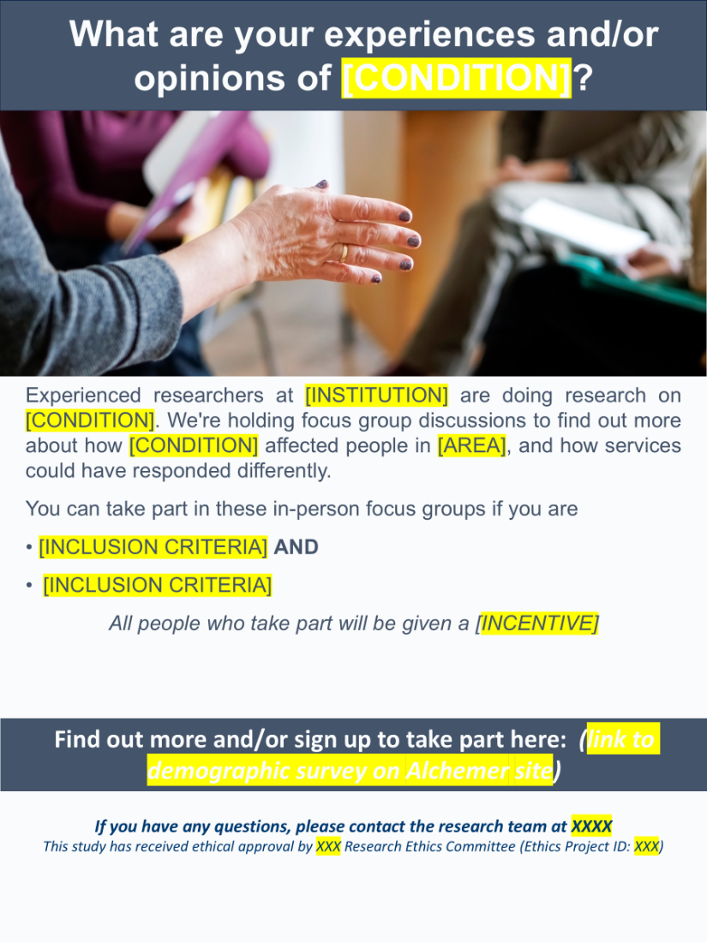

Sample ground rules
Ask participants to amend or add.
Respect all opinions: Every viewpoint is valid and should be treated respectfully.

Confidentiality: What is shared in the group stays in the group.

One person speaks at a time: Avoid interruptions to ensure clarity and inclusivity.

No right or wrong answers: All responses are valuable and contribute to understanding.

Speak freely and honestly: Encourage openness without fear of judgment.

Stay on topic: Keep discussion focused on the research questions.

Allow everyone to contribute: Ensure equal participation; no one dominates.

Listen actively: Engage with and consider others’ perspectives.

Use first-person language: Share personal experiences rather than generalizations.

Turn off distractions: Phones and other devices should be silenced or put away.
Sample discussion guide
Focus Group Discussion Topic Guide

Who are we and what are we trying to do?
- Thank you for agreeing to participate in this focus group discussion on [disease].
- We are a team of experienced researchers from [Institution].
- We are very interested to hear your opinion on [subject]
- The purpose of this study is to learn what you think about [subject]. We hope to learn things that we can use to improve [objective].
What will be done with this information?
- The information you give us is completely confidential. We would like to make a sound recording of the focus groups so that we can capture the full discussion. The recordings will be typed up (transcribed) and then destroyed. No names will be used on the transcriptions.
- You do not have to answer any questions you’re not comfortable with and you can withdraw from the study at any time.
- We understand how important it is that this information is kept private and confidential. Participants will be asked to keep what is said within the group. However, the group setting means that we are unable to promise confidentiality.
- If you have any questions, you can always contact a study team member, or you can call the project team leaders whose names and phone numbers are on this form.
- Please check and sign the consent form to show you agree to participate in this focus group.
Introduction
- Welcome
Introduce yourself and the notetaker and send the Sign-In Sheet with a few quick demographic questions (age, gender) around to the group while you are introducing the focus group.
- Explanation of the process
Ask the group if anyone has participated in a focus group before. Explain that focus groups are being used more and more often in health and human services research.

- About focus groups
- We learn from you (positive and negative)
- Not trying to achieve consensus, we’re gathering information.
- No virtue in long lists: we’re looking for priorities.
- In this project, we are doing both interviews and focus group discussions. The reason for using both tools is that we can get more in-depth information from individual interviews and an overall perspective on the topic of interest in focus groups.
- Logistics
- The focus group will last about [X] hours.
- Feel free to move around.
- Where is the bathroom? Fire exit?
- Help yourself to refreshments.

- Ask the group if there are any questions before we get started and address those questions.

- Turn on recorder x2.

- Introductions
- Go around the table and ask everyone to say who they are, why they wanted to take part, and how their day has been so far.
  - The person leading the FGD should answer the icebreaker question first.
  - Listen Actively and ask follow-up questions if necessary. The goal is to unite the team and give each person the opportunity to answer.
  - Let people interact with one another.
  - Allocate enough time, and don’t rush the answers.
Discussion begins, make sure to give people time to think before answering the questions and do not move too quickly. Use the prompts to make sure that all issues are addressed but move on when you feel you are starting to hear repetitive information.

[Question 1]
Use open-ended questions: What did you think of the…? How did you feel about…?
Avoid leading and closed-ended questions: How happy are you with…? Did you like…?
Prompts: Follow up questions to a broad question, topic not mentioned or elaboration needed
Probes: Further detail of something participant has said. For example, Can you tell us more about … What do others think? Has anyone else experienced that?

Focus group RAP Sheets
Instructions: If there is a third person facilitating, they may take notes on the RAP sheet during discussion. Otherwise, RAP sheet is completed the following morning (or straight after if appropriate) with all facilitators. The same RAP sheet is used by all facilitators for all FGDs. FGDs will be transcribed which will include all of the discussion. These RAP sheets will summarise main points of interest as agreed by the facilitators, as well as notes on the dynamic and pertinent quotes as appropriate.
Researchers will also make notes on emerging themes of interest for future papers separately.
Name of researchers:
Discussion guide question | Discussion (could include quotes) | Dynamic | Discussion/thoughts/ideas

References
1. Braun V, Clarke V, Hayfield N, Davey L, Jenkinson E. Doing reflexive thematic analysis. Supporting Research in Counselling and Psychotherapy: Qualitative, Quantitative, and Mixed Methods Research: Springer; 2023. p. 19-38.
2. Clarke V, Braun V. Thematic analysis. Encyclopedia of critical psychology: Springer; 2014. p. 1947-52.
3. Lupton D. Discourse analysis: a new methodology for understanding the ideologies of health and illness. Australian Journal of Public Health. 1992;16(2):145-50.
4. Wong G, Breheny M. Narrative analysis in health psychology: a guide for analysis. Health Psychology and Behavioral Medicine. 2018;6(1):245-61.
5. Gale NK, Heath G, Cameron E, Rashid S, Redwood S. Using the framework method for the analysis of qualitative data in multi-disciplinary health research. BMC Medical Research Methodology. 2013;13(1):117.

