Supporting information
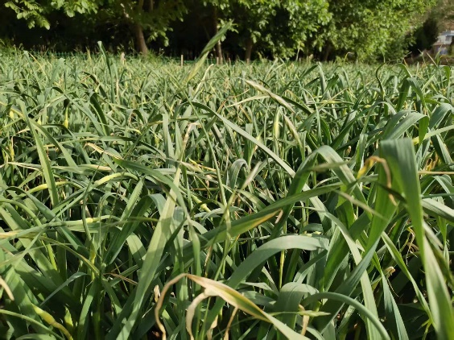 | 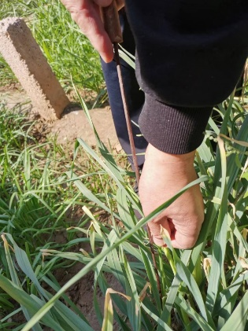
S1 Fig. Garlic scape planting base. Sampling was picked at the Sanyangchuan Garlic scape Planting Base in Tianshui City, Gansu Province in May 2025.

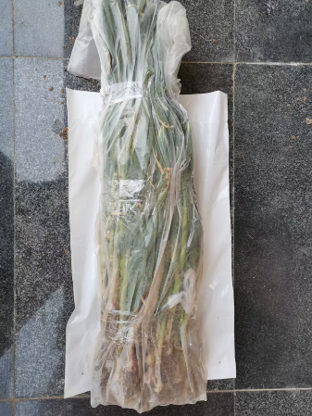 | 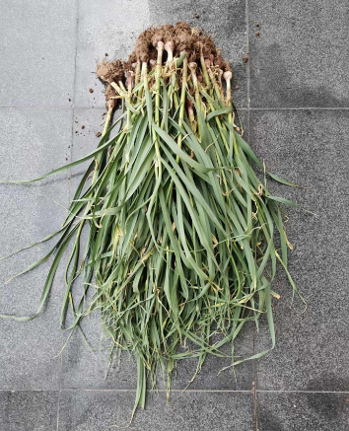 | 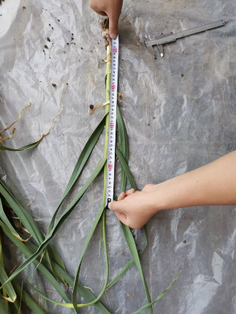
S2 Fig. Picked experimental samples. The picked test samples were taken back to the laboratory for measurement of parameters such as diameter and length.

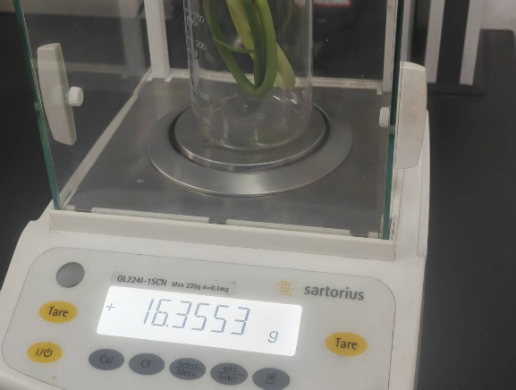 | 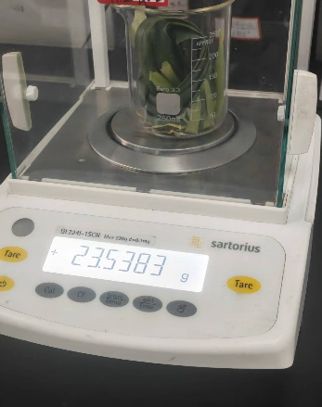
(a) (b)
S3 Fig. The drainage method is used to measure garlic scape density and pseudo-stem density. (a) The drainage method is used to measure the density of garlic scape.(b) The drainage method is used to measure the density of pseudo-stems.

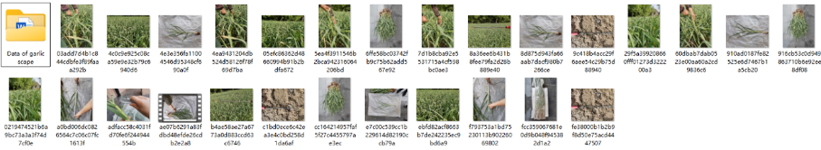

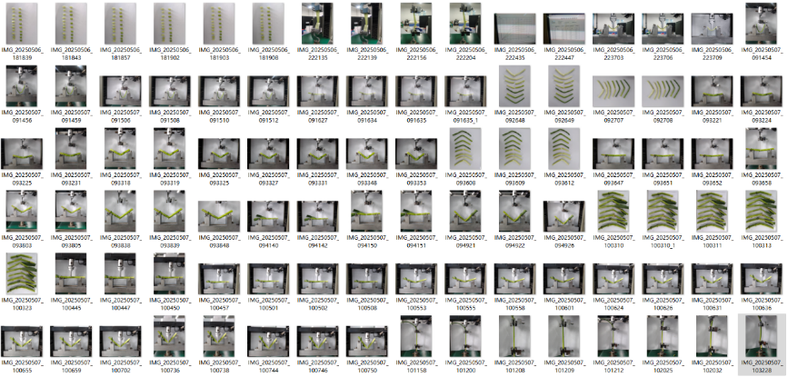

S4 Fig. Storage path of experimental photos.


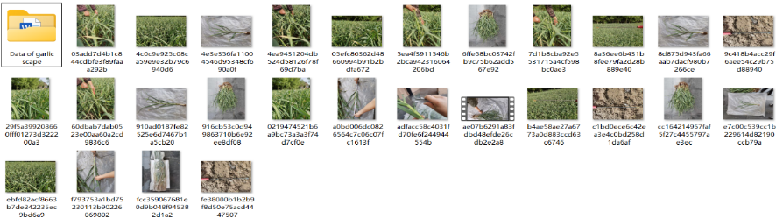

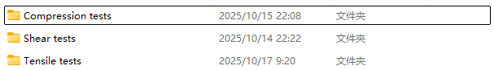

S5 Fig. Storage path of the compression experimental data.

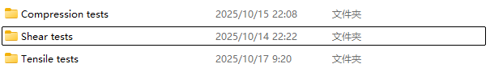

S6 Fig. Storage path of the shear experimental data.


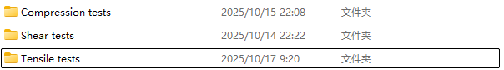

S7 Fig. Storage path of the tensile experimental data.
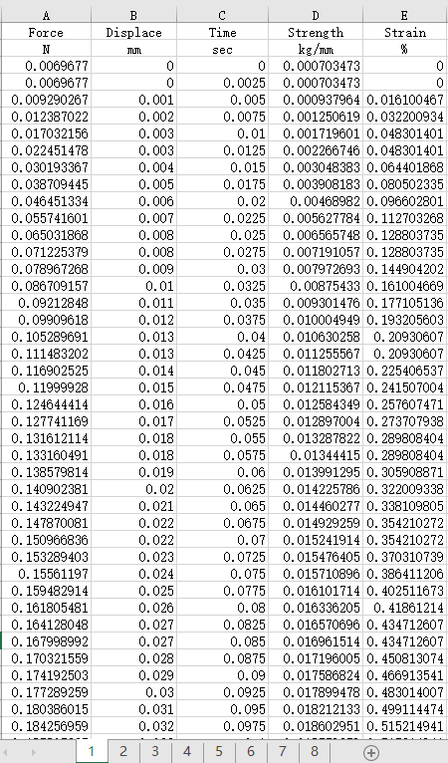 | 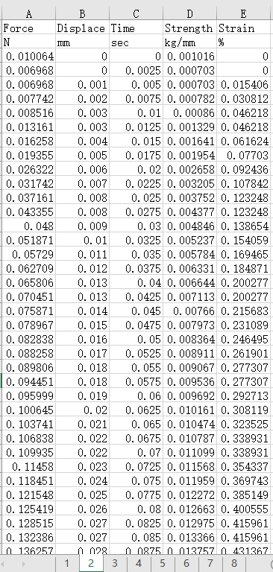 | 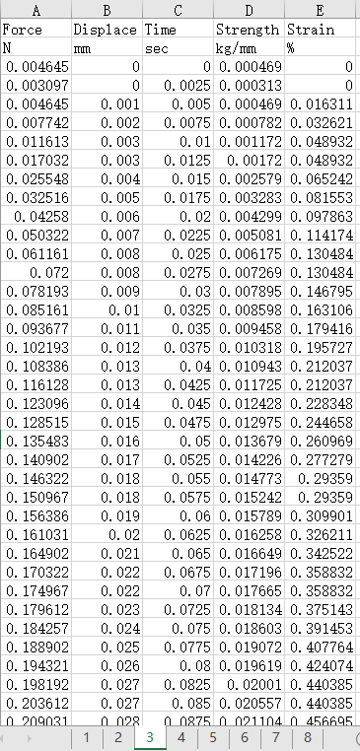 | 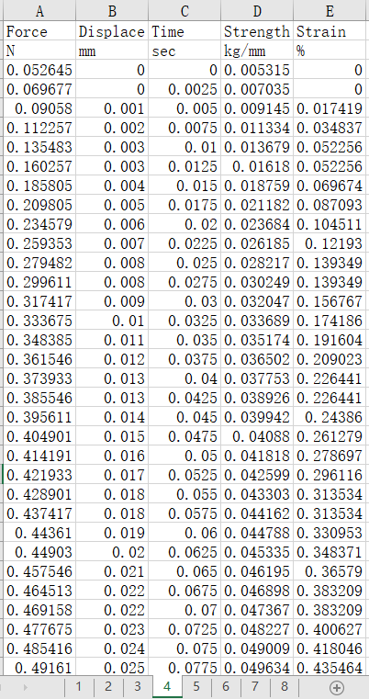
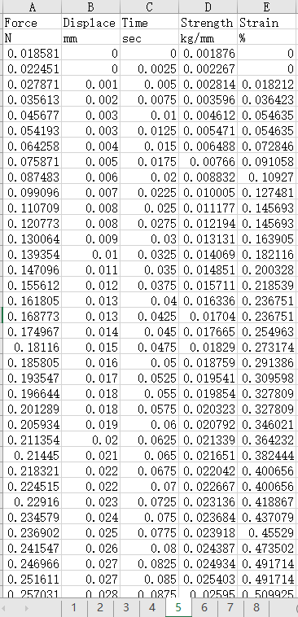 | 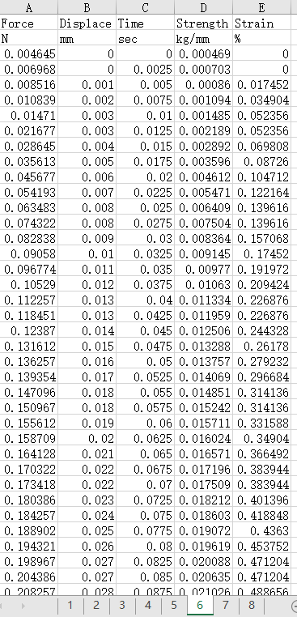 | 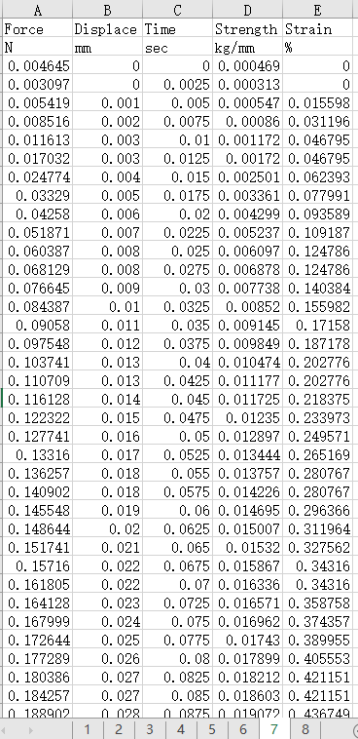 | 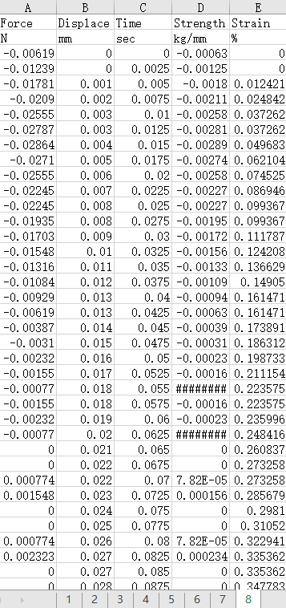
S8 Fig. Partial experimental data from the garlic scape compression tests.
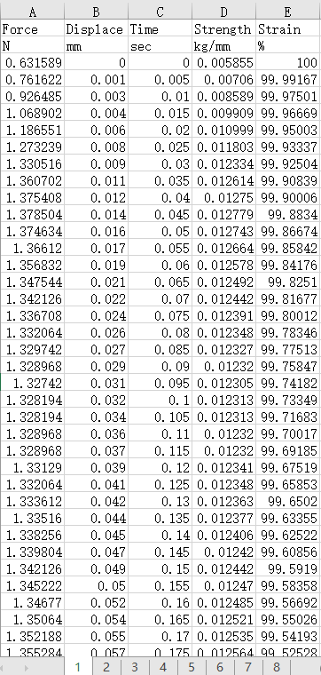 | 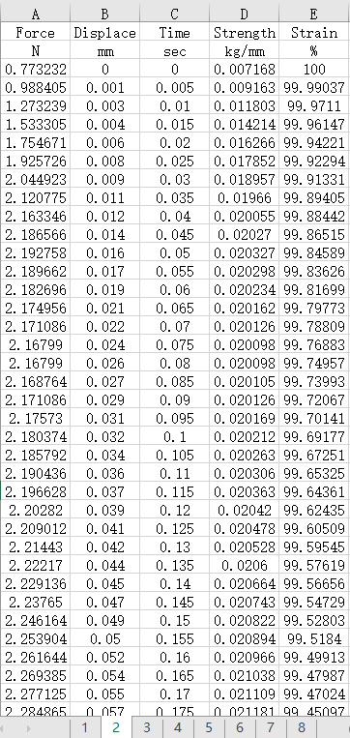 | 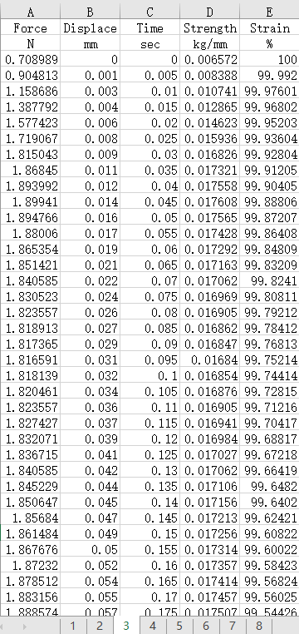 | 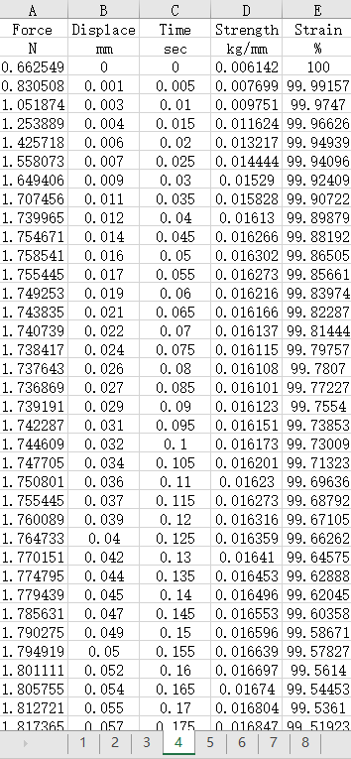
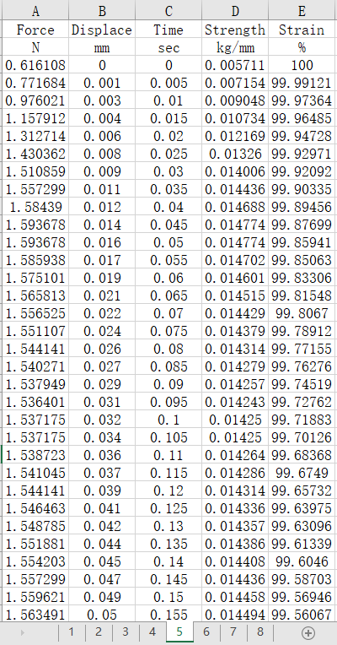 | 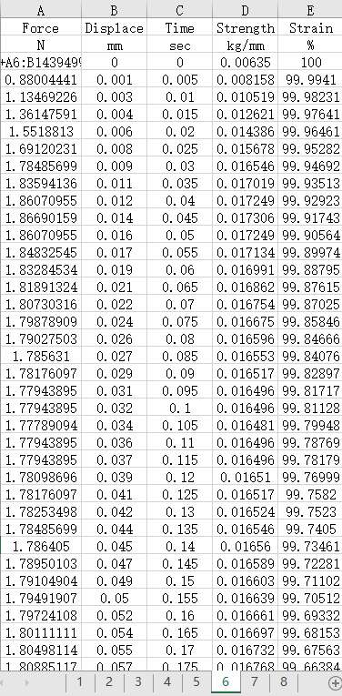 | 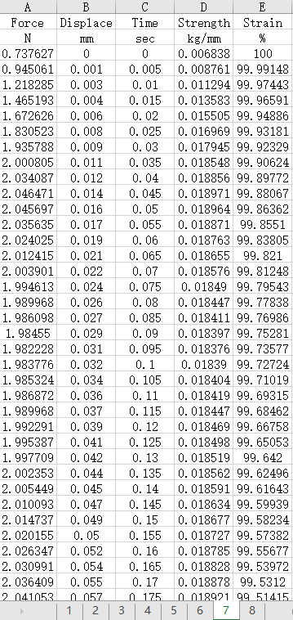 | 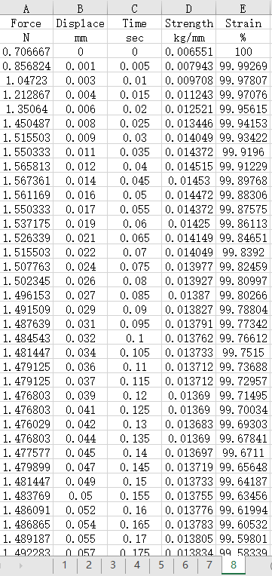
S9 Fig. Partial experimental data from the garlic plant compression tests.

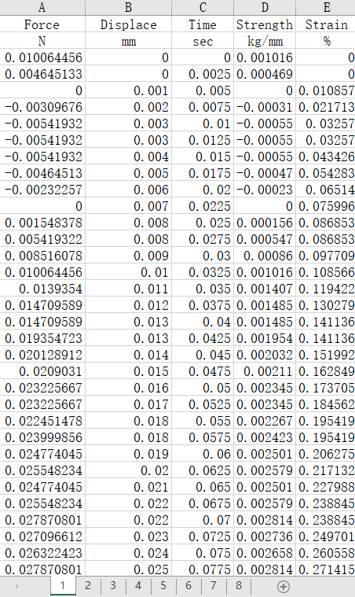 | 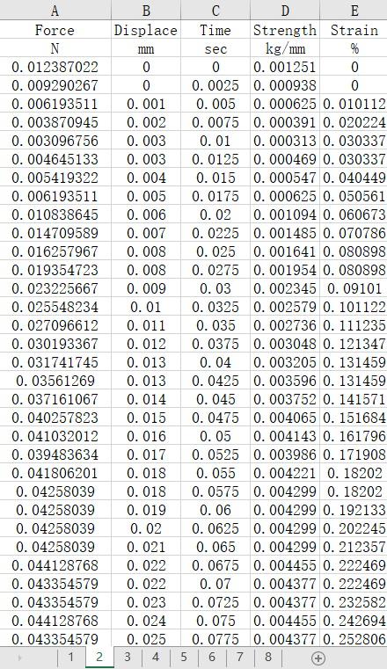 | 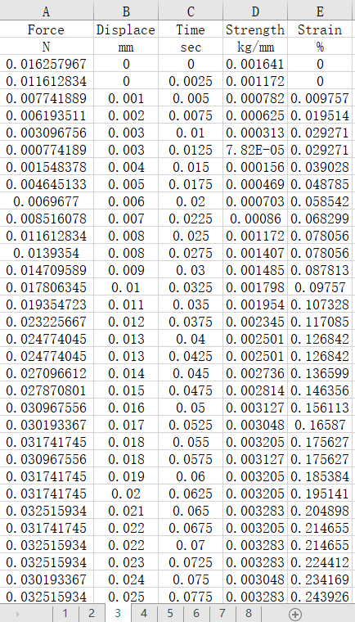 | 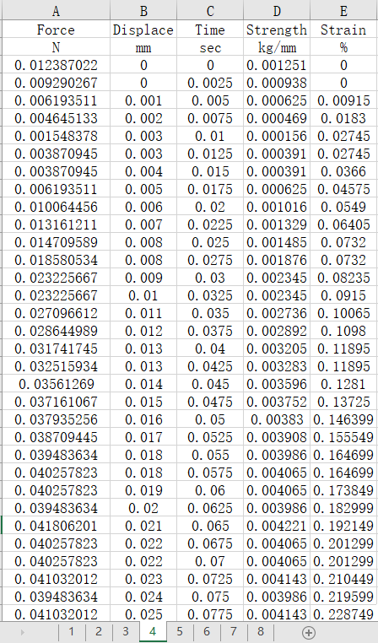
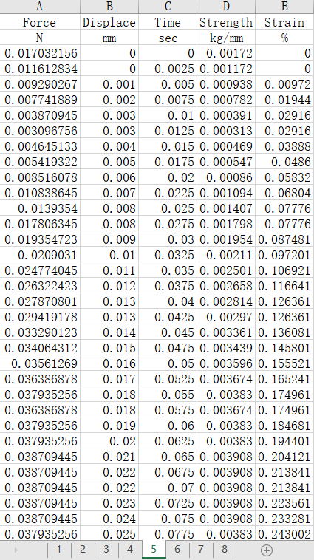 | 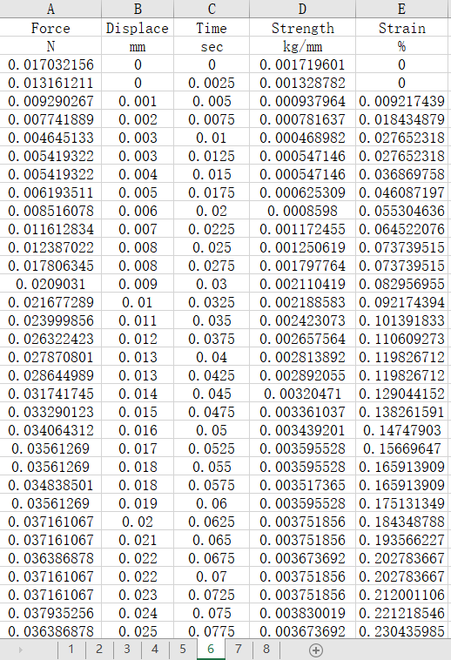 | 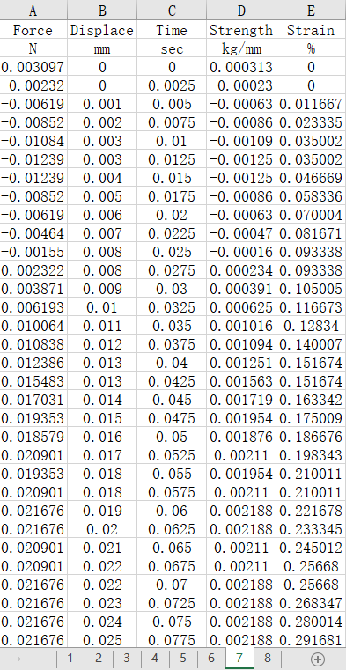 | 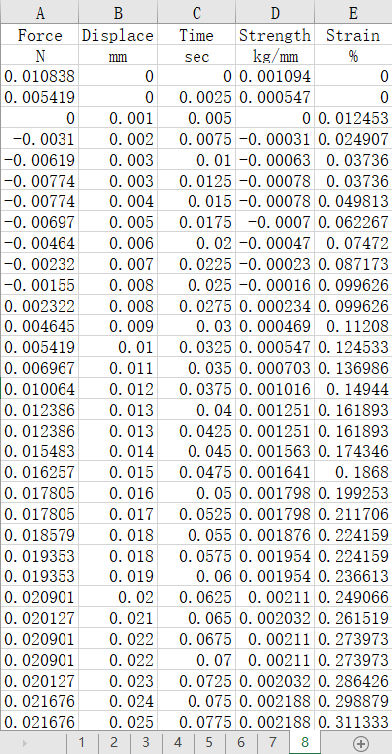
S10 Fig. Partial experimental data from the pseudo-stem compression tests.

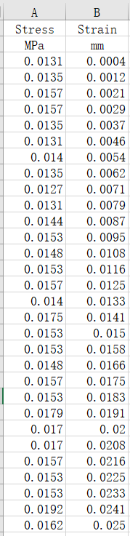 | 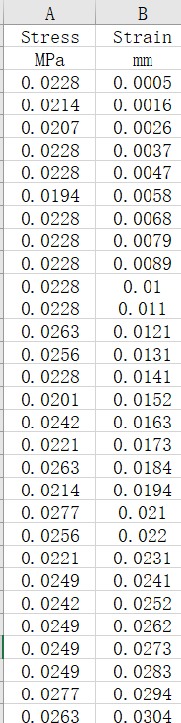 | 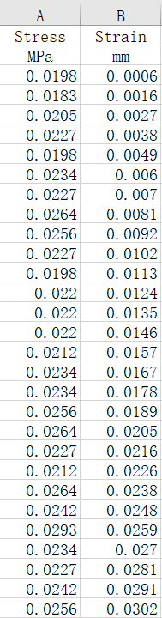 | 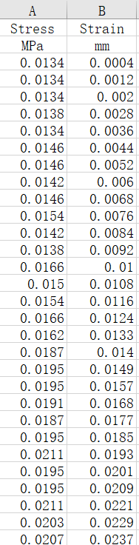 | 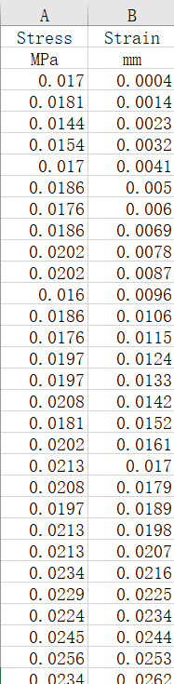 | 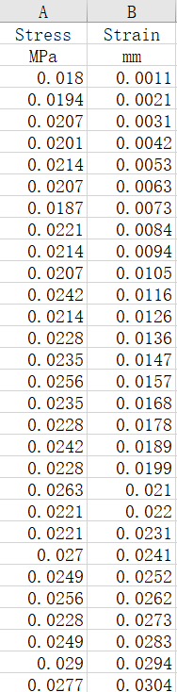 | 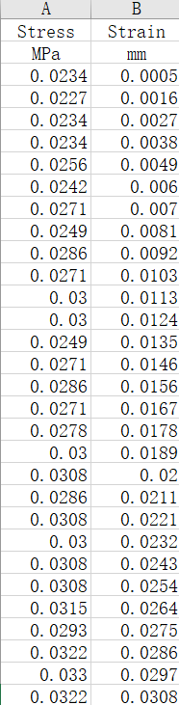 | 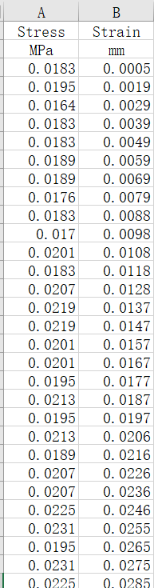
S11 Fig. Partial experimental data from the garlic plant shear tests.

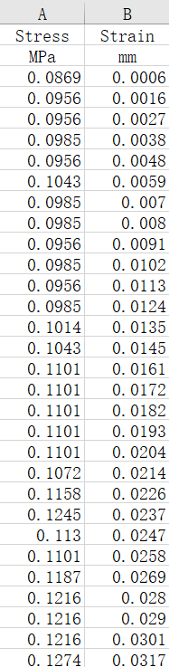 | 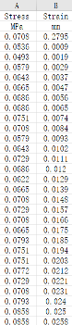 | 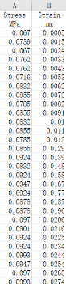 | 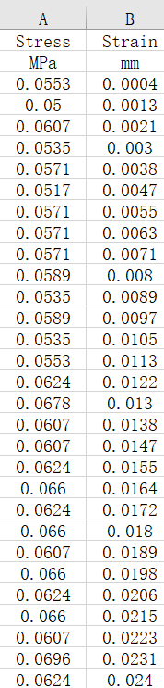 | 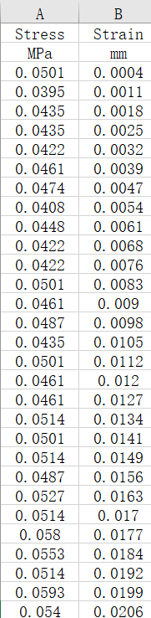 | 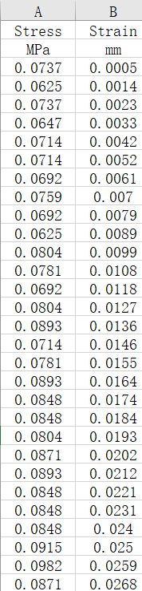 | 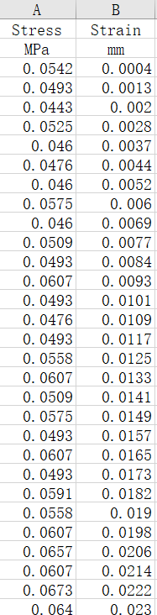 | 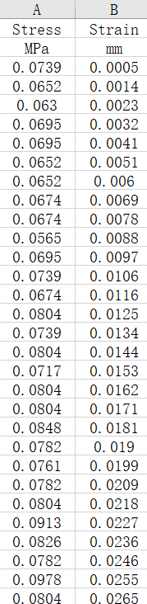
S11 Fig. Partial experimental data from the garlic scape shear tests.

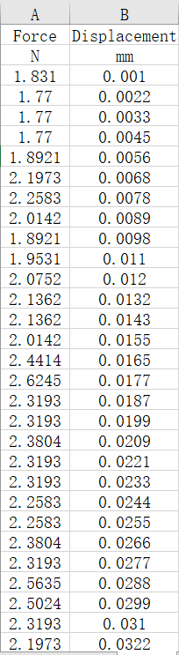 | 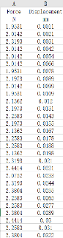 | 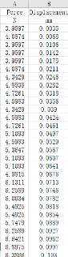 | 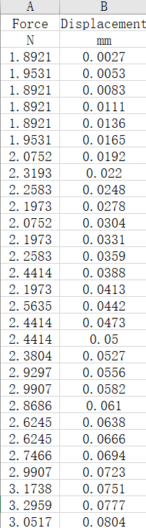 | 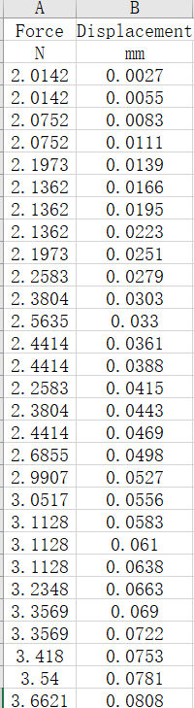 | 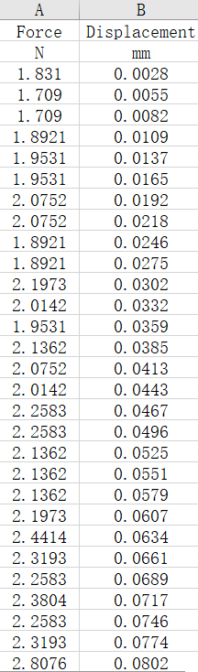 | 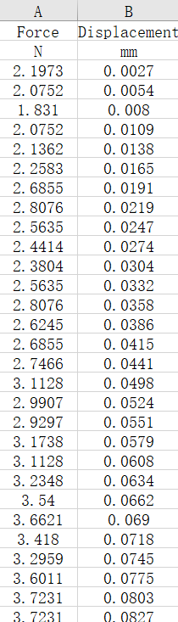 | 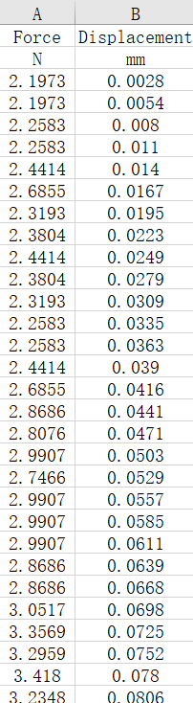
S12 Fig. Partial experimental data from the pseudo-stem shear tests.
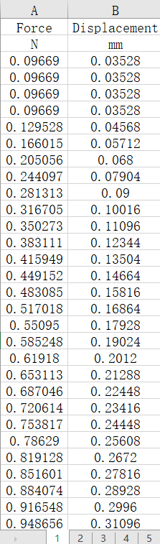 | 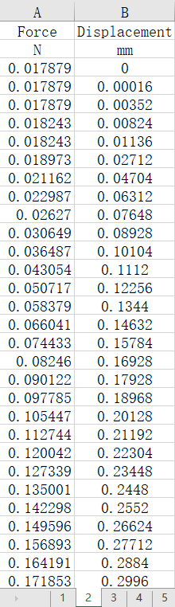 | 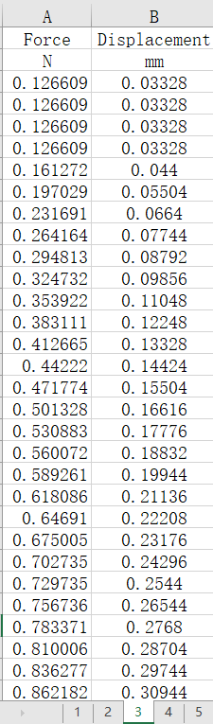 | 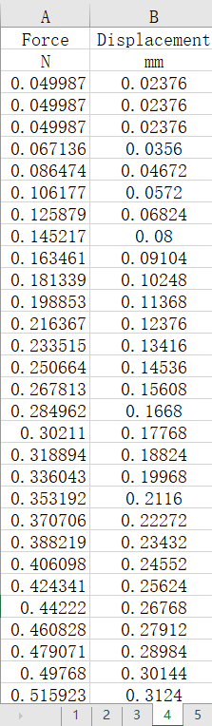 | 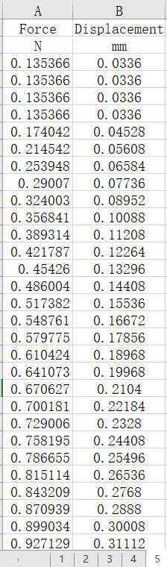 | 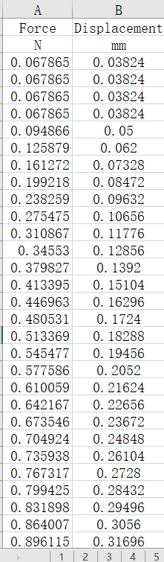 | 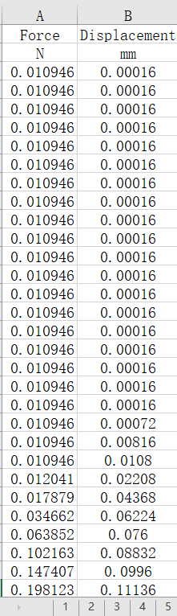 | 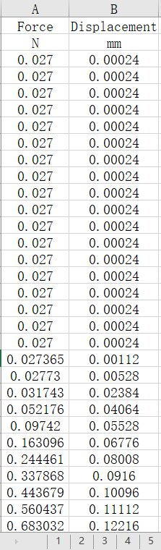
S13 Fig. Partial experimental data from the garlic scape tensile tests.

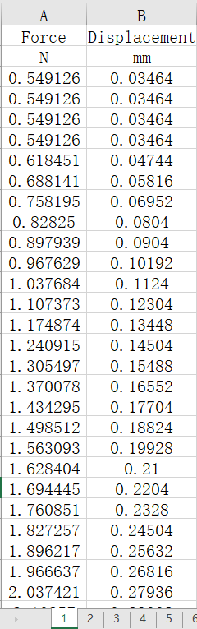 | 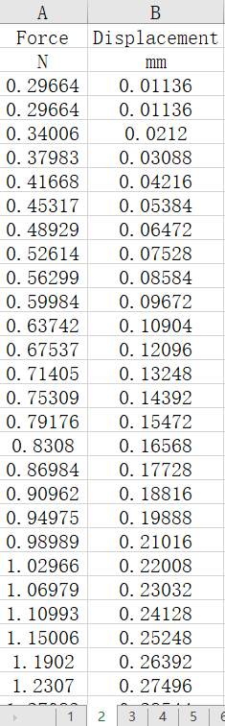 | 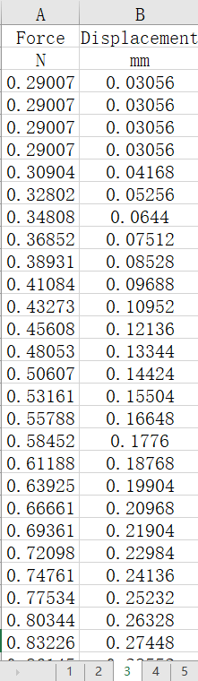 | 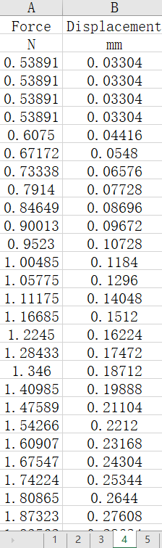 | 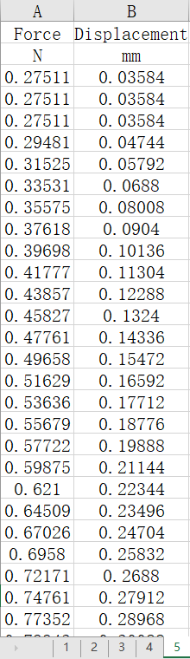 | 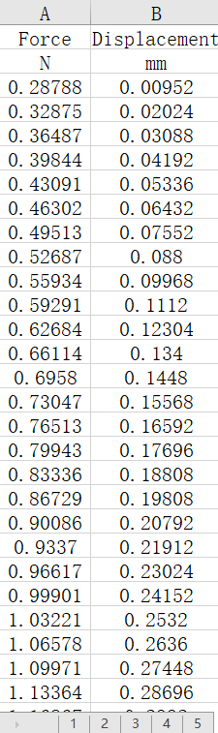 | 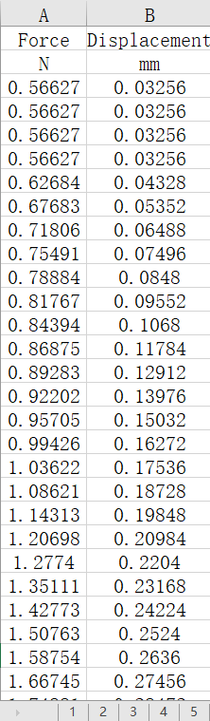 | 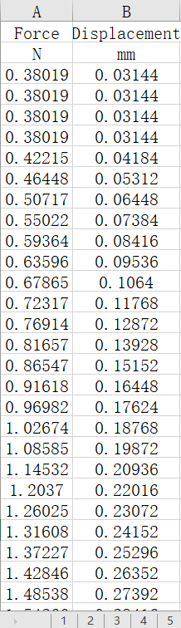
S14 Fig. Partial experimental data from the pseudo-stem tensile tests.
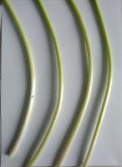 | 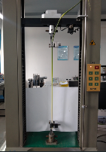 | 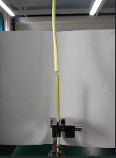 | 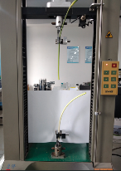
(a) | (b) | (c) | (d)
S15 Fig. The garlic scape tensile tests. (a) Samples of tensile tests. (b), (c), (d) Tensile test process.
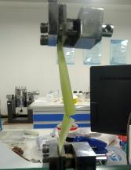 | 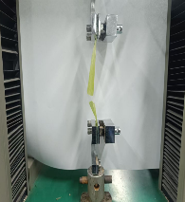 | 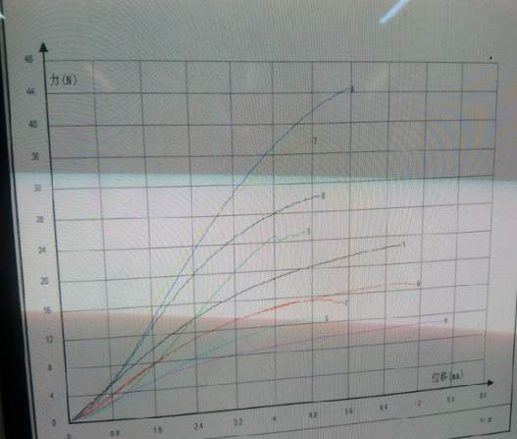
(a) | (b) | (c)
S16 Fig. The pseudo-stem tensile tests. (a), (b)Process of pseudo-stem tensile tests.(c) Pseudo-stem tensile force-displacement curves obtained via the universal testing machine.

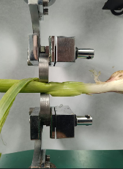 | 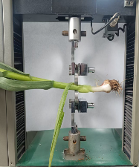
S17 Fig. The garlic plant compression tests.
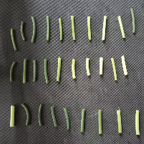 | 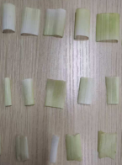 | 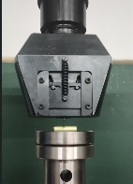
(a) | (b) | (c)
S18 Fig. The shear tests. (a) Garlic scape samples for shear test. (b) Pseduo-stem samples for shear test. (c) Process of garlic scape shear tests.
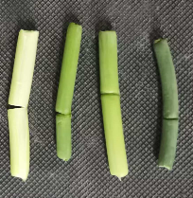 | 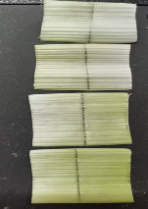
(a) | (b)
S19 Fig. Shearing effect Diagram. (a)Garlic scape shearing effect Diagram. (b) Pseudo-stem shearing effect diagram.
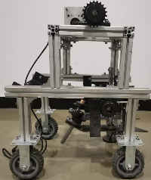

S20 Fig. Prototype model of the garlic scape harvester. The prototype model is currently in the construction phase. To date, the construction of the clamping device has been completed, and the construction of the drawing device will be advanced subsequently.

