Combined Nudging and Cardiac Pilot Hypotheses/Objectives/Analysis Plans for Examining Postoperative Opioid Misuse Incidence

February 16, 2026
Daniel B. Larach, M.D., M.S., M.A.
Vanderbilt University Medical Center

- Primary: In the combined datasets, we will use COMM-9 data to determine the percentage of the combined sample displaying the following descriptive characteristics regarding postoperative opioid misuse behaviors:
    - Incidence: yes/no, where “moderate” and “high” severity as defined below are considered “yes” and “low” severity is considered “no”.
    - Severity: graded “low”, “moderate”, and “high” as per the official COMM-9 Scoring Algorithm and Score Interpretation Table procured from the MAPI Research Trust: 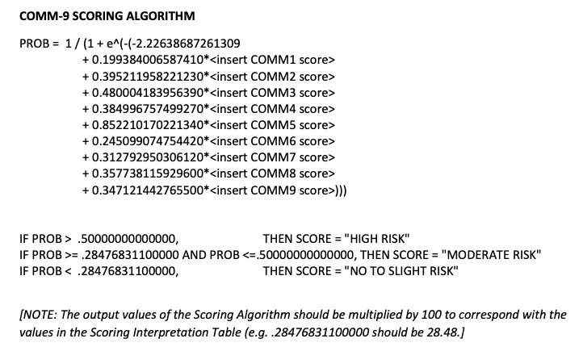
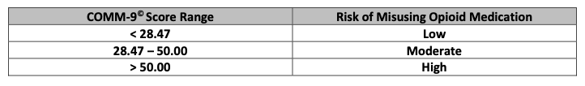
- Secondary #1: In the combined datasets, we will test for an association between the independent variable opioid consumption (numerical opioid pill count, with possible follow-up sensitivity analysis examining milligram morphine equivalents; MMEs) and the dependent variable opioid misuse behaviors (continuous COMM-9 probability score, as described above).
  - Analytic plan:
    - Linear regression.
    - Prespecified covariates include:
      - Nudging patient vs. cardiac pilot patient. 14-day follow-up period for nudging study vs. 30-day follow-up for period cardiac pilot study may influence observed opioid consumption and assessment of opioid misuse behaviors. As nearly all cardiac pilot patients used opioids for ≤15 days, we believe this is sufficient to control for this interstudy protocol discrepancy.
      - Age.
      - Sex.
      - As both cohorts were mostly non-Hispanic white, we are not prespecifying race or ethnicity as covariates but may consider conducting sensitivity analysis using them.
- Secondary #2: In the combined datasets, we will test for an association between the independent variable opioid consumption (numerical pill count and possible follow-up sensitivity analysis using MMEs) and the dependent variable opioid misuse behaviors defined as the categorical COMM-9 score [“low”, “moderate”, “high”] as above).
  - Analytic plan:
    - Ordinal logistic regression.
    - Prespecified covariates are identical to “Secondary #1”, above.
- Secondary #3: In the combined datasets, we will describe which specific misuse behaviors resulted in classification of individual patients as “moderate” or higher per the COMM-9 scoring algorithm.
  - Analytic plan: Given the likely low incidence of misuse among the combined cohort, we will not perform formal hypothesis testing but will simply report each pertinent individual patient’s COMM-9 responses (below) in a table.
