MERSCOPE Imaging

- Scope and Applicability: High-throughput MERFISH imaging of prepared tissues on the MERSCOPE platform.

- Materials:
  - MERSCOPE Sample Prep Kit (PN 10400012)
    - Sample Prep Wash Buffer (PN 20300001)
    - Formamide Wash Buffer (PN 20300002)
  - MERSCOPE 140, 300, 500 or 1000 Gene Imaging Kit (PN 1040004, 1040005, 1040006, 10400126)
    - MERSCOPE Imaging Cartridge (included with Gene Imaging Kits)
    - DAPI and PolyT Stain (PN 20300021)
    - Imaging Buffer Activator (PN 20300015)
  - RNase Inhibitor, Murine (New England BioLabs M0314L)
  - Mineral Oil (Millipore-Sigma M5904-6X500ML or equivalent)

- Equipment:
  - Water bath (VWRU76308-896 or larger) set to 37°C
  - Benchtop cooler
  - RNase Zap RNase Decontamination Solution (Thermo Fisher AM9782 or equivalent)
  - Lens Tissue (Thorlabs MC-5 or equivalent)
  - Serological Pipettes (25 ml) and pipettor
  - P1000 and P200 pipettes
  - Kimwipes

- Safety:
  - Nitrile Gloves
  - Clean lab coat
  - PCR Hood

Warning: Personal Protective Equipment (PPE) should be used at all times while operating this protocol. If you are unsure what PPE you should be using, see your immediate supervisor.

- Output:
  - Complete MERFISH imaging experiment.

- Reference Documents
  - RP0236 Nuclease-Free 70% Ethanol
    - To be Published
  - 91600001: MERSCOPE Instrument User Guide
  - MERSCOPE Imaging Worksheets
  - MERSCOPE Specimen Inventory Tracker

- Setup:
  - Fill out the MERSCOPE Imaging Worksheet online.
    - Fill cells C3 and C4 with the name(s) of the users performing the imaging.
    - Fill cell G4 with the date imaging was performed.
    - Fill cells C7-C10 with all Specimen IDs for tissue being imaged.
      - Note that some coverslips will contain multiple tissue sections. Make sure the number of Specimen IDs matches the number of tissue sections and not the number of coverslips.
      - Specimen IDs can be found on the MERSCOPE Specimen Inventory Tracker.
    - Fill cells G7-G10 with the names of the MERSCOPEs used for imaging.
    - Fill cells C12 and G12 with the initials of the lab member who witnessed the selecting of the Imaging cartridge and the ID of the cartridge kit respectively.
    - Print and use the worksheet as a guide during imaging.
  - Thoroughly clean all tools, lab bench, and gloves with RNaseZap followed by 70% ethanol.
  - Take Sample Prep Wash Buffer and Formamide Wash Buffer out of the 4°C refrigerator located at the back of lab 753S (EC_735S+4B), and place at room temperature for 30 minutes before use.
  - Thaw frozen MERSCOPE Imaging cartridge in water bath for at least 1 hour. Ensure that the cartridge valve/receptor does not come into contact with the water. Gently invert the cartridge 10 times after thawing, to ensure that all reagents are well-mixed.
    - You will need an Imaging Kit and respective cartridge for each coverslip being imaged that day.
  - Thaw the DAPI/PolyT stain in water bath for 10 minutes. Gently shake the tube after thawing, to ensure that the reagents are well-mixed.
  - Place imaging buffer activator and RNase Inhibitor in a benchtop cooler until use. Both need to be kept cold at all times.
  - Set up the MERSCOPE instrument for imaging.
    - Power cycle the MERSCOPE by shutting down the acquisition computer via Windows and flipping the power switch at the back of the computer. Wait 5 minutes before rebooting the instrument.
    - Log in to the computer via the assigned credentials.
    - Double-click the MERSCOPE application.
    - Check that there is at least 5 TB of available space on the machine before initiating an experiment. If there is at least 5 TB available, click “Start MERFISH” to initialize MERFISH hardware (Figure 1).
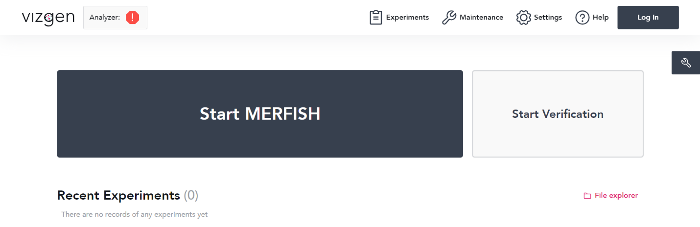
Figure 1. Click “Start MERFISH” to initialize the experiment.

    - After a few minutes, a screen will pop up where one can configure the experiment details (Figures 2-4).
      - Enter in the desired experiment name, experiment description, and select the appropriate codebook for the gene panel and then hit “Next.”
      - Click “Next” to confirm an Imaging Depth of 10 microns.
      - Click “Next” to skip Image Processing Properties.
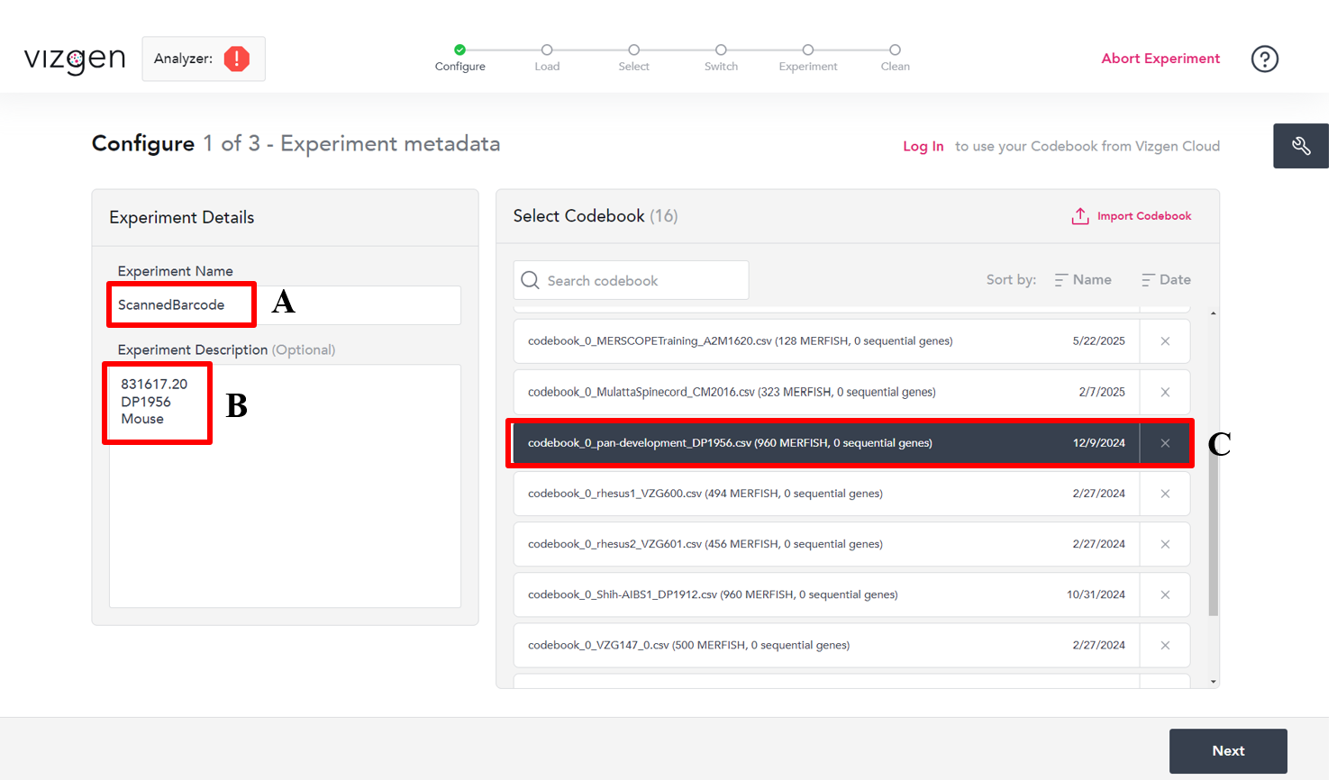
Figure 2. When inputting Experiment Metadata, make sure to scan the barcode (A) for the Experiment Name. In Experiment Description, input the BrainID.Coverslip#, Gene Panel, and Species (B). Select the codebook that corresponds to the Gene Panel (C).

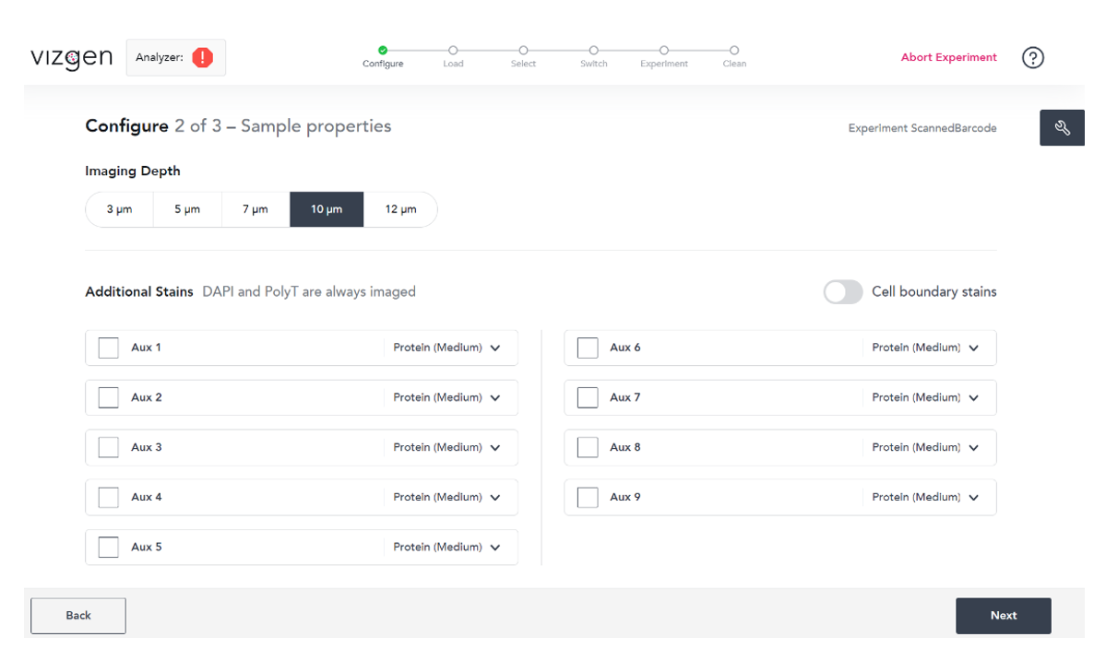
Figure 3. Confirm an Imaging Depth of 10 microns and click “Next.” There are no additional stains –
all that needs to be done is confirming that the imaging depth is 10 microns before clicking “Next”.

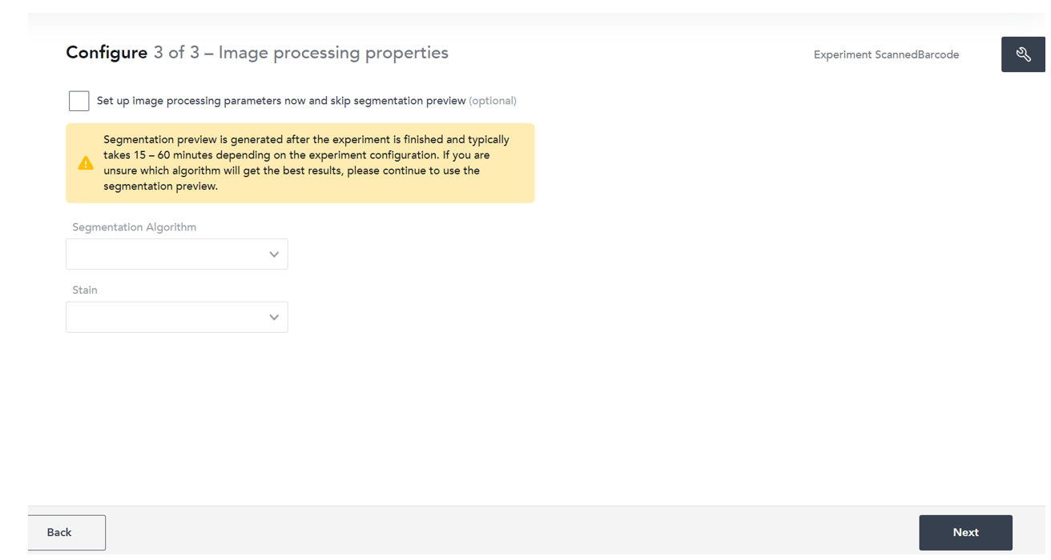
Figure 4. Skip all Imaging Processing Properties. Just click “Next” and proceed.

    - Click “Next” to finalize the experiment details and complete the MERSCOPE set up (Figure 5). Open the lid to the imaging cartridge chamber and discard the previous experiment’s imaging cartridge if necessary. Follow the steps on the screen throughout the rest of the imaging protocol.
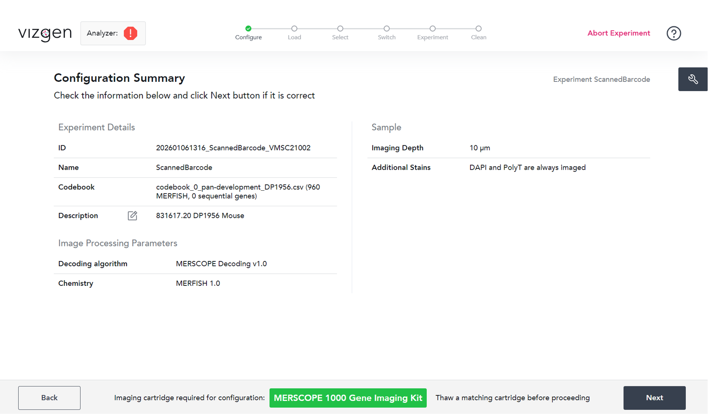
Figure 5. Confirm all Experiment Metadata is correct and click “Next.”

- Methodology/Procedures:
  - Remove the gel-embedded sample from the 37°C incubator, and aspirate off the clearing solution. Wash the sample twice with 5 ml of Sample Prep Wash Buffer, for 5 minutes each wash.
    - Throughout the washes, inspect the gel to ensure that there is no lifting on the tissue or around the edges.
    - The washing step can be performed while the DAPI/PolyT stain is thawing.
  - Once the DAPI/PolyT stain has thawed, gently shake the tube to ensure that the reagents are well-mixed. Add the full 3 ml solution to each petri dish and incubate for 15 minutes with a cover to protect from light.
    - The rest of the sample prep for imaging should be performed in darkness. Try to limit light exposure during each successive step of this procedure before imaging.
  - Aspirate the DAPI/PolyT stain, and wash once with 5 ml of Formamide Wash Buffer for 10 minutes (covered).
  - Aspirate the Formamide Wash Buffer, and wash once with Sample Prep Wash Buffer (cover after wash).
  - By the end of this sample preparation protocol, the MERSCOPE imaging cartridge should be nearly thawed. Once thawed, gently invert 10 times to ensure that all reagents are properly mixed.
  - Remove the imaging cartridge lid and use a Kimwipe to thoroughly dry all surfaces of the imaging cartridge before use. Replace the cartridge lid.
  - Clean the valve of the MERSCOPE Imaging Cartridge with RNaseZap followed by 70% Ethanol.
    - Avoid spraying directly onto the valve; spray onto a Kimwipe and then wipe the valve.
  - Ensure that the cartridge lid has been replaced in the correct orientation, with the concave portion aligned with the valve. Using a clean pipette tip, pierce the foil at the designated cartridge activation port.
  - Prepare the activation mix for imaging buffer activation: mix 250 µl of imaging buffer activator with 100 µl of RNase inhibitor in a separate tube.
  - With a 1 ml pipette set to 1 ml, carefully add all of the imaging activation mix (via the cartridge activation port) by inserting the pipette tip below the level of the liquid in the imaging cartridge. Pipet up and down 10 times to thoroughly mix the solution in the imaging cartridge.
  - Slowly layer 15 ml of mineral oil over the liquid in the imaging cartridge via the cartridge activation port.
    - When adding the mineral oil to the cartridge, make sure to expel the oil very slowly with the serological pipette to ensure the oil is layered atop the rest of the liquid in the cartridge.
  - Clean the barcode with 70% Ethanol. Insert the imaging cartridge into the instrument with the valve facing the back, and the barcode facing the front and close the chamber. Follow the instructions on the MERSCOPE: click “Scan Barcode,” and then “Prime Fluidics” to prime the fluidics system with the imaging fluids.
    - The priming fluidics step should take about 5 minutes.
  - Once the fluidics system has been primed, the MERSCOPE flow chamber lid will unlock. Remove the flow chamber and thoroughly clean it with RNaseZap followed by 70% Ethanol.
  - Assemble the flow chamber with the prepared coverslip (figure 6).
    - With the small divot in the chamber base facing the user, insert the coverslip with the sample gel facing up.
    - Place the gasket on top with straight sides of the internal hexagon on the left and right, perpendicular to the fluid input line.
    - Place the aqueduct on top, with the arrows pointing on the ends to the left. These arrows indicate direction of fluid flow.
    - Place the flow chamber top and screw clockwise until some resistance is encountered. Firmly twist the top until a loud “click” is heard.
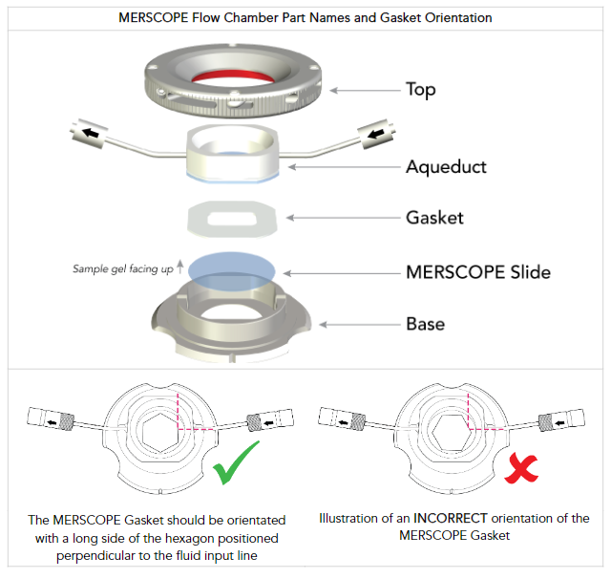
Figure 6. Illustration of the correct method for assembling the flow chamber.

  - Thoroughly clean the bottom of the coverslip with 100% Ethanol.
  - Click “Next” once flow chamber assembly and cleaning is complete. Connect the assembled flow chamber to the fluidics lines in the MERSCOPE instrument as instructed on the screen.
    - First connect the output line on the left, and then the input line on the right. Click “Next”.
  - Orient the sample vertically with the input at the bottom and the output at the top. Click “Wet Flow Chamber” to initiate wetting the flow chamber. Liquid should begin to pull once the progress bar reaches the end of the word “Pulling”.
  - Watch the fluid output line to ensure that liquid is pulling properly. Tap out any air bubbles that are pulled and/or created. If there are bubbles remaining in the flow chamber or input fluid line, click “Pull More Liquid” until no bubbles remain. When done, click “Next”.
    - When eliminating air bubbles, it can be useful to tilt the assembly in the direction of the liquid flow (i.e. the left end higher than the right) while you tap/hit the assembly.
      - Getting rid of bubbles can require a bit of force – gentle tapping may not be enough to push the bubbles through the system.
    - Liquid can only be pulled a total of three times before the risk of running out of liquid in the imaging cartridge is run. If bubbles remain after pulling liquid three times, contact Vizgen Support. Small bubbles near the output line should be fine.
  - Insert the flow chamber into the MERSCOPE instrument, ensuring that it is flush within the stage adapter. Lock the chamber into place and close the lid.
  - Click “Acquire Mosaic” to acquire a low-resolution mosaic with the 10x objective. This should take approximately 10 minutes.
  - Once the mosaic has been acquired, select the region of interest to be imaged in this experiment using the touch screen or the mouse.
    - A summary of the selected region appears on the right side of the screen. If an error is made, one can click the selected region summary on the right side of the screen to adjust specific points of the selected area.
    - Multiple regions can be selected in one experiment, and are by default named “region 0,” “region 1,” etc. These regions can be renamed.
    - Up to 10 regions can be selected, with a total area of up to 100 mm².
  - When selections are complete, click “Next”.
  - Follow the instructions to switch to the high-magnification objective.
    - Unlock the flow chamber from the stage adapter and remove it to the side of the stage.
    - Do not detach fluidics lines.
  - Using a Lens wipe, gently clean the 60x objective. Slowly apply two drops of immersion oil onto the 60x objective, ensuring that it does not drip down the side of the objective into the instrument.
    - If the oil drips, clean the objective and reapply the oil.
    - Ensure that the oil is free of bubbles. If there are bubbles, clean the objective and reapply the oil.
      - To prevent oil bubbles, it can help to have a kimwipe available to slowly drip oil onto until you see the nozzle is bubble-free.
  - Re-insert the flow chamber into the instrument, ensuring that it is flush with the stage adapter. Lock the chamber into place.
  - Close the flow chamber and click “Next”. The MERSCOPE will attempt to find the focal plane with the high magnification objective.
    - If focusing is successful, click “Next” to view the experiment summary.
    - If focusing is unsuccessful, repeat steps 8.23 – 8.26 until focusing succeeds.
  - Review the details in the experiment summary. Click “Start Measurement” if all details are satisfactory, to initiate the full MERFISH imaging experiment.

- Take Down:
  - The progress bar will be green and full once the experiment is complete. Click “Select Segmentation Parameters” to proceed to imaging analysis.
  - Select the segmentation parameters in the DAPI channel. Try to select a region that is completely on the tissue, with plenty of cells in view that have been outlined and detected as a single cell. Click “Select this region” once a desired region is found.
  - Click “Start Image Processing” to start the imaging processing analysis. This will continue in the background on the analysis computer, and should not affect the acquisition of another experiment.
  - Click “Clean Instrument” to clean the MERSCOPE. Follow the instructions on the screen.
    - Remove the waste bottle from its designated chamber at the bottom right of the MERSCOPE and dispose of the waste accordingly.
    - Replace the bottle once emptied.
      - One can only proceed to the next step once the detected weight of the waste bottle is less than 250 g. If the weight is below this limit, click “Next”.
    - This waste contains formamide and should be handled with proper PPE.
  - The MERSCOPE flow chamber lid will unlock. Remove the flow chamber from the stage insert, without detaching fluidics lines. Using a lens wipe, gently and thoroughly clean the 60x objective to remove the oil. Gently press down to reset the 60x objective’s z-plane.
  - Replace and relock the flow chamber in the stage insert. Close the flow chamber lid.
  - Click “Done” once the instrument is clean. The MERSCOPE will return to its main menu, and the experiment is complete.

