Counting cells using a hemocytometer

Preparing hemocytometer
- If using a glass hemocytometer and coverslip, clean with alcohol before use.
- If using a disposable hemocytometer (for example, INCYTO DHC-N01), simply remove from the packet before use.

Preparing cell suspension
- Resuspend the pellet cell with 1 ml of media or cold PBS and pipette up and down the cell suspension several times at least 10 times.
- Before the cells have a chance to settle, take out 0.5 mL of cell suspension and place in a 1.5ml Biosphere Safe Seal Tube.
- Take 100 µl of cells into a new 1.5ml Biosphere Safe Seal Tube and add 300 µl 0.4% Trypan Blue plus 100 ul PBS. Mix gently.

Counting
- Using a pipette, take 10 µl of Trypan Blue-PBS-treated cell suspension and apply to the hemocytometer in each chamber. If using a glass hemocytometer, very gently fill both chambers underneath the coverslip, allowing the cell suspension to be drawn out by capillary action. If using a disposable hemocytometer, pipette the cell suspension into the well of the counting chamber, allowing capillary action to draw it inside.
- Using a microscope, focus on the grid lines of the hemocytometer with a 10X objective.
- Using a hand counter, count the live, unstained cells (live cells do not take up Trypan Blue) in one set of 16 squares (Figure 1). When counting, employ a system whereby cells are only counted when they are set within a square or on the right-hand or bottom boundary line. Following the same guidelines, dead cells stained with Trypan Blue can also be counted for a viability estimate if required.
- Move the hemocytometer to the next set of 16 corner squares and carry on counting until all 4 sets of 16 corners are counted.

Viability
To calculate the number of viable cells/ml:
- Take the average cell count from each of the sets of 16 corner squares.
- Multiply by 10,000 (10⁴).
- Multiply by 5 to correct for the 1:5 dilution from the Trypan Blue and PBS addition.
The final value is the number of viable cells/ml in the original cell suspension.
Example:
If the cell counts for each of the 16 squares are 50, 40, 45, 52, the average cell count would be:
(50 + 40 + 45 +52) ÷ 4 = 46.75
46.75 x 10,000 (10⁴) = 467,500
467,500 x 5 = 2,337,500 live cells/ml in original cell suspension

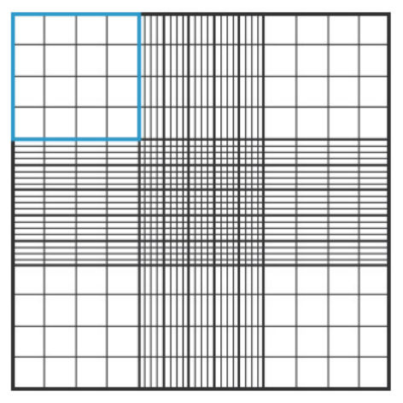
Figure 1. Hemocytometer gridlines. Hemocytometer diagram indicating one of the sets of 16 squares that should be used for counting.

