Annealing adaptor:

Tn5MErev, 5'-[phos]CTGTCTCTTATACACATCT-3';
Tn5ME-A, 5′ - TCGTCGGCAGCGTCAGATGTGTATAAGAGACAG-3′;
Tn5ME-B: 5′- GTCTCGTGGGCTCGGAGATGTGTATAAGAGACAG-3′.

- Resuspended oligonucleotides (Tn5ME-A, Tn5ME-B, Tn5MErev) in water to a final concentration of 100µM each.

- Mix equimolar amounts of Tn5MErev/Tn5ME-A and Tn5MErev/Tn5ME-B in separate 200 µl PCR tubes.

- Denature on a thermocycler for 5 min at 95°C, and cool down slowly on the thermocycler by turning off the thermocycler.

Tn5 assembly
- Tn5 from PSF = 63.64uM (3.5 mg/ml) (batch WH)

- Mix the following gently with pipette and incubate 1h at room temperature (the final concentration is 2uM).
(Adjust the concentration of Tn5; example: make a small batch first, if the condition works, you could make a big batch with the same condition)

50uM Tn5MErev/Tn5ME-A 2ul
50uM Tn5MErev/Tn5ME-B 2ul
Glycerol 21.56ul
2X Dialysis buffer 21.3ul
Tn5 3.14ul
Total 50ul

2x Dialysis buffer
Stock conc. | Solution | Final conc. | For 10 ml
0.25M | HEPES-KOH pH 7.2 | 100 mM | 4 ml
5M | NaCl | 0.2 M | 0,4 ml
0.5M | EDTA | 0.2 mM | 4 ul
20mM | DTT* | 2 mM | *
10% | Triton X-100 | 0.2% | 200 ul
100% | Glycerol | 20% | 2 ml
 | dH2O |  | 3,4 ml
* DTT is toxic and should only be added to the stock solution immediately prior to use (e.g. 45 ul buffer + 5 ul DTT)
Keep buffer at 4 °C

Keep enzyme at -80°C

Tn5 activity assay

- Test the Tn5 activity with 5 ng mouse tail intact genome. Incubate at 55 degree for 7mins with the following mixture:

Reagent | Volume | Concentration | Final conc.
DNA |  | 5 ng
TD buffer (2X) * | 10 ul
Tn5 | 1 ul | 2uM | 100 nM
dH₂O
Final | 20 ul
*Home made TD buffer (Wang et al., 2013), see end of protocol for information

- Purify DNA and do the PCR with 9 cycles.

- Check the size distribution on bioanalyzer (should be 100-400bp)
One good example is in the following: The majority of PCR product is between 100-400bp.

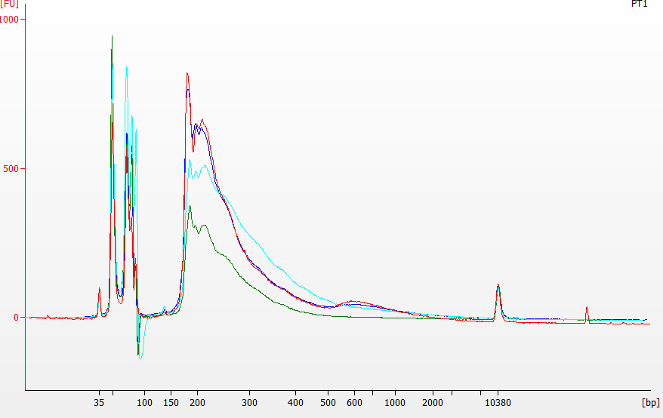

HEPES 1M, pH 7.2

Dissolve 23.83 g HEPES into 50 ml autoclaved water

Stir, while adjusting the pH with KOH to the appropriate pH (pH 7.2)

Add autoclaved water up to 100 ml

Filter if necessary. Store in the fridge if desired.

Home made TD buffer (Wang et al., 2013)

20 mM Tris(hydroxymethyl)aminomethane
- Dissolve 12,1 g Tris in 100 ml to get 1M -> use 2 ml of 1M Tris in 97 ml dH2O to obtain 20mM

10 mM MgCl₂
- Use 1ml of 1M MgCl₂ in 97ml dH2O to obtain 10 mM MgCl₂

Adjust the pH to 7.6 with 100% acetic acid (wear protective clothes, labcoat, goggles, gloves)

20% (vol/vol) DiMethylFormamide (DMF) (toxic, work in fumehood)
- Take 8 ml of Tris buffer and add 2 ml of DMF to obtain 20% DMF

Sterilize the buffer by filtration and aliquot in 500ul. This solution can be stored at −20 °C for at least 6 months.

